**Lab6**

**R. Harini**

**18BCE1010**

import pandas as pd

from ggplot import *

g1=ggplot(aes(x='carat', y='price'), data=diamonds) +geom_area()+ggtitle("Carat vs Price")

g1.show()

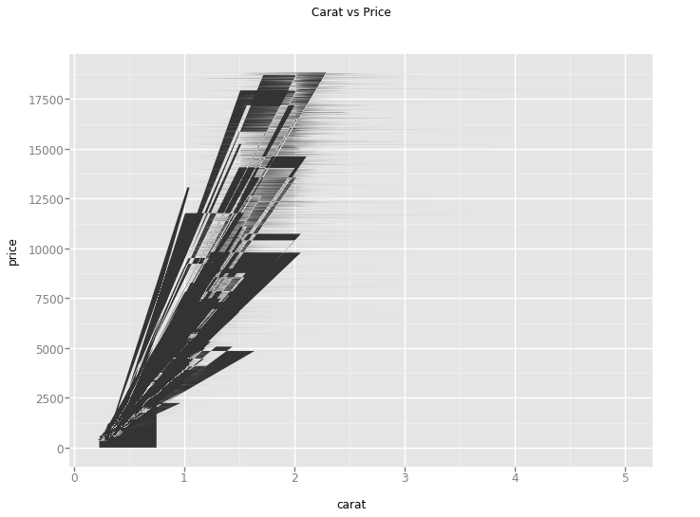

g2=ggplot(aes(x='carat', y='price'), data=diamonds)+ geom_jitter()+ggtitle("Carat vs Price")

g2.show()

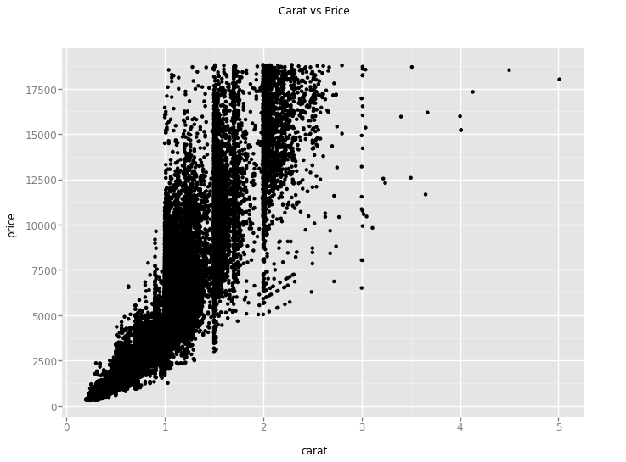

g3=ggplot(aes(x='carat', color='cut'), data=diamonds)+ geom_point()+ggtitle("Carat vs Price")

g3.show()

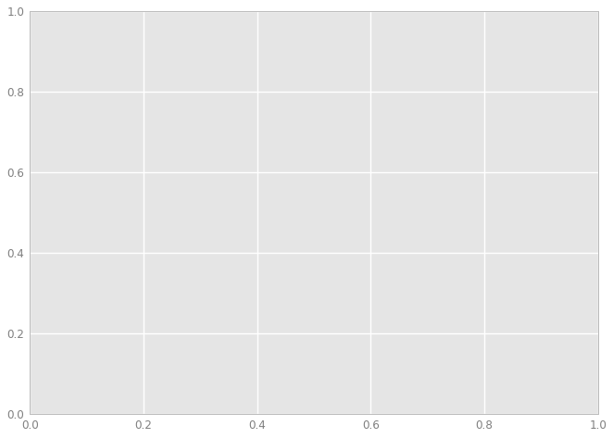

g4=g2+theme_bw()

g4.show()

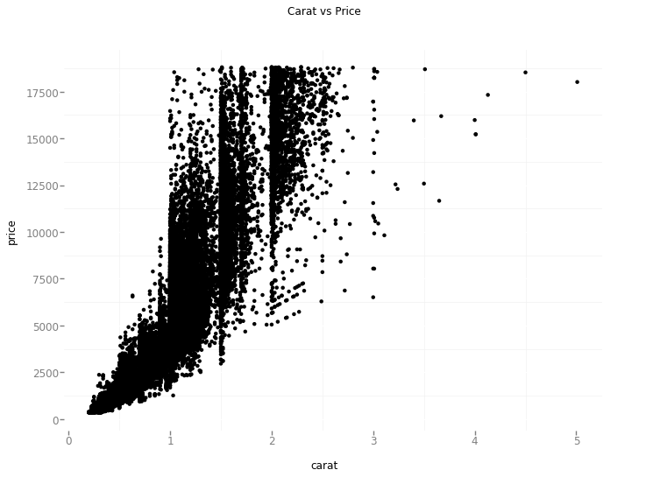

g5=ggplot(aes(x='carat', y='price', size='cut'), data=diamonds)+geom_point()

g5.show()

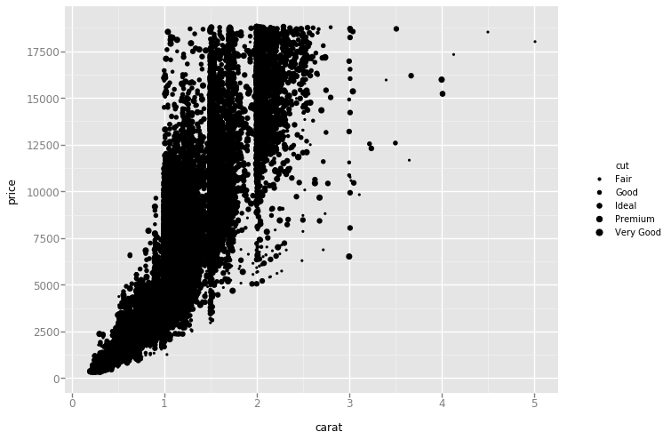

g6=ggplot(aes(x='carat', y='price'), data=diamonds)+ geom_jitter(alpha=0.6)+ggtitle("Carat vs Price")

g6.show()

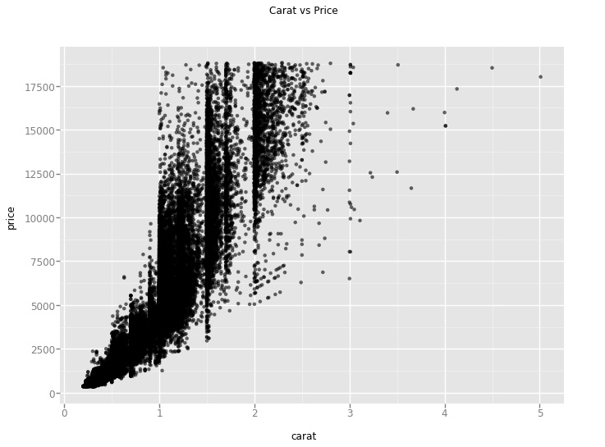

g7=ggplot(aes(x='carat', y='price', color='clarity'), data=diamonds)+geom_point(alpha=.4)

g7.show()

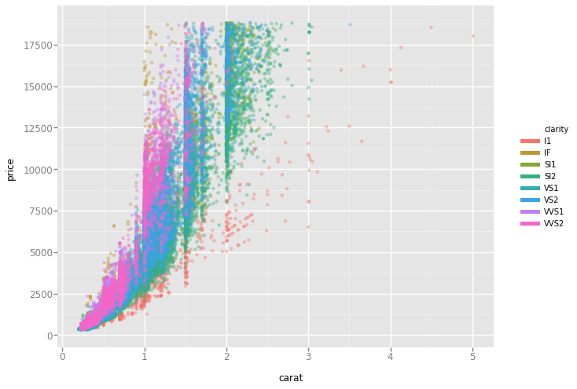

g8=ggplot(aes(x='carat', y='price', color='clarity'), data=diamonds)+geom_jitter()+facet_grid('cut')

g8.show()

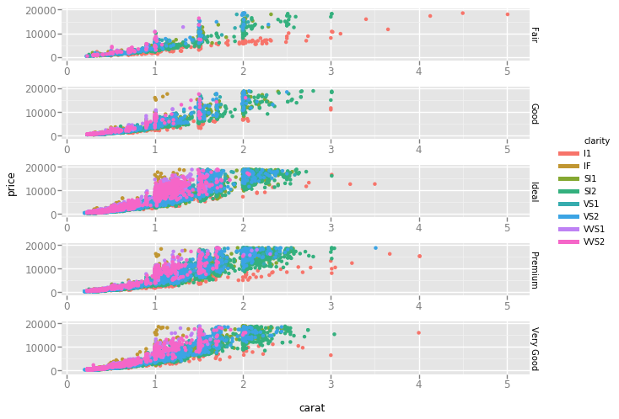

g9=ggplot(aes(x='carat', y='price'), data=diamonds)+geom_bar()

g9.show()

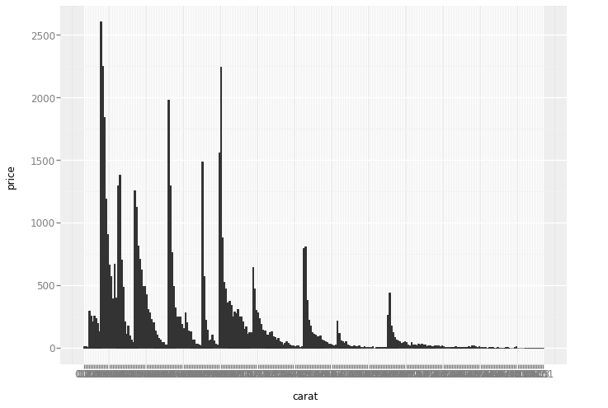

g10=ggplot(aes(x='carat', y='price'), data=diamonds)+geom_bar(fill='red', colour='white')

g10.show()

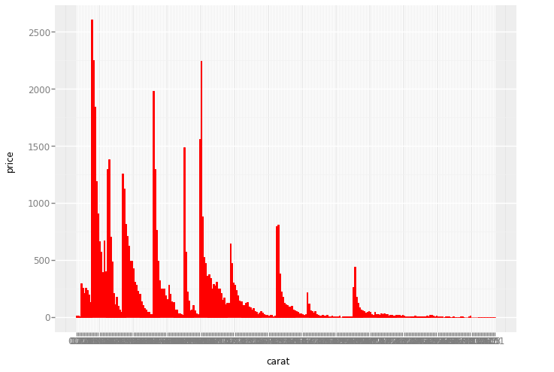

g11=ggplot(aes(x='carat', y='price'), data=diamonds)+geom_boxplot()

g11.show()

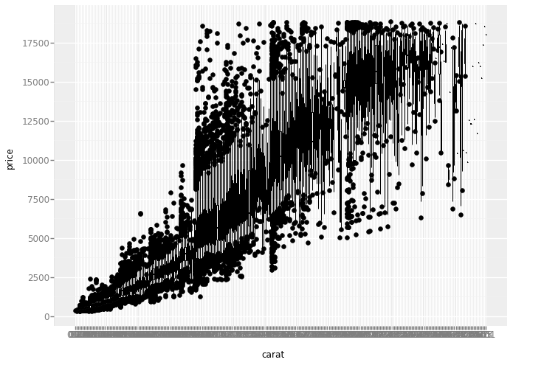

g12=ggplot(aes(x='carat', y='price'), data=diamonds) +geom_area(alpha=0.5)+ggtitle("Carat vs Price")

g12.show()

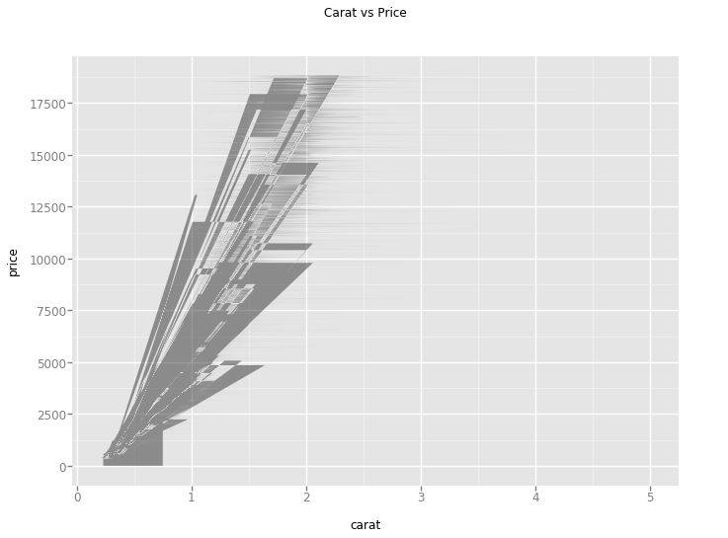

g13=ggplot(aes(x='carat', y='price'), data=diamonds) +geom_area(fill='red')+ggtitle("Carat vs Price")

g13.show()

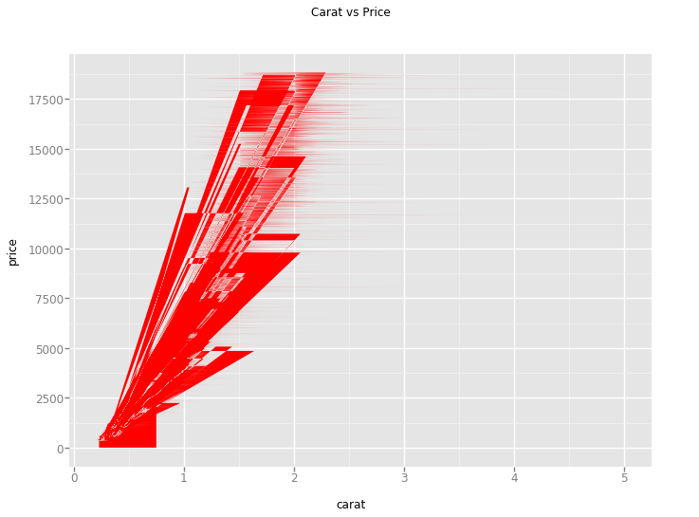

g15=ggplot(aes(x='carat', y='price'), data=diamonds)+ geom_density()

g15.show()

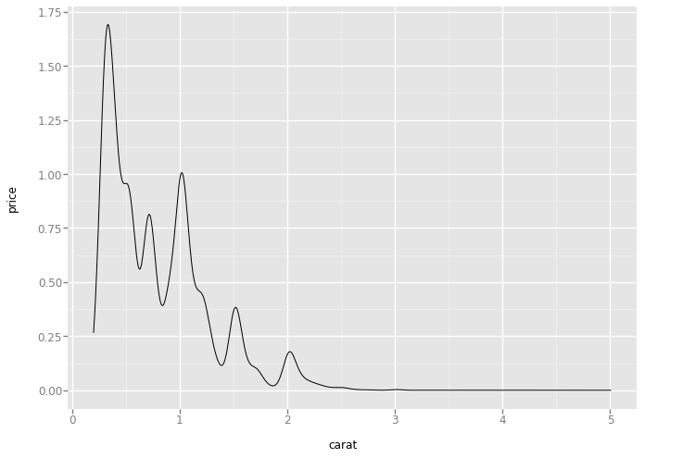

g16=ggplot(aes(x='carat', y='price'), data=diamonds)+geom_histogram()

g16.show()

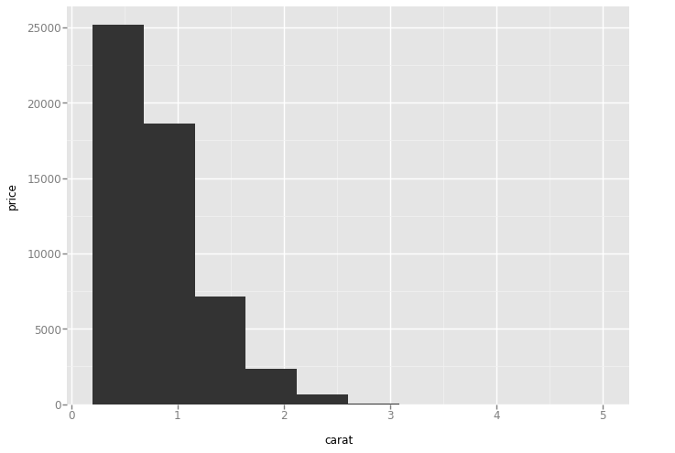

g17=ggplot(aes(x='carat', y='price'), data=diamonds)+ geom_histogram(bins=200)

g17.show()

