**Lab 6**

**R Harini**

**18BCE1010**

**KNN Classifier**

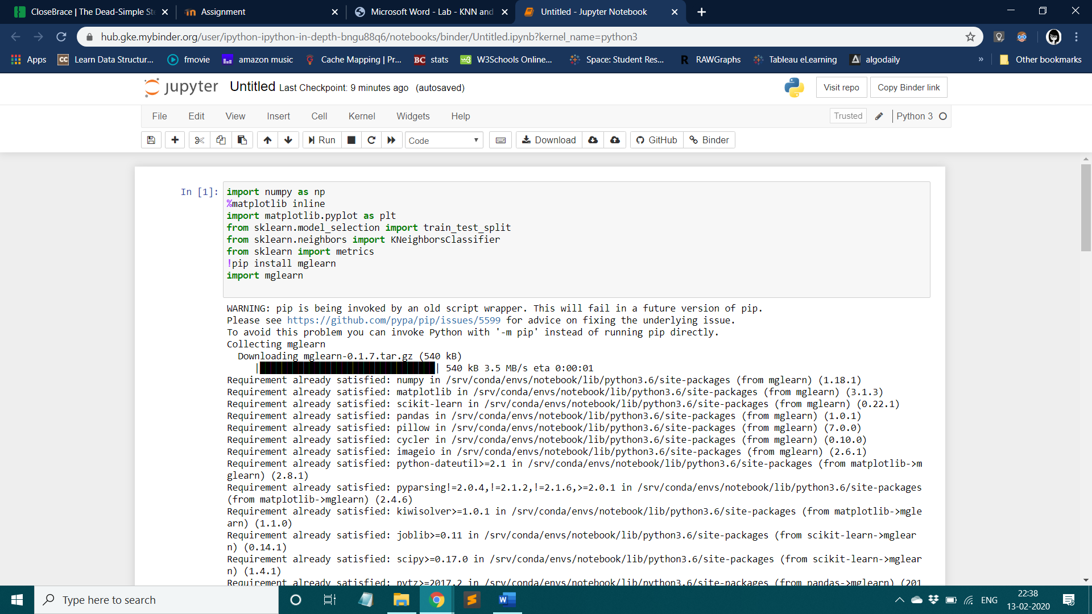

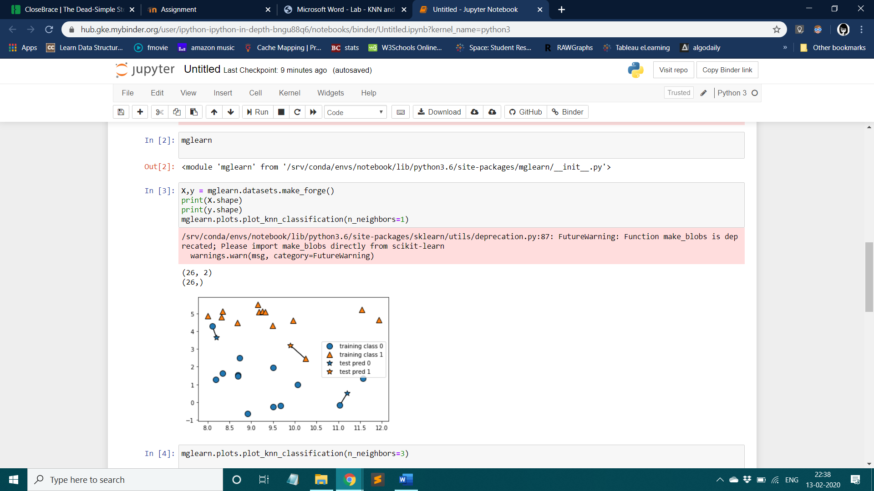

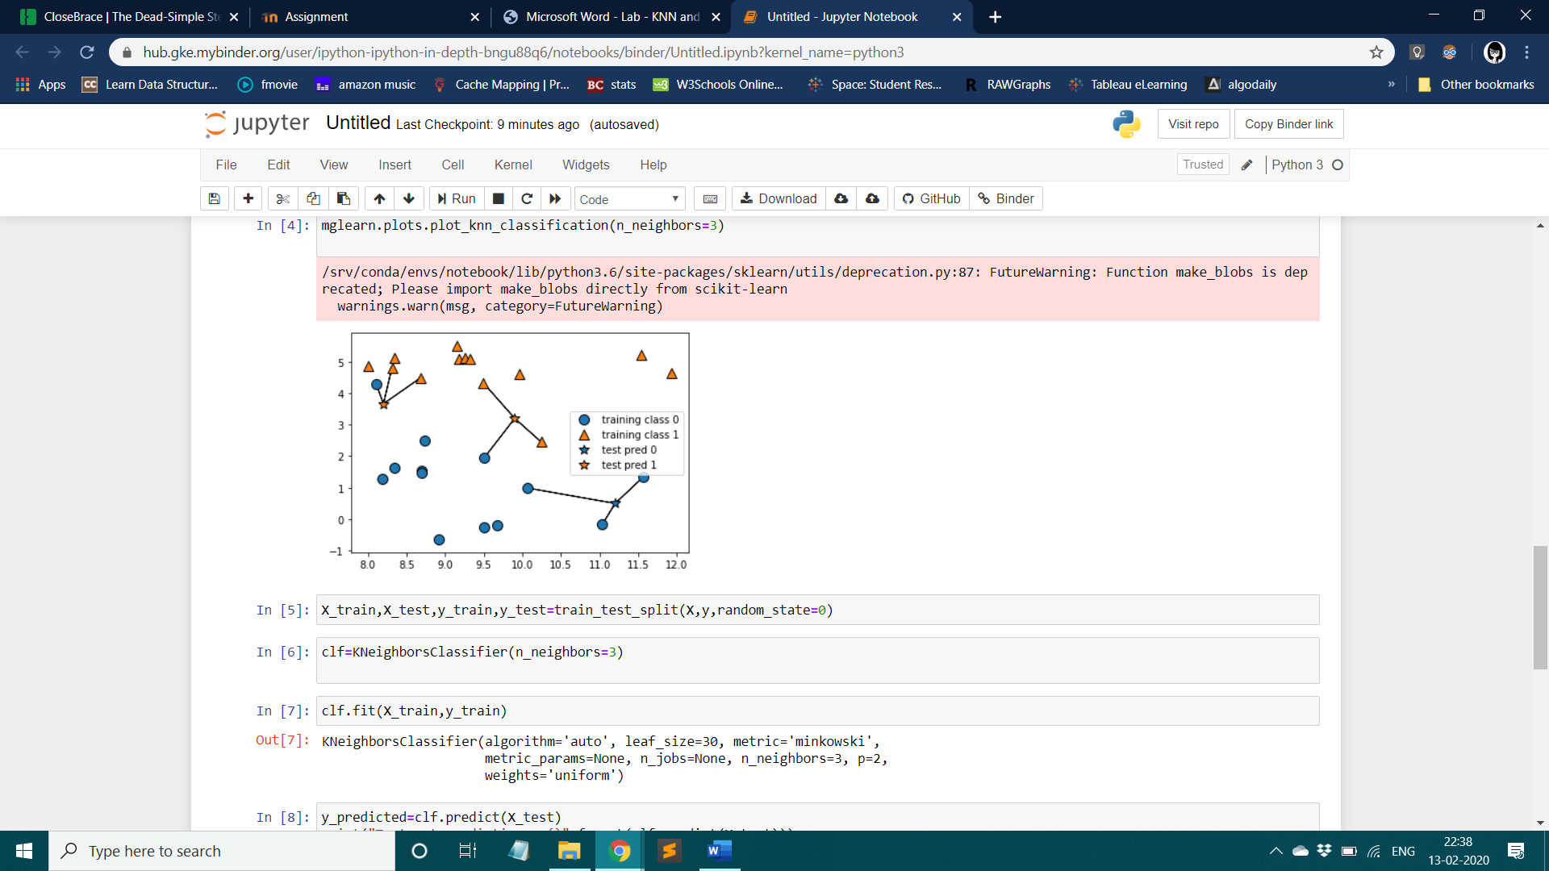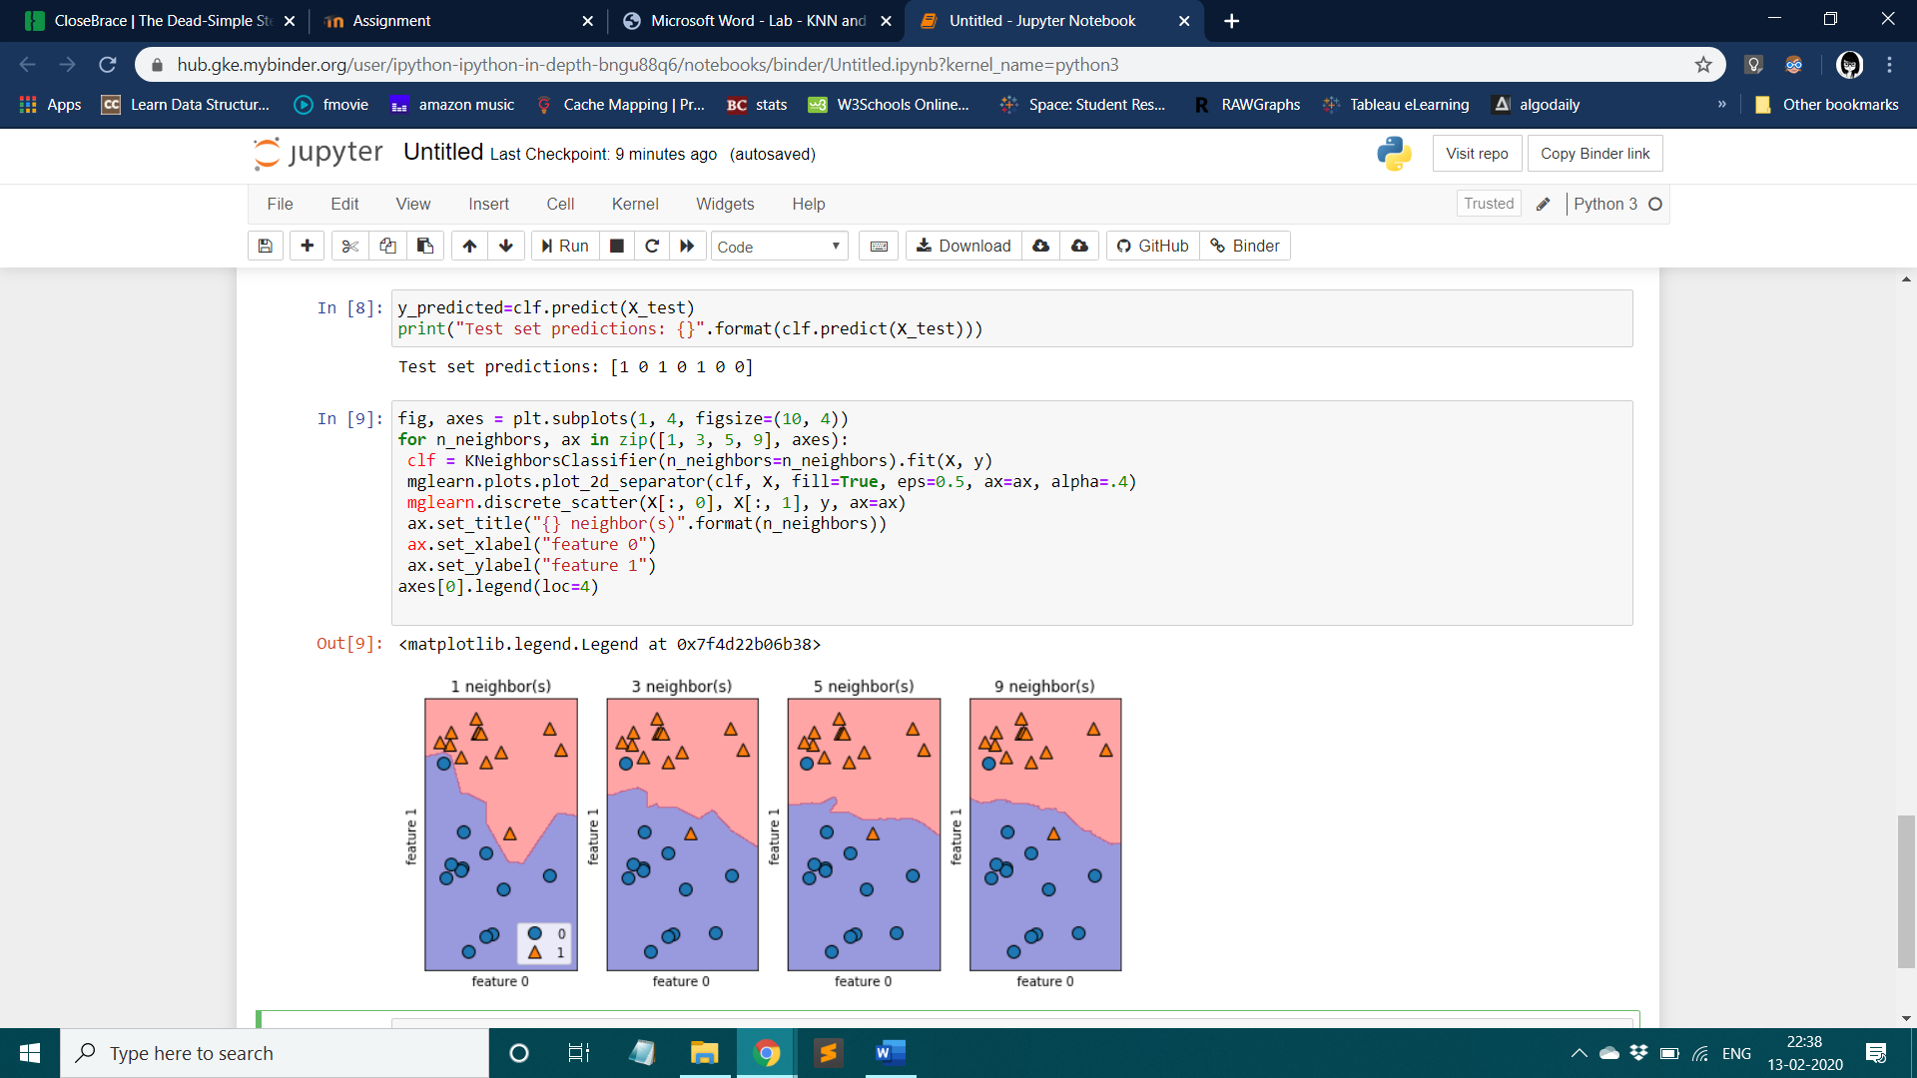

df=pd.read_csv('cancer.csv')

df

df= df.drop(columns=['id','Unnamed: 32'])

df.head()

from sklearn.model_selection import train_test_split

array=df.values

df.head()

X=array[:,1:33]

y=array[:,[0]]

X_train, X_test, y_train, y_test = train_test_split(X, y, test_size=0.2, random_state=0)

X_train.shape,X_test.shape

clf=KNeighborsClassifier(n_neighbors=3)

clf.fit(X_train,y_train)

acc_train = clf.score(X_train, y_train)

print('Train set accuracy: ', acc_train)

acc_train = clf.score(X_test, y_test)

print('Train set accuracy: ', acc_train)

training_accuracy =[]

testing_accuracy = []

neighbors_settings = range(1, 10)

for n_neighbors in neighbors_settings:

clf = KNeighborsClassifier(n_neighbors=n_neighbors)

clf.fit(X_train, y_train)

training_accuracy.append(clf.score(X_train, y_train))

testing_accuracy.append(clf.score(X_test, y_test))

plt.plot(neighbors_settings, training_accuracy, label="training accuracy")

plt.plot(neighbors_settings, testing_accuracy, label="test accuracy")

plt.ylabel("Accuracy")

plt.xlabel("n_neighbors")

plt.legend()

plt.show()

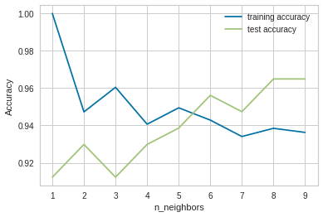

**KMeans Clustering**  
  
  
from sklearn.cluster import KMeans

import numpy as np

df=pd.read_csv('protein.csv')

df

X = df.iloc[:,1:].values

kmeans = KMeans(n_clusters=4)

y_kmeans = kmeans.fit_predict(X)

print(y_kmeans5)

kmeans.cluster_centers_

plt.scatter(X[:, 1], X[:,4], c=y_kmeans, s=50, cmap='viridis')

centers = kmeans.cluster_centers_

plt.scatter(centers[:, 0], centers[:, 1], c='black', s=200, alpha=0.5);

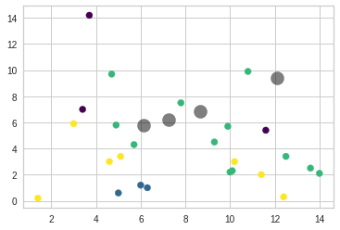

from sklearn.metrics import pairwise_distances_argmin

def find_clusters(X, n_clusters, rseed=2):

# 1. Randomly choose clusters

rng = np.random.RandomState(rseed)

i = rng.permutation(X.shape[0])[:n_clusters]

centers = X[i]

while True:

# 2a. Assign labels based on closest center

labels = pairwise_distances_argmin(X, centers)

# 2b. Find new centers from means of points

new_centers = np.array([X[labels == i].mean(0)

for i in range(n_clusters)])

# 2c. Check for convergence

if np.all(centers == new_centers):

break

centers = new_centers

return centers, labels

Error =[]

for i in range(1, 11):

kmeans = KMeans(n_clusters = i).fit(X)

kmeans.fit(X)

Error.append(kmeans.inertia_)

import matplotlib.pyplot as plt

plt.plot(range(1, 11), Error)

plt.title('Elbow method')

plt.xlabel('No of clusters')

plt.ylabel('Error')

plt.show()

