**Lab 9**

**R. Harini**

**18BCE1010**

1. Do states with higher GDPs have higher Human Development Indexes? This graph will show that California has the highest real GDP, but not the highest GDP per capita. This distinction makes any difference?

**Real GDP (2010) and HDI bar chart:**

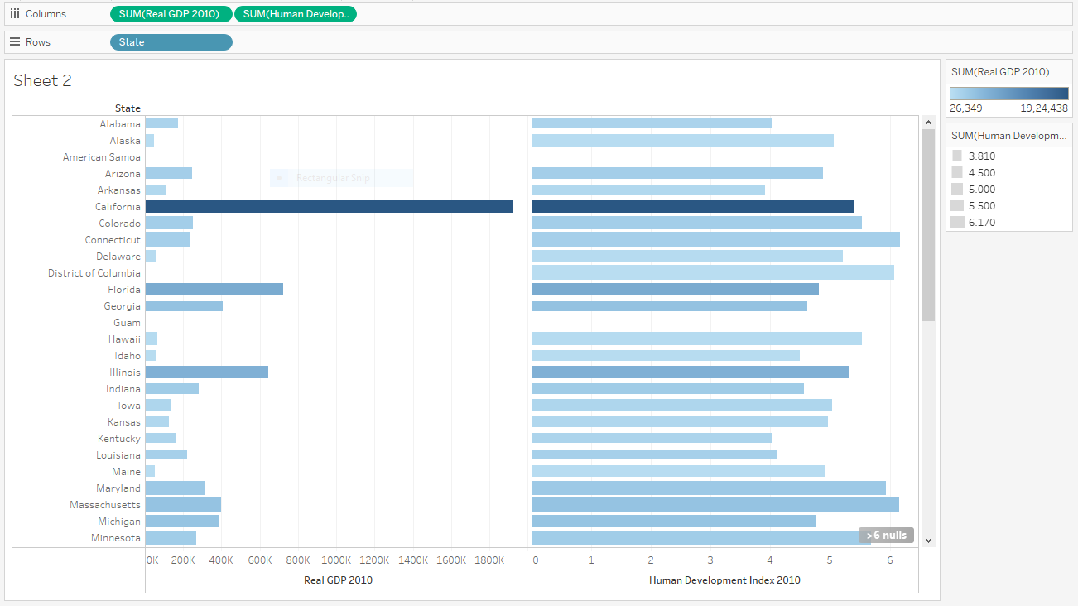

**Human Development Index mapping visualization:**

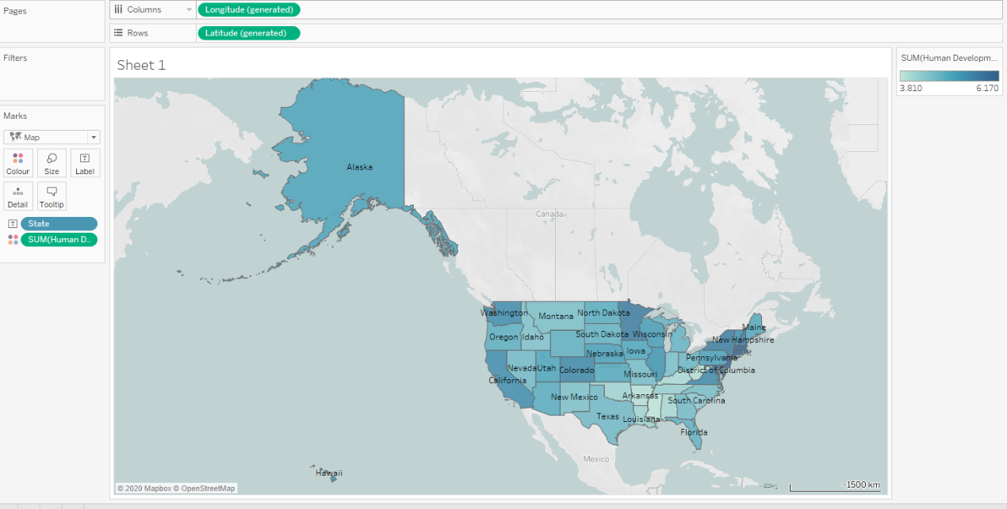

The above mappings give an inference that California has highest human development index.

**GDP per capita mapping visualization:**

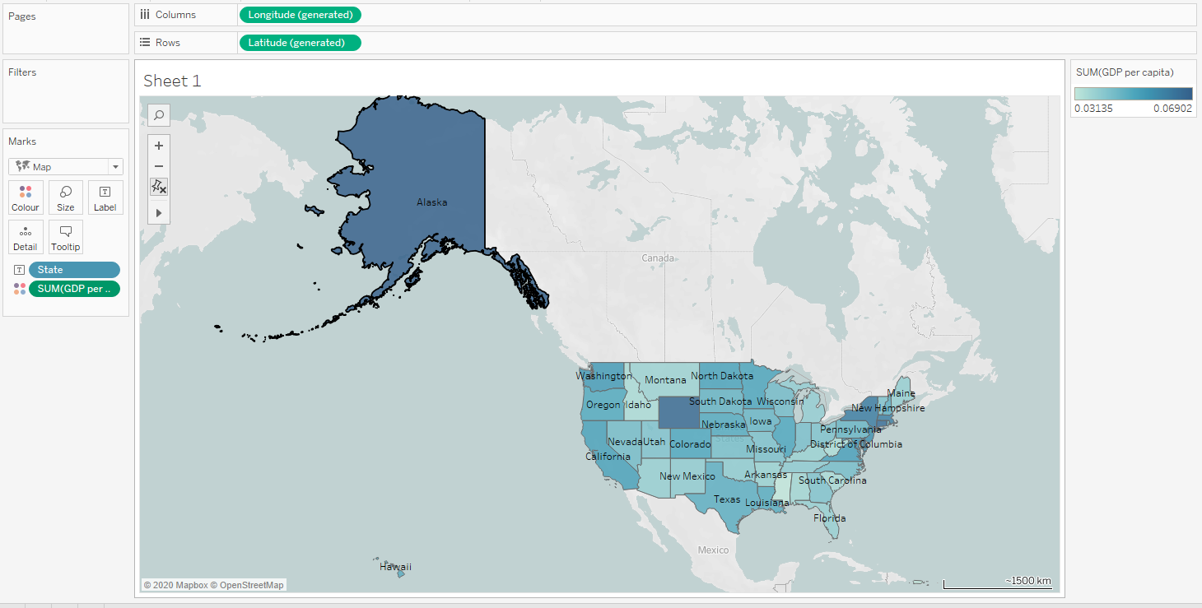

**RESULT1:** States with higher GDP do not have higher Human Development Index. GDP (2010) and GDP per capita are not same.

**California** has highest GDP (2010) while **Alaska** has highest GDP per capita.

Real GDP (2010) shows the overall GDP per state while GDP per capita shows the GDP of a state by its population.

1. Let's compare the 2010 real GDP with the Human Development Index for each state. It is instantly clear that CA has the highest GDP, but not the highest HDI. Connecticut and Massachusetts have the highest HDIs, but not the highest GDPs. They both have GDPs that are higher than the median GDP. But how will this change if we look at GDP per capita instead?

**Human Development Index (HDI) vs Real GDP (2010) scatterplot visualization:**

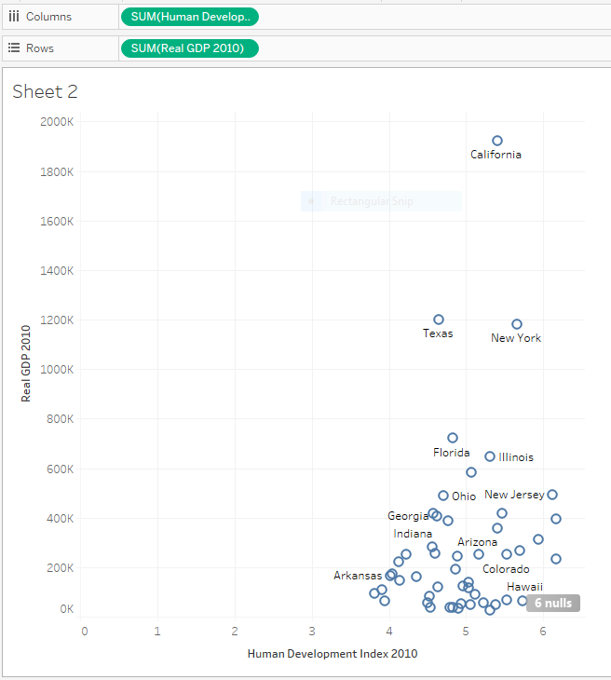

**Bubble Plot showing HDI vs GDP (2010):**

In the below shown bubble plot also the colour intensity indicates the HDI while the size of the bubble indicates the GDP per capita.



**RESULT:** There are significant differences between the plots of GDP (2010 vs HDI and GDP per capita vs HDI which are noted via the various plots.

**FINAL RESULT:** Thus, the plots of the US states dataset were done and conclusions were observed and noted with the help of Tableau.