**Lab 11**

**R. Harini**

**18BCE1010**

**Prof Sadhya P**

Main Page (main.html):

<html>

    <body>

        <center>

            <h1>Shopping Website</h1>

         <form action="1.php" method="POST">

             <br><br>

             <input type="submit" value="Display Items"><br><br>

             <button><a href="Delete.html">Delete an item</a></button>

         </form>

        </center>

    </body>

</html>

1.php:

<?php

$servername="localhost";

$username="root";

$password="";

$conn=mysqli_connect($servername, $username, $password);

if(! $conn ) {

    die('Could not connect: ' . mysqli_error($conn));

}

$data="Select * from items";

mysqli_select_db($conn, 'shopping');

$val=mysqli_query($conn, $data) or die("Error: " . mysqli_error($conn));

echo "<table >";

echo "<tr><th>Item Code</th><th>Item Name</th><th>Price</th><th>Stock</th></tr>";

while($row=mysqli_fetch_array($val,MYSQLI_ASSOC)){

    echo "<tr><td >".$row['item_code']."</td><td> " .$row['name']. "</td><td> " .$row['price']. "</td><td> " .$row['stock']. "</td></tr>";

}

echo "</table>";

echo "<br><br>";

echo "<button><a href='purchase.html'>Purchase</a></button>";

mysqli_close($conn);

?>

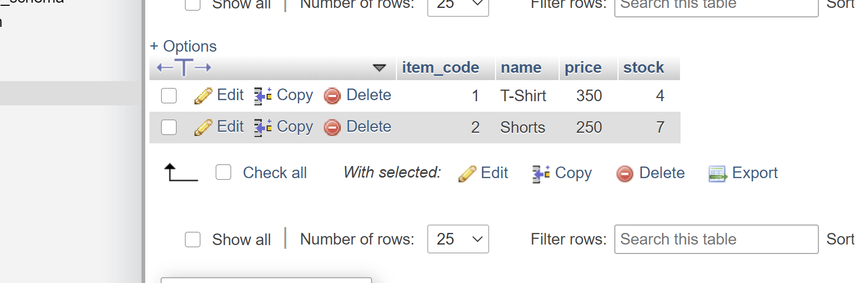

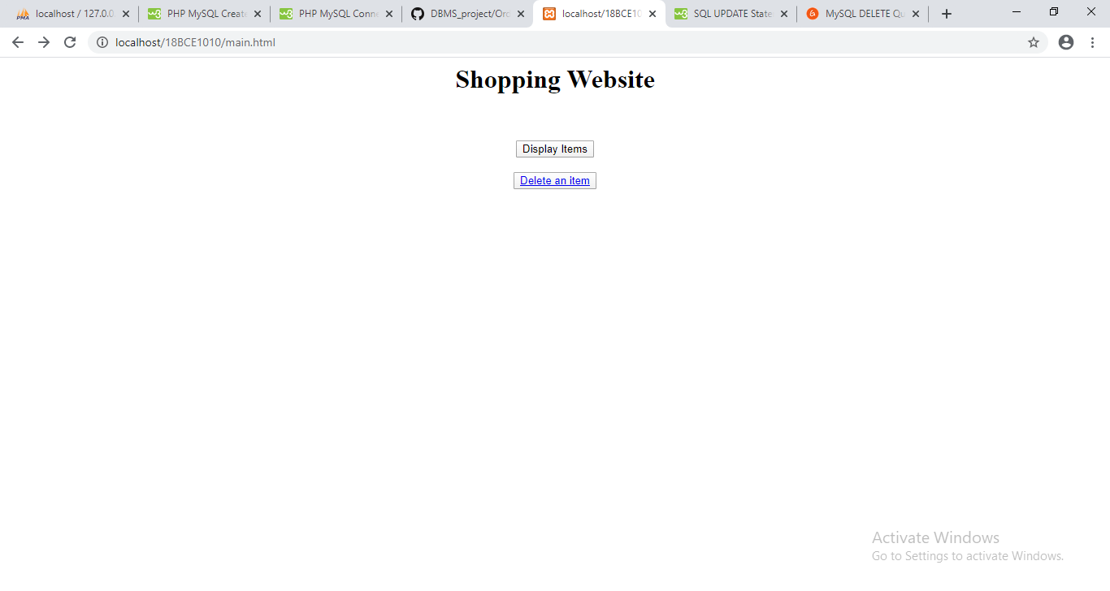

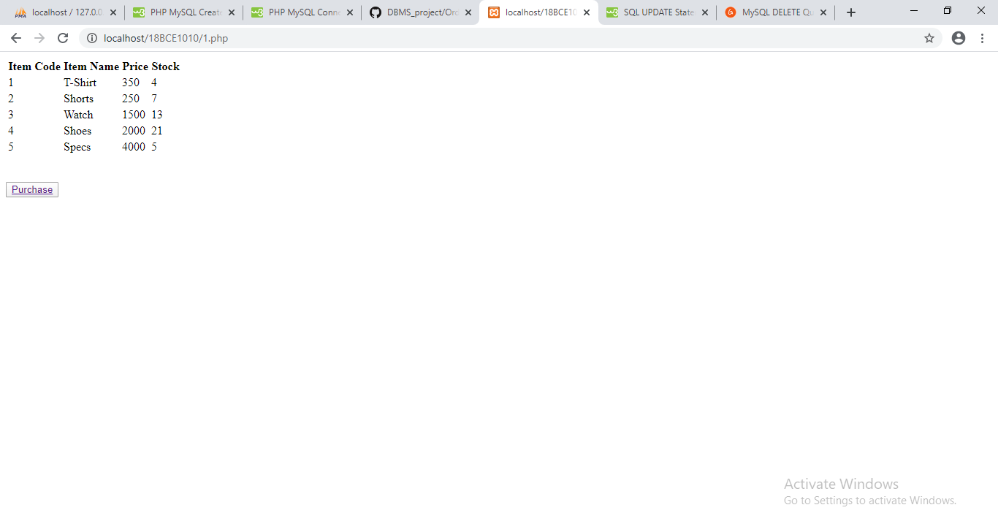

Purchase.html:

<html>

    <body>

        <center>

        <form name="Purchase" method="POST" action="2.php">

            Item Code:<input type="number" name="item_code"><br><br>

            Quantity to be purchase:<input type="number" name="quantity"><br><br>

            <input type="Submit" value="purchase" name="purchase">

        </form>

        </center>

    </body>

</html>

2.php:

<?php

        $dbhost = 'localhost';

        $dbuser = 'root';

        $dbpass = '';

        $conn = mysqli_connect($dbhost, $dbuser, $dbpass);

        if(! $conn ) {

           die('Could not connect: ' . mysqli_error($conn));

        }

        else{

            $item_code=$_POST['item_code'];

            $quantity=$_POST['quantity'];

            $sql1="SELECT price from items where item_code='$item_code'";

            mysqli_select_db($conn, 'shopping');

            $query=mysqli_query($conn,$sql1)or die("Error: " . mysqli_error($conn));

            $row1=mysqli_fetch_object($query);

            $price=$row1->price;

            $total_cost=$price*$quantity;

            $sql2="Select stock from items where item_code='$item_code'";

            mysqli_select_db($conn, 'shopping');

            $query1=mysqli_query($conn,$sql2)or die("Error: " . mysqli_error($conn));

            $row2=mysqli_fetch_object($query1);

            $stock=$row2->stock;

            $qty=$stock-$quantity;

            if ($qty<0){

                die("Error: Stock is insufficient");

            }

            $sql3="Update items set stock='$qty' where item_code='$item_code'";

            mysqli_select_db($conn,'shopping');

            $query2=mysqli_query($conn,$sql3) or die("Error:" . mysqli_error($conn));

                echo "<center>Your total cost is: '$total_cost'</center><br><br><br>";

                $data="Select * from items";

mysqli_select_db($conn, 'shopping');

$val=mysqli_query($conn, $data) or die("Error: " . mysqli_error($conn));

echo "<table >";

echo "<tr><th>Item Code</th><th>Item Name</th><th>Price</th><th>Stock</th></tr>";

while($row=mysqli_fetch_array($val,MYSQLI_ASSOC)){

    echo "<tr><td >".$row['item_code']."</td><td> " .$row['name']. "</td><td> " .$row['price']. "</td><td> " .$row['stock']. "</td></tr>";

}

echo "</table>";

                mysqli_close($conn);

        }

?>

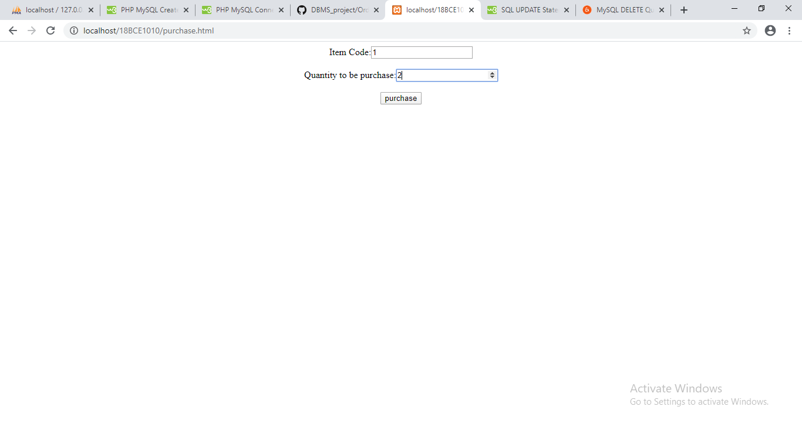

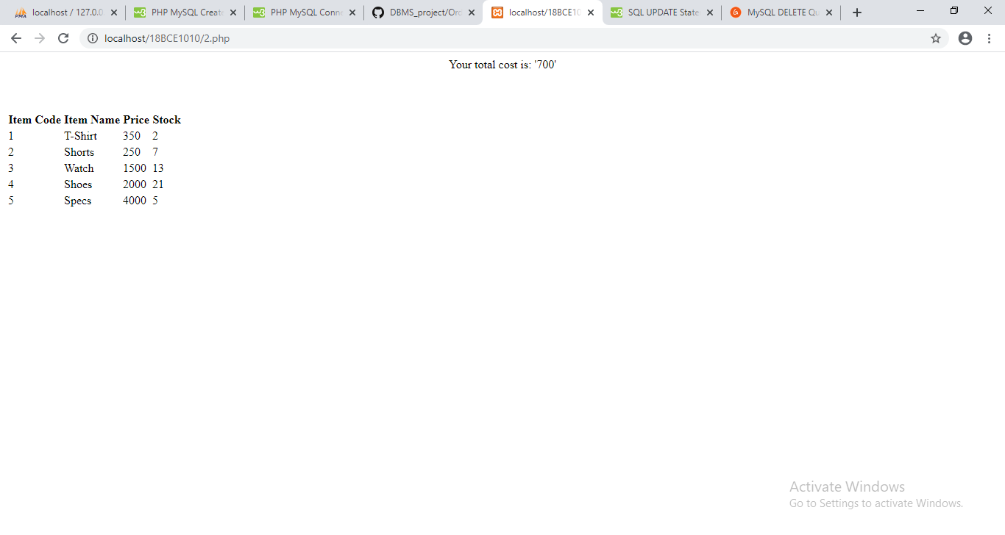

Delete.html:

<html>

    <body>

        <center>

            <form method="POST" action="3.php">

                Item Code:<input type="number" name="item_code"><br>

                <input type="Submit" value="Delete">

            </form>

        </center>

    </body>

</html>

3.php:

<?php

     $dbhost = 'localhost';

     $dbuser = 'root';

     $dbpass = '';

     $conn = mysqli_connect($dbhost, $dbuser, $dbpass);

     if(! $conn ) {

        die('Could not connect: ' . mysqli_error($conn));

     }

     else{

         $item_code=$POST['item_code'];

         $dql="DELETE FROM ITEMS where item_code='$item_code'";

         mysqli_select_db($conn, 'shopping');

         $query=mysqli_query($conn,$sql)or die("Error: " . mysqli_error($conn));

         echo "<b>Successfully Deleted</b><br><br>";

         $data="Select * from items";

mysqli_select_db($conn, 'shopping');

$val=mysqli_query($conn, $data) or die("Error: " . mysqli_error($conn));

echo "<table >";

echo "<tr><th>Item Code</th><th>Item Name</th><th>Price</th><th>Stock</th></tr>";

while($row=mysqli_fetch_array($val,MYSQLI_ASSOC)){

    echo "<tr><td >".$row['item_code']."</td><td> " .$row['name']. "</td><td> " .$row['price']. "</td><td> " .$row['stock']. "</td></tr>";

}

echo "</table>";

     }

