**Lab5**

**R.Harini**

**18BCE1010**

**Prof. Sandhya P**

1. **Krishnamoorthy Number**

<html>

<head>

<script>

function number(){

//alert("Hi!");

var n=document.getElementById("number").value;

//document.write(n);

var k=n;

var num=0;

while (k!=0){

var l=k%10;

num+=fact(l);

k=(k/10)>>0;

}

if (n==num){

alert("Yes, your number is a Krishnamoorthy number");

}

else{

alert("No,your number is not a Krishnamoorthy number");

}

}

function fact(n){

if (n==1){

return 1;

}

else{

return n*fact(n-1);

}

}

</script>

</head>

<body>

<h1><center>Check for Krishnamoorthy number</center></h1>

Enter number:<input type="number" id="number">

<br>

<input type="button" value="Check" onclick="number()">

</body>

</html>

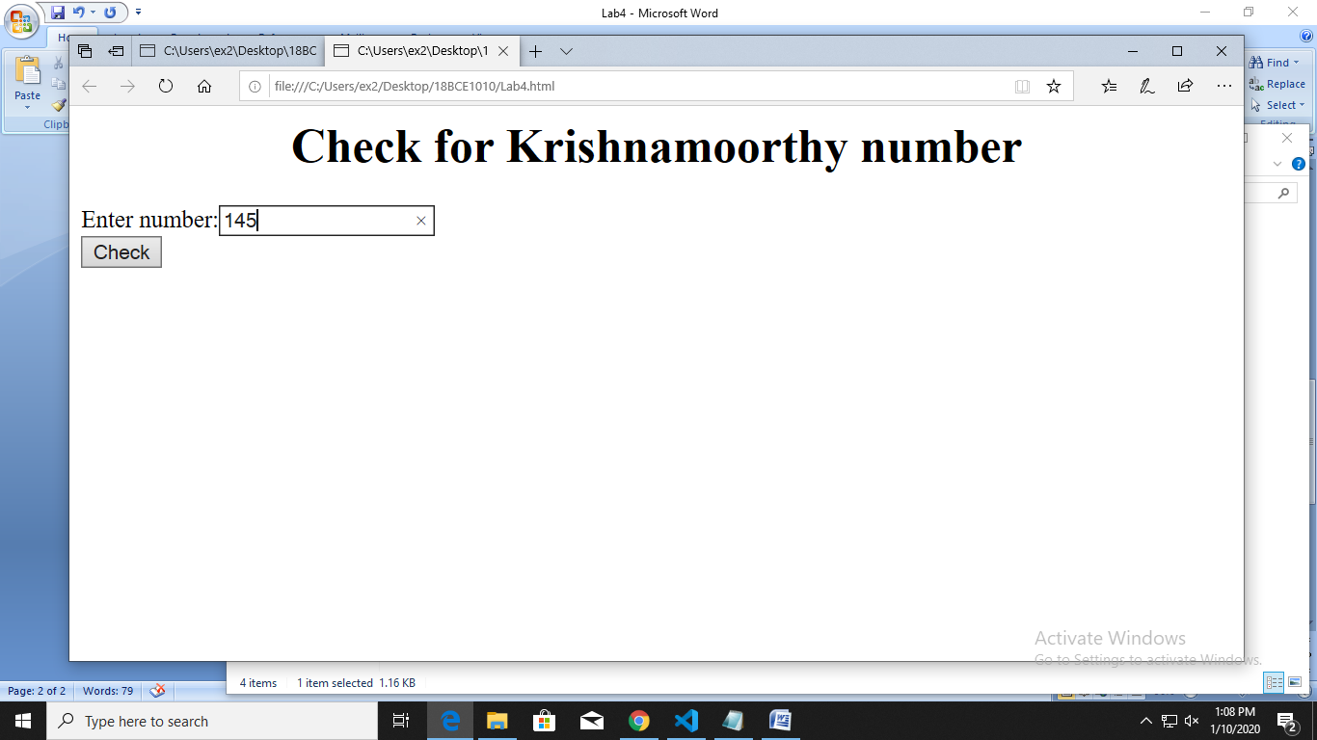

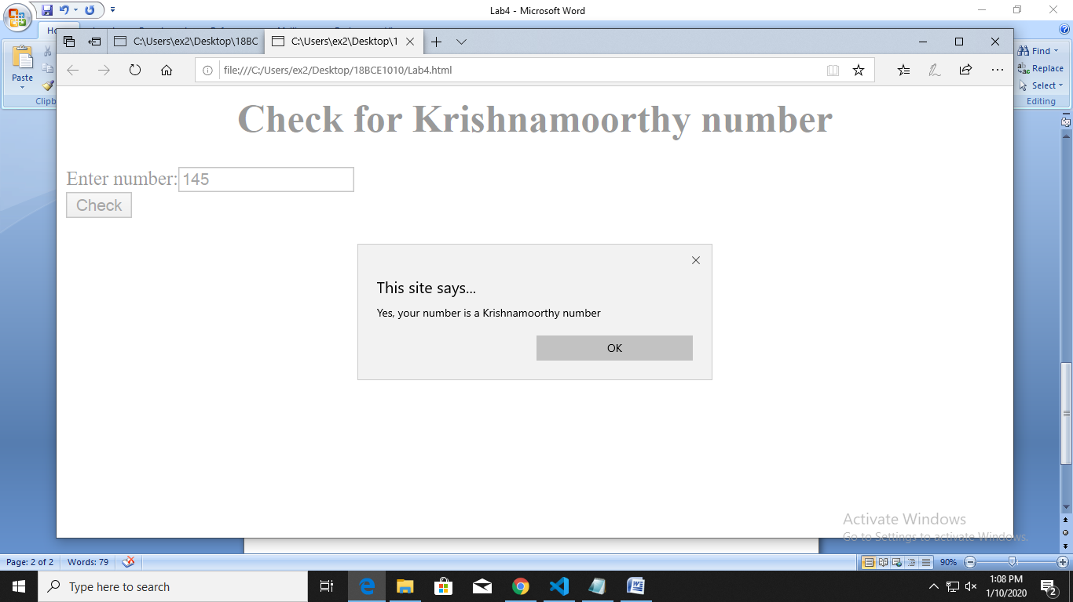

1. **Calculator**

<html>

<head>

<script>

function calculate(){

var val=document.getElementById("output").value;

var o=eval(val);

document.getElementById("output").value=o ;

}

function append(val){

var num=document.getElementById("output").value+=val;

}

</script>

</head>

<body>

<h1><center>Calculator</center></h1>

<table >

<tr>

<td colspan="4"><input type="text" id="output"></td>

</tr>

<tr>

<td><input type="button" value="7" id="7" onclick="append('7')"></input></td>

<td><input type="button" value="8" id="8" onclick="append('8')"></input></td>

<td><input type="button" value="9" id="nine" onclick="append('9')"></input></td>

<td><input type="button" value="-" id="sub" onclick="append('-')"></input></td>

</tr>

<tr>

<td><input type="button" value="4" id="four" onclick="append('4')"></input></td>

<td><input type="button" value="5" id="five" onclick="append('5')"></input></td>

<td><input type="button" value="6" id="six" onclick="append('6')"></input></td>

<td><input type="button" value="+" id="add" onclick="append('+')"></input></td>

</tr>

<tr>

<td><input type="button" value="1" id="one" onclick="append('1')"></input></td>

<td><input type="button" value="2" id="two" onclick="append('2')"></input></td>

<td><input type="button" value="3" id="three" onclick="append('3')"></input></td>

<td><input type="button" value="x" id="mul" onclick="append('*')"></input></td>

</tr>

<tr>

<td><input type="button"></input></td>

<td><input type="button" value="0" id="zero" onclick="append('0')"></input></td>

<td><input type="button" value="=" id="equal" onclick="calculate()"></input></td>

<td><input type="button" value="/" id="div" onclick="append('/')"></input></td>

</tr>

</table>

</body>

</html>

