**Lab 7**

**R. Harini**

**18BCE1010**

**Prof Sandhya P**

**Start Page:**

<!DOCTYPE html>

<html>

    <head>

        <title>Election polling</title>

        <script src="Voting.js"></script>

    </head>

    <body>

        <script>

            then=new Date("15 February, 2020 21:00:00").getTime();

            var x=setInterval(function(){

            now=new Date().getTime();

            var distance=then-now;

            var hours = Math.floor((distance % (1000 * 60 * 60 * 24)) / (1000 * 60 * 60));

              var minutes = Math.floor((distance % (1000 * 60 * 60)) / (1000 * 60));

              var seconds = Math.floor((distance % (1000 * 60)) / 1000);

            document.getElementById('demo').innerHTML="Hours Left "+hours+":"+minutes+":"+seconds+"<br>";

            if (distance < 0) {

                clearInterval(x);

                //document.getElementById("demo").innerHTML = "EXPIRED";

                window.location.replace("file:///C:/Code/IWP_Lab/Lab7/Winner.html")

              }

            },1000);

            </script>

        <link rel="stylesheet" href="Lab7.css">

        <h1>Election polling</h1>

        <font size=10px><center><b><p id="demo"></p></b></center></font>

        <center><button id="start" ><a href="Voting.html">Start</a></button></center>

    </body>

</html>

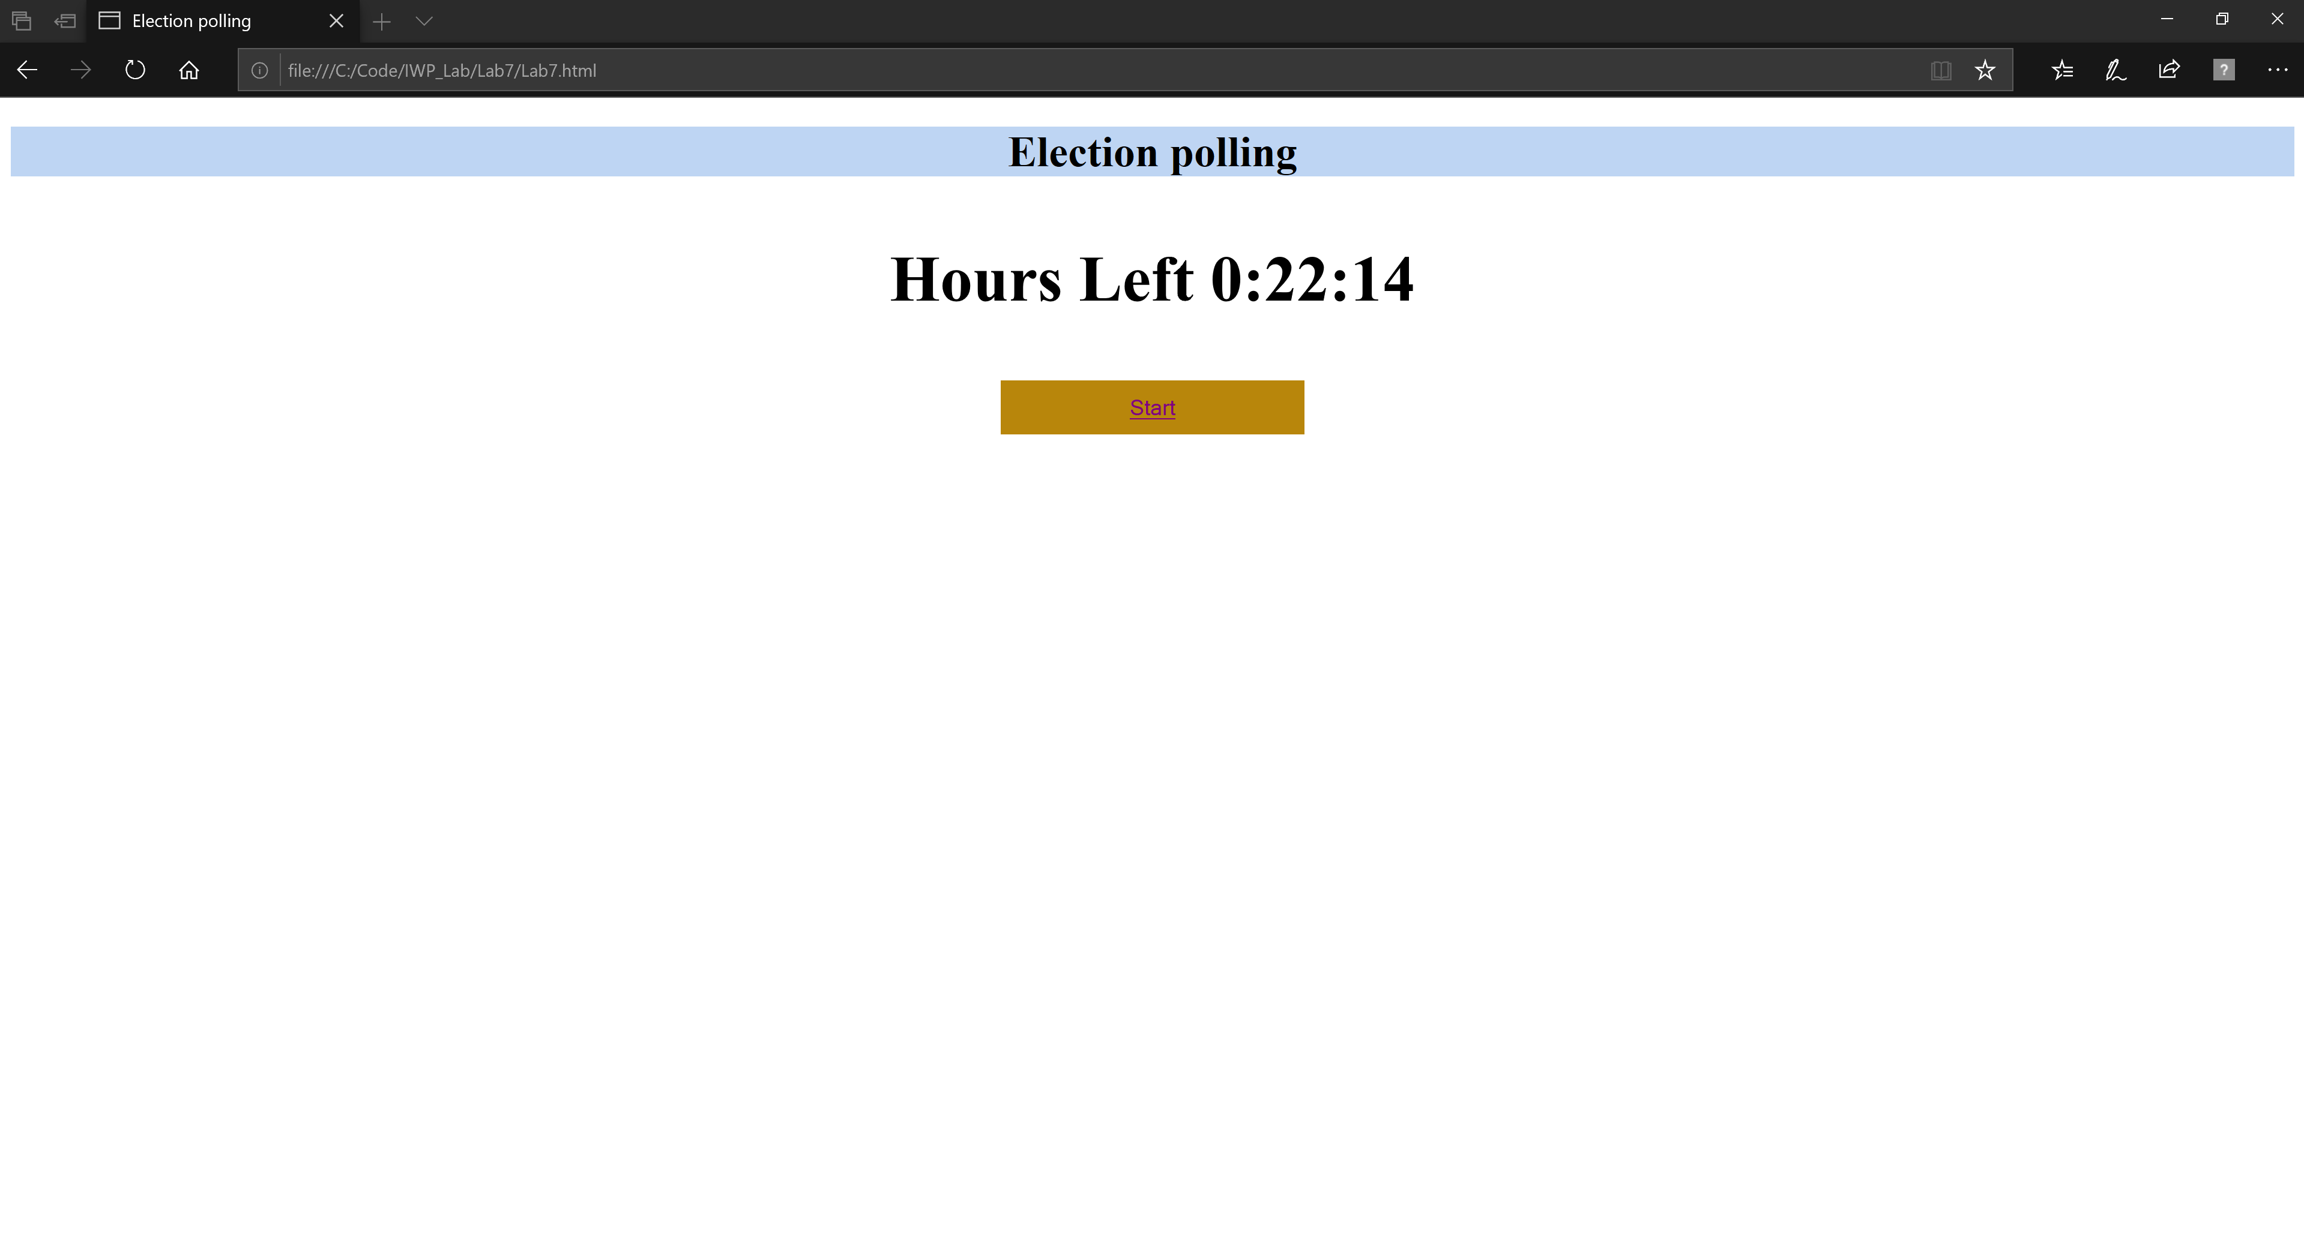

**Voting Page:**

<!DOCTYPE html>

<html>

    <head>

        <script src="Voting.js"></script>

    </head>

    <body onload="redirect()">

        <link rel="stylesheet" href="Lab7.css">

        <h1> Election Polling</h1>

        <div><b> <center>Voting closes in <span id="time">19:43</span> seconds!</center></b></div><br>

        <script>

            function startTimer(duration, display){

                var timer=duration, minutes, seconds;

                setInterval(function(){

                    minutes=parseInt(timer/60, 10);

                    seconds=parseInt(timer%60,10);

                    minutes=minutes<10 ? "0" +minutes: minutes;

                    seconds=second<10 ? "0" +seconds : seconds;

                    display.textContent= minutes + ":" + seconds;

                    if (--timer <0){

                        timer=duration;

                    }

                }, 1000;)

            }

            window.onload=function(){

                var oneminute=60*5, display=document.querySelector('#time');

                startTimer(oneminute, display);

            }

        </script>

        <form name="voting">

            <center>

            <table id="table1">

                <tr>

                    <td> <input type="radio" value="1" name="p"> Party A</td>

                    <td><img src="Lotus.png" height="150px"> </td>

                </tr>

                <tr>

                    <td><input type="radio" value="2" name="p">Party B</td>

                    <td><img src="cycle.jpg" height="100px"></td>

                </tr>

                <tr>

                    <td> <input type="radio" value="3" name="p"> Party C</td>

                    <td><img src="hand.png" height="150px"> </td>

                </tr>

                <tr>

                    <td><input type="radio" value="4" name="p">Party D</td>

                    <td><img src="clock.jpg" height="100px"></td>

                </tr>

            </table><br><br>

            <button value="cast" id="start" onclick="cast()">Cast</button>

            </center>

        </form>

    </body>

</html>

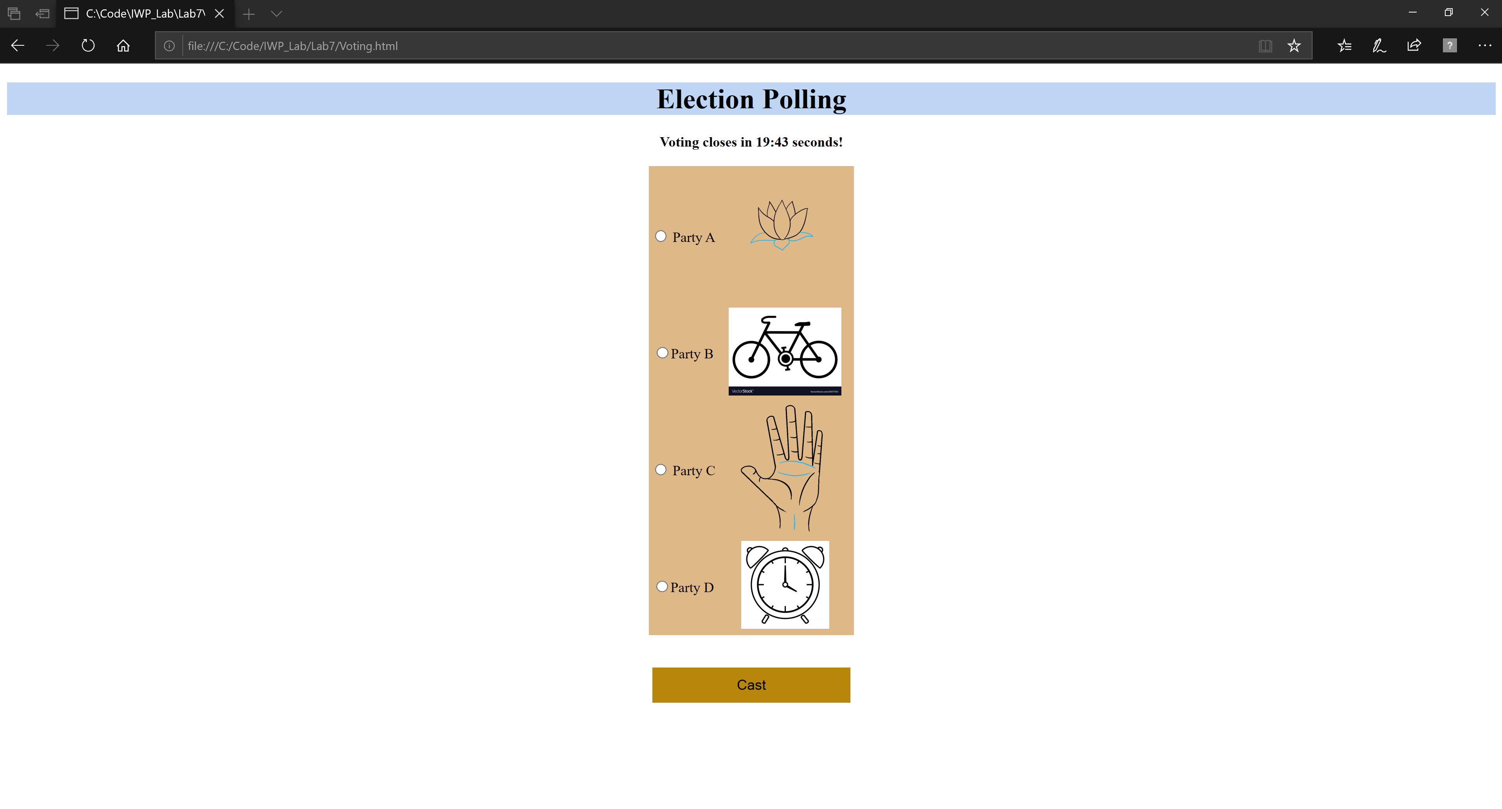

**Winner Page:**

<!DOCTYPE html>

<html>

    <head>

        <script src=”Voting.js”>

        </script>

    </head>

    <body onload="winner()">

        <link rel="stylesheet" href="Lab7.css">

        <h1>Electronic Polling</h1>

        <font size=10px><center><b>The winner is:&nbsp;<p id="winner"></p></b></center></font>

    </body>

</html>

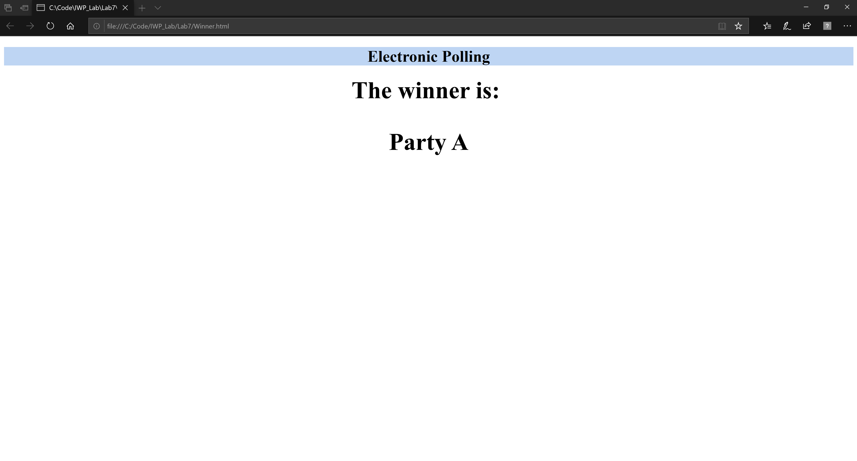

**Javascript Code (Voting.js):**

Parties=[0,0,0,0];

function redirect(){

    setTimeout(function() {window.location.replace("file:///C:/Code/IWP_Lab/Lab7/Lab7.html");}, 5000);

}

function cast(){

    alert("A:"+ Parties[0]+"\nB:"+Parties[1]+"\nC:"+Parties[2]+"\nD:"+Parties[3]);

    var q=document.getElementsByName("p");

    var i=0;

    for (i=0;i<q.length;i++){

        if (q[i].checked){

            Parties[i]++;

        }

    }

    alert("A:"+ Parties[0]+"\nB:"+Parties[1]+"\nC:"+Parties[2]+"\nD:"+Parties[3]);

}

function winner(){

    var max=0;

    var k=0;

    for (var i=0;i<4;i++){

        if (Parties[i]>max){

            max=Parties[i];

            k=i;

        }

    }

    if (i==0){

        document.getElementById("winner").innerHTML='Party A';

    }

    else if(i==1) {

        document.getElementById("winner").innerHTML='Party B';

    }

    else if(i==2) {

        document.getElementById("winner").innerHTML='Party C';

    }

    else{

        document.getElementById("winner").innerHTML='Party D';

    }

}

**CSS Code (Lab7.css) :**

h1{

    text-align: center;

    background-color:rgb(190, 213, 243);

}

#start{

    background-color: darkgoldenrod;

    width: 225px;

    border:none;

    height: 40px;

    font-size: 16px;

    color: black;

}

#table1{

    background-color: burlywood;

    align-content: center;

    text-align: center;

}

#demo{

    text-align: center;

}