**Lab 8**

**R. Harini**

**18BCE1010**

**Start.html:**

<!DOCTYPE html>

<html>

    <head>

        <title>Kids Zone</title>

        <script>

            var queue=[10];

            var front=-1;

            var rear=-1;

            var max=10;

            function enq(name){

                var u=document.getElementById("customer");

                var l=document.createElement("Li");

                var t=document.createTextNode(name)

                l.appendChild(t);

                u.appendChild(l);

            }

            function deq(){

                    var u=document.getElementById("customer");

                    var lc=u.firstChild;

                    u.removeChild(lc);

            }

            function entry(){

                var name=document.getElementById('name').value;

                enq(name);

            }

            function remove(){

                deq();

                //alert(name+ " is going to enter the zone");

            }

        </script>

    </head>

    <body style="text-align: center;" >

        <link rel="stylesheet" href="Main.css">

        <div id="header">

            <h1><center>Kids Zone</center></h1>

            <h2>Registration Form</h2>

            <br>

        </div>

        <form name="form">

            <br>

            Customer Name:

            <input type="text" id="name">

            <br><br>

            <b><ul id="customer" type="none"></ul></b>

            <button onclick="entry()" type="button"><b>Register</b></button>

            <button onclick="remove()" type="button"><b>Remove</b></button>

        </form>

    </body>

</html>

**Main.css:**

#header{

    background-color: rgb(216, 248, 71);

}

body{

    background-color: rgb(215, 250, 228);

}

h1{

    font-size: 50px;

}

button{

    background-color: rgb(78, 247, 196);

    height: 30px;

    width: 100px;

    border: none;

}

#customer{

    list-style-type: none;

}

**Screenshots:**

**Adding:**

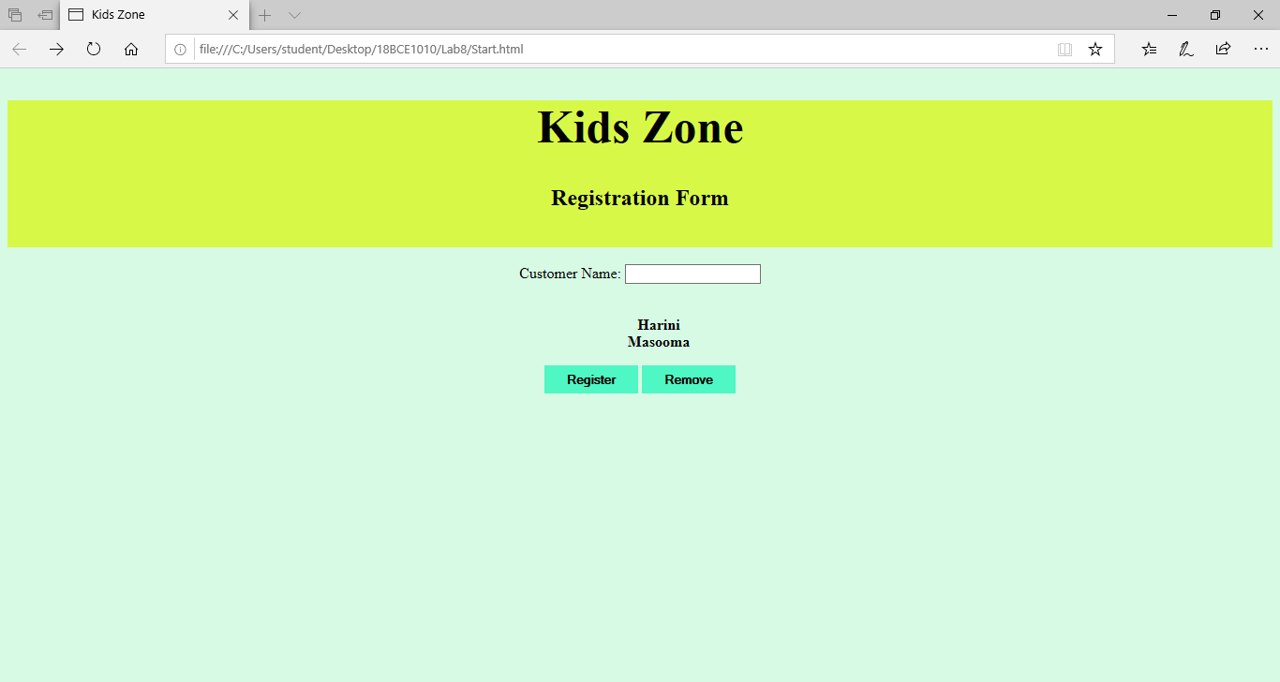

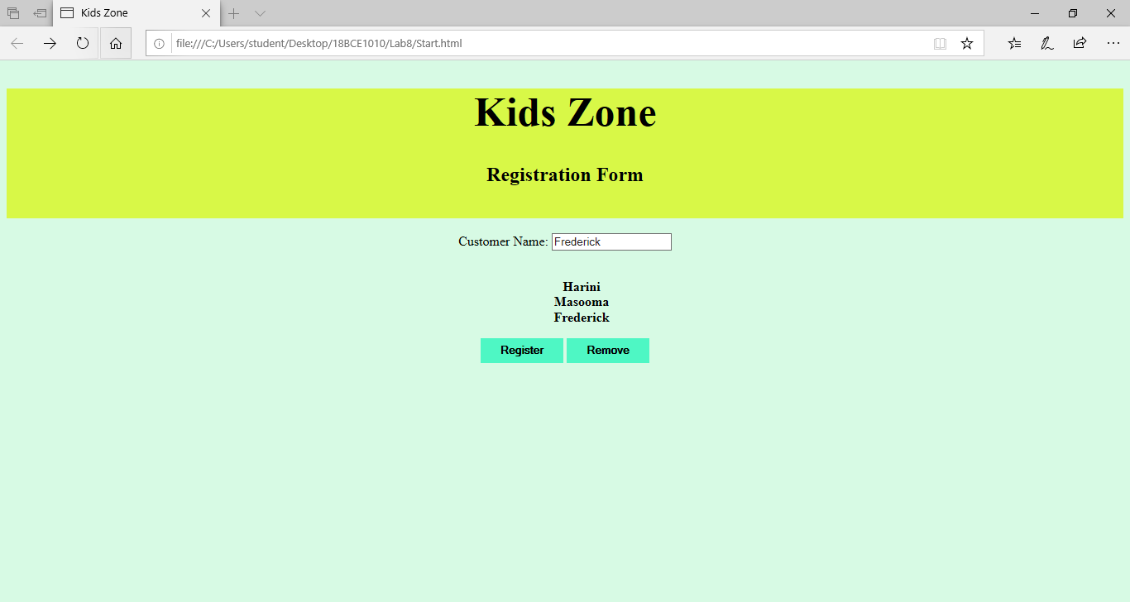

**Removing:**

