1. mkdir -p exercise/dir1/dir2/dir3

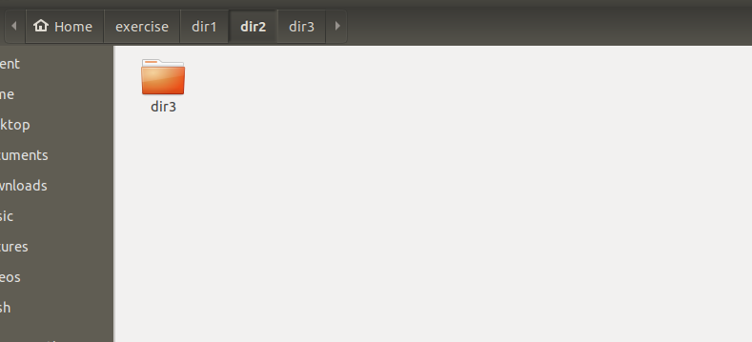
2. cd exercise/dir1/dir2/
touch emptyFile1 emptyFile2

3. echo “hello world” >> file1.txt

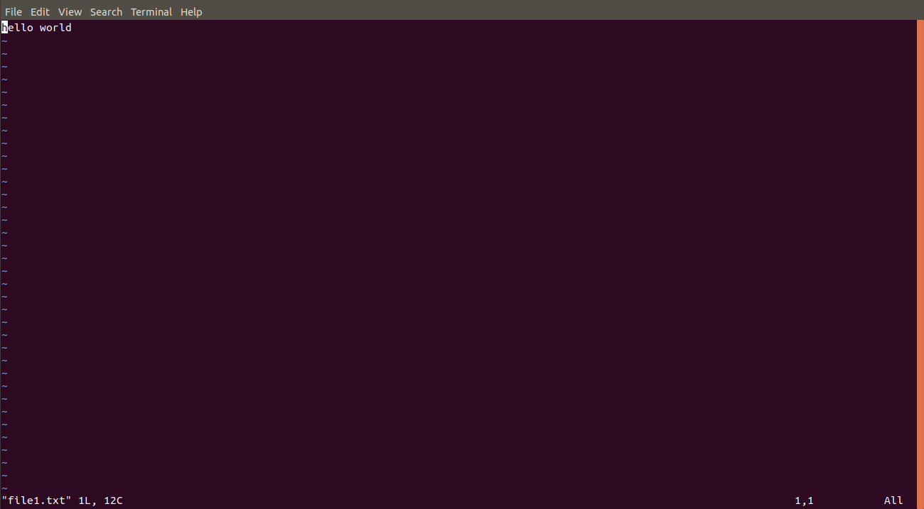

4. sudo find /etc -name passwd
cp /etc/passwd /home/rohit/Desktop/passwd_copy
mv /home/rohit/Desktop/passwd_copy /home/rohit/Desktop/passwd_backup

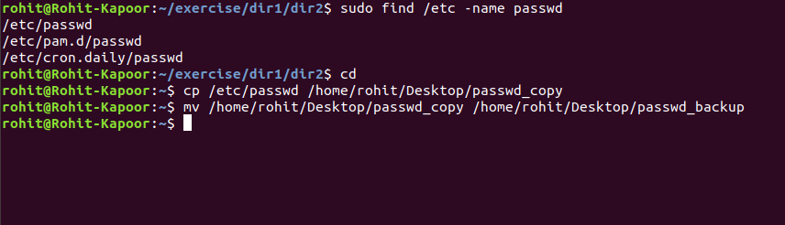

5. cat passwd_backup
cat passwd_backup | less
cat passwd_backup | more
cat passwd_backup | strings
strings passwd_backup

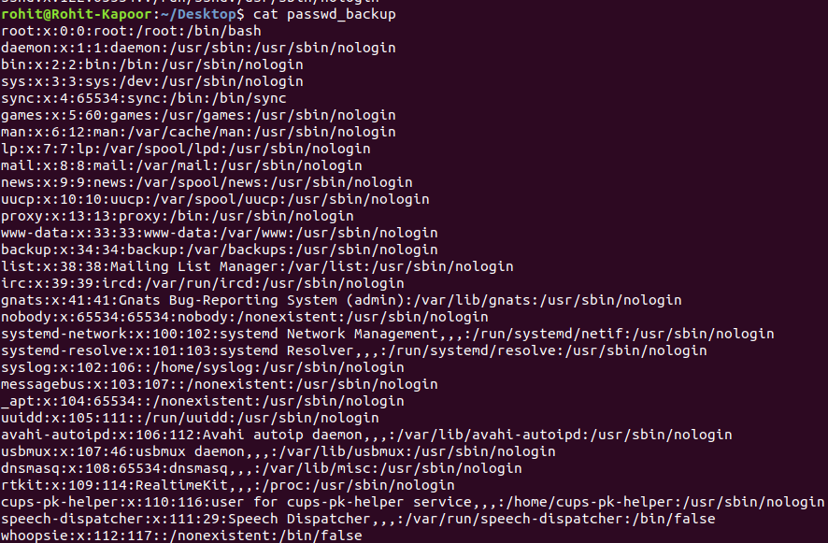
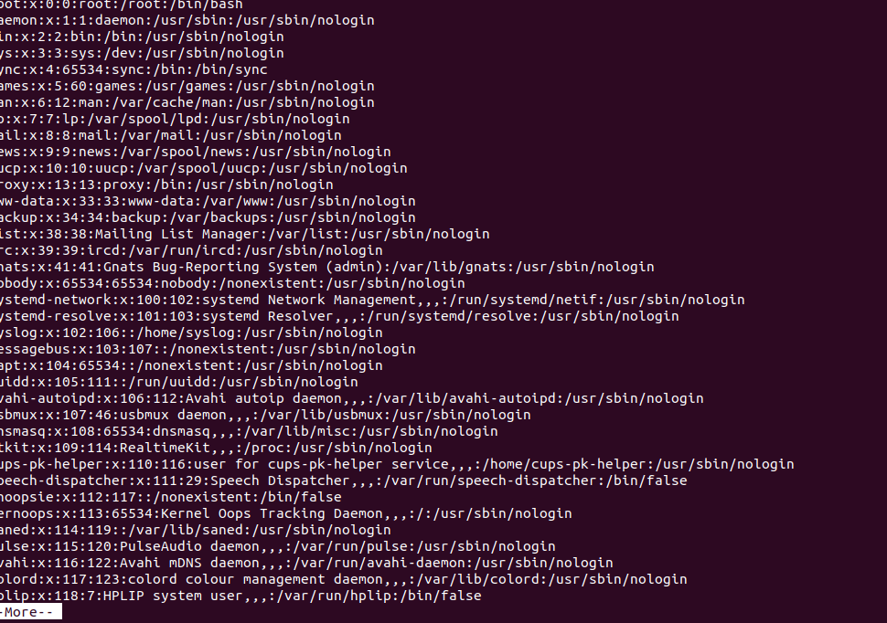

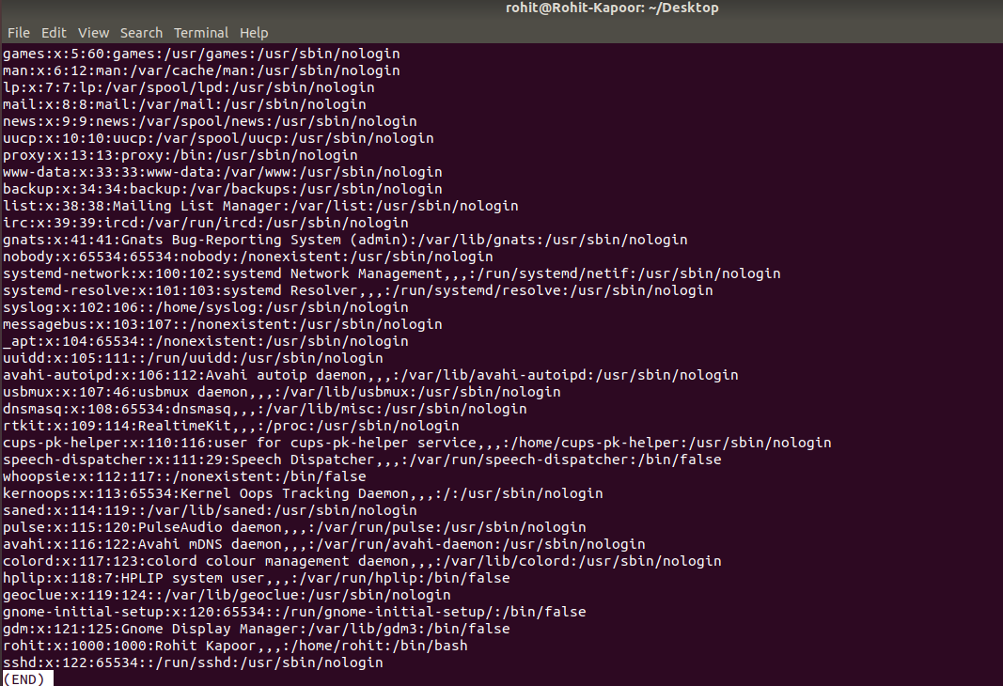

6. grep “/bin/false” passwd_backup | wc -l

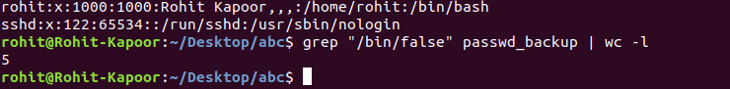

7. head -n 5 passwd_backup >> output.txt

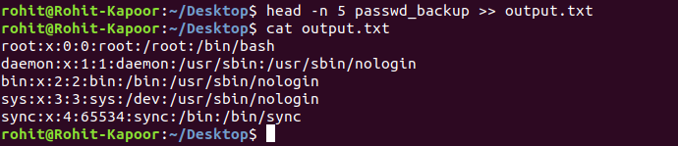

8. sudo useradd test
sudo su
passwd test

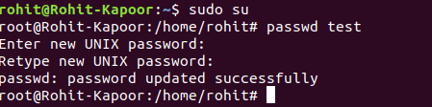

9. touch touch -d "6 hours ago" emptyfile1
touch touch -d "4 hours ago" emptyfile2
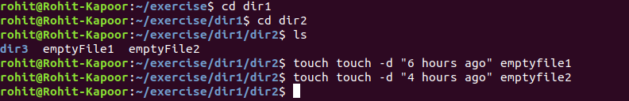

10.
a. sudo usermod -G rohit test
chmod g=w output.txt
chmod g=-w output.txt
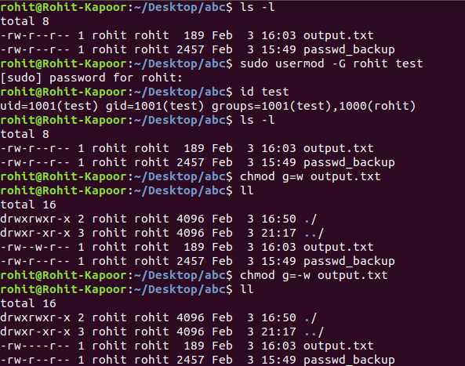

b. Making file editable to everyone: chmod 777 output.txt
Reverting the changes: chmod 624 output.txt
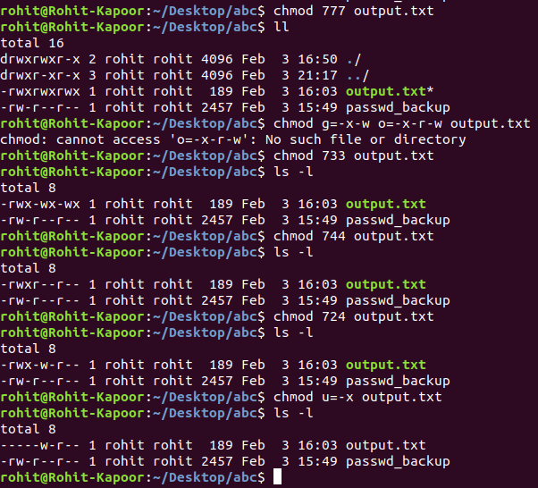

c. Changing ownership of file: sudo chown test output.txt

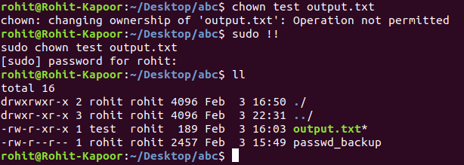

11. alias shortName="Rohit-Kapoor"
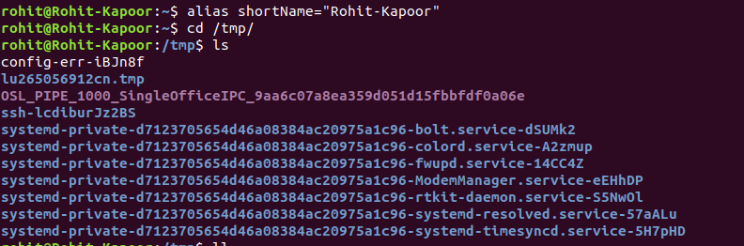

12.
in .bashrc append:
clear
echo “Welcome”
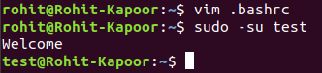

13. sudo apt-get install zip
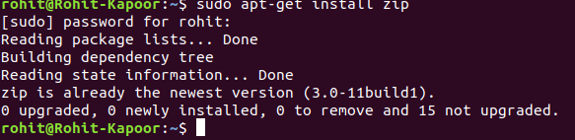

14. tar -cvf abc.tar.gz /home/rohit/Desktop/abc/
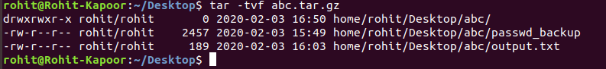

15.

.

16.
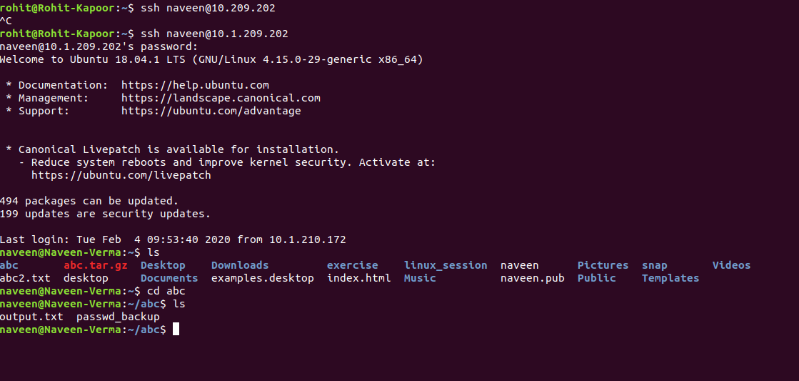

17. mv pexels-photo-443446.jpeg /home/rohit/Desktop/
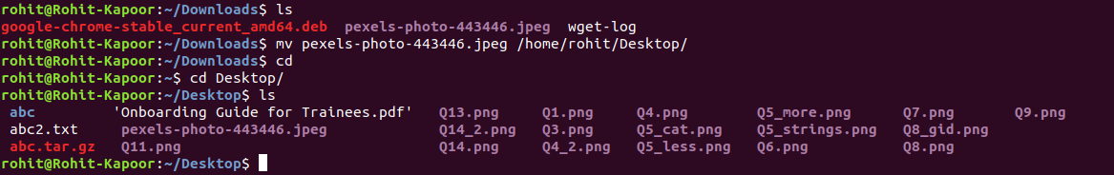

18. ls --help
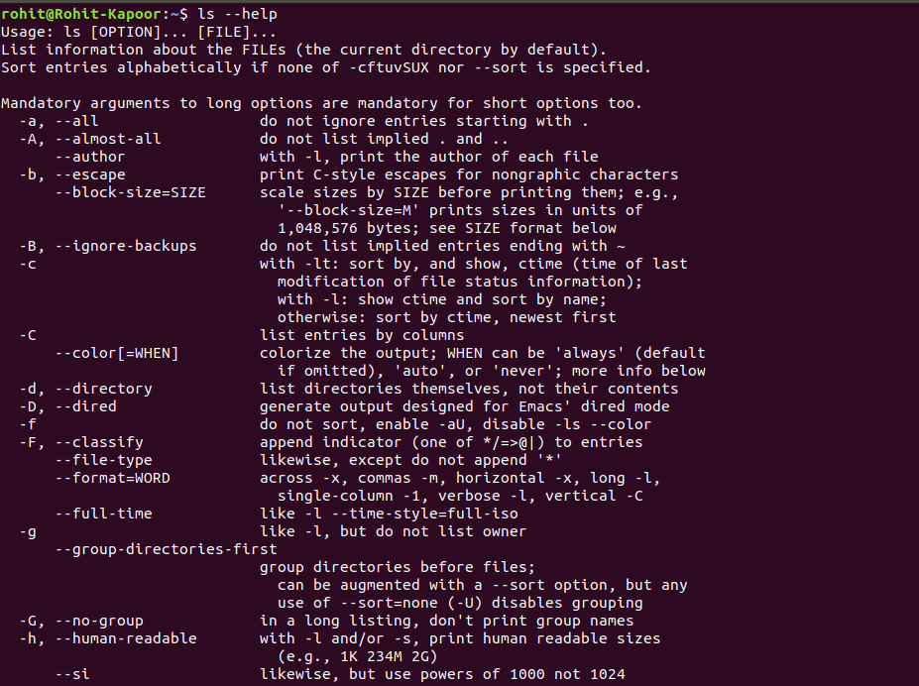

19. ln -s /etc/services /tmp/ports-info

20. whereis xyz

