API Contract Copilot
System Design
Learning project architecture for API contract change impact analysis
Design intent
Production-style enough to demonstrate RAG, agents, tools, MCP, approvals, planning, tracing, sessions, and dynamic UI - while remaining small enough to build as a learning project.

Version 1.0 | October 2026

1. Design Goals and Scope
API Contract Copilot helps an engineer understand how an API contract change affects an existing consumer integration. The system combines deterministic contract comparison, code search, retrieval-augmented generation (RAG), and LLM-based reasoning to produce an evidence-backed impact report and migration plan.
- Prefer deterministic tools for facts that can be computed reliably.
- Use RAG for contextual knowledge such as changelogs, migration guides, and internal notes.
- Use LLMs for interpretation, explanation, prioritization, and planning - not as the source of truth for contract diffs.
- Keep one central orchestrator and a small number of specialist agents.
- Persist workflow state so planning, clarification, and approval flows can resume safely.
- Start as a modular monolith; avoid microservices and heavy agent frameworks in the MVP.
Core architecture principle
LLM != source of truth. Contract changes come from deterministic comparison, exact code matches come from search tools, knowledge comes from RAG, and the LLM explains the combined evidence.

2. Primary Use Cases
Use case | Outcome
Compare API versions | Detect breaking and non-breaking OpenAPI changes.
Analyze one change | Find relevant code and documentation, then explain likely impact.
Plan migration | Generate implementation steps, tests, and open questions.
Ask follow-up questions | Continue analysis using persisted session and workflow context.
Approve action | Require explicit approval before creating a migration task.
Expose via MCP | Allow external AI clients/projects to query contract and change information.

3. High-Level Architecture
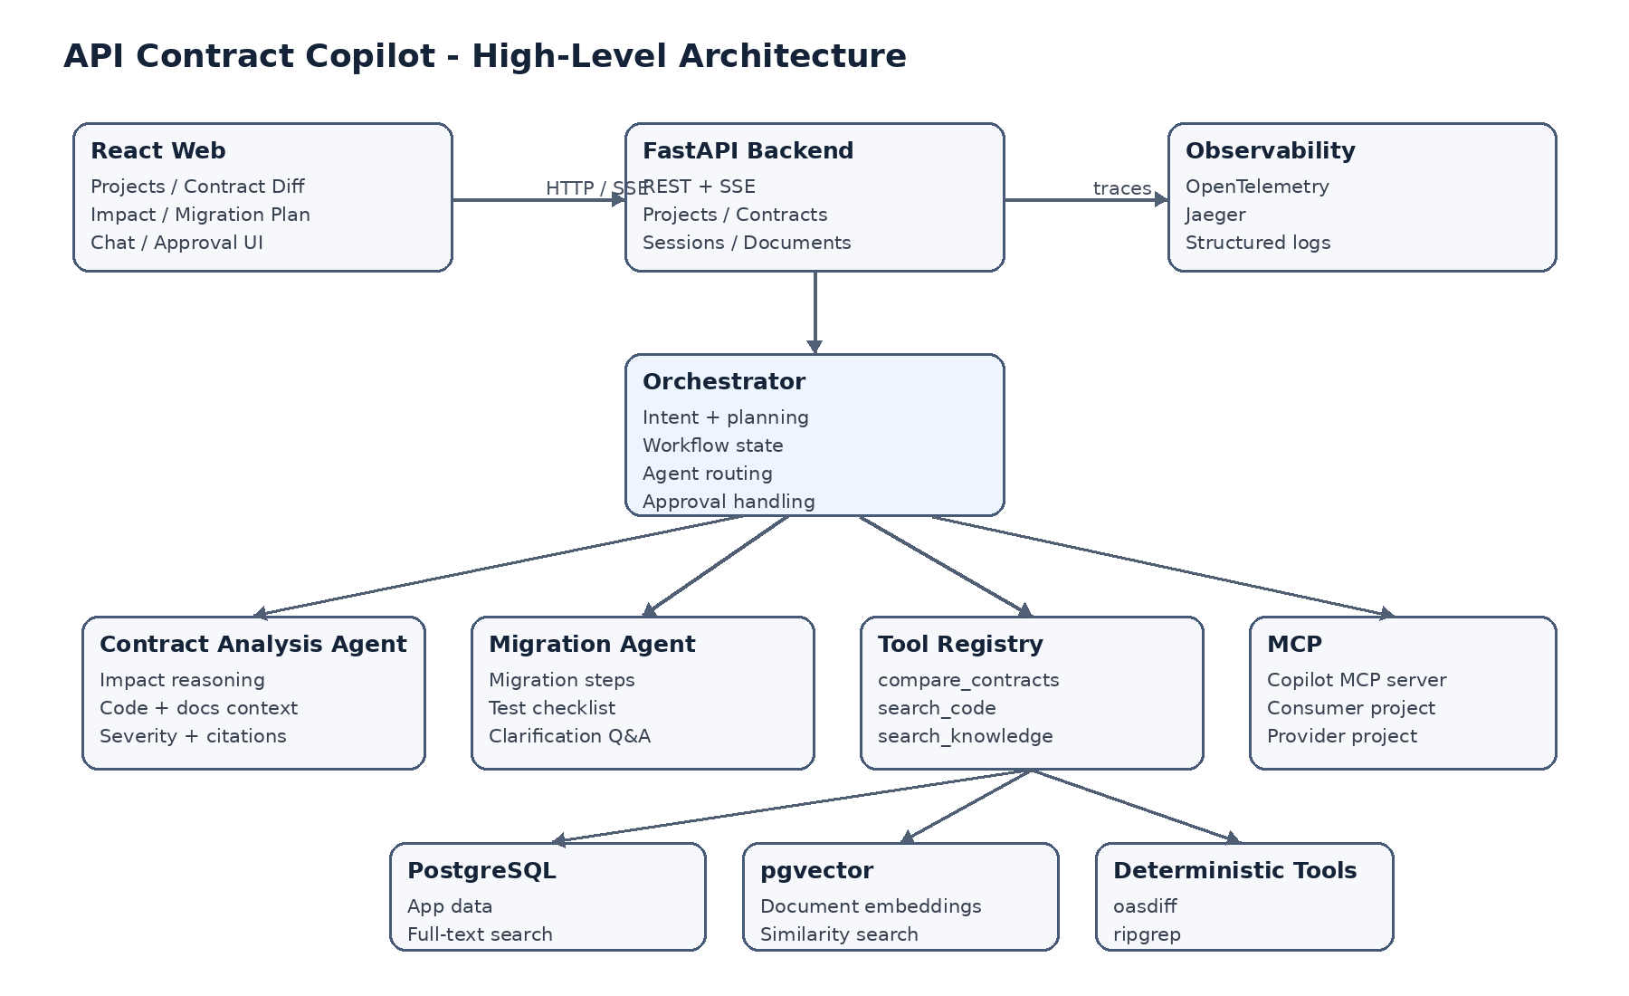

4. Component Responsibilities
Component | Responsibility
React Web | Project setup, contract diff view, chat, impact report, migration plan, approval UI, dynamic event rendering.
FastAPI Backend | HTTP/SSE API, validation, business services, persistence, workflow entry points.
Orchestrator | Intent, planning, workflow state, agent/tool routing, clarification, approval, resume.
Contract Analysis Agent | Combines contract change + code matches + RAG context to create an impact report.
Migration Agent | Creates migration steps, test checklist, open questions, and proposed task.
Tool Registry | Typed access to deterministic tools and RAG/MCP capabilities.
RAG Layer | Document ingestion, chunking, embeddings, hybrid retrieval, citations.
MCP Layer | Copilot MCP server plus clients to two demo projects.
Persistence | Projects, contracts, changes, sessions, messages, workflow state, tool runs, approvals.
Observability | End-to-end traces, structured logs, latency, token and retrieval metrics.

5. Technology Stack
Layer | Choice | Why
Frontend | React + TypeScript | Familiar UI stack; typed dynamic UI events.
Backend | Python + FastAPI | Learn Python AI ecosystem with a simple async API framework.
Validation | Pydantic v2 | Strong schemas for API payloads, tool inputs, and structured LLM outputs.
Persistence | PostgreSQL + SQLAlchemy 2 + Alembic | Single relational store for app state and migrations.
Vector search | pgvector | Keeps RAG storage in the same database for MVP simplicity.
Keyword search | PostgreSQL FTS | Supports hybrid retrieval without another search service.
LLM | OpenAI / Claude via provider interface | Model flexibility and easy test doubles.
Contract diff | oasdiff | Deterministic OpenAPI comparison.
Code search | ripgrep / MCP | Simple exact search first; advanced AST analysis is deferred.
MCP | Python MCP SDK | Expose and consume tools/resources across demo projects.
Tracing | OpenTelemetry + Jaeger | Vendor-neutral traces with a local visualizer.
Testing | pytest + pytest-asyncio | Native async Python testing.

6. Backend Structure
backend/
app/
api/ # FastAPI routes
core/ # config, logging, exceptions
db/ # session, models, repositories
schemas/ # Pydantic request/response models
ai/
orchestrator.py
workflow_state.py
providers/ # OpenAI / Anthropic adapters
agents/ # contract + migration agents
tools/ # registry + deterministic tools
rag/ # ingestion + retrieval
mcp/ # MCP server + clients
services/ # application/business services
observability/ # tracing + metrics
alembic/
tests/
pyproject.toml

7. Main Analysis Workflow
- User selects OpenAPI v1 and v2 and starts an analysis.
- FastAPI validates the request and creates an analysis run.
- Orchestrator creates/persists WorkflowState and starts a trace.
- compare_contracts runs deterministically and produces structured changes.
- For a selected change, search_knowledge retrieves relevant docs and search_code finds exact usages.
- Contract Analysis Agent combines the evidence into a structured impact report with citations.
- Migration Agent creates steps, test checklist, and open questions.
- Backend emits typed UI events; the frontend renders trusted components.
- If the user requests a write action, the workflow pauses for approval and resumes only after a decision.
OpenAPI v1 + v2
|
v
compare_contracts (deterministic)
|
v
structured breaking changes
|
+--> search_knowledge (RAG)
+--> search_code (exact/MCP)
|
v
Contract Analysis Agent
|
v
Impact Report + Citations
|
v
Migration Agent -> Plan / Questions / Approval

8. Workflow State and Resumability
The workflow is stateful because planning, clarification, and approval may span multiple user turns. State is stored after important transitions so a request can be resumed without replaying the entire process.
State | Meaning
running | Workflow is executing tools/agents.
waiting_for_user | A clarification question must be answered.
waiting_for_approval | A proposed write action is paused.
completed | Final result is available.
failed | Execution stopped with a recorded error.
WorkflowState
- id, project_id, session_id, trace_id
- intent, status, plan
- contract_changes
- retrieved_documents
- affected_files
- tool_results
- impact_report
- migration_plan
- approval_request_id

9. Tools and Deterministic Boundaries
Tool | Input | Output | Why deterministic / controlled
compare_contracts | Old + new OpenAPI specs | Structured ContractChange[] | LLM should not decide syntactic compatibility.
search_code | Validated search terms + repo | File/line matches | Exact evidence is more reliable than generated guesses.
search_knowledge | Question/change + filters | Ranked chunks + source IDs | Retrieval is controlled; LLM only interprets results.
run_contract_tests (optional) | Selected test target | Pass/fail + logs | Executable validation if added later.

10. RAG Design

10.1 Sources
- Vendor API documentation
- Changelogs
- Migration guides
- Internal integration notes
- Architecture notes

10.2 Ingestion
Document -> Parse -> Chunk -> Metadata -> Embedding -> PostgreSQL / pgvector
Each chunk stores project, document type, provider, API version, and source reference metadata. This enables project/version filtering before ranking.

10.3 Retrieval
Query / contract change
|
+--> PostgreSQL full-text search
+--> pgvector similarity search
|
v
merge (RRF or simple weighted ranking)
|
v
Top 5-10 chunks -> LLM context + citations
MVP choice
Use hybrid retrieval but skip a dedicated reranking model initially. Add reranking only if evaluation shows retrieval quality is insufficient.

11. Agents and Planning

11.1 Contract Analysis Agent
- Input: structured contract change, code matches, RAG results.
- Output: severity, summary, affected files, recommendations, source IDs.
- No direct calls to other agents; all tool use is coordinated through the orchestrator/tool registry.

11.2 Migration Agent
- Input: contract change, impact report, relevant documentation.
- Output: ordered migration steps, test checklist, open questions, proposed migration task.

11.3 Planning Mode
Planning is used only for broad requests. A short structured plan is stored in workflow state. Missing information moves the workflow to waiting_for_user instead of letting the model guess.

12. MCP Design
Surface | Operations
Copilot MCP Server | get_contract; list_contract_versions; compare_contracts; search_api_docs; get_change_details
Consumer Demo MCP | search_code; get_file; list_dependencies
Provider Demo MCP | get_openapi_spec; get_api_version; get_changelog
The two demo MCP projects are intentionally small. Their purpose is to demonstrate MCP integration, not to build full GitHub/Jira/observability connectors.

13. Data Model
Entity | Purpose
projects | Top-level workspace for one integration analysis.
api_contracts | Stored contract versions and metadata.
contract_changes | Normalized diff results between versions.
documents | Knowledge source metadata.
document_chunks | Chunk text, embedding, and retrieval metadata.
sessions / messages | Conversation history.
analysis_runs | One end-to-end analysis execution.
workflow_states | Persisted resumable orchestrator state.
tool_calls | Inputs, outputs, duration, status, trace data.
migration_plans | Generated plan and test checklist.
approval_requests | Pending/approved/rejected actions.
migration_tasks | MVP write-action result.

14. API Surface (MVP)
Method | Endpoint | Purpose
POST | /projects | Create a project.
POST | /projects/{id}/contracts | Upload a contract version.
POST | /projects/{id}/documents | Upload/index documentation.
POST | /analyses | Start contract comparison/impact analysis.
GET | /analyses/{id} | Read current analysis state.
GET | /analyses/{id}/events | SSE stream of typed UI events.
POST | /sessions/{id}/messages | Ask follow-up / answer clarification.
POST | /approvals/{id}/decision | Approve or reject a write action.

15. Dynamic UI
The LLM never generates raw HTML or JavaScript. The backend emits typed events and the frontend maps each event to a trusted React component.
message
plan
plan_step
contract_change
affected_files
source_list
impact_summary
migration_plan
tool_execution
approval_request
error

16. Observability
analysis.run
|- orchestrator.intent
|- tool.compare_contracts
|- agent.contract_analysis
| |- rag.search
| `- tool.search_code
|- agent.migration
`- approval.create
- Trace ID, project ID, session ID
- Model name and token usage
- LLM/tool/MCP/RAG latency
- Retrieved chunk IDs and scores
- Agent/tool errors and retries
- Approval wait/resume events

17. Security and Safety Boundaries
- Secrets are stored outside prompts and source code (environment/secret store).
- No arbitrary shell command is exposed to the model.
- oasdiff/ripgrep subprocesses use validated arguments, never raw model-generated command strings.
- MCP exposes only explicitly defined methods.
- Write actions pass through a policy check and require approval.
- Uploaded/project data is scoped by project; multi-tenant enterprise authorization is out of MVP scope.

18. Failure Handling
Failure | Behavior
LLM timeout / invalid structured output | Limited retry; Pydantic validation; fail with explicit error if still invalid.
Tool failure | Persist failure; return evidence gap; never fabricate a result.
MCP unavailable | Continue with partial analysis and mark source unavailable.
Weak RAG retrieval | State limited evidence; avoid unsupported citations.
Approval not answered | Keep workflow paused and resumable.

19. Deployment Model
React frontend
|
v
FastAPI modular monolith
|
+--> PostgreSQL + pgvector
+--> S3-compatible storage (optional)
+--> OpenTelemetry -> Jaeger
+--> External LLM API
+--> Demo MCP projects
Local development uses Docker Compose. Redis/Celery is intentionally omitted until document ingestion or long-running jobs prove that a queue is needed.

20. Non-Functional Requirements
Area | MVP target
Latency | Typical single-change demo analysis < 10 seconds, excluding unusually slow external model calls.
Reliability | Failed tool/LLM calls are handled without corrupting persisted workflow state.
Traceability | 100% of agent/tool executions have a trace ID.
Approval safety | 100% of write actions require explicit approval.
Retrieval quality | Relevant source appears in top-5 for >=80% of a curated evaluation set.
Maintainability | Typed boundaries: Pydantic schemas for API, tools, agents, workflow state, and UI events.

21. Key Design Decisions and Trade-offs
Decision | Reason | Trade-off
Modular monolith | Simpler learning/deployment and transactions. | Less independent scaling; acceptable for MVP.
Custom orchestrator first | Makes agent/tool/state mechanics visible. | More code than a framework; intentional for learning.
PostgreSQL + pgvector | One persistence platform. | Less specialized than dedicated vector/search systems.
ripgrep first | Fast to implement and easy to verify. | No semantic/AST-level dependency analysis.
Deterministic diff tool | Reliable compatibility facts. | Depends on external CLI behavior/version.
SSE for UI events | Simple server-to-client streaming. | Not bidirectional like WebSocket; sufficient for this UX.

22. Implementation Plan
Phase | Deliverable
1. Foundation | FastAPI app, database, project/contract upload, basic React shell.
2. Vertical slice | oasdiff comparison -> select change -> docs retrieval -> code search -> impact report.
3. RAG quality | Hybrid retrieval, metadata filters, citations, evaluation set.
4. Agent workflow | Contract agent, migration agent, planning/Q&A, persisted workflow state.
5. HITL + Dynamic UI | Approval flow, SSE events, React cards.
6. MCP | Copilot MCP server + consumer/provider demo MCP projects.
7. Observability | OpenTelemetry traces, metrics, Jaeger, error paths.
8. Evaluation / polish | Automated tests, RAG evaluation, demo dataset, deployment.
First usable vertical slice
Upload OpenAPI v1/v2 -> compare -> select breaking change -> retrieve docs -> search affected code -> generate impact report. Build this before adding planning, approval, MCP, or advanced agent behavior.

23. Explicitly Out of MVP
- LangChain / LangGraph at the start
- Celery, Kafka, Kubernetes
- Dedicated vector database or Elasticsearch
- Microservices
- Large-repository AST dependency graphs
- Runtime production traffic analysis
- Automatic code changes or PR creation
- Autonomous production remediation
- Enterprise SSO, billing, multi-tenant organization support

24. Definition of Done
- Two OpenAPI versions can be uploaded and compared.
- Breaking changes are displayed as structured data.
- A selected change can be analyzed against documentation and a codebase.
- Impact report includes evidence/citations and affected files.
- Migration plan and clarification questions work.
- Write action is paused for approval and resumes correctly.
- Sessions/workflow state persist across requests.
- At least five Copilot MCP operations are available and two demo projects are connected.
- LLM, RAG, tool, agent, and MCP calls are visible in traces.
- Core flows have automated tests and the demo runs locally via documented setup.

