SPS30 sensor

Table of Contents
Background 3
Hardware connection 4
UART communication 4
ESP32 4
ATMEGA2560 4
Failed UNO R3 4
Failed ESP8266 4
I2C communication 5
ESP32 5
ATMEGA2560 5
UNO R3 5
ESP8266 6
Software 6
Examples overview 6
Basic reading 6
Basic reading with fan-clean 6
Basic reading specific data & order 6
SPS30 plotter 6
SPS30 higher precision + typical value compare 7
Overview of user level calls 8
begin(Comms_port) 8
probe() 8
reset() 8
start() 8
stop() 8
clean() 8
GetAutoCleanInt(uint32_t *val) 8
SetAutoCleanInt(uint32_t val) 8
GetErrDescription(code, *buf, len) 9
GetSerialNumber(*buf, len) 9
GetArticleCode(*buf, len) 9
GetProductName(*buf, len) 9
I2C_expect() 9
GetValues(struct sps_values *v) 10
Driver configuration 11
Exclude I2C communication code 11
Exclude UART communication code 11
I2C communication 12
Number of valid values 12
Relationship PM10 and PM2.5 14
Compare against Dylos 15
DYLOS-1700 definition 15
SPS30 definition 15
Comparing 15
compare against SDS-011 16
SDS-011 definition 16
SP30 definition 16
Comparing 16
Personal conclusion (feb 2019) 17
Appendix A : Error messages 18
Appendix B : some example output 19
Example 1 : Basic reading 19
Example 9 : Basic reading + typical + average 19
Appendix C: inside SPS30 21

Background

This project is part of a number of projects to measure the air quality. I bought a new sensor : SPS30 from Sensirion. Having worked on another sensor from them (SCD30) before the quality is normally good. The aim is to compare the output with other sensors and provide the learning.

The board is relative new at the time of writing this documentation and as such a lot of preliminary documents from supplier. Actually the documentation looks to be incorrect on a number of places that I will point to in this document.

While there is a driver available from Sensirion it is very modular, to a point where it feel to be over engineered and complex. Also it looked to be half-library as I did not find good user examples for Arduino / ESP32. Hence I wrote the driver from scratch and it supports UART communication (different serial ports, but not on all boards !!) as well as I2C.

A number of examples have been added, more work to be do for WIFI connection and compare with other sensors.

Paul van Haastrecht
paulvha@hotmail.com

Hardware connection

Depending on UART or I2C the connections are different. Has been tested by others on many other platforms including SAMD.

UART communication

ESP32
Using serial port1, setting the RX-pin(25) and TX-pin(26)
Different setup can be configured in the sketch.

SPS30 pin ESP32
1 VCC -------- VUSB
2 RX --------- TX pin 26
3 TX --------- RX pin 25
4 Select (NOT CONNECTED)
5 GND -------- GND

Also successfully tested on Serial2 (default pins TX:17, RX: 16)
NO level shifter is needed as the SPS30 is TTL 5V and LVTTL 3.3V compatible

ATMEGA2560
Used SerialPort2. No need to set/change RX or TX pin
SPS30 pin ATMEGA
1 VCC -------- 5V
2 RX --------- TX2 pin 16
3 TX --------- RX2 pin 17
4 Select (NOT CONNECTED)
5 GND -------- GND

Also successfully tested on SerialPort1 and Serialport3

Failed UNO R3
Failed as I had to use softserial as there is not a separate serial port. But as the SPS30
is only working on 115K the connection failed all the time with CRC errors. (see 2.2.3)

Failed ESP8266
As the power is only 3V3 (the SPS30 needs 5V) and one has to use softserial which failed with 115K speed

I2C communication

As documented in the datasheet, make sure to use external 10K pull-up resistor on both the SDA and SCL lines. Otherwise the communication with the sensor will fail random. Also read chapter 4 about the expected valid values in I2C.

ESP32

SPS30 pin ESP32
1 VCC -------- VUSB
2 SDA -------- SDA (pin 21)
3 SCL -------- SCL (pin 22)
4 Select ------ GND (select I2c)
5 GND ------- GND

The pull-up resistors should be to 3V3.

ATMEGA2560

SPS30 pin ATMEGA
1 VCC -------- 5V
2 SDA -------- SDA
3 SCL --------- SCL
4 Select ------- GND (select I2c)
5 GND -------- GND

UNO R3

SPS30 pin UNO
1 VCC ------- 5V
2 SDA ------- A4
3 SCL -------- A5
4 Select ------ GND (select I2c)
5 GND ------- GND

When UNO-board is detected the UART code is excluded as that does not work on UNO and will save memory. Also some buffers reduced and the call to GetErrDescription() is removed to allow enough memory. Apart from that ALL examples work with UNO as well :-)

ESP8266

SPS30 pin External ESP8266
1 VCC -------- 5V
2 SDA ----------------------- SDA
3 SCL ------------------------ SCL
4 Select ---------------------- GND (select I2c)
5 GND ------- GND -------- GND

The pull-up resistors should be to 3V3 from the ESP8266.

Software
This software has been written from scratch. The driver has no dependencies on other libraries, some examples have. It has a number of user level calls to set and get data from the SPS30 and can be used independent of the communication channel setting. The I2C communication however could have some restrictions. See chapter 4.

Examples overview
At the top of each sketch there is detailed information about the hardware connections and dependencies on external libraries.

Basic reading
This sketch will detect an SPS30 and read and display all the data every 3 seconds
It will allow to configure for communication channel, serial-RX and TX pins as well as debug level.

Basic reading with fan-clean
This sketch will detect an SPS30, read the current auto clean interval, optionally set new auto clean interval or force a manual fan-clean. After that it wile read and display all the data every 3 seconds.
It will allow to configure for communication channel, serial-RX and TX pins, debug level and options to set the auto clean interval or force a manual fan-clean.

Basic reading specific data & order
This sketch will detect an SPS30 and allows to set and display specific data in a specific order every 3 seconds. It will allow to configure for communication channel, serial-RX and TX pins, debug level and define the wanted data in a wanted order.

SPS30 plotter
This sketch will detect an SPS30, reads and displays the data every seconds The output format is aimed for the plotter (cntrl+shift+L). It will allow to configure for the SPS30 communication channel, serial-RX and TX pins as well as debug level. You can configure the data to plot (MassPMx, NumPMx or average size) as well as how of the first readings to skip to remove invalid start-up info.

SPS30 higher precision + typical value compare
Read the SPS30 information and display with high precision. Calculated average size and compare that against the reported typical value. Provide an actual and longer running error margin.

Overview of user level calls

begin(Comms_port)
This will initialize the communication channel. Unlike in other sketches, you should NOT first perform a begin ( Serial1.begin()) in the sketch. That is all handled by the driver. The following options are supported :

I2C_COMMS I2C communication
SERIALPORT ONLY IF there is NO monitor attached

Will return ‘true’ if successful, else ‘false’.

probe()
This will try to connect the SPS30 over the requested communication channel.
Will return ‘true’ if successful, else ‘false’.

reset()
This will sent a soft-reset to the SPS-30.
Will return ‘true’ if successful, else ‘false’.

start()
This will sent a start-measurement command to the SPS-30.
Will return ‘true’ if successful, else ‘false’.

stop()
This will sent a stop-measurement command to the SPS-30.
Will return ‘true’ if successful, else ‘false’.

clean()
This will sent a manual clean fan command to the SPS-30. The fan will spin faster for 10 seconds.
The SPS30 must be in measurement mode. Will return ‘true’ if successful, else ‘false’.

GetAutoCleanInt(uint32_t *val)
This will read the current Auto Fan clean interval from the SPS30 and return that in pointer to ‘val’.
Will return ‘ERR_OK’if successful read, else on the error messages documentation in Appendix A.

SetAutoCleanInt(uint32_t val)
This will SET the Auto Fan cleaning interval on the SPS30 to the value defined in ‘val’. Will return ‘ERR_OK’ if successful read, else on the error messages documentation in Appendix A.

GetErrDescription(code, *buf, len)
This will provide a description of an error code as documented in Appendix A. ‘Code’ the error code, ‘buf’ is a buffer to store the message and ‘len’ is the length of the buffer. (not supported on Uno : see chapter 3.2)

GetSerialNumber(*buf, len)
This will try to read the serial number from the device and store that in buffer ‘buf’ with a maximum number of bytes ‘len’. The maximum can be 32 bytes. Will return ‘true’ if successful, else ‘false’.

GetArticleCode(*buf, len)
This will try to read the Articlecode from the device and store that in buffer ‘buf’ with a maximum number of bytes ‘len’. The maximum can be 32 bytes. Will return ‘true’ if successful, else ‘false’.

GetProductName(*buf, len)
Tries to read the product name from the device and store that in buffer ‘buf’ with a maximum number of bytes ‘len’. The maximum can be 32 bytes. Will return ‘true’ if successful, else ‘false’.

I2C_expect()
Will return the number of valid float values to expect from reading in I2C. See chapter 4.

GetValues(struct sps_values *v)
This will try to read all the values from the SPS30 and store those in structure pointer v. Will return ‘ERR_OK’ if successful read else on the error messages documentation in Appendix A.
The structure is defined in sps30.h, for details read the datasheet
typedef struct sps_values
{
float MassPM1; // Mass Concentration PM1.0 [μg/m3]
float MassPM2; // Mass Concentration PM2.5 [μg/m3]
float MassPM4; // Mass Concentration PM4.0 [μg/m3]
float MassPM10; // Mass Concentration PM10 [μg/m3]
float NumPM0; // Number Concentration PM0.5 [#/cm3]
float NumPM1; // Number Concentration PM1.0 [#/cm3]
float NumPM2; // Number Concentration PM2.5 [#/cm3]
float NumPM4; / / Number Concentration PM4.0 [#/cm3]
float NumPM10; // Number Concentration PM4.0 [#/cm3]
float PartSize; // Typical Particle Size [μm]
};

As mentioned in chapter 4, when the communication channel is I2C, depending on the receive buffer size in wire.h, only the MassPMx may be available. The others will be zero.

Driver configuration
In the config.h configuration settings are available.

Exclude I2C communication code
In case you do not plan to use the I2C code and want to remove that in order to reduce the memory size of the driver in config.h comment out the line : #define INCLUDE_I2C 1.
Compile will fail if UART communication is excluded at the same time.

Exclude UART communication code
In case you do not plan to use the I2C code and want to remove that in order to reduce the memory size of the driver in config.h comment out the line : #define INCLUDE_UART 1
Compile will fail if I2C communication is excluded at the same time.

I2C communication

In datasheet (page 11) the disclaimer is made:

Some considerations should be made about the use of the I 2 C interface. I 2 C was originally designed to connect two chips on a PCB. When the sensor is connected to the main PCB via a cable, particular attention must be paid to electromagnetic interference and crosstalk. Use as short as possible (< 10 cm) and/or well shielded connection cables.
We recommend using the UART interface instead, whenever possible: it is more robust against electromagnetic interference, especially with long connection cables

While the above is true, the I2C implementation, which works good as long as you apply the 2 x 10K pull-up resistors as indicated in the datasheet on pag 11.

Number of valid values
Opposite to an earlier assumption that the SPS30 is only sending 32 bytes, it turned out that the I2C / Wire receive buffer on many boards is set a maximum value of 32. After that the boards will stop with receiving.

A size needed for each float value is 6 bytes (LSB + MSB + CRC ) ++ (LSB + MSB + CRC) To read all values an I2C receive buffer of at least 6 x 10 = 60 bytes is needed. As on many boards the default buffer size is set to 32 in Wire.h, it will only be providing 5 valid float values.

To cope with this we determine the I2C buffer-size in the sps30.h and calculate in the constructor for sps30 the expected valid bytes. If the I2C buffer size is less than 64 only the MASS values are provided.

One can check the impact by calling I2C_expect(), which will return the number of valid float values to expect from reading SPS30.

Of course you can increase the buffer (if memory size allows) for your board in Wire.h. This is NOT part of this library, but part of your IDE.

ATMEGA (UNO or 2560 .. maybe others)
I had to increase BOTH otherwise the connection would fail:
Wire/src/wire.h #define BUFFER_LENGTH 64 // was 32
Wire/src/utility/twi.h #define TWI_BUFFER_LENGTH 64 // was 32

Note :
Got input from Bert Heusinkveld that on a windows system for PRO-Mini (UNO variant) he had to change these values on:
-c:\program files (x86)\arduino\hardware\avr\libraries\wire…
-c:\users\...\AppData\local\arduino15\packages\arduino\hardware\avr\1.6.23\libraries\wire....

esp8266
Wire/src/wire.h #define BUFFER_LENGTH 64 // was 32

esp32
The buffer is already 128
Wire/src/wire.h #define I2C_BUFFER_LENGTH 128

MKRZERO / SAMD
The SAMD library has a different definition as it has a ‘sercom’ setup for all communication.
In wire.h for the a SAMD the RX buffer is defined as : RingBufferN<256> rxBuffer;
The library will handle that and set to 256, BUT given the 6 communication options, the SoftSerial is NOT available and thus disabled.

Relationship PM10 and PM2.5

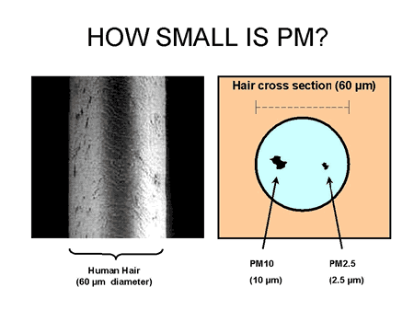
https://www.arb.ca.gov/research/aaqs/pm/pm.htm
An PM10 surface is 16 x PM2.5, while the PM10 volume is 64 x PM2.5. This means that the <PM 2.5 as much smaller, much lighter than the PM25 <> PM10 particles. And while the PM2.5 <> PM10 numbers are much less they have a size-able impact on the numbers.
The PM10 number INCLUDE the PM2.5 numbers. Different investigations have provided information around the relationship between PM2.5 and PM10 ug/m3.
The university of Montana 70% of the weight of PM10 constitutes of PM2.5.
HongKong:
Annual(μg/m3) | Daily(μg/m3)
PM2.5 = 0.71 x PM10 | PM2.5 = 0.75 x PM10

(https://www.epd.gov.hk/epd/english/environmentinhk/air/guide_ref/guide_aqa_model_g5.html)
Scotland:
The annual average ratio of daily mean PM2.5 concentration to daily mean PM10 concentration typically varied from 0.51 to 0.69 with a mean of 0.63

This was supported by the PCM modeled data, which indicated that the ratio of annual mean PM2.5 / PM10 ranged from 0.63 to 0.69

(http://www.scottishairquality.scot/assets/documents/technical%20reports/pm2.5-pm10ratio_29Mar2016-FINAL_Version_Approved.pdf)

Compare against Dylos

DYLOS-1700 definition
A DYLOS-1700 is providing information particle information per 0.01 cubic foot. It has 2 numbers:
A. Particle count > 0.5 μm
B. Particle count > 2.5 μm. This is a good representation of the PM10 value.(different tests)
From this you can calculate the Particle count between 0.5 μm and 2.5 μm: C = A - B
DYLOS numbers from cubic feet to cm3: DYLOS 0.01 ft³ / 283.1685 => cm³

SPS30 definition
The SPS30 numbers show in cm³ the particle count SMALLER than the size. Datasheet pag 2
PMx defines particles with a size smaller than “x” micrometers (e.g., PM2.5 = particles smaller than 2.5 μm).
The SPS30 starts measurement from 0.3um

Comparing
Let take an example of values captured (nearly) at the same moment :
SPS30 (concentration count)
PM0.5 PM1 PM2.5 PM4 PM10
123.09985 142.61128 143.41982 143.47649 143.48987
DYLOS-1700
A = 5523 B = 42 calculated C = 5481
Compare < 2.5μm concentration
Dylos > 5481 / 283.1685 = 19.536 particles / cm³ (> 0.5)
sps30 > 143.41982 –123.09985 = 20.31 particles /cm³ (> 0.5)
Compare >2.5μm concentration
Dylos > 42 / 283.1685 = 0.148 particles /cm³
SPS30 > 143.48987 – 143.41982 = 0.07 particles /cm³
Having run the above compare 10 times, the results < 2.5μm are within 92%, where the > 2.5μm varies between 1 to 40 times difference, but on a very small amount.

Interesting / surprising to see the high number between 0.3 μm to 0.5 μm. The Dylos starts at 0.5 where the SPS40 starts at 0.3 μm.

compare against SDS-011

SDS-011 definition
The SDS011 using principle of laser scattering,can get the particle concentration between 0.3 to 10μm in the air. It provides the mass of 2.5 μ/m³ and 10 μ/m³ . It is not defined whether this is inclusive or exclusive of the 2.5 μm particle, but it looks they follow official definition of the < 2.5 μm particle.

SP30 definition
The SPS30 numbers show in cm³ the particle count SMALLER than the size. Datasheet pag 2
PMx defines particles with a size smaller than “x” micrometers (e.g., PM2.5 = particles smaller than 2.5 μm).
The SPS30 starts at 0.3 μm as well and provides mass numbers as 1 μg/m³ , 2.5 μg/m³ , 4 μg/m³ and 10 μg/m³

Comparing
We had the 2 sensors run side by side for ~3500 samples, every 3 seconds.
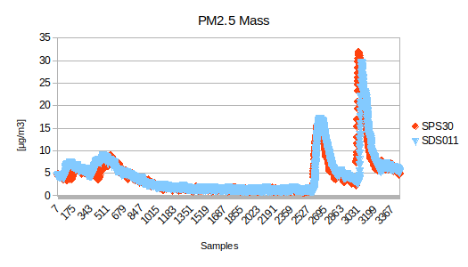
The 2.5 μ/m³ numbers are extremely close. They follow the same pattern, same reaction to change and the average over the 3500 samples is SPS30 : 4.27 μg/m³ where the SDS011 is showing : 4.45 μg/m³
Actually over a longer time it > 95% the same.

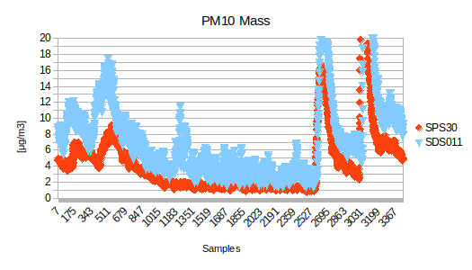
For the 10 μ/m³ the numbers are different
While they follow the same pattern and reaction, the values of SPS30 are nearly 50% of the SPS011. Over the 3500 samples on average the SPS30 is 4.35 μg/m³ where the SDS011 is 7.52 μg/m^{3.}

We reference to chapter 5 :
Checking the relationship of SDS011 results shows over 3500 samples a factor between PM10 and PM2.5 of 0.567, often 0.6 / 0.7 drawn down especially when the μg/m3 reading is low.
Checking the relationship of SPS30 results shows over 3500 samples a factor between PM10 and PM 2.5 of 0.967, often 0.99 or 100% with lowest around 0.92.
Next to that when using example 9, compare Typical Particle Size (TPS) against average (AVG), it seems that the particles numbers above 2.5 μm to 10 μm are below of what to expect.
Using Example 9 and looking at the reported 10um mass, they are sometimes LESS than the 4um (nearly or the same as 2.5um). Also sometimes the 4 μm mass is less than 2.5 μm mass. I have 2 SPS30 sensor and BOTH have similar behavior. I have triple checked the real HEX values received from the SPS30. Below example with UART communication. :
sending: 0x7E 0x00 0x03 0x00 0xFC 0x7E
Received: 0x7E 0x00 0x03 0x00 0x28 0x41 0xB5 0x07 0x06 0x41 0xBF 0x36 0x47 0x41 0xBF 0x36 0x65 0x41 0xBF 0x36 0x47 0x43 0x18 0x06 0xDA 0x43 0x30 0xFB 0xD9 0x43 0x31 0xA0 0x35 0x43 0x31 0xA3 0x50 0x43 0x31 0xA4 0xB7 0x3F 0x09 0xD2 0x78 0xA9 0x7E length: 46
0x7E header
0x00 address
0x03 command
0x00 state
0x28 length
0x41 0xB5 0x07 0x06 1 ug/m3
0x41 0xBF 0x36 0x47 2.5 ug/m3
0x41 0xBF 0x36 0x65 4 ug/m3
0x41 0xBF 0x36 0x47 10 ug/m3 (PM10 mass values is the same as PM.25 and lower than PM4 ?)
0x43 0x18 0x06 0xDA 0.5 #/m3
0x43 0x30 0xFB 0xD9 1 #/m3
0x43 0x31 0xA0 0x35 2.5 #/m3
0x43 0x31 0xA3 0x50 4 #/m3
0x43 0x31 0xA4 0xB7 10 #/m3 (but at the same time the PM10 particle count is higher ???)
0x3F 0x09 0xD2 0x78 Typical particle
0xA9 CRC
0x7E trailer

Personal conclusion (feb 2019)
I believe the mass and volume numbers up to 2.5um are well representing the environment. But I wonder whether the sensor is able to detect / report above 2,5 μm particle size the average weight and/or the number of particles in the right way.

Appendix A : Error messages
Defined in sps30.h

Hex
00 ERR_OK “All good"
01 ERR_DATALENGTH "Wrong data length for this command (too much or little data)"
02 ERR_UNKNOWNCMD "Unknown command"
03 ERR_ACCESSRIGHT "No access right for command"
04 ERR_PARAMETER "Illegal command parameter or parameter out of allowed range"
28 ERR_OUTOFRANGE "Internal function argument out of range"
43 ERR_CMDSTATE "Command not allowed in current state"
50 ERR_TIMEOUT "No response received within timeout period"
51 ERR_PROTOCOL "Protocol error"

Appendix B : some example output

Example 1 : Basic reading

SPS30-Example1: Basic reading. press <enter> to start
Trying to connect
Detected SPS30.
Serial number : 361D4FD3AA941A76
Product name : not available
Article code : not available
Measurement started

Hit <enter> to continue reading
Hit <enter> to continue reading (Note 1)
-------------Mass ----------- ------------- Number -------------- -Average-
Concentration [μg/m3] Concentration [#/cm3] [μm]
P1.0 P2.5 P4.0 P10 P0.5 P1.0 P2.5 P4.0 P10 PartSize

13.31 16.19 18.14 18.85 107.15 103.87 106.74 107.09 0.00 0.60
12.88 14.86 16.06 16.51 103.75 101.60 103.49 103.71 0.00 0.61
12.77 14.80 16.06 16.52 102.83 100.61 102.56 102.79 0.00 0.65
12.50 14.04 14.90 15.22 100.64 99.02 100.45 100.61 0.00 0.61
12.14 13.42 14.08 14.32 97.77 96.48 97.63 97.75 0.00 0.62
11.97 13.09 13.63 13.82 96.39 95.29 96.27 96.37 0.00 0.61
11.80 12.87 13.37 13.55 95.02 93.98 94.92 95.01 0.00 0.61
11.61 12.60 13.04 13.20 93.50 92.55 93.40 93.48 0.00 0.60
11.50 12.44 12.84 12.99 92.59 91.70 92.50 92.58 0.00 0.59
11.37 12.29 12.67 12.81 91.58 90.72 91.49 91.56 0.00 0.59
11.43 12.32 12.68 12.82 92.02 91.19 91.94 92.01 0.00 0.57
11.43 12.31 12.65 12.77 92.07 91.27 92.00 92.06 0.00 0.58
11.43 12.28 12.60 12.72 92.09 91.32 92.01 92.07 0.00 0.57
11.34 12.15 12.45 12.56 91.33 90.60 91.26 91.31 0.00 0.57
11.25 12.03 12.31 12.41 90.58 89.88 90.51 90.57 0.00 0.56
11.10 11.85 12.10 12.19 89.42 88.77 89.37 89.41 0.00 0.56
11.13 11.85 12.08 12.17 89.61 88.98 89.55 89.60 0.00 0.56
11.00 11.69 11.90 11.98 88.56 87.97 88.51 88.55 0.00 0.57
10.76 11.42 11.61 11.68 86.67 86.12 86.63 86.66 0.00 0.56
10.71 11.35 11.53 11.60 86.23 85.70 86.19 86.23 0.00 0.56
10.67 11.30 11.47 11.53 85.94 85.42 85.90 85.93 0.00 0.56
10.56 11.17 11.33 11.39 85.02 84.52 84.98 85.01 0.00 0.57
10.51 11.11 11.26 11.32 84.62 84.13 84.58 84.61 0.00 0.56
10.55 11.16 11.31 11.36 85.00 84.52 84.97 85.00 0.00 0.57
10.73 11.36 11.51 11.57 86.46 85.96 86.42 86.45 0.00 0.57
11.08 11.72 11.88 11.94 89.23 88.72 89.19 89.22 0.00 0.56
11.17 11.81 11.96 12.02 89.95 89.44 89.91 89.94 0.00 0.56
11.01 11.63 11.78 11.83 88.66 88.16 88.62 88.65 0.00 0.57
10.89 11.50 11.65 11.70 87.70 87.22 87.67 87.70 0.00 0.58

Example 9 : Basic reading + typical + average
Hit <enter> to continue reading
-----------------------Mass --------------------- -------------------------- Number --------------------------- -----Partsize -------- ----- Error Margin -----
Concentration [μg/m3] Concentration [#/cm3] [μm] %
PM1.0 PM2.5 PM4.0 PM10 PM0.5 PM1.0 PM2.5 PM4.0 PM10 Typical Average Actual last 10 samples

2.44646 3.72065 4.61890 4.84432 13.60713 17.95112 19.25093 19.41132 19.43798 0.68469 0.78369 -14.46 -14.46
2.98158 3.99828 4.66924 4.83762 17.91819 22.43591 23.43956 23.55998 23.58018 0.66387 0.70377 -6.01 -10.30
3.25240 4.01541 4.47382 4.58886 20.40710 24.83409 25.55428 25.63722 25.65131 0.62317 0.65614 -5.29 -8.72
3.52776 4.20484 4.58310 4.67803 22.50948 27.09331 27.71152 27.78041 27.79225 0.58633 0.63696 -8.64 -8.70
3.68784 4.34082 4.69292 4.78127 23.66743 28.37988 28.96679 29.03113 29.04225 0.56174 0.63027 -12.20 -9.33
3.82785 4.54891 4.94859 5.04888 24.45823 29.41227 30.06833 30.14116 30.15369 0.59167 0.63536 -7.39 -9.02
3.90359 4.63237 5.03476 5.13575 24.95849 30.00106 30.66302 30.73637 30.74899 0.59676 0.63461 -6.34 -8.65
3.94991 4.69951 5.11631 5.22090 25.22431 30.34434 31.02732 31.10326 31.11631 0.60294 0.63599 -5.48 -8.26
3.94206 4.61696 4.97509 5.06495 25.35640 30.36026 30.96264 31.02818 31.03953 0.59949 0.62764 -4.70 -7.87
3.85170 4.45136 4.75403 4.82998 24.92396 29.72656 30.25042 30.30610 30.31580 0.60135 0.62064 -3.21 -7.41
3.79606 4.38160 4.67558 4.74935 24.57754 29.30286 29.81325 29.86734 29.87679 0.60597 0.61999 -2.31 -6.52
3.74854 4.33460 4.63112 4.70552 24.25030 28.92784 29.44034 29.49486 29.50437 0.60642 0.62094 -2.39 -6.11
3.73187 4.26205 4.51513 4.57863 24.27512 28.85470 29.30724 29.35406 29.36230 0.60149 0.61450 -2.16 -5.79
3.81722 4.27159 4.46097 4.50849 25.04913 29.60613 29.97384 30.00942 30.01584 0.58703 0.60410 -2.91 -5.07
3.86197 4.29266 4.46133 4.50366 25.41500 29.98342 30.32403 30.35597 30.36181 0.58214 0.60071 -3.19 -4.09
3.84442 4.25367 4.40619 4.44445 25.34799 29.86744 30.18542 30.21449 30.21984 0.58537 0.59842 -2.23 -3.63
3.93010 4.40392 4.60364 4.65376 25.77495 30.47541 30.86048 30.89796 30.90471 0.60476 0.60479 -0.01 -3.18
3.79063 4.30330 4.53995 4.59933 24.72161 29.33589 29.76757 29.81152 29.81931 0.61342 0.61143 0.32 -1.61
3.70268 4.20668 4.44037 4.49902 24.14001 28.65187 29.07703 29.12041 29.12809 0.61379 0.61182 0.32 -1.41

Note 1:
The PM10 showing 0 in some examples was an error that has been fixed in the code in a later version

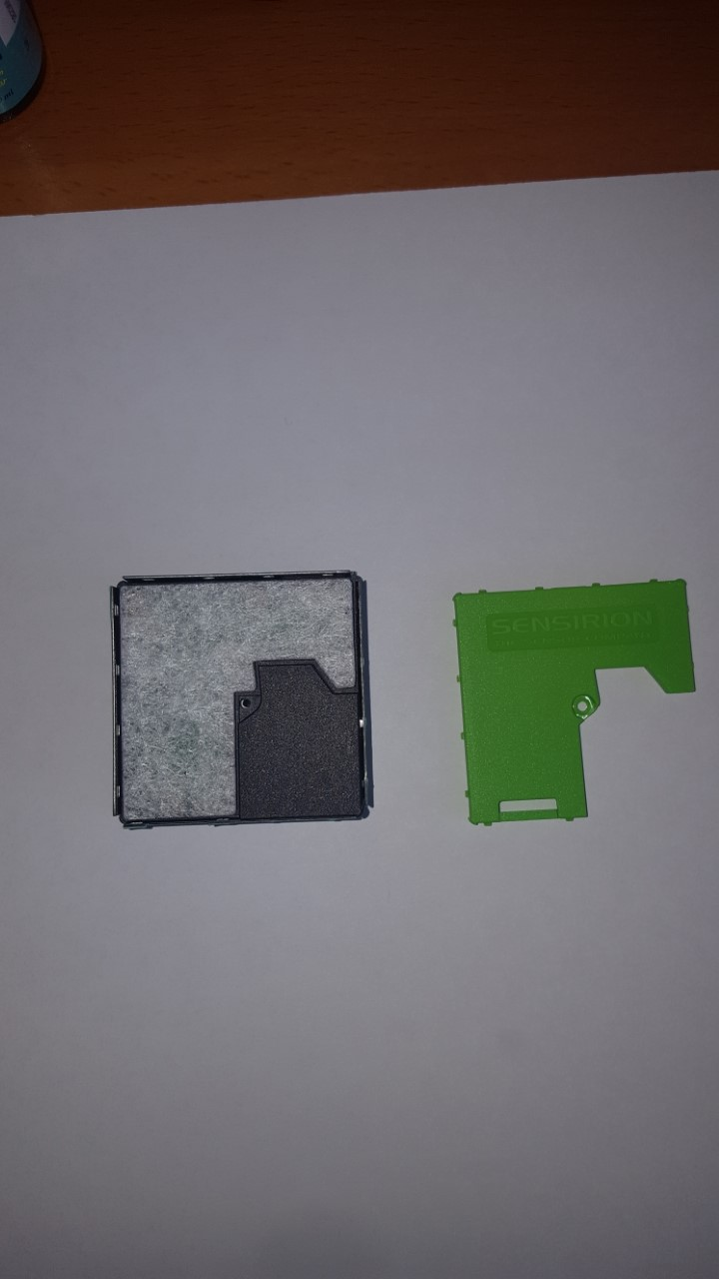
Appendix C: inside SPS30

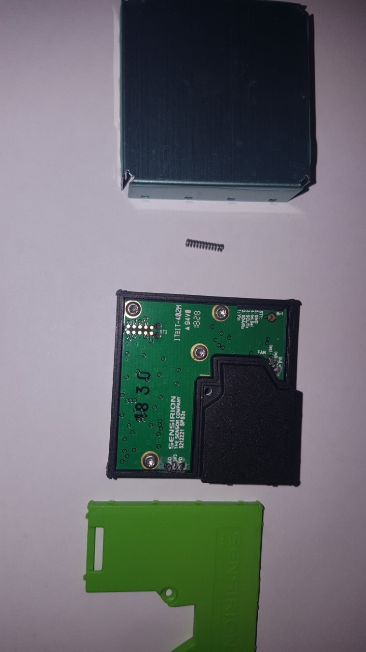
Removing the top cover screw

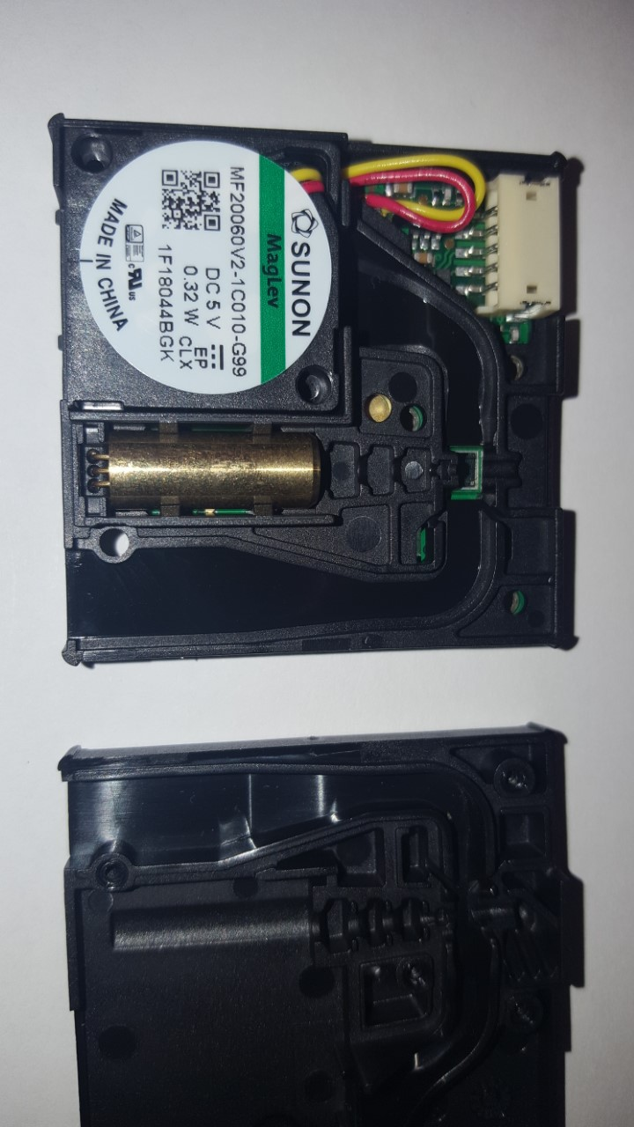
Carefully remove from the housing. Watch the spring at the back. Removing the 4 screws allows the top panel to be removed

Air goes in on the right hand side, through a measurement chamber and is coming out through the fan. At the bottom, the golden piece, is the led.

