**joinTracks**

**User Manual**

To run joinTracks, the following variables (in the trackGUI_OpeningFcn function) have to be set by the user:

* **tiamFile** – this should begin with “/data/” and the contain the path to an output file of TIAM, which is a .mat cell array
* **ch1PicNames** – and **ch2PicNames** are set by dir(fullfile()). The fullfile() function takes as arguments the parts of the paths to files. The arguments should be of the form “pwd,’data’,[some directory], ‘*.jpg’.” The “*.jpg” expression should be different for **ch1PicNames** and **ch2PicNames** as they should be the pictures corresponding to different channels
* **handles.frameSize** – this should be the number in nm that corresponds to the length of one side of the area depicted in the frames.

Once these variables are properly set, navigate to [the directory containing trackGUI.m] in MatLab and type trackGUI. The following should display:

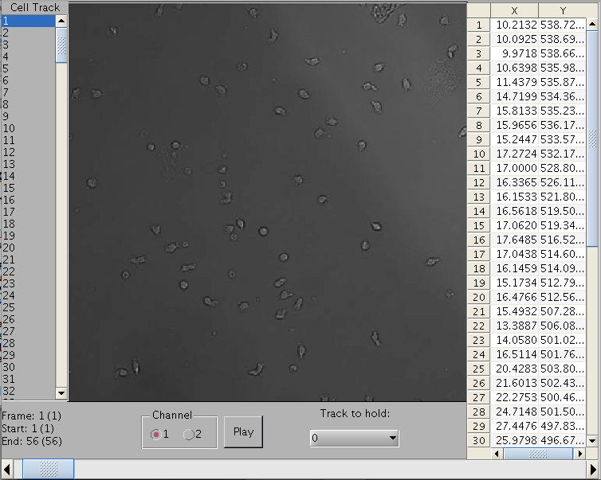

**1**

**2**

**3**

**6**

**5**

**4**

**7**

1. Contains a list of all the cell tracks in the tiamFile. When the user runs trackGUI, the first track is selected (off-screen in the picure above), but the user may click any of the tracks. After a track is selected, **7** displays the frame at which that track starts. The curve of that track is drawn in blue. A lime-green box outlines the cell’s position:

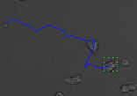

1. Diplays the x and y position of the selected track indexed relative to the frame at which that track starts.
2. Provides information about which frame is being displayed as well as at which frames the selected cell track starts and ends. The parenthetical numbers correspond to the indexing in **2**.
3. Lets the user pick a channel.
4. ‘s relative position corresponds to a frame. The user can move it around for fine control or click the arrows at either end to navigate more coarsely. When the play button (**6**) is down, **5** scrolls automatically.
5. When pressed, the frames are cycled through at a constant rate, thus displaying a video. When the the end frame is reached, **5** moves to the position corresponding to the start frame and the video stops playing.
6. Displays the frames and the graphs.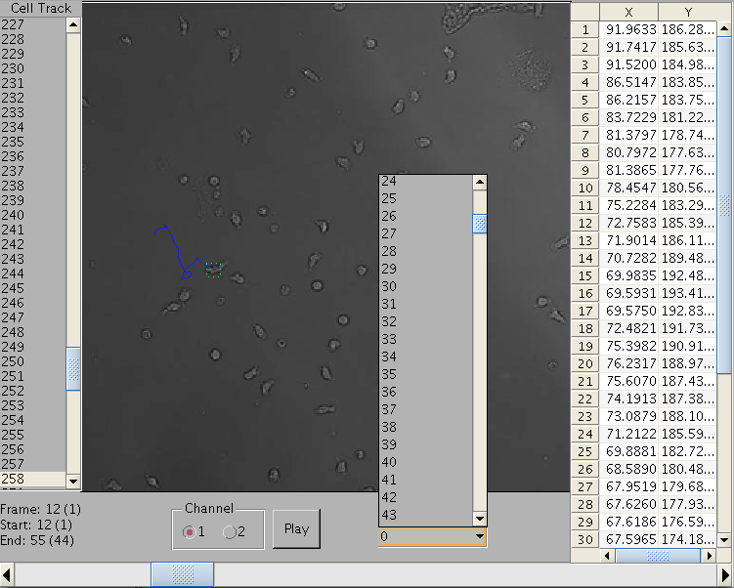

**8**

1. Allows the user to select a track to be held on the screen (curve in red) regardless of which cell track is selected: