WattWise
AI-Based Personalized Energy Consumption Forecasting & Cost Optimization
Project Update Report
Bill OCR Insights · Trend & Forecast Advisor · Appliance What-If Simulator · Volt AI Assistant
Including Chapter 5 result figures:
Fig. 5.4 – Model Performance Comparison
Fig. 5.5 – Actual vs Predicted Daily Household Consumption
Fig. 5.7 – Appliance-Level Energy Consumption Distribution
Fig. 5.8 – Budget vs Projected Cost Before and After Optimization

Repository: github.com/r-prakashh/optimized-energy-consumption-FINAL-YEAR-PROJECT
October 2026

1. Summary of the update
WattWise previously answered one question: given a budget and a list of appliances, how should a Tamil Nadu household plan its usage? This update lets the system also learn from the resident's own history and talk to them about it. Four capabilities were added, all integrated into the existing FastAPI + React application and documented on the in-app Methodology page.
Capability | What the resident can do | Technique
Bill upload & OCR | Upload past electricity bills as PDF e-bills, phone photos, scans or a handwritten list of meter readings. | PDF text layer (pypdf); RapidOCR (PaddleOCR on ONNX Runtime); rule-based field parser; optional Claude vision for handwriting
Trend & forecast advisor | See their monthly trend, unusual months, a 3–6 month forecast, saving advice and an optimal usage target. | Month normalisation; model tournament (naive, seasonal-naive, damped Holt, ridge) chosen by rolling backtest; robust z-score anomalies
Appliance what-if | Predict how adding or removing appliances changes monthly units and the TNEB bill. | Spec-aware appliance model + TNEB slab re-pricing on top of the bill forecast
Volt AI assistant | Ask questions in plain language from any page, through a chat bubble with an animated mascot. | Claude tool use calling the app's own estimators; offline intent engine when no API key is set

End-to-end flow: Upload bills → OCR & parsing → user verifies readings → trend / anomaly / forecast analysis → advice & optimal target → appliance what-if on top of the forecast → ask Volt follow-up questions.

2. Bill upload and OCR module
Location: backend/app/bills/ (ocr.py, parser.py, ai_extract.py); endpoint POST /api/bills/upload; page /bills (Bill Insights).

2.1 Extraction pipeline (cheapest path first)
- Digital PDF. TNEB/TNPDCL e-bills downloaded from the portal carry an embedded text layer, which is read directly with pypdf. This is exact and instant, with no OCR error.
- Scanned PDF / photo / screenshot. Pages are rasterised at about 144 DPI with pypdfium2, and phone photos are EXIF-rotated and upscaled to at least 1000 px. Text is then recognised with RapidOCR, PaddleOCR's detection and recognition networks exported to ONNX. It installs with pip alone (no system Tesseract binary), so it runs on the free Render tier. Recognised boxes are re-assembled into lines top-to-bottom, left-to-right.
- Optional AI vision pass. When an Anthropic API key is configured and OCR leaves gaps, typically with handwriting or blurred photos, the file is also sent to a Claude vision model with a strict JSON schema. Its readings replace the OCR ones when they are more complete.

2.2 Field parser
OCR output mangles spacing and casing (for example "UnitsConsumed:362"), so the parser uses tolerant regular expressions and fixes common digit confusions (O→0, l/I→1 between digits). It extracts:
- Single bills: units consumed, net amount payable, previous and present meter readings, and assessment/bill dates.
- Cross-check: if the meter difference (present − previous) disagrees with the printed units by more than 5%, the meter difference wins and a note is shown. This catches a misread units digit.
- Billing period: two assessment dates 20–70 days apart set the billing period; TNEB markers default it to 60 days (bi-monthly), otherwise 30.
- Handwritten or typed logs: lines such as "Mar 2026 – 245 units – Rs 690" become one reading per month.
Every reading carries a confidence score and its source (PDF text, OCR, AI vision, manual) and is shown in an editable table. The user confirms or corrects values before any analysis, so OCR errors never silently reach the model. Files are processed in memory and never stored on the server.
Verification: a rendered TNEB-style bill (PNG and image-only PDF) was read with 98% mean OCR confidence and every field (units 362, amount ₹1,186, readings 12450→12812, date 14-03-2026, 60-day period) was extracted correctly. This case is now an automated test.

3. Trend, anomaly and forecast advisor
Location: backend/app/ml/bill_trend.py; endpoint POST /api/bills/analyze.
The existing LightGBM forecaster needs dense daily history (1-day/7-day lags, 30-day rolling windows). A resident uploading bills has a few monthly points, so this layer uses small, regularised time-series models instead, chosen per household by evidence.

3.1 Normalisation
Each bill's units are spread uniformly over the days it covers and re-aggregated into calendar months (monthly-equivalent kWh = mean daily kWh × 30.4). A 60-day TNEB bill therefore becomes two monthly points, and months covered by fewer than 10 days are dropped.

3.2 Model tournament
Candidate | Idea | Min. points
Naive | Last month carried forward — the benchmark to beat | 1
Seasonal naive | Recent de-seasonalised level × Tamil Nadu cooling-season index (Apr–Jun peak) | 1
Damped Holt | Level + trend exponential smoothing on the de-seasonalised series; α, β grid-searched; trend damped (φ = 0.8) | 3
Ridge regression | Features [time, sin(month), cos(month)], L2-regularised | 6

Each eligible candidate is scored by rolling-origin one-step-ahead MAE on the household's own history, and the lowest-error model produces the forecast. The 80% prediction interval is ±1.28 × (1.25 × MAE) × √h, so it widens with the horizon h. The UI shows the tournament scores so the choice is transparent.

3.3 Anomalies, advice and optimal target
- Anomalies: robust z-score (median/MAD) on the de-seasonalised series, threshold 2.5. A hot May is not flagged just for being May. Anomalous months are replaced by their seasonal expectation before fitting, so one unusual month does not bend the forecast.
- Advice cards: generated from the season-adjusted trend (rising/falling/stable), each anomaly, the TNEB slab position of next month's forecast (with the cut in kWh/day and AC-hours needed to drop a slab), the upcoming season, the always-on baseload, and a check of billed amounts against the tariff.
- Optimal usage target: the slab boundary below the forecast if reaching it needs a cut of 20% or less, otherwise a realistic 10% efficiency target. It is shown with the daily kWh budget and the monthly ₹ saving.

4. Appliance add / remove what-if simulator
Location: backend/app/optimization/scenario.py; endpoint POST /api/scenario; page /simulator.
The resident lists changes, for example "add 1 × 1.5-ton 5-star inverter AC for 8 h/day" or "remove the geyser", with quantity, hours and model specs. Each change is costed with the same spec-aware ApplianceModel used by the planner (BEE star rating, tonnage, inverter, live-weather AC multiplier), averaged over a week. It is then applied to the household's own bill forecast month by month, or to a typed baseline. The bill is recomputed through the TNEB slabs on the new total, not with a flat rate. This matters because a purchase that pushes the home into a higher slab costs more per extra unit than the household's current average, and the simulator says so explicitly. Purchase tips are attached, for example 5-star inverter vs non-inverter AC, BLDC fans, a geyser timer, and the 5-star refrigerator payback.

5. Volt — the smart project assistant
Location: backend/app/assistant/chat.py; frontend/src/components/ChatWidget.tsx and VoltMascot.tsx; endpoint POST /api/chat.
Volt is a floating chat assistant available on every page. Its icon is a custom mascot: a round power-orb with a lightning-bolt crest, drawn as inline SVG. It bobs and blinks, waves when the page loads, and squints while it is "thinking". Two engines sit behind one endpoint:
- With an Anthropic API key: the assistant runs on Claude (claude-opus-5-5) with tool use. It does not do energy arithmetic itself: it calls estimate_appliance_change and estimate_bill_cost, the same functions the simulator and tariff engine use, so its numbers always match the rest of the app. Server-side refusal fallback is enabled.
- Without a key: an offline intent engine answers the common questions (TNEB slabs, "what if I add two 1.5-ton ACs for 8 hours", "how much will 320 units cost", forecast and trend, saving tips, how to upload bills) using the same estimators. The free deployment therefore works with no paid key.
The user's bill analysis (history, trend, forecast, anomalies, optimal target) is sent as context, so Volt answers personal questions such as "what is my bill next month?" from the user's own data. Chat history lives only in the browser session.

6. Results (Chapter 5 figures)
All figures are generated from the trained models by backend/experiments/report_figures.py, which also writes the exact numbers to docs/figures/figure_metrics.json, so every value below is reproducible.

Fig. 5.4 – Model Performance Comparison
Six day-ahead forecasters were evaluated on the same held-out data: the last 20% of each REFIT house's own timeline (2,161 training and 543 test house-days across houses 1–5). Three are naive baselines that need no training, and three are learned models using the identical time/lag/rolling feature set.
Model | MAE (kWh/day) | RMSE (kWh/day) | WMAPE (%)
Random forest | 2.53 | 3.77 | 23.1
LightGBM (deployed) | 2.56 | 3.77 | 23.3
Linear regression | 2.67 | 3.88 | 24.4
7-day moving average | 2.98 | 4.18 | 27.2
Naive (yesterday) | 3.12 | 4.71 | 28.5
Seasonal naive (last week) | 3.60 | 5.17 | 32.9

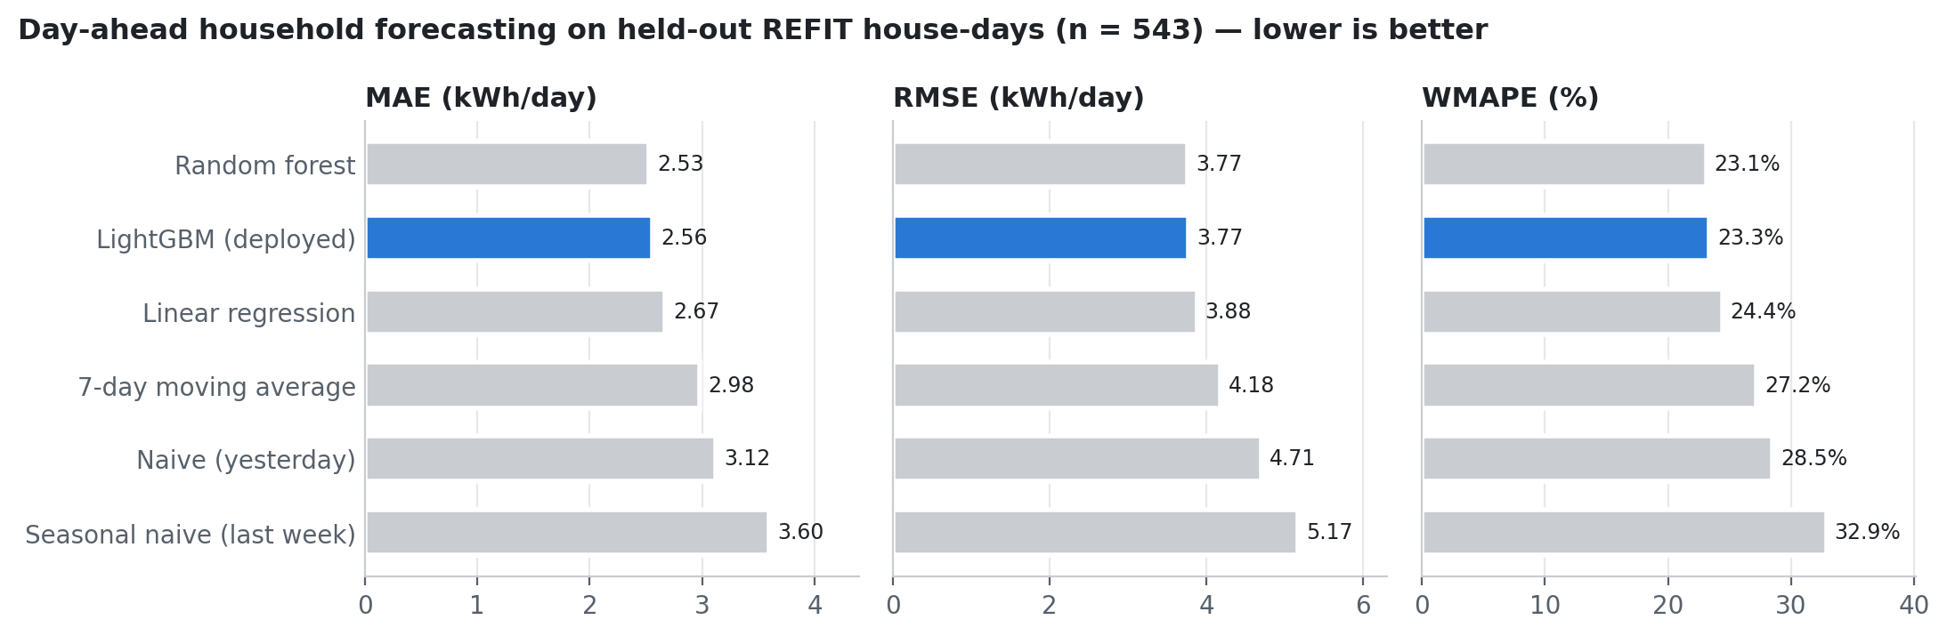
Fig. 5.4 – Model Performance Comparison
The learned models clearly beat the baselines. The deployed LightGBM reduces MAE by 18% against the naive "same as yesterday" forecast and lowers WMAPE from 28.5% to 23.3%. Random forest and LightGBM are practically indistinguishable (MAE 2.53 vs 2.56, identical RMSE 3.77). Random forest is marginally ahead on this split. LightGBM is retained for deployment because of its smaller model file and faster inference on the free-tier server, at no meaningful accuracy cost. A 23% WMAPE is within the 20–40% range typically reported for single-household day-ahead forecasting.

Fig. 5.5 – Actual vs Predicted Daily Household Consumption
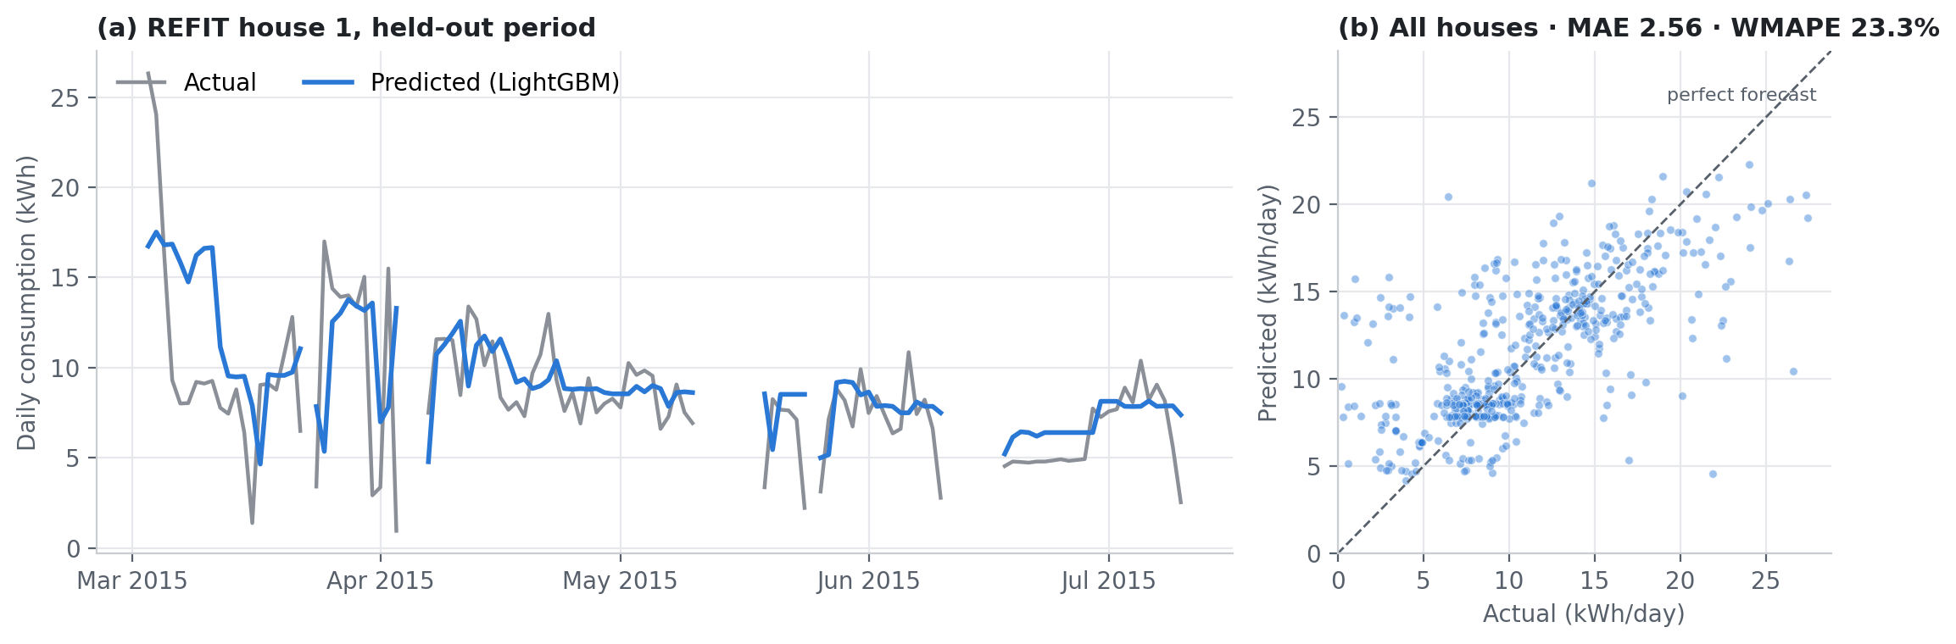
Fig. 5.5 – Actual vs Predicted Daily Household Consumption
Gaps in (a) are days missing from the REFIT recording, shown as breaks rather than interpolated.
Panel (a) traces the deployed LightGBM model against measured consumption for REFIT house 1 over its held-out period. The forecast follows the household's level and week-to-week shifts but smooths single-day spikes, which are inherently unpredictable from the previous days' consumption alone. Panel (b) plots every held-out house-day. Points cluster around the diagonal, with the largest misses on unusually high or near-zero days (occupants away or a one-off heavy load).
REFIT house | MAE (kWh/day) | RMSE (kWh/day) | WMAPE (%)
House 1 | 2.45 | 3.56 | 28.9
House 2 | 4.08 | 5.58 | 43.9
House 3 | 2.66 | 3.69 | 19.7
House 4 | 1.29 | 1.95 | 17.0
House 5 | 2.57 | 3.60 | 16.7

Per-house accuracy ranges from about 17% WMAPE (houses 4 and 5, regular routines) to about 44% (house 2, irregular occupancy). This spread is why the new bill advisor selects a model per household by backtest rather than assuming one model fits every home.

Fig. 5.7 – Appliance-Level Energy Consumption Distribution
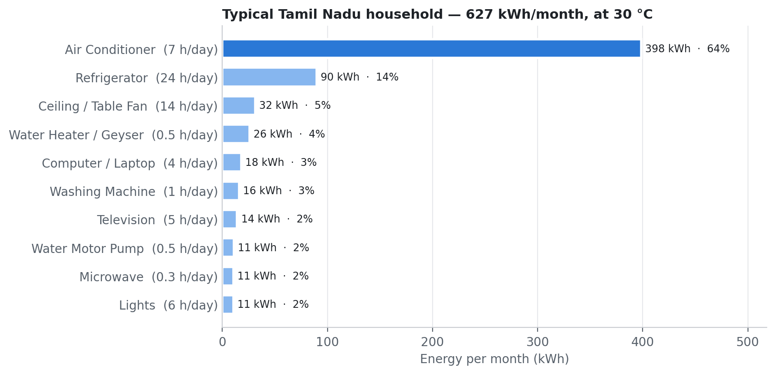
Fig. 5.7 – Appliance-Level Energy Consumption Distribution
Monthly consumption of a typical Tamil Nadu household was estimated with the spec-aware appliance model: 1.5-ton 3-star inverter AC for 7 h/day, 250 L 3-star refrigerator, standard ceiling fans, 43-inch TV, 15 L geyser, motor pump, washing machine, computer, microwave and lighting. Ambient temperature was fixed at 30 °C so the figure is reproducible (the live app uses current Chennai weather). The home uses about 627 kWh/month.
Appliance | Hours/day | kWh/month | Share
Air Conditioner | 7 | 398 | 63.5%
Refrigerator | 24 | 90 | 14.4%
Ceiling / Table Fan | 14 | 32 | 5.0%
Water Heater / Geyser | 0.5 | 26 | 4.1%
Computer / Laptop | 4 | 18 | 2.9%
Washing Machine | 1 | 16 | 2.6%
Television | 5 | 14 | 2.3%
Water Motor Pump | 0.5 | 11 | 1.8%
Microwave | 0.3 | 11 | 1.7%
Lights | 6 | 11 | 1.7%

The air conditioner dominates at 64% of the bill, and together with the always-on refrigerator, cooling and refrigeration account for about 78% of consumption. This is why the optimizer prioritises high-flexibility, high-draw loads, why the advisor's summer tips focus on AC set-point and hours, and why the what-if simulator highlights star rating and inverter choice when an AC is added.

Fig. 5.8 – Budget vs Projected Cost Before and After Optimization
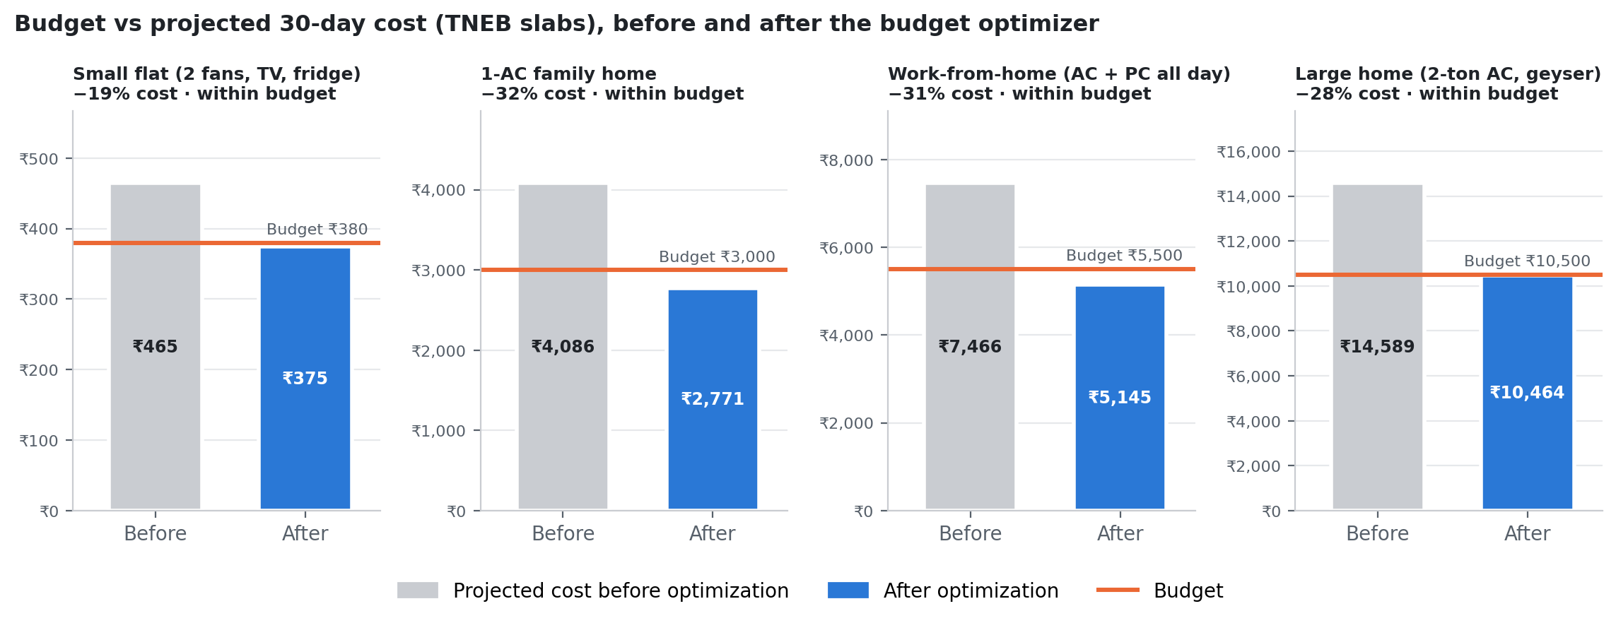
Fig. 5.8 – Budget vs Projected Cost Before and After Optimization
Each panel has its own ₹ scale so smaller households remain readable.
Household profile | Budget (₹) | Before (₹) | After (₹) | Cost cut | Budget met
Small flat (2 fans, TV, fridge) | 380 | 465 | 375 | 19% | Yes
1-AC family home | 3,000 | 4,086 | 2,771 | 32% | Yes
Work-from-home (AC + PC all day) | 5,500 | 7,466 | 5,145 | 31% | Yes
Large home (2-ton AC, geyser) | 10,500 | 14,589 | 10,464 | 28% | Yes

Four household profiles were run through the budget optimizer for a 30-day period, each with a budget about 70–80% of its unoptimized TNEB cost. In every case the greedy optimizer brought the projected cost under budget, with cuts of 19–32%. It reduced hours on high-flexibility, high-draw appliances (AC, geyser, motor pump) first and never touched essential loads such as the refrigerator. Because TNEB slabs are telescopic, the percentage cost cut is larger than the energy cut: removing the most expensive top-slab units first gives a disproportionate saving.

7. New API endpoints
Method & path | Input | Output
POST /api/bills/upload | multipart files (PDF, PNG, JPG, WEBP; ≤12 files, ≤10 MB each) | per-file extraction method, OCR confidence, parsed readings, notes
POST /api/bills/analyze | readings [{period_end, period_days, units_kwh, amount_inr}], horizon 1–12 | monthly history, trend, anomalies, forecast ± interval, model scores, advice, optimal target
POST /api/scenario | changes [{add|remove, appliance, qty, hours, specs}] + baseline | before/after kWh and ₹, per-month impact, per-change impact, verdict, tips
POST /api/chat | messages + page context (bill analysis) | reply, engine (claude | offline), tools used
GET /api/assistant/status | – | whether the Claude engine is enabled

8. Testing and verification
- Backend: 24 automated tests pass. They cover TNEB bill parsing, the meter-difference override, handwritten multi-month logs, bi-monthly normalisation, rising-trend detection, anomaly flagging, slab-aware targets, add/remove scenarios, assistant answers, and real OCR on a rendered bill image.
- Frontend: TypeScript type-check, oxlint and the production build pass. The Bill Insights, What-If and Volt flows were exercised end to end in the browser against the running API.
- Integration fix: a Windows-specific DLL conflict (ONNX Runtime failing to load after LightGBM's OpenMP runtime) was found during integration and fixed by loading ONNX Runtime first.

9. Configuration and deployment
- Backend: new dependencies are pypdf, pypdfium2, rapidocr-onnxruntime, pillow and anthropic, all pip-installable on Render's free Python runtime.
- Optional: set ANTHROPIC_API_KEY (declared in render.yaml) to enable the Claude assistant and handwritten-bill reading. Without it, everything still works with OCR plus the offline assistant.
- Frontend: no new environment variables; new routes /bills and /simulator, plus the Volt widget on every page.

10. Limitations and future work
- Handwriting: handwriting recognition relies on the optional vision model, and classical OCR is reliable only on printed text. The verification table keeps a human in the loop either way.
- Short histories: with fewer than 4 months of bills the forecast leans on the Tamil Nadu seasonal prior, and the UI says so. Accuracy improves as more bills are added.
- Tariff detail: fixed charges, fuel-cost adjustments and subsidies are not modelled, so outputs are planning estimates, not meter-accurate bills.
- Next steps: retrain the household forecaster on Indian smart-meter data when it becomes available, and store bill history per user account (with consent) for long-term tracking.

