# Contents

Contents 1

Introduction 3

Debug flow 4

Why Debug flow? 4

The application 4

Advanced functions 5

Philosophy 6

Progress 6

The node 7

overview 7

Visual node 8

Deriving nodes 8

fields 9

functions 9

utils 10

Node styles 10

Node settings 10

Node properties 11

Connections 13

Node base 14

Circular buffer 14

Subscriptions 14

Scene 14

Itemlist 14

Node serialization 14

Selection 14

Undo redo 15

Window management 15

Construction 15

destruction 15

building a node 15

tests 15

flow en ui 16

todo 17

Features 17

Figure 1: *The debug flow user interface* 5

Figure 2: *A visual representation of a node* 7

Figure 3: Class diagram VisualNodeBase, NodeBase 7

Figure 4: *Class diagram VisualNodeBase, NodeBase, NodeSettingsBase* 7

Figure 5: *Class diagram node* 8

Figure 6: *Property widget* 8

Figure 7: *Class diagram VisualNodeBase deriving* 9

Figure 8: *Bounding rect* 10

Figure 9: *Class diagram serial node settings* 11

Figure 10: *Node properties* 11

Figure 11: *Class diagram Properties widget deriving* 12

Figure 12: *Class diagram PropertyWidgetManager* 13

Figure 13: *Visual connection* 13

# Introduction

This document provides information for software developers to clarify the source code of Debug flow. After reading this document the software architecture can be better understood, design choices will be clearer and in the end software developers can contribute to the project.

When things are not clear an issue can be made on GitHub.

# Debug flow

## Why Debug flow?

In this decade software developers have powerful tools to build software, development environments make work easier and have a perfect integration with toolchains. Furthermore, debuggers will allow developers to find issues. However, that console thing that all programmer use is stupid simple and I’m happy when the console in an IDE supports color codes. For the most developers that is enough, but some need better tools.

Some tools like debuggers, custom software applications, dashboards, application specific log viewers, log files, and logging standards like log4j does the job. But the ultimate freeware solution for easier log viewing is still missing or did not become known.

As embedded software developer I’ve worked on software with high data-rate sensor data, control algorithms and network protocols. These applications are a worst-case scenario for logging and debugging, putting real-time sensor values in a control algorithm can result in unpredictable outputs during development, to find out what’s going wrong sensor values and algorithm outputs must be logged. This sensor values are read with a high rate, so the logs are difficult to read when the application is running.

These situations also happen in general software development, much developers enables logs when they need them and disables them when they don’t need them to clean up their logs. When a bug occurs, they compile the code again with the logs enabled, but unfortunately the bug doesn’t appear again after that. Much developers know this phenomenon, much developers add a logging difficulty when asking them, some want data visualization, others just want to store their output, others want to combine logs or they want to process them, they want a user interface and much more.

Debug flow is supposed to be a user-friendly tool for almost all these situations, an ambitious goal.

## The application

The possible use cases for this software are unlimited, making a user interface with all needed options will become huge and user unfriendly. Therefore, Debug flow works like flow-based programming where a desired application can be made with dragging and dropping blocks.

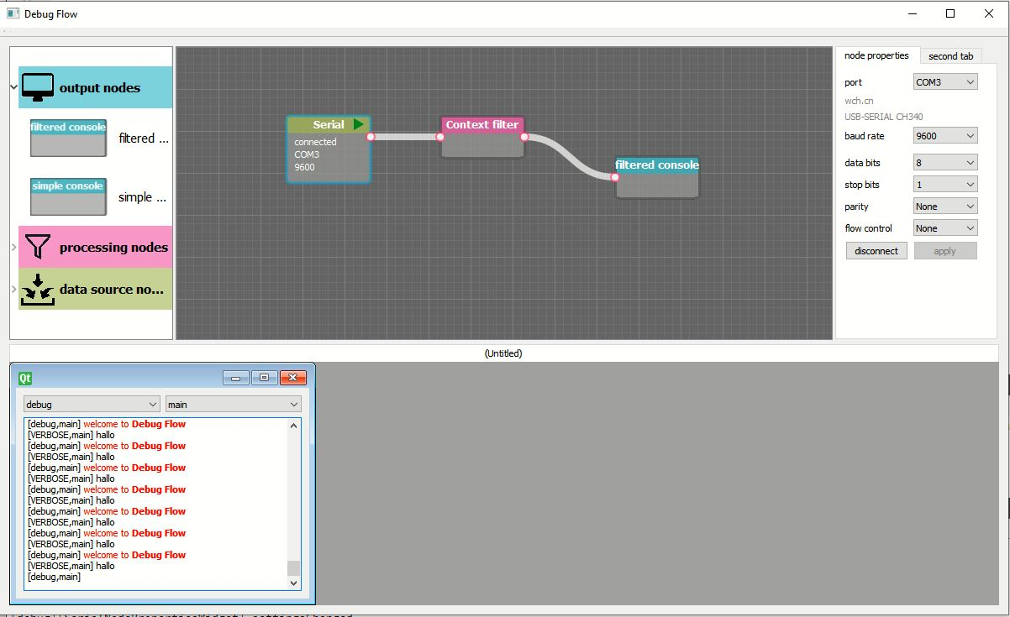

Figure : *The debug flow user interface*

With debug flow all kinds of inputs can be used like output from a certain application which is in development, input from a serial port, input from a file or input from an internet connection. Because Debug flow works with nodes (also called blocks) multiple different inputs can be used at the same time.

Putting the data from an input to a processing node useful functions possible, think about filtering on a tag. Adding or removing colors, hiding data, translating error code and much more.

Output nodes present the data to the user like the standard simple console, Debug flow will offer much more advanced outputs like a console with filters, graphs, tables, html view and user interface components. Its also possible to have nodes that send data or nodes that save data to a file.

Using filter nodes data can be splitted into different windows which is useful for multiple tasks in one application.

## Advanced functions

Debug flow will implement some advanced functions, one of this functionS is that the time when data is received at the input is saved, because of that the timestamp can be seen at the output console, with a tooltip for example. With the timestamp its also possible combine data from different input nodes base on time. Or more useful is using a timeline to view which events did occur at a certain time. The timeline can be dragged to a certain timestamp, all output nodes will show a cursor on place where the nearest event did occur, this is useful when comparing data in a graph with data in a log or in another graph.

The timeline feature is a challenging feature which is not implemented yet.

Another challenging feature of Debug flow is that the flow and all settings can be changed on-the-go while everything is still running. Even more challenging, when a setting is changed its possible to backwards update all logs and graphs. So, when a setting is changed all outputs will update their history. Therefore, huge buffers are needed, which will limit the amount of historical data.

Using this feature the problem that a bug occurs but certain needed logs are not enabled is belongs to the past.

This feature is not implemented yet and will challenge the developers of Debug flow.

## Philosophy

Debug flow implements difficult functions with need a challenging architecture, in much applications the development method keep-it-stupid-simple or You-aren’t-gonna-need-it is used, which is a good advice in some cases. Debug flow is made with an opposite development method. Debug flow is with no money or time budget, so special things are possible.

In this decade computers are becoming faster, but software is becoming more inefficient due to developments like interpreted programming languages. Debug flow is written in C++ with efficiency as an important requirement. The architecture is made with efficiency in mind.

## Progress

Debug flow is in the architecture stage, some fundamental features like memento, backward update, timeline and windows management are not fully done yet. After this is done more nodes will be made.

Making more nodes at this stage is not rational because all nodes must be refactored when something change in the base architecture of the node.

# The node

## overview

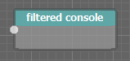

Figure : *A visual representation of a node*

The node is a main object of debug flow, nodes must perform different complex functions in an efficient way, nodes must be visualized on the scene, nodes have different properties and there is the possibility to open and save the scene.

Each of these properties provoke structural challenges because nodes with very different functionalities need to communicate with each other so abstraction is important.

Although a node is one object from the user perspective, a node consists of different classes in the code.

The visual representation and the low-level function are separated. For the visual representation all nodes are derived from the class *VisualNodeBase*, while the functional part of the node will be derived From *NodeBase*.

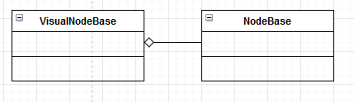

Figure : Class diagram VisualNodeBase, NodeBase

The *VisualNodeBase* have a pointer to *NodeBase*, these two objects have a shared object called *NodeSettingsBase,* all nodes have an object derived from this class.

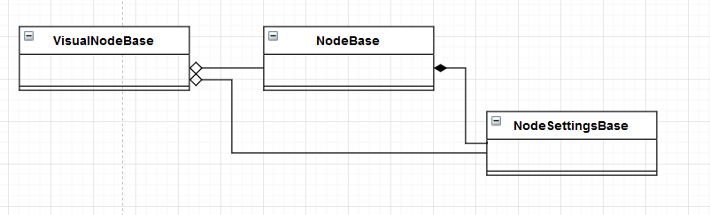

Figure : *Class diagram VisualNodeBase, NodeBase, NodeSettingsBase*

Furthermore, nodes have settings, this setting can be changed via the user interface, each node have its own settings widget so the user can view and change the settings. The settings widget is a separated class derived from property widget base.

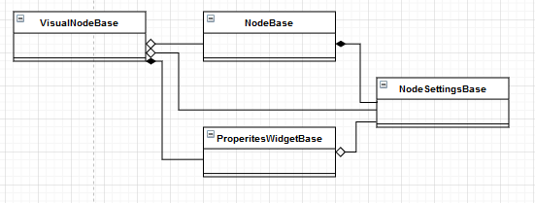

Figure : *class diagram node*

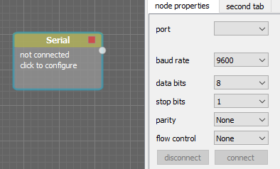

Figure : *Property widget*

## Visual node

### Deriving nodes

The *visualNodeBase* class is abstract, no *VisualNodeBase* instance can be made, instead you should derive an instance from it. As well there are general types like input and output nodes, these nodes are special because they share properties like having a window to visualize data. An input node should be derived from *VisualSourceNodeBase* and an output node should be derived from *VisualOutputNodeBase.*

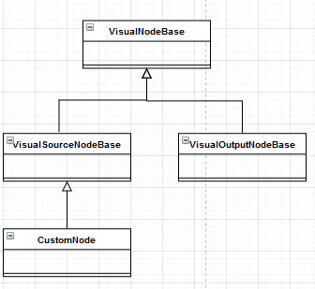

Figure : *Class diagram VisualNodeBase deriving*

### fields

Some fields of the *VisualBaseNode* will be explained in this paragraph.

The *VisualBaseNode* have some fields that will be filled in by the derived class, for example the name field will be used in the resource list and the shortDiscription will be used as tooltip.

//will be filled in by the derived class

QString name = "";

QString shortDiscription = "";

The centerX and centerY variables are the position of the node on the scene, the width and height are the size of the node.

//position on the scene

int centerX = graphicsViewOriginX;

int centerY = graphicsViewOriginY;

int width = 125;

int height = 50;

### functions

The *VisualNodeBase* is derived from QGraphicsItem, therefore it implements the functions BoundingRect() and paint().

The BoundingRect() fuction returns the size of the node, this size includes the connectors that are sticking out. The InnerRect() function returns the size of the rectangle.

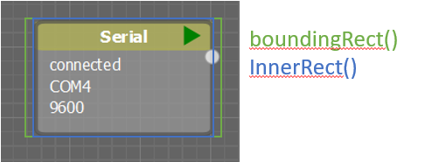

Figure : *Bounding rect*

The paint function is abstract, it will be done by the derived class.

virtual void ***paint***(QPainter *painter, const QStyleOptionGraphicsItem *option, QWidget *widget) = 0;

The derived class can later call functions that draws the standard functions that all nodes have, similarly classes like the **VisualOutputNodeBase** can also have additional paint functions like the functions to draw and running or stop button.

void **drawConnectors**(QPainter *painter, NodeStyleBase *nodeStyle);

void **paintBase**(QPainter *painter, NodeStyleBase *nodeStyle, QString name);

The abstract function active activates the derived class, the *NodeScene* class will activate the node when the node is placed, because while dragging its not desirable that the node already starts doing things. As result a window pops up when an outputnode is placed on the scene.

//activate the derived class

virtual void ***activate***() = 0;

the following functions are being used to open and close the properties widget of an node, the functions will be called from *PropertyWidgetManager* which will be explained later. When ***loadPropertiesWidget*** is called a new PropertiesWidget will be constructed. When the node is not displayed anymore PropertyWidgetManager will call ***releasePropertiesWidget*** to delete the propertiesWidget from the memory.

virtual PropertyWidgetBase* ***loadPropertiesWidget***(QWidget* parent) = 0;

virtual void ***releasePropertiesWidget***() = 0;

read more about the node properties widget in the following paragraphs.

Other fields and functions will be explained in the following paragraphs.

### utils

The *visualNodeBase* use fields from VisualNodeConfig.h

## Node styles

Its desirable that different nodes have different style properties, to realize this without losing the possibility to draw almost everything from the **VisualNodeBase** class there are nodes style classes. Via a node style class different style property can be parsed to the **VisualNodeBase**. There is a **NodeStyleBase** with the default style options. **OutputStyle, ProcessingStyle** and **SourceStyle** are derived to provide style differences between node types.

The styles are implemented using inheritance. example:

class **VisualFilteredConsole** : public VisualOutputNodeBase, public OutputStyle

## Node settings

Nodes have setting, this setting can determine what the node does, the settings are visualized on the Visual node and the settings can be edited in the Properties widget.

As described in a previous paragraph these functions are split into different classes.

Different nodes have different settings classes, a settings class must be derived from **NodeSettingsBase**. A derived setting class only need to implement a serialization method which will be explained in another paragraph. The rest of the content can be made by the developer.

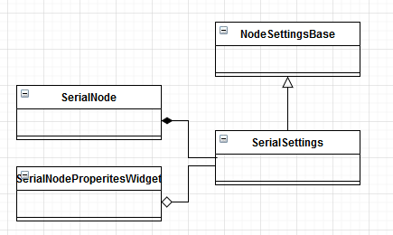

Figure : *Class diagram serial node settings*

## Node properties

The node properties can be viewed and edited on the properties widget which is placed on the tab widget on the right side of the application.

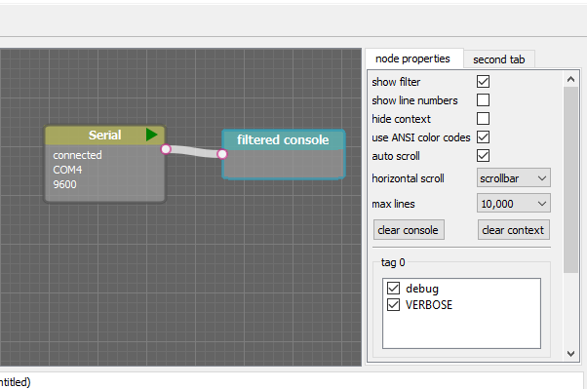

Figure : *Node properties*

The properties widget pops up when clicking on a node and it disappears when clicking on something else in the scene.

To save memory a property widget is constructed when it pops up, and it will be deleted from the memory when is disappears.

A property widget for a certain node is a class that is derived from **PropertyWidgetBase**, **PropertyWidgetBase** is derived from QWidget. Buttons, checkboxes and other components can be placed on the QWidget.

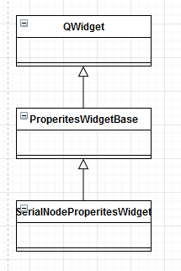

Figure : *Class diagram Properties widget deriving*

To manage opening and closing, constructing and destructing the properties widget there is a **PropertyWidgetManager**. The **PropertyWidgetManager** is constructed by **FlowWidget** and its’s passed to the **SelectionManager**. The **SelectionManager** will be discusses in a later paragraph, in short, the **SelectionManager** will call functions of the **PropertyWidgetManager** like **notifyNodeSelected**, **notifyMultipleSelected** and **notifyNoneSelected**.

When **notifyNodeSelected** is called the **PropertyWidgetManager** will construct and show the property widget the selected node. When **notifyMultipleSelected** and **notifyNoneSelected** is called the **PropertyWidgetManager** will close and delete the property widget if it was open.

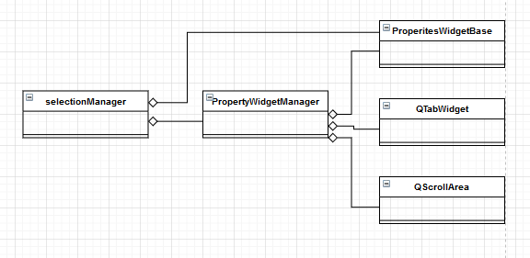

Figure : *Class diagram PropertyWidgetManager*

## Connections

A visual connection is a visual line between two nodes. It doesn’t have a function for transmitting or receiving data, that is done with subscriptions which will be discusses later. The visual connection is a way to visualize that there is a kind of connection between nodes.

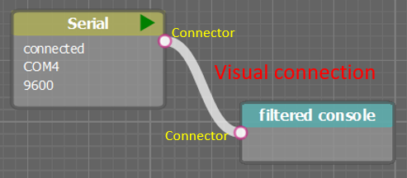

Figure : *Visual connection*

Visual nodes have connectors, a connector indicate that a connection can be made from or to that point. When clicking on the connector a connection will be made between the connector and the mouse position. When clicking on a second connector the connection is made between the two nodes and the nodes will make the low-level subscription for data transfer.

A **Connector** is owned by the **VisualNodeBase**, the **VisualNodeBase** have a list with connectors.

More connectors can be added on the go when settings are changed. The **Connector** has fields like and x and y location, an angle for drawing the line, a name which is an identifier for the serialization and deserialization, a type like INPUT or OUTPUT and a list with connected **VisualConnection** ‘s because a connector can have multiple nodes connected.

A **Connector** is not derived from QGraphicsItem, instead the **VisualNodeBase** paints the connectors. Beside the painting the **VisualNodeBase** will animate when hovering over the connector and will give visual feedback when a connection cannot be made.

A **VisualConnection** is owned by both nodes, is derived from QGraphicsItem and paints itself. The way the **VisualConnection** is painted can be configured with the **ConnectionStyle** class. The line between the nodes can be a straight line or a nice belzier curve. The belzier curve will only be calculated when connected nodes are moved, therefore the Boolean settingsChanged tracks if there is anything changed.

A **VisualConnection** is usually connected between two nodes, except when making the node then one side of the connection follows the mouse, therefore to Booleans connection1Set and connection1Set must be checked before using functions like **getConnector1**.

When to make a low-level subscription the **makeConnection** function of **VisualNodeBase** can be used. But before calling this function make sure to call **requestConnection** and **recursiveCircularDependencyCheck** first. This these functions will prevent making a connection between two inputs or two outputs. Also, it’s important to use the circular dependency check so no data loops will appear in the flow.

The **VisualNodeBase** internally uses this functions to give a red or green symbol to show if a connection is possible or not.

## Main MainWindow and FlowWidget

The main.c file is where a C++ program starts, the **main** function makes the **MainWindow** class. **MainWindow** build the frame of the program including the menubar, the UI is build using **Ui_MainWindow**. **MainWindow** doesn’t build the window widget itself, that is done by the **FlowWidget**. The build all components of the flow using **Ui_flowWidget**. Since **MainWindow** and **FlowWidget** are separated there is the possibility to make a tabWidget with multiple FlowWidgets on it in the future.

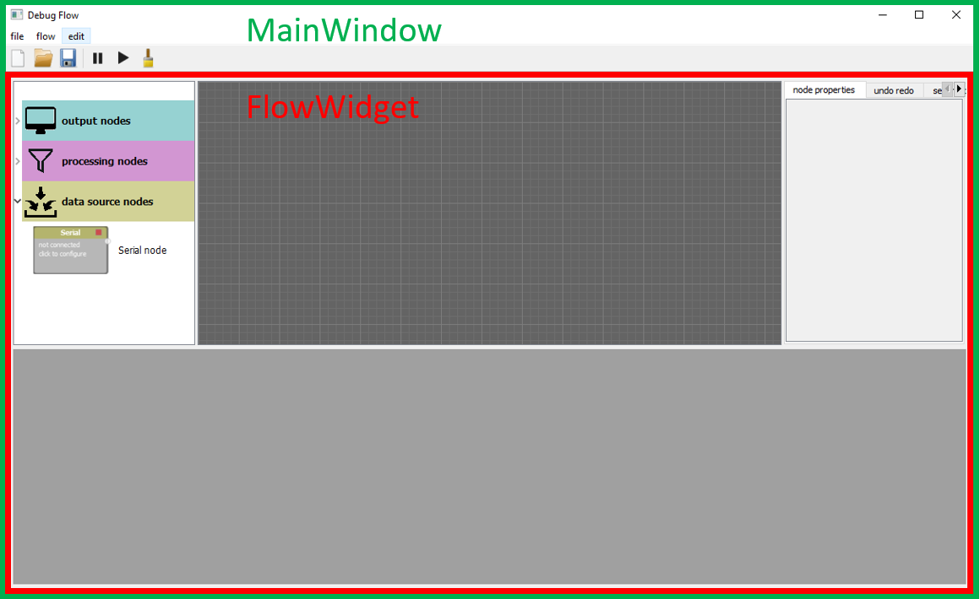

Figure : *MainWindow and FLowWidget*

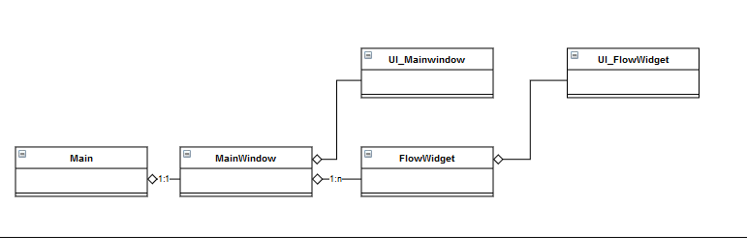

Figure : *Class diagram main window*

The **FlowWidget** has all components of the flow. It has visual user interface components like the item list, the graphical scene. And, functional components like a WindowManager, PropertyWidgetManager, FlowData, LoadStore, UndoRedoManager, some will be explained later.

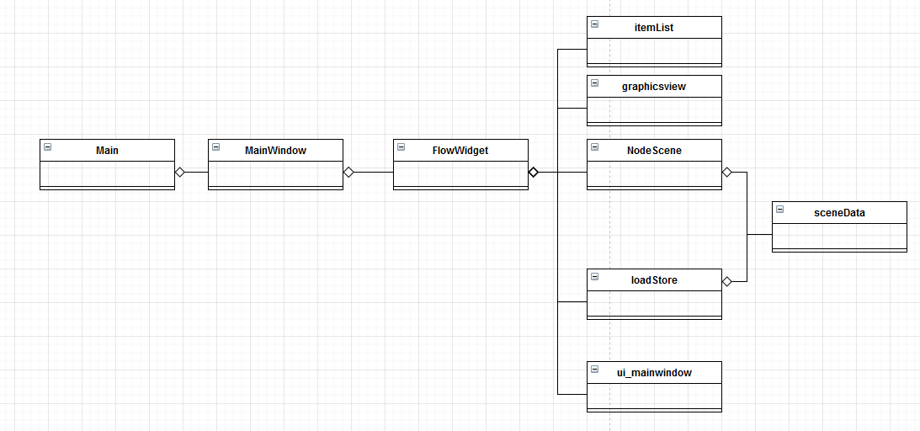

Figure : *Class diagram FlowWidget*

## Scene

## Itemlist

## Node serialization

## Selection

In Debug flow nodes can be selected as

## Undo redo

## Window management

## Node base

## Circular buffer

## Subscriptions

## Configurations

## Construction

## destruction

## building a node

### steps

1. Make sure that you understand the differences between the 4 classes which are needed to build a node.
2. Choose what kind of node you like to make, a sourcenode, a processing node or a outputNode.
3. Copy the tamplate node files to your desired folder, in case of a source node:

* Copy nodes/tamplate/tamplateNode.h to nodes/source_nodes/your_folder/yourNode.h
* Copy nodes/tamplate/tamplateNodeSettings.h to nodes/source_nodes/your_folder/yourNodeSettings.h
* Copy visualNodes/tamplate/visualtamplatenode.h to visualnodes/source_nodes/your_folder/VisualyourNode.h
* Copy visualNodes/tamplate/tamplatenodepropertieswidget.h to visualnodes/source_nodes/your_folder/yournodepropertieswidget.h
* Do the same with the .cpp of course
* With qt creater, the easiest way is to make a new class and copy manually

1. Now you need to rename a lot, to make it a bit easier, comment the tamplate files out in the debug-flow.pro file with #. The Tamplate files now disappear
2. Refactor all names to your own node name, don’t forget the #include lines in the .cpp files
3. In the nodesettings.h the type of node(SOURCE_NODE, PROCESSINGNODE, OUTPUT_NODE). Choose the one you want. Delete the other things you don’t need in the files.
4. Add your node to the resourcelist so you can see it. Include your visualNode in the ‘itemlist.h’ and add it to the nodes list in ‘itemlist.cpp’::generateList()
5. Add your node to loadStore::constructNode()
6. Now you have an emty nodeisd

### visual node

### node

### resource list

## tests

## historical update

### goal

A goal of debug flow was to have a dynamic environment, never restarting a application again because you missed some important message. Another goal was to have a flexible application, where all user interactions can be done on-the-go.

The historical update feature makes it possible to filter and visualize data which came in a little while ago, when it was not visible on the screen. This satisfies the on-the-go flexibility goal and the never-miss-a-message goal.

### principle

The input nodes of the flow have a larger circular buffer. This buffer is the same as the other circular buffers except for its size, it is the same object, saved in RAM.

When a user changes a setting which does affect the data, the buffers of surrounding nodes must be cleared, and the buffers must be filled again from the first input node in the flow. For efficiency, only the nodes which depends on the effected node (so all nodes connected to the output), and the nodes which are on the path to the input node. An example of which nodes are affected when a node initiates a historical update is shown below.

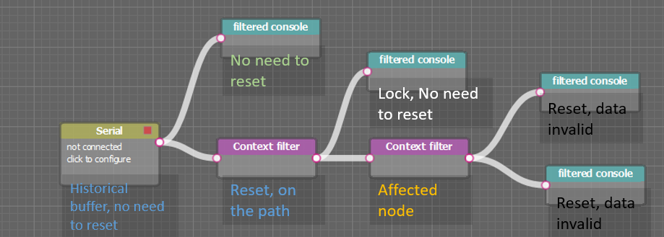

### historical update manager

The class HistoricalUpdateManager is responsible for the historical updates, it works with the flow like the observer pattern does with a structure. It uses functions to move through the parent and children.

It moves through the flow using recursion, first it recursively goes through all children. After that it recursively moves though the parents. During this process the buffers are being reset and the nodes are being notified.

The nodes that don’t need a reset because they are not on the path, are protected for the historical updates by locking them. When such node is being found during the search it the function **lock()** from InputNode is called. When the historical update is finished **unlock()** is called.

### multiple runs

The historical capable buffer at the input has a large size, 100kb for example. The following node buffers are a lot smaller, 1kb for example. So, when 100kb of data need the be processed through such small buffers, multiple runs are needed. so that means that:

* The developer should care for buffer overflows
* The developer should set the variable processingDone from **OutputNode** false in case the data didn’t fit in the buffer in one time. Please care about this variable, when it remains false the program could crash in an infinite loop. A safety mechanism has been added to check this, when such thing is detected it will exit the software.

stopped here because merging is not implemented yet

## timestamp

|  |  |  |
| --- | --- | --- |
| 0 | 1 | 2-7 |
| Mark, will be start of heading ‘\001’ | Header, may specify an extention | Timestamp in ms since 1970 |

|  |
| --- |
| **Byte 1: header** |
| Bit 0 | Reserved |
| Bit 1 | Microsecond time support, 1 = enabled |
| Bit 2 | Source tracking support |
| Bit 3 | Route tracking support |
| Bit 4 - 7 | Extended length, per 64 bits |

# todo

* Safe merge
* Source tracking and rout tracking
* Multithread
* Performance monitor

## Circularbuffer thread

* Mutex for deletion(done by subscription)
* resizeOperation **returnToBegin**() -> **reset**() -> **resize()**

|  |  |  |  |
| --- | --- | --- | --- |
|  | Main | Producer | Consumer |
| head | w | rw | r |
| iterations | w | rw | r |
| capacity | w | rw | r |
| newBufferCapacity | rw |  |  |
| oldBufferCapacity | w |  |  |
| maxCapacity | rw |  |  |
| historicalCapable | rw |  |  |
| minTail | w | r |  |
| minTailIteration | w | r |  |
| resizeOperation | rw | rw |  |
| dbgLogger | w | w |  |
| writeBuffer | rw | rw |  |
| originalBuffer | rw | rw | r |
| resizeBuffer | wr | rw | r |
|  |  |  |  |

* support special method for notifymergeupdate in child node. Many updates to one nofity
* update return in serialnode(also updatemanager)
* infinity loop when one of the inputs provides no data
* historical update merge support
* circular buffer unsafe add