1A. Paste the two screenshots that you have taken
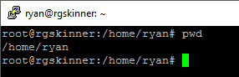

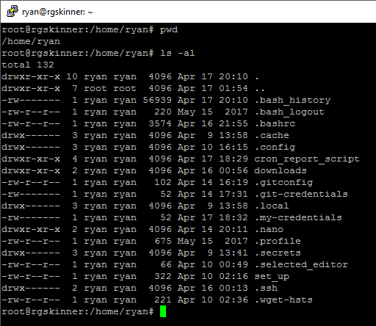
B. Describe from where has the ls command has gotten the contents of the directory. What is a directory?
The directories data blocks store the i-nodes for the files in the directory

C.What is the absolute path to the folder that you are in?
Absoulte: /home/ryan

D.What is the relative path to this folder?
Relative: ~

2A. Paste a screenshot of the results
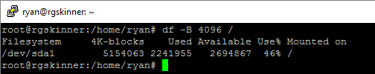
B. Calculate the size of the root directory (/) in KB, MB, or GB
5154063 blocks * 4KB/block * 1/2^30 = 19.66 GB
C. What is the path of the device to which root is mounted?
/dev/sda1 is mounted at /

D. Paste the screenshot of the results.
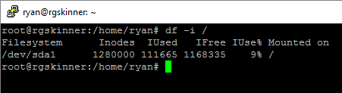
E.How many i-nodes are available for root?
1280000 i-nodes
F.How many are currently used and how many are free?
Used: 111655; Free: 1168335
G.What is an i-node and where is it stored on the hard drive?
i-nodes are a data structure to link files to their blocks and are stored in the i-node table near the front of the partition.
H.What sort of information does it hold?
Attributes about the file and disk address for the files blocks.

3A. Paste the screenshots
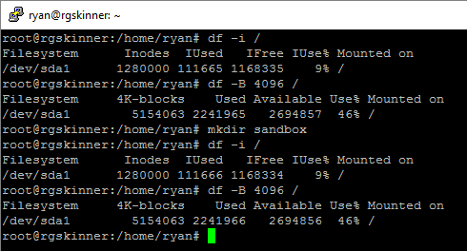

B.How does the i-node count differ between the two ​df -i​ screenshots with respect to the root volume?
One i-node has moved from free to used
C.How does the free-block count differ between the two df - B 4096 screenshots with respect to the root volume
One free block as been used
D.What has happened to cause these changes, explain?
One i-node was used to point to the directory file and one block was used for it’s data

4A.What is the absolute path for src?
/home/ryan/sandbox/src
B.What is the relative path of dst if you were currently in src?
../dst/
C. Paste the screenshots
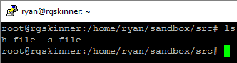
C. Explain what the “../” represents in the command above.
.. means the parent folder
D. What is the absolute path of your current directory?
/home/ryan/sandbox/
E. Paste the screenshots
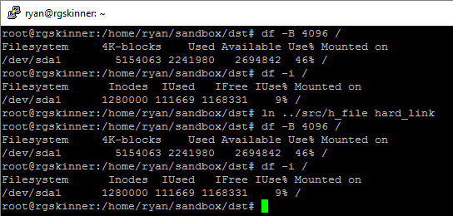
F. Describe and explain the changes in the free i-nodes for the root directory. Has the number of free block changed? If so/not, why/why not?
No change has been made, the dst and src directory both point to the same i-node, which points to the same block.
G.Paste the screenshots
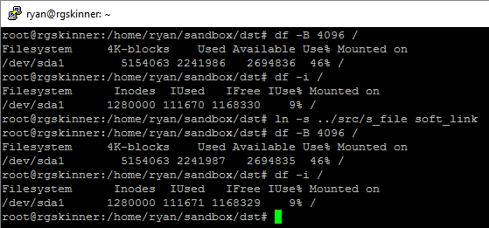
H. Describe and explain the changes in the free i-nodes for the root directory. Has the number of free block changed? If so/not, why/why not?
An i-node and a block were used because a symbolic link is a type of file that points to another file
I. Describe and explain the results of the two cat commands?
The hard link printed the data from the block, while the soft did not, because it points to a nonexistent file, so there is no data to print

