Project 0 Report

Rachel Weber

August 28, 2018

## Introduction

The data contain 130 people, 101 of whom have no missing data. The question addressed in this report asks if one of the gel treatments used to improve gum health had a greater impact on patients after 1 year of use than others. Patients were given a placebo gel, no gel at all, or one of 3 levels of a gel containing medication. The study was randomized and 26 people were assigned to each treatment group. Table 1 shows the demographic distribution of the study population.

Table 1: Demographic Information

|  |  |
| --- | --- |
|  | N = 130 |
|  | N(%) |
| Sex |  |
| Male | 54(42) |
| Female | 76(58) |
| Smoking Status |  |
| Nonsmoker | 81(62) |
| Smoker | 48(37) |
| Missing | 1(1) |
| Race |  |
| Native American | 4(3) |
| African American | 9(7) |
| Asian | 3(2) |
| White | 114(88) |
|  | Mean(SD) |
| Age | 49.94(10.03) |
| Missing | 1(1) |

A good portion of participants were current smokers and since smoking is known to affect oral health, adjusting for smoking status when assessing treatment effects will be important. Though 130 were randomized, 101 will be used for analysis owing to their complete measurement status. The remaining 29 people without all measures will not be utilized.

## Methods

Before formal analysis began, some exploratory work was done to find trends in the data. Figure 1 below shows the relationship between patient values measured at baseline, and those measured at 1 year. There is a moderate linear relationship between the variables, seen by the large

$$R^{2}$$

values, which indicates that including baseline values in a predictive model will be important in this studyfor the sake of improving predictive power.

## Warning: Removed 27 rows containing non-finite values (stat_smooth).

## Warning: Removed 27 rows containing missing values (geom_point).

## Warning: Removed 28 rows containing non-finite values (stat_smooth).

## Warning: Removed 28 rows containing missing values (geom_point).

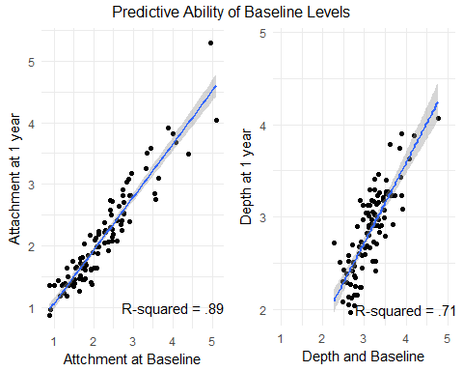 The 101 people with both before and after measurements were used for model assessment. 10 patients in treatment group 5 did not complete the study. This number accounts for 34.5% of the people who dropped out, a higher proportion than expected by chance. Change in depth and attachment between baseline and 1 year was calculated to create the outcomes for modeling. 1 year values were subtracted from baseline values so positive difference scores are indicative of improvement in gum health.

## Results

Since hydrating the gums can improve attachment and depth, 2 controls were used. One where patients received no gel for 1 year, and one were they used a gel that contained no active medication. T-tests comparing changes in gum depth and attachment between the two groups were run and the results are shown below.

|  |  |  |  |
| --- | --- | --- | --- |
|  | Placebo (N=22) | Control (N=23) | P-value |
|  | mean(sd) | mean(sd) | NA |
| Attachment Change | 0.09(0.24) | 0.22(0.28) | 0.0884 |
| Depth Change | 0.35(0.28) | 0.22(0.28) | 0.8793 |

Neither p-value is significant. This indicates that there was no effect of the gel alone in improvement of a patient’s gum tissue over that seen in controls.

An anova test assessing treatment effect on change in attachment indicated that overall treatment was significant (p-value: .117). After adjustment for baseline attachment and other demographic variables, treatment had no effect on gum attachment after 1 year.

Anova Table (Type II tests)

|  |  |  |  |  |
| --- | --- | --- | --- | --- |
|  | Sum Sq | Df | F value | Pr(>F) |
| **trtgroup** | 0.4621 | 4 | 1.903 | 0.1166 |
| **attachbase** | 0.8747 | 1 | 14.41 | 0.0002632 |
| **smoker** | 0.1509 | 1 | 2.485 | 0.1183 |
| **age** | 0.05312 | 1 | 0.8751 | 0.352 |
| **sex** | 0.03924 | 1 | 0.6464 | 0.4235 |
| **Residuals** | 5.585 | 92 | NA | NA |

An anova test assessing change in depth predicted by treatment group was non-significant (p-value: .112). After adjustment for baseline attachment and other demographic variables, treatment had no effect on pocket depth after 1 year.

Analysis of Deviance Table (Type II tests)

|  |  |  |  |
| --- | --- | --- | --- |
|  | LR Chisq | Df | Pr(>Chisq) |
| **trtgroup** | 7.503 | 4 | 0.1116 |
| **pdbase** | 2.702 | 1 | 0.1002 |
| **smoker** | 0.08163 | 1 | 0.7751 |
| **age** | 0.972 | 1 | 0.3242 |
| **sex** | 2.545 | 1 | 0.1107 |

## Conclusion:

Our results indicate that attachment loss and pocket depth of patient gums are not impacted by treatment levels in the medicated gel used in this study. No treatment confered a significant change in measured outcome. Additionally, we found that there is no difference in gum health between people who receive no gel, and those who receive a placebo gel. Though it was suspected that the increased hydration that results from using a gel could itself improve gum health, the data do not support this hypothesis. A larger portion of patients in treatment group 5 did not complete follow-up assessments than those in other groups. We consider their data ‘not missing at random’ and it may be worth investigating why a disproportionately larger group of people assigned high levels of medicated gel failed to complete the study.