Malaria in Mozambique:
  - Predicting incidence using weather and intervention data

Background:
Caused by a protozoan parasite transmitted to humans via mosquito bite, Malaria infects hundreds of millions of people each year. With 13 countries, mainly in Sub-Saharan Africa, bearing 76% of the world’s malaria cases each year, intervention efforts to reduce transmission have become commonplace¹. Individuals who have contracted malaria often show early symptoms of chills, fever, and chills. If left undiagnosed or untreated, an ill person may develop cerebral malaria, often perishing as a result. Interestingly, adults who grew up in regions where malaria is endemic often develop some level of immunity to the parasite and can have asymptomatic infections¹. It is for this reason that data for children who have contracted malaria is used in this study, as they are more likely to visit a clinic to receive treatment.

Weather:
Malaria parasites grow optimally in climates with at least 60% humidity and average temperatures of 20-30 degrees Celsius³. Mozambique has averages temperatures around 28 degrees Celsius and yearly average rainfall of 85 centimeters. 82% of this rainfall comes between the months of March and November². Such conditions make Mozambique an ideal climate for malaria to flourish. The mosquitos that transmit malaria benefit from rainfall to complete their own life cycle. Circumstances in which there are manmade environmental changes, such as large bodies of stagnant water, can be prime breeding grounds for both the malaria parasite and its mosquito hosts. Periods of heavy rainfall and high temperatures have been shown to predict an increase in malaria incidence in the weeks that follow.

Transmission and Incubation:
Living a relatively complex life cycle, a parasite enters a human host through a mosquito’s saliva and initially incubate in the liver, before releasing themselves to infect and destroy red blood cells. It is the bursting of red blood cells in which the parasite has grown and multiplied that causes symptoms. An incubation period of roughly 2 weeks is typical between time of infection and onset of symptoms. However, studies have shown that exposure can occur 4 or even 8 weeks before a person becomes symptomatic (_____).

Interventions:
Two common interventions employed are insecticide treated mosquito nets (ITNs) and indoor residual spraying (IRS). ITNs have shown to reduce child mortality in homes outfitted with such⁵. While the ITNs can be quite useful, there have been cases where improper uses have been documented—though a review of such suggests that these incidences are less common than initially thought⁶.

The Problem
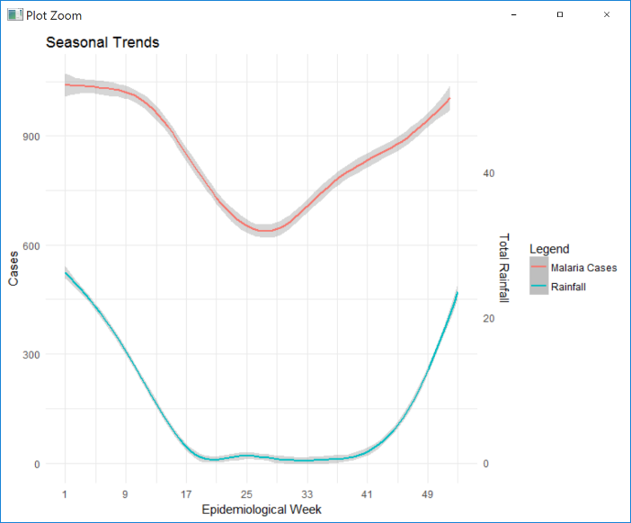
Comprising of 140 districts with a total population of 28.8 million people, Mozambique had an estimated 8.3 million cases of Malaria in 2015⁴. Such high incidence of malaria across such a geographically diverse region affords researchers the ability to study malaria transmission rates and intervention success on a fine scale.
Mozambique experiences yearly average rainfall of 769mm with the majority of their rain coming between November and March⁸. Mid-year monthly rain totals fall as Mozambique enters its fry season. Since malaria is intrinsically linked with rainfall, cases of malaria rise and fall as the seasons change (Figure 1).
Health officials wish to combat this seasonal rise in malaria by implementing two main interventions. ITNs and IRS are both deployed in the country throughout the year. The rate at which they are used is decided at the district level, making Mozambique heterogeneous for intervention treatments. This heterogeneity makes it difficult to detect transmission reduction as a result of interventions at the national level, but does permit study at the district level to observe how malaria cases in each district change as the seasons progress and as interventions are applied. For the purposes of this analysis, indoor residual spray is assumed to be entirely completed in a district in the week it is first applied, though for logistic reasons it may take several weeks to fully cover a district.

Data
Seven years of weather data for all districts in Mozambique have been compiled in a database where individual days are summarized to be represented by Epidemiological week. This data includes rain totals, temperature, and other climate features. Reported cases from Mozambique’s main health ministry are used and incidence is reported at the district level by week. In addition, intervention data informing week and district in which either ITNs were distributed or indoor residual spray was applied is used to understand the relationship between interventions and malaria transmission rates.

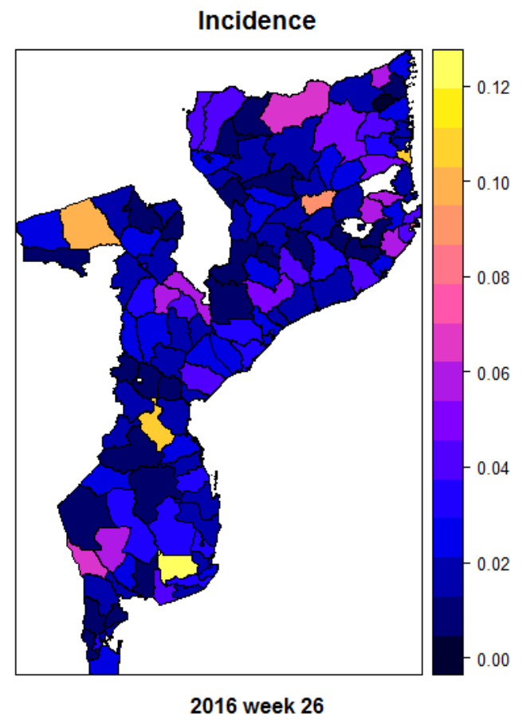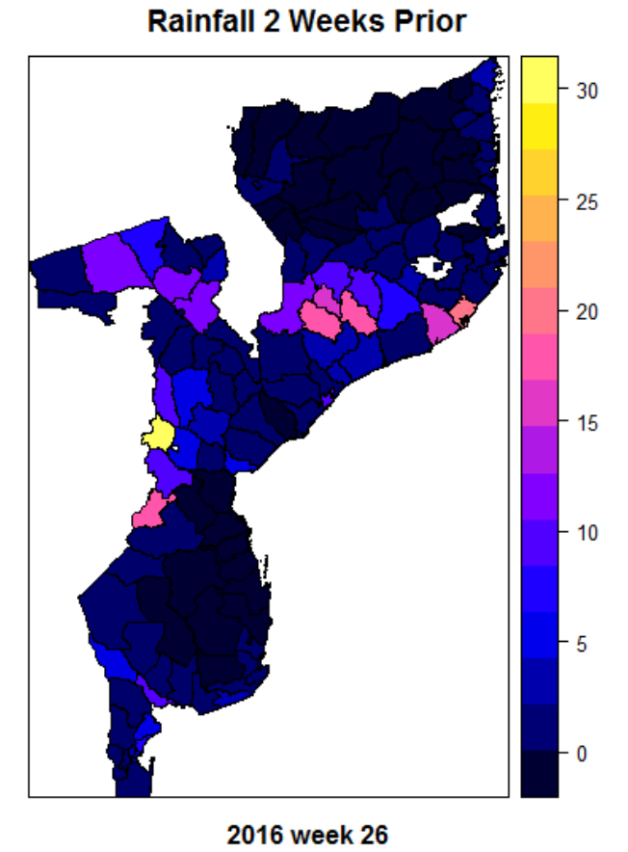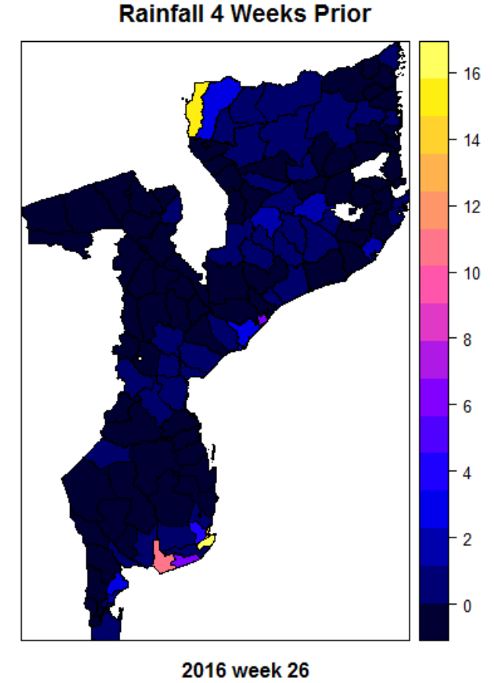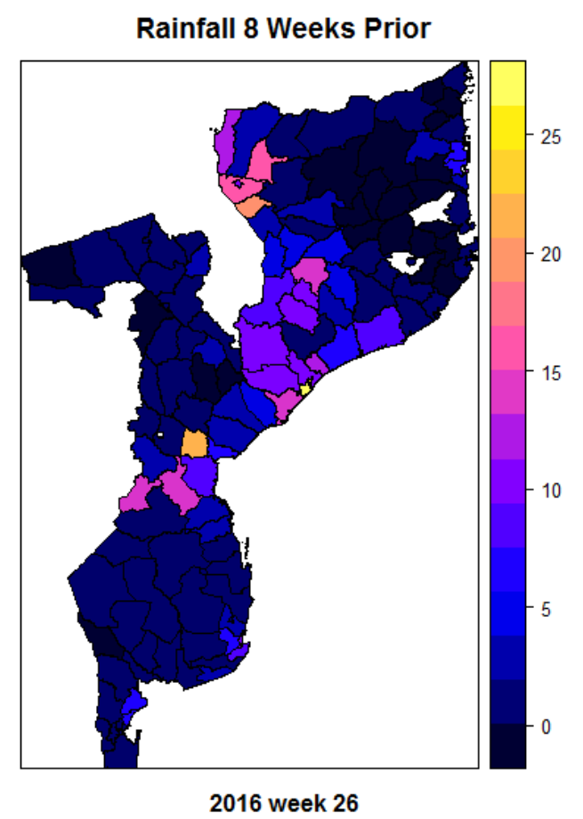

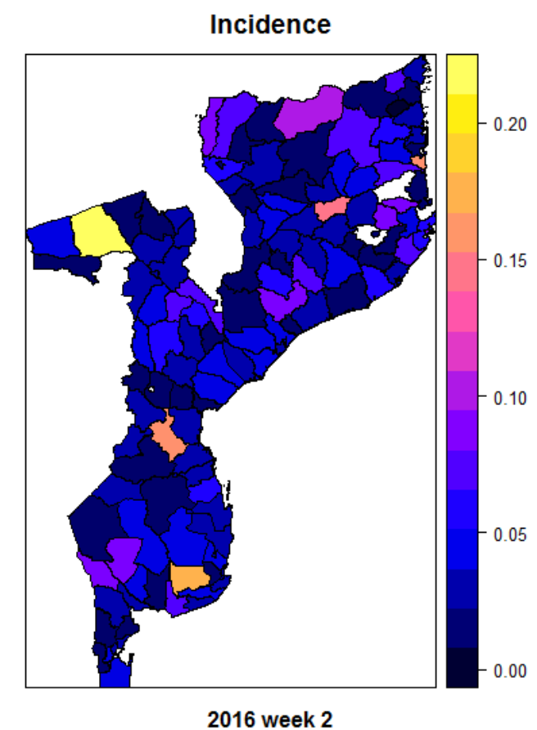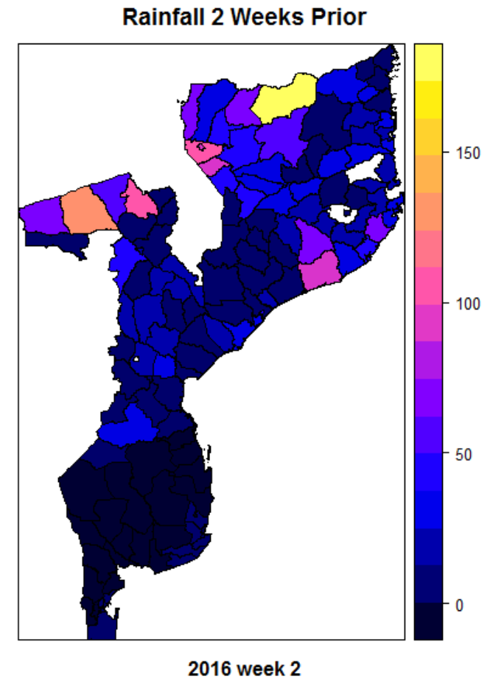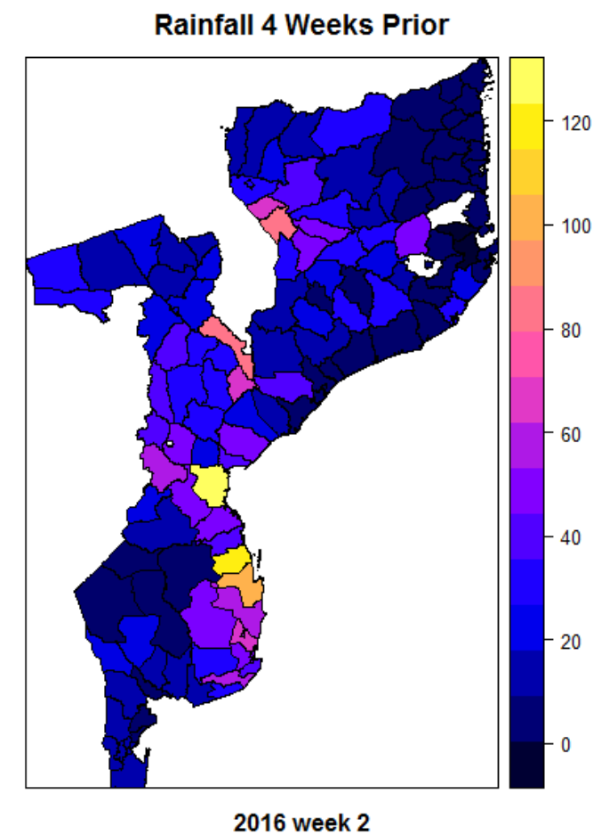

- Fact sheet about Malaria. (n.d.). Retrieved November 24, 2017, from http://www.who.int/mediacentre/factsheets/fs094/en
- Ryan, C. (2011). School of GeoSciences. Retrieved November 24, 2017, from https://www.geos.ed.ac.uk/homes/cryan/moz_met.html
- Oaks, S. C. (1991). Malaria: obstacles and opportunities. Retrieved November 24, 2017.
- Country Profiles: Mozambique. (2016). Retrieved November 24, 2017, from http://www.who.int/malaria/publications/country-profiles/profile_moz_en.pdf
- Lim, S. S., Fullman, N., Stokes, A., Ravishankar, N., Masiye, F., Murray, C. J., & Gakidou, E. (2011). Net benefits: A multicountry analysis of observational data examining associations between insecticide-treated mosquito nets and health outcomes. PLoS Medicine, 8(9).
- Eisele, T. P., Thwing, J., & Keating, J. (2011). Claims about the misuse of insecticide-treated mosquito nets: Are these evidence-based? PLoS Medicine, 8(4), 2. https://doi.org/10.1371/journal.pmed.1001019
- Rainfall/Precipitation in Maputo, Mozambique. (n.d.). Retrieved November 29, 2017, from http://www/maputo.climatemps.com/precipitation.php

