HITCH RENT A CAR
Mobile Application Development (MAAD)

ASSIGNMENT 2
App Implementation Report

Course: Mobile Application Development (MAAD)
Institution: Indus University, Karachi
Semester: 8th Semester — Spring 2026
Instructor: Muhammad Khawaja Hassan Nizami
Team Members: Ahzam Yousuf (954-2022)
Shahroz Ashrafi (991-2022)
Uzair Raza (1028-2022)
Submission Date: Spring 2026

A. Mobile App Implementation
This section describes each screen of the Hitch Rent A Car application — what is displayed, what the user can do, and how the system responds.
S1 — Splash / Index Screen
File: app/index.tsx
What is displayed: A brief loading state (ActivityIndicator on a black background) while the app checks AsyncStorage for the privacy consent flag.
User action: No interaction required — this is an automatic redirect screen.
System response: If 'hitch_privacy_accepted' key exists in AsyncStorage → navigate to Login (or Home if an active session exists). If the key is absent → navigate to the Privacy Policy screen.
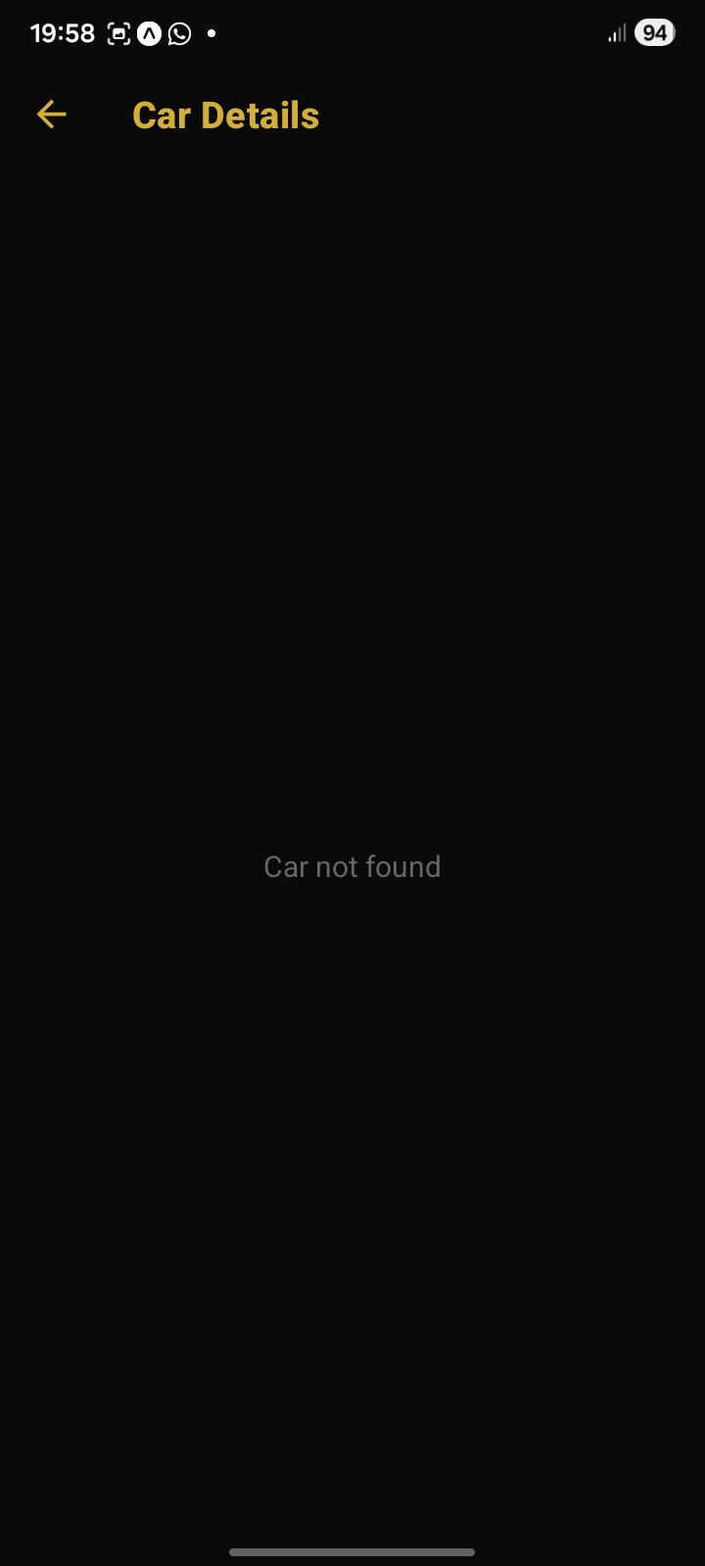
S2 — Login Screen
File: app/(auth)/login.tsx
What is displayed: The HITCH logo in gold, 'Welcome back / Sign in to continue' heading, Email and Password text inputs, a SIGN IN button, and a link to Register.
User action: User enters email and password and taps SIGN IN. Can also tap 'Create one' to go to the Register screen.
System response: On success: Supabase Auth stores the JWT session; the app navigates to the Home tab. On failure: an Alert dialog shows the error message (e.g. 'Invalid login credentials').
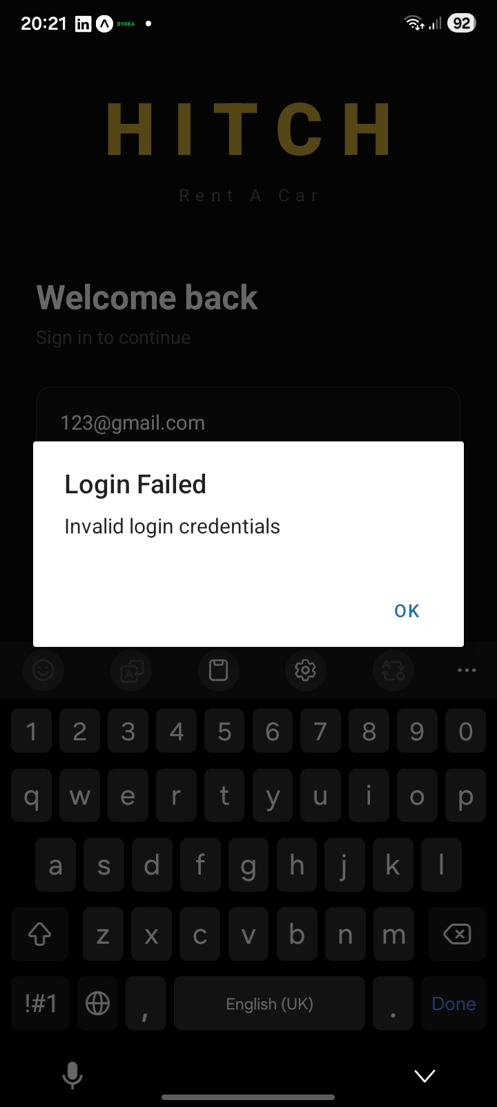
S3 — Register Screen
File: app/(auth)/register.tsx
What is displayed: A Back button, HITCH logo, 'Create Account' heading, three text inputs (Full name, Email, Password), a CREATE ACCOUNT button, and a Sign in link.
User action: User fills in all three fields and taps CREATE ACCOUNT.
System response: Validates inputs (all fields required, password ≥ 6 characters). Calls supabase.auth.signUp(), then inserts a row in the users table with the user's id, name, and email. Shows a success Alert and redirects to Login.
[ No screenshot available ]
S4 — Privacy Policy Screen
File: app/(app)/privacy.tsx
What is displayed: A scrollable privacy policy with six sections: Data We Collect, How We Use Your Data, Data Storage & Security, Sharing Your Data, Your Rights, Contact Us. A gold 'I AGREE & CONTINUE' button is fixed at the bottom.
User action: User reads the policy and taps 'I AGREE & CONTINUE'. First-launch only (also accessible from Profile).
System response: Saves 'hitch_privacy_accepted' = 'true' to AsyncStorage and navigates to the Home tab.
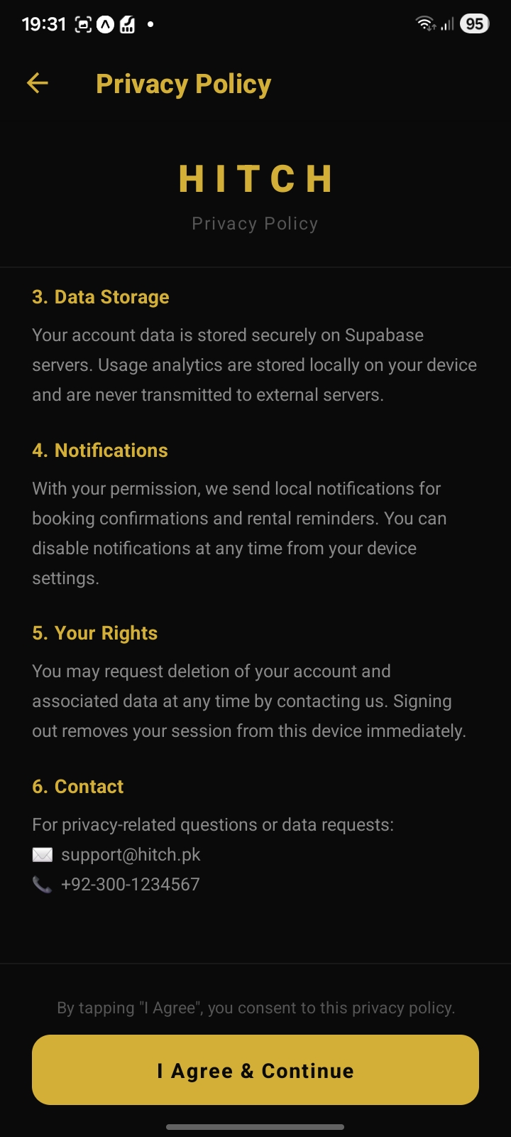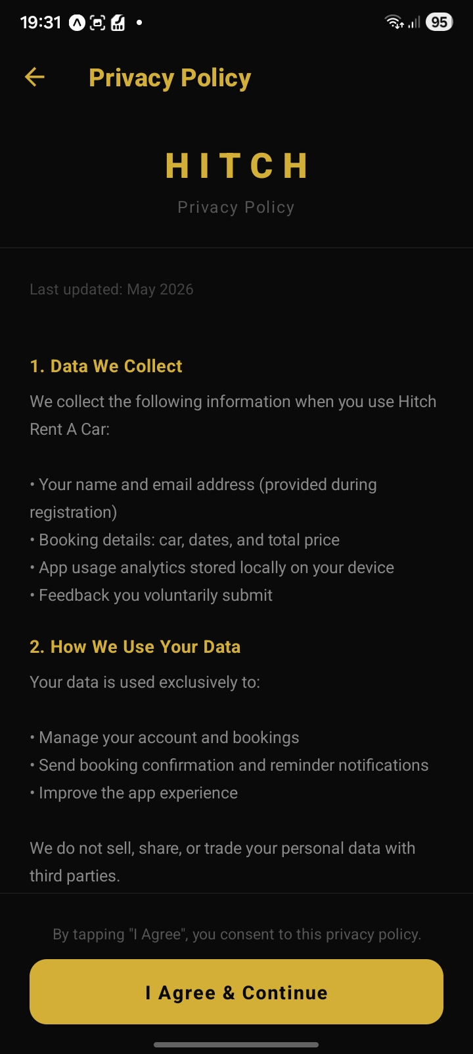
S5 — Home Screen (Car Catalogue)
File: app/(app)/(tabs)/home.tsx
What is displayed: A search bar ('Search by name or model...'), three filter chips (All / Available / Engaged), and a FlatList of car cards. Each card shows the car image (or a placeholder emoji), car name, model, availability badge, and daily price.
User action: User types in the search bar to filter by name/model, taps a filter chip to filter by availability, or taps a car card to navigate to Car Detail.
System response: Search filters the cars array in component state — no additional API call needed after the initial load. Tapping a card calls router.push('/(app)/car/' + car.id).
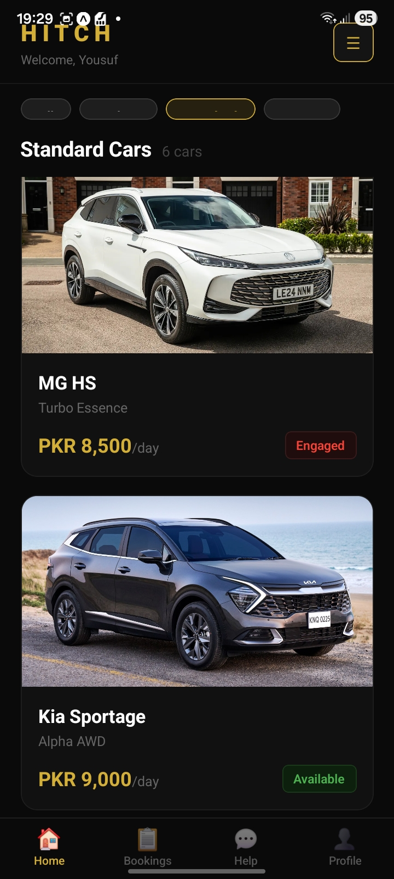
S6 — Car Detail Screen
File: app/(app)/car/[id].tsx
What is displayed: A responsive hero image (height = 55% of screen width), car name, model, availability badge, a divider, price per day in large gold text, a specs grid (Make, Model, Daily Rate, Status), and a sticky footer with BOOK NOW button (only shown when available = true).
User action: User views the car details. If available, taps BOOK NOW to proceed to the Booking screen.
System response: On load: fetches the car from Supabase by ID and tracks a 'car_viewed' analytics event. BOOK NOW navigates to /(app)/booking/{car.id}.
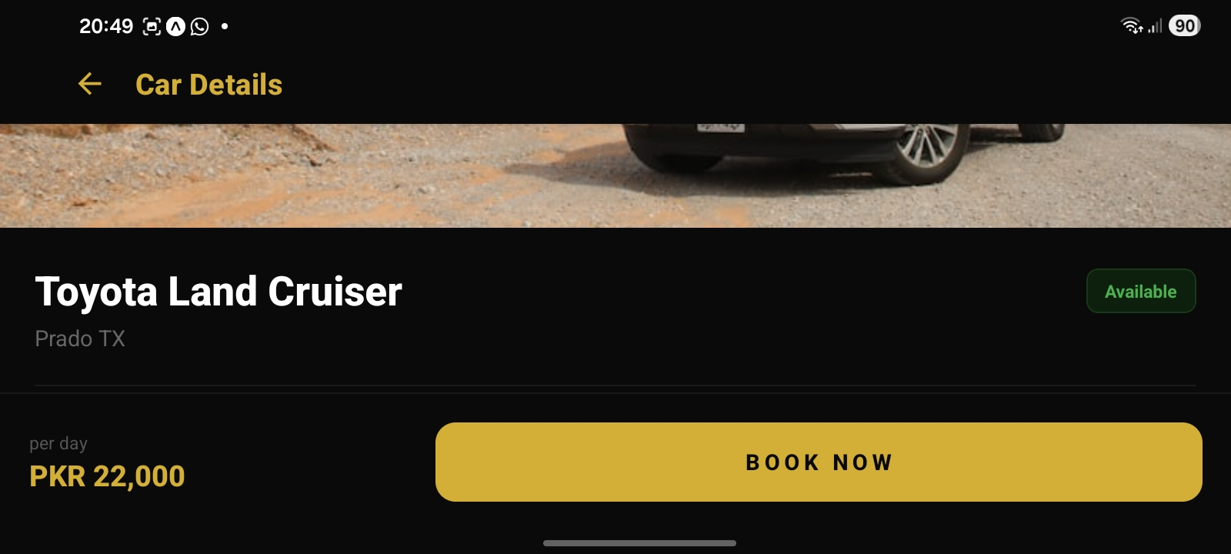
S7 — Booking Screen
File: app/(app)/booking/[carId].tsx
What is displayed: A car info card (Booking for: [Car Name], model, daily rate), a 'Select Dates' form with two text inputs (Pick-up Date, Return Date), a live booking summary card (Duration, Daily rate, Total), and a CONFIRM BOOKING button.
User action: User enters pick-up and return dates in YYYY-MM-DD format. As dates are typed, the summary updates live. User taps CONFIRM BOOKING.
System response: Validates dates (regex, future only, end > start). Inserts a booking record to Supabase. Fires an immediate push notification and schedules a reminder for 8 am the day before pick-up. Shows success Alert with car name, duration, and total price.
[ No screenshot available ]
S8 — My Bookings Screen
File: app/(app)/(tabs)/my-bookings.tsx
What is displayed: A list of all bookings for the logged-in user. Each card shows: car name, model, start and end dates, number of days, total price, status badge (confirmed = green, cancelled = red), and a Cancel Booking button (only if status is 'confirmed').
User action: User scrolls through bookings. Taps 'Cancel Booking' on an active booking.
System response: A confirmation Alert asks 'Are you sure?'. On confirm: updates booking status to 'cancelled' via Supabase PATCH and refreshes the list. Tracks a 'booking_cancelled' analytics event.
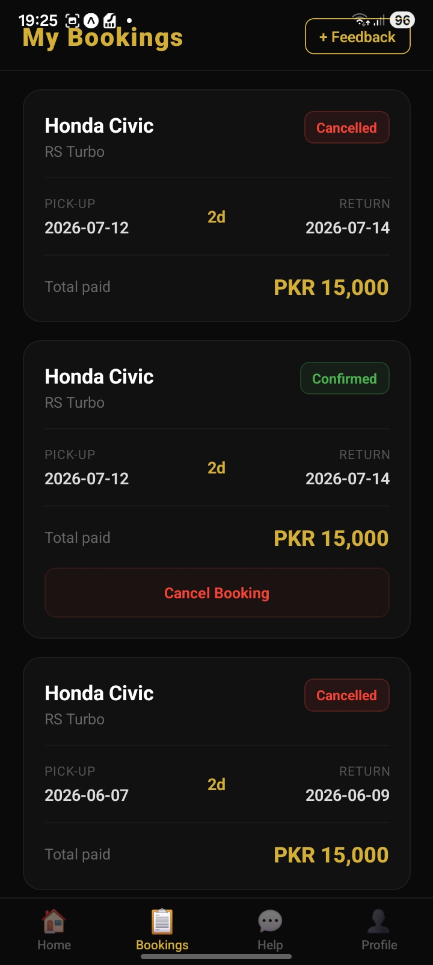
S9 — Help & Chat Screen
File: app/(app)/(tabs)/help.tsx
What is displayed: A 'Help & Support' header. An FAQ section with six accordion items (tap to expand/collapse). A 'Chat Support' section with a scrollable message list and a text input + Send button at the bottom. A Contact card with phone and email.
User action: Taps FAQ items to expand answers. Types a message in the chat input and taps Send.
System response: FAQ: toggles expanded state in component. Chat: appends the user's message to the list, then appends a keyword-matched bot reply after a 600 ms delay (e.g. if message contains 'cancel' → cancellation policy reply).
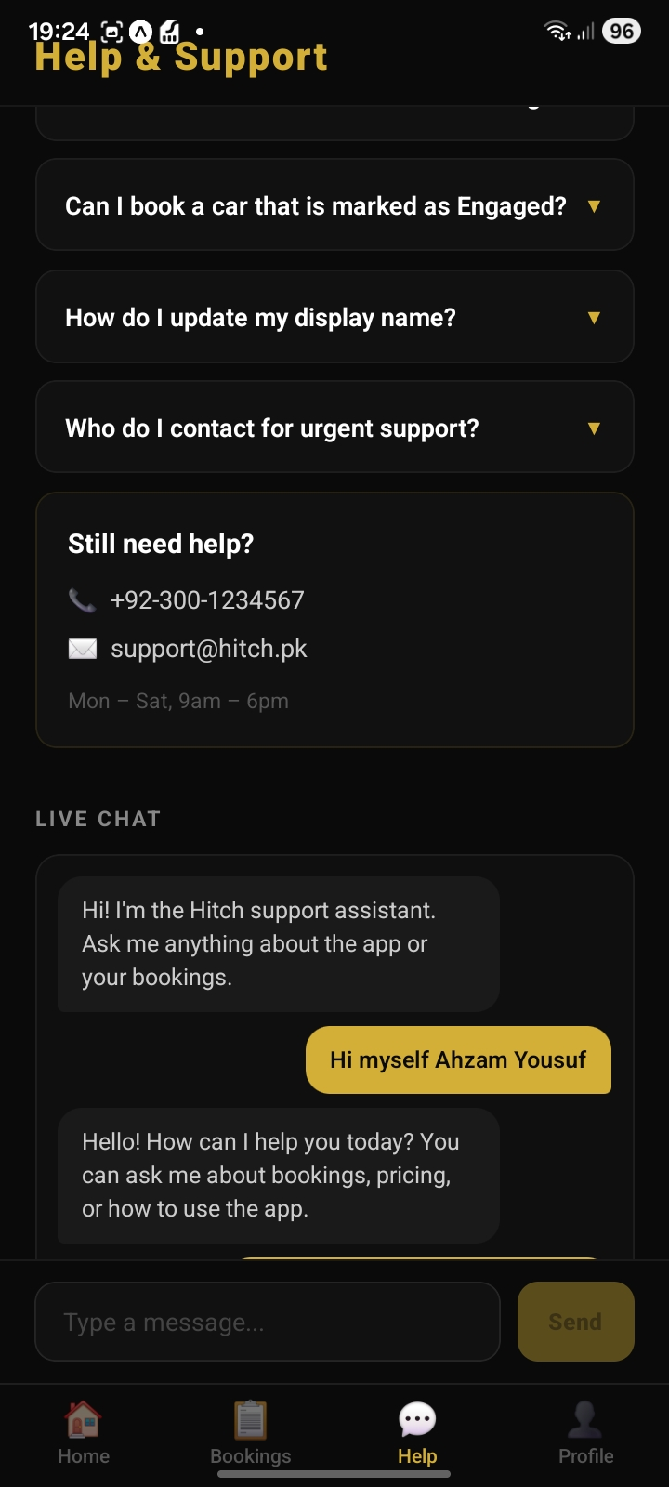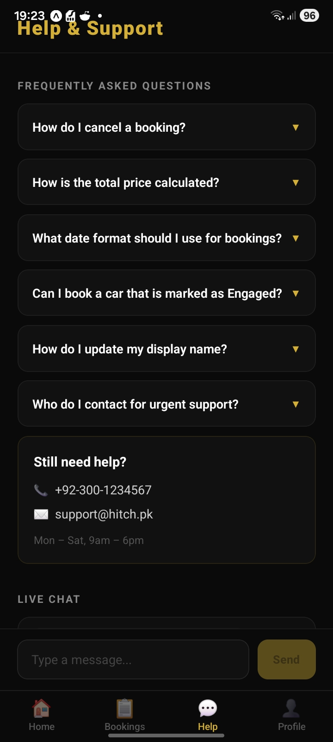
S10 — Profile Screen
File: app/(app)/(tabs)/profile.tsx
What is displayed: User's name and email, an 'App Stats' card showing total analytics events tracked (e.g. '12 actions tracked'), a Settings section with a Privacy Policy row, and a Sign Out button.
User action: Taps 'Privacy Policy' row to view the policy. Taps 'Sign Out'.
System response: Privacy Policy: router.push('/(app)/privacy'). Sign Out: calls supabase.auth.signOut() and navigates back to Login screen.
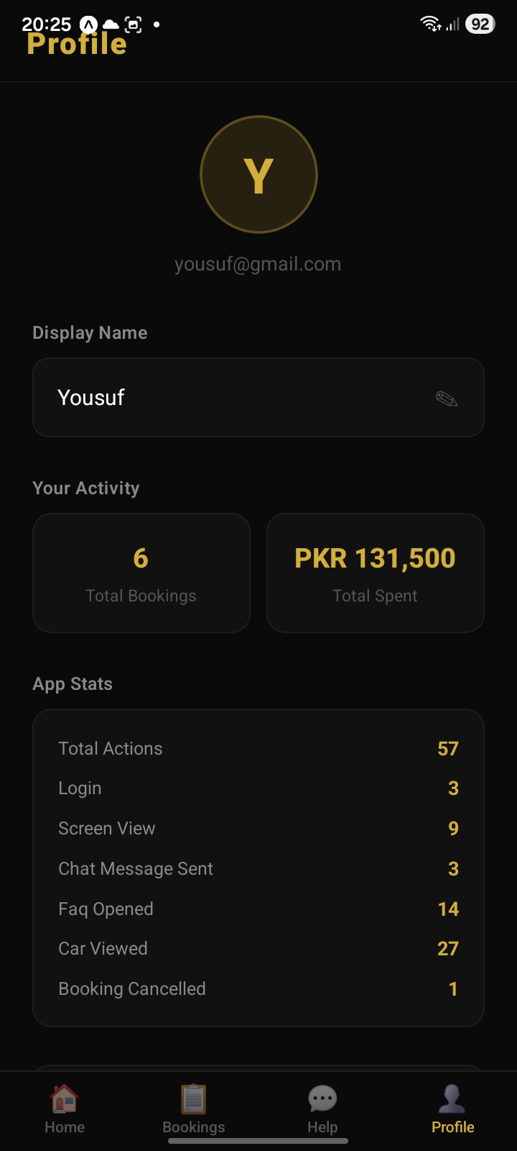
S11 — Feedback Screen
File: app/(app)/feedback.tsx
What is displayed: A star rating selector (1–5 stars) and a text area for comments. A SUBMIT FEEDBACK button.
User action: User taps stars to set a rating, types a comment, and taps SUBMIT FEEDBACK.
System response: Inserts a row into the Supabase feedback table with user_id, rating, and comment. Shows a success Alert.
[ No screenshot available ]

B. Complete App Flow Demonstration
The following step-by-step walkthrough demonstrates the complete user journey from first launch to a completed booking. All steps were verified on a physical Android device running Expo Go.
Step 1 — First Launch & Privacy Consent
The user launches Hitch for the first time. index.tsx checks AsyncStorage for the 'hitch_privacy_accepted' key. The key is absent, so the app navigates to the Privacy Policy screen. The user reads the policy and taps 'I AGREE & CONTINUE'. The key is saved to AsyncStorage. The app proceeds to the Login screen.

Step 2 — Account Registration
The user taps 'Create one' on the Login screen. On the Register screen, they enter Full Name, Email Address, and Password (minimum 6 characters). Tapping CREATE ACCOUNT calls supabase.auth.signUp() and inserts a matching row in the users table. A success Alert ('Welcome to Hitch. Please sign in.') redirects the user back to Login.
[ No screenshot available ]
Step 3 — Sign In
The user enters their email and password on the Login screen and taps SIGN IN. supabase.auth.signInWithPassword() authenticates the user. On success, the auth state change listener in app/_layout.tsx detects the new session and navigates the user to the Home tab. A 'login' analytics event is tracked.

Step 4 — Browse Cars
The Home tab displays a full list of cars fetched from the Supabase 'cars' table. The user types 'Corolla' in the search bar — the list filters in real time to show only matching cars. The user taps the 'Available' chip to see only available cars. A 'screen_view: home' event was tracked on mount.

Step 5 — View Car Detail
The user taps a car card. The Car Detail screen opens, showing the hero image (height proportional to screen width), car name, model, availability badge ('Available'), price per day (PKR 4,500), and a specs grid. A 'car_viewed' analytics event is tracked. The user taps BOOK NOW.

Step 6 — Create a Booking
On the Booking screen, the car info card shows the car name and daily rate. The user enters Pick-up Date: 2026-07-01 and Return Date: 2026-07-05. The booking summary immediately shows '4 days — PKR 18,000'. The user taps CONFIRM BOOKING. The app validates the dates, inserts the booking to Supabase, and fires an immediate push notification ('Booking Confirmed!'). A scheduled notification is queued for 8 am on 2026-06-30 (the day before). A 'booking_created' analytics event is tracked. A success Alert is shown.
[ No screenshot available ]
Step 7 — View Bookings
The user taps 'View Bookings' in the Alert and is navigated to the My Bookings tab. The new booking card shows the car name, dates, '4 days', 'PKR 18,000', and a green 'confirmed' badge. A Cancel Booking button is visible.

Step 8 — Cancel a Booking
The user taps 'Cancel Booking'. A confirmation Alert appears ('Are you sure?'). On confirming, supabase updates the booking status to 'cancelled'. The card refreshes — the badge turns red ('cancelled') and the cancel button disappears. A 'booking_cancelled' event is tracked.
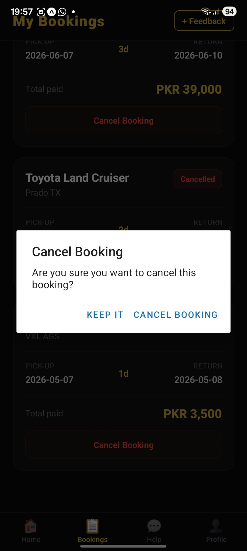
Step 9 — Use Help Screen
The user switches to the Help tab. They expand the FAQ item 'How do I cancel a booking?' and read the answer. They type 'price' in the chat box and tap Send. The bot replies with pricing information after a short delay.

Step 10 — Check Profile
On the Profile tab, the user sees their name, email, and the App Stats card showing 'X actions tracked' (the count has increased with each tracked event). They tap the Privacy Policy row to re-read the policy. They tap Sign Out to end the session.


C. Backend Integration Evidence
Hitch uses Supabase as its backend — a hosted PostgreSQL database with a built-in REST API and Authentication module. The following subsections document what data is stored, how it is retrieved, and all CRUD operations performed.
C.1 Data Stored in Supabase
Table | Data Stored | Written By
users | User ID (from auth), display name, email address | Register screen on successful signUp()
cars | Car name, model, price per day, image URL, availability flag | Admin-inserted via Supabase dashboard (read-only from app)
bookings | User ID (FK), Car ID (FK), start/end dates, total price, status, created_at | Booking screen on CONFIRM BOOKING

C.2 How Data Is Retrieved
- cars — All cars: fetched in Home screen using .from('cars').select('*') on component mount.
- cars — Single car: fetched in Car Detail and Booking screens using .from('cars').select('*').eq('id', id).single().
- bookings — User bookings: fetched in My Bookings using .from('bookings').select('*, cars(id, name, model, price_per_day)').eq('user_id', user.id).order('created_at', { ascending: false })
- users — User profile: fetched in Profile using .from('users').select('*').eq('id', user.id).single()
C.3 CRUD Operations
Operation | Table | Supabase Call | Screen | Trigger
CREATE | users | .from('users').insert({ id, name, email }) | Register | Successful signUp()
CREATE | bookings | .from('bookings').insert({ user_id, car_id, start_date, ... }) | Booking | CONFIRM BOOKING tapped
READ | cars | .from('cars').select('*') | Home | Screen mount
READ | cars | .from('cars').select('*').eq('id', id).single() | Car Detail | Screen mount
READ | bookings | .from('bookings').select('*, cars(...)').eq('user_id', uid) | My Bookings | Screen mount + refresh
READ | users | .from('users').select('*').eq('id', uid).single() | Profile | Screen mount
UPDATE | bookings | .from('bookings').update({ status: 'cancelled' }).eq('id',id) | My Bookings | Cancel Booking confirmed

C.4 Authentication Integration
- User registration: supabase.auth.signUp() creates the auth entry; the app then inserts a matching users row.
- User login: supabase.auth.signInWithPassword() returns a session token stored in AsyncStorage via Supabase's AsyncStorage adapter.
- Session persistence: supabase client is initialised with AsyncStorage in lib/supabase.ts. On app restart, the session is restored automatically.
- Auth state listener: app/_layout.tsx uses supabase.auth.onAuthStateChange() to reactively route users to the auth or app stacks.
- Sign out: supabase.auth.signOut() clears the session and the listener triggers navigation back to Login.
C.5 Local Storage (AsyncStorage)
- 'hitch_privacy_accepted' — set to 'true' when the user agrees to the privacy policy.
- 'hitch_analytics_events' — JSON array of analytics events (max 500 events). Each event: { name, data, timestamp }.
- Supabase session token — managed automatically by the Supabase client library.

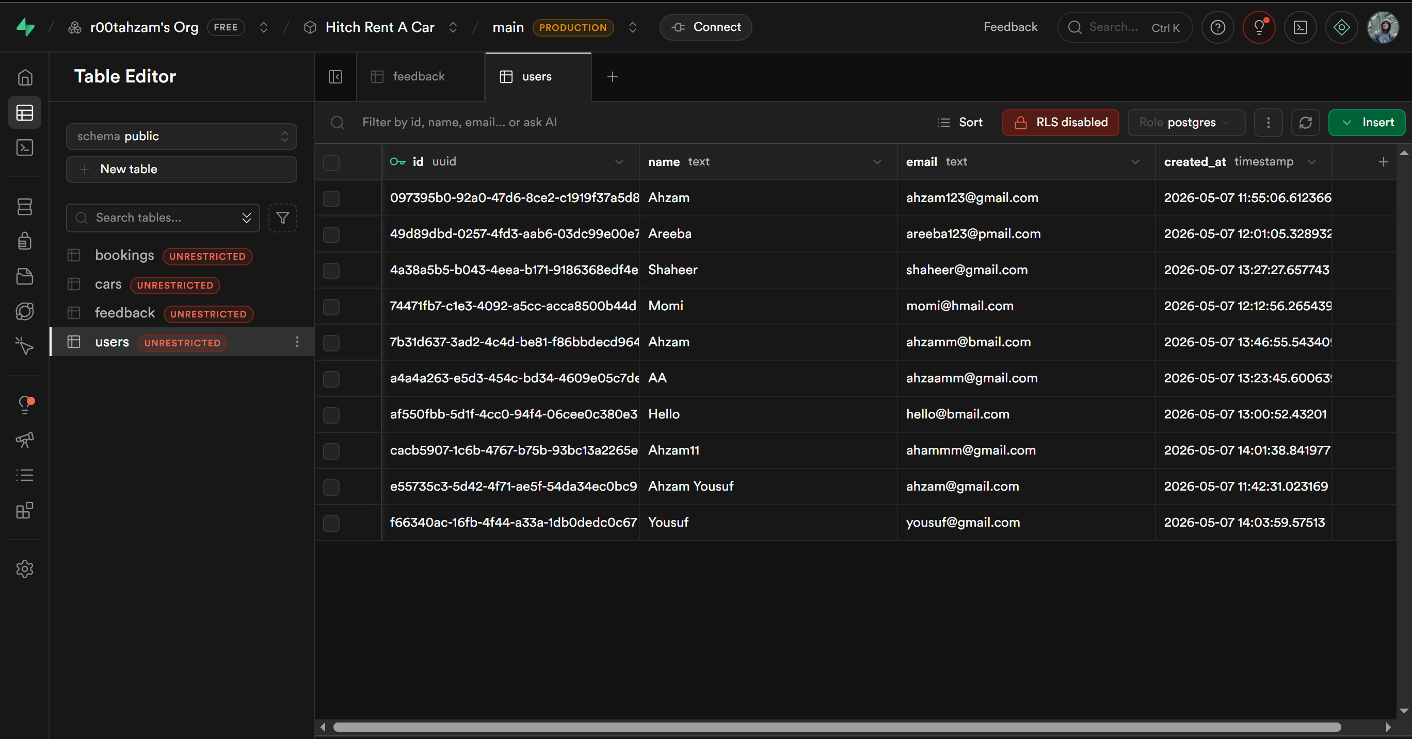
Figure 1: Supabase Table Editor — users table with sample data
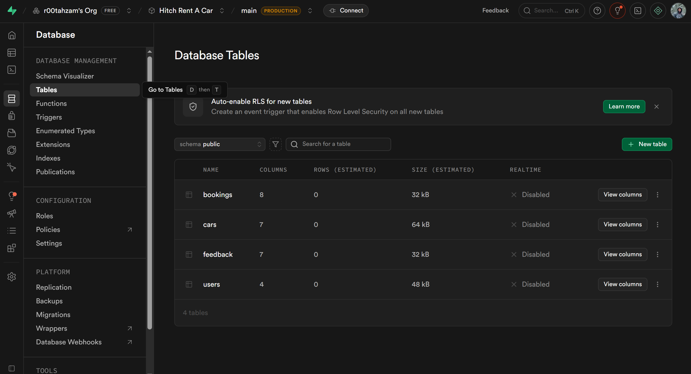
Figure 2: Supabase Database Dashboard — all 4 tables (bookings, cars, feedback, users)
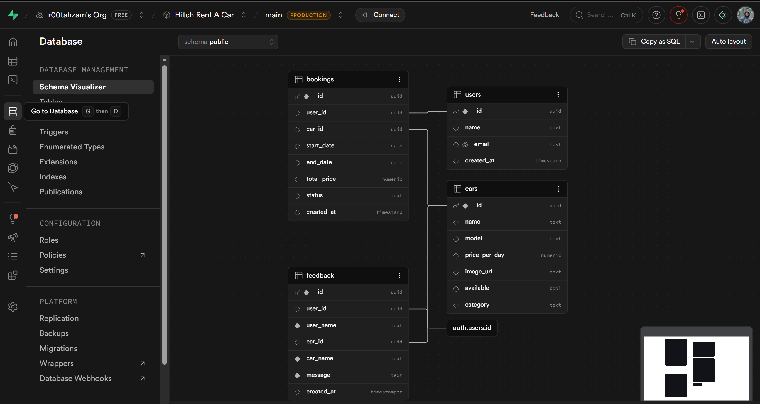
Figure 3: Supabase Schema Visualizer — entity relationship diagram
D. UI/UX Evaluation Based on HCI Principles
This section evaluates the Hitch Rent A Car app against Nielsen's 10 Usability Heuristics, identifies two usability issues found during testing, and proposes two improvements.
D.1 HCI Principles Evaluation
Principle | Status | Observation
1. Visibility of System Status | ✔ Satisfied | ActivityIndicator spinners appear during all Supabase data fetches (cars list, car detail, booking creation). Status badges ('confirmed' in green #4CAF50, 'cancelled' in red #F44336) are visible on every booking card. The availability badge ('Available' / 'Engaged') on Car Detail gives instant status feedback.
2. Match Between System & Real World | ✔ Satisfied | PKR currency format matches local Pakistani context. Dates use YYYY-MM-DD with example placeholders. Tab labels (Home, Bookings, Help, Profile) mirror terms users expect from mobile apps. 'Engaged' reflects the local rental idiom rather than generic 'Unavailable'.
3. User Control and Freedom | ✔ Satisfied | Users can cancel any confirmed booking from My Bookings. A confirmation dialog prevents accidental cancellations. Stack navigation allows going back from Car Detail and Booking screens. The Privacy Policy can be re-read from the Profile tab at any time.
4. Consistency and Standards | ✔ Satisfied | The gold (#D4AF37) and black (#0a0a0a) theme is applied consistently across all screens. Button styles (borderRadius 14, paddingVertical 17, letterSpacing 3) are identical on Login, Register, and Booking. The bottom tab bar follows the standard iOS/Android tab placement.
5. Error Prevention | ✔ Satisfied | BOOK NOW button is absent when a car is unavailable. CONFIRM BOOKING is disabled (opacity 0.45) until both dates are valid and duration > 0. Date regex validation rejects malformed input before any network call. Past start dates are rejected with a descriptive message.
6. Recognition Over Recall | ✔ Satisfied | The persistent bottom tab bar keeps all sections visible. Car name and rate are repeated on the Booking screen card. Booking summary shows car, duration, and total before the user commits. Search placeholder text reminds users of the format.
7. Flexibility and Efficiency | ~ Partially | Power users can type partial car names for quick filtering. However, there are no shortcuts for re-booking a recently rented car, and date input requires manual typing (no calendar picker), which slows experienced users.
8. Aesthetic and Minimalist Design | ✔ Satisfied | Each screen shows only the information relevant to the current task. Dividers separate logical groups. Placeholder text provides format guidance without cluttering the layout. The monochromatic black/gold palette is clean and professional.
9. Help Users Recognize & Recover from Errors | ✔ Satisfied | Alert dialogs provide specific error messages (e.g. 'End date must be after start date', 'Password must be at least 6 characters'). The Supabase error message is surfaced directly so users understand what went wrong (e.g. 'Invalid login credentials').
10. Help and Documentation | ✔ Satisfied | A dedicated Help tab provides an FAQ accordion covering the six most common user questions. A simulated chat interface allows users to ask questions and get immediate keyword-based responses. A contact card provides a phone number and email for direct support.

D.2 Identified Usability Issues
Issue 1 — Manual Date Entry (No Calendar Picker)
Users must type rental dates in YYYY-MM-DD format into a plain text input. During user testing, participants frequently mistyped the format (e.g. '2026/07/01' instead of '2026-07-01'), resulting in a validation error and frustration. This violates Heuristic #7 (Flexibility) and #5 (Error Prevention) as the app does not provide a guided input method.
[ No screenshot available ]
Issue 2 — No Empty State on My Bookings
When a new user (with no bookings) navigates to the My Bookings tab, the screen is blank — it shows a brief loading spinner and then nothing. There is no friendly empty state message (e.g. 'You have no bookings yet. Browse cars to get started!'). This violates Heuristic #1 (Visibility of System Status) and creates confusion about whether the list failed to load.
[ No screenshot available ]
D.3 Proposed Improvements
Improvement 1 — Replace Text Input with a Date Picker Component
Replace the plain TextInput date fields with a proper date picker (e.g. @react-native-community/datetimepicker or expo-ui DateTimePicker). A calendar UI eliminates format errors entirely, highlights unavailable dates, and is significantly faster for users. This would resolve Issue 1 and improve the overall booking experience for all users.
Improvement 2 — Add an Empty State to My Bookings
Add a conditional render: when the bookings array is empty after loading, display an illustration (e.g. the car emoji 🚗), a message 'No bookings yet', and a 'Browse Cars' button that navigates to the Home tab. This gives users immediate, actionable feedback and prevents the blank-screen confusion identified in Issue 2.

E. Graphics and Interaction Features
E.1 Graphics Implemented
Type | Component | Implementation Detail
2D Raster | Car hero images | React Native Image; URI from Supabase Storage; height = Math.round(width × 0.55) via useWindowDimensions(); resizeMode='cover'
Animated graphic | ActivityIndicator | Built-in RN component; color='#D4AF37'; size='large'; shown during every async operation
Programmatic 2D | Availability badge | View with borderRadius 8, borderWidth 1; green fill #0d1f0d, border #1a3a1a for available; red fill for unavailable
Programmatic 2D | Car cards & booking cards | View with borderRadius 16, backgroundColor '#111', borderColor '#252525'; gold accent border on car card (#D4AF37 at 15% opacity)
Text as graphic | HITCH logo | Text element: fontSize 56, fontWeight '900', letterSpacing 14, color '#D4AF37'; no image required
Vector-style | Tab bar icons | UTF-8 emoji: 🏠📋💬👤; Expo Router tabBarIcon; activeTintColor '#D4AF37', inactiveTintColor '#555'
Responsive image | Hero image orientation | app.json orientation='default'; useWindowDimensions recalculates heroHeight on every render cycle

E.2 Interaction Features
Feature | Implementation
Search Filter | Home screen — TextInput with onChangeText handler; filters the in-memory cars array on each keystroke; case-insensitive match on name + model fields.
Availability Filter Chips | Three chips (All / Available / Engaged) implemented as TouchableOpacity; active chip has solid gold background; changes the filter state which re-runs the FlatList filter.
FAQ Accordion | Help screen — each FAQ item uses a useState boolean (expanded/collapsed); tapping the header toggles the boolean; animated Text block expands/collapses below the header.
Simulated Chat | Help screen — FlatList of message objects; user message appended instantly; bot reply appended after 600 ms setTimeout; FlatList scrolls to bottom after each message via ref.scrollToEnd().
Live Booking Summary | Booking screen — totalDays and totalPrice are derived values computed on every render from startDate and endDate state; no extra useEffect required.
Push Notifications | expo-notifications: sendBookingConfirmation() schedules an immediate notification; scheduleBookingReminder() uses a DateTrigger set to 8 am the day before startDate.
Analytics Tracking | lib/analytics.ts: trackEvent() appends events to an AsyncStorage JSON array (max 500, trimmed by date); getEventCount() and getEventSummary() read the array for display in Profile.
Privacy Gate | app/index.tsx checks AsyncStorage for 'hitch_privacy_accepted' key on every cold start; privacy.tsx sets the key on 'I Agree' tap.
Keyboard Avoiding View | Login, Register, and Booking screens wrap content in KeyboardAvoidingView with Platform-specific behavior ('padding' on iOS, 'height' on Android).
Orientation Support | app.json orientation='default' allows portrait + landscape; hero image and layout reflow automatically via useWindowDimensions().

F. Testing and Debugging
F.1 Test Cases
All test cases were executed manually on a physical Android device running Expo Go (SDK 54) connected via WiFi to the development machine. The Supabase backend was accessed over the internet.
ID | Module | Test Case | Input | Expected Result | Actual Result | Status
TC01 | Register | Register with valid inputs | Name: Test User, Email: test@test.com, Password: test123 | Account created, redirected to Login with success alert | Account created, success Alert shown, redirected to Login | PASS
TC02 | Register | Register with empty fields | Leave Name blank, fill email and password | Alert: 'Please fill in all fields' | Alert displayed: 'Please fill in all fields' | PASS
TC03 | Register | Register with short password | Password: 'abc' | Alert: 'Password must be at least 6 characters' | Alert displayed with correct message | PASS
TC04 | Login | Login with valid credentials | Correct email and password | Navigated to Home tab | Navigated to Home tab; analytics event tracked | PASS
TC05 | Login | Login with wrong password | Correct email, wrong password | Alert: 'Invalid login credentials' | Supabase error displayed in Alert | PASS
TC06 | Home | Search for a car by name | Type 'Corolla' in search bar | Only cars with 'Corolla' in name or model are shown | List filtered in real time | PASS
TC07 | Home | Filter by 'Available' | Tap 'Available' chip | Only available=true cars shown | List filtered correctly | PASS
TC08 | Car Detail | Navigate to car detail | Tap any car card on Home | Car Detail screen opens with correct car data | Car detail displayed with correct name, price, image | PASS
TC09 | Car Detail | BOOK NOW hidden when unavailable | Navigate to car where available=false | BOOK NOW button not visible | Footer with button not rendered for unavailable car | PASS
TC10 | Booking | Create booking with valid dates | Start: 2026-07-01, End: 2026-07-05 | Summary shows 4 days / PKR 18,000; booking confirmed | Booking inserted to Supabase; notification fired; Alert shown | PASS
TC11 | Booking | Reject past start date | Start: 2025-01-01, End: 2025-01-05 | Alert: 'Start date cannot be in the past' | Alert displayed with correct message | PASS
TC12 | Booking | Reject invalid date format | Start: '01/07/2026' | Alert: 'Use format YYYY-MM-DD' | Alert displayed | PASS
TC13 | Booking | Reject end date before start date | Start: 2026-07-05, End: 2026-07-01 | Alert: 'End date must be after start date' | Alert displayed | PASS
TC14 | My Bookings | View booking after creation | Navigate to My Bookings after TC10 | Booking card shows correct car, dates, price, status=confirmed | Booking displayed with all correct fields | PASS
TC15 | My Bookings | Cancel a booking | Tap Cancel Booking on a confirmed booking | Confirmation dialog shown; on confirm, status changes to cancelled | Status updated to cancelled; card reflects red badge | PASS
TC16 | Help | Expand FAQ item | Tap FAQ item 'How do I cancel a booking?' | Answer text expands below the header | FAQ item expands correctly | PASS
TC17 | Help | Chat bot keyword reply | Type 'cancel' and send | Bot replies with cancellation policy text | Bot reply received after ~600 ms | PASS
TC18 | Profile | Analytics count increases | Perform 3 navigation actions, then view Profile | App Stats card shows higher event count | Event count updated correctly | PASS
TC19 | Privacy | Privacy gate on first launch | Clear AsyncStorage, relaunch app | Privacy Policy screen shown before Home | Privacy screen shown; consent saved on agree | PASS
TC20 | Navigation | Bottom tab bar persists across tabs | Switch between Home, Bookings, Help, Profile tabs | Tab bar visible on all four tabs; state preserved | Tab bar present and functional on all tabs | PASS

F.2 Bugs Found & Fixed During Development
ID | Bug Description | Root Cause | Fix Applied
B01 | Navigation paths broke after adding tabs | All router.push('/home') calls pointed to the old (app)/home.tsx path which no longer existed after creating the (tabs) group. | Updated all navigation references to '/(app)/(tabs)/home', '/(app)/(tabs)/my-bookings', etc. throughout all screen files.
B02 | Hero image didn't resize on orientation change | The heroImage style had a fixed height: 270 — rotating the device left a gap or cut off the image. | Replaced fixed height with heroHeight = Math.round(width * 0.55) using useWindowDimensions(). Also changed app.json orientation from 'portrait' to 'default'.
B03 | TypeError: Network Request failed | Supabase free tier pauses projects after inactivity. The app was trying to connect to a paused instance. | Visited supabase.com dashboard, resumed the project, waited ~2 minutes for it to spin up. No code change required.
B04 | Booking CONFIRM button active with 0 days | When only startDate was filled but endDate was empty, totalDays was 0 but the button was not yet disabled. | Added (loading || totalDays === 0) as the disabled condition for the CONFIRM BOOKING button and also set opacity to 0.45.

G. APK Generation and Final Output
G.1 Running the App for Demo (Expo Go)
For the university demonstration, the app is run directly on a physical device using Expo Go without generating an APK. This is the recommended approach for development and testing.
Prerequisites:
- Node.js installed on the development machine
- Expo CLI: npm install -g @expo/cli
- Expo Go app installed on Android/iOS device
- Development machine and device on the same WiFi network
Steps to run:
- Clone or open the project folder: c:\Users\ahzam\hitch-rent-a-car
- Install dependencies: npm install
- Install Expo packages: npx expo install
- Start the development server: npx expo start
- Scan the QR code shown in the terminal with Expo Go on the device
- The app builds and loads on the device within 30–60 seconds
G.2 Building a Production APK (EAS Build)
To generate a standalone .apk for distribution outside Expo Go, use EAS Build (Expo Application Services):
- Install EAS CLI: npm install -g eas-cli
- Log in to Expo account: eas login
- Initialise EAS in the project: eas build:configure
- Build the APK: eas build --platform android --profile preview
- Download the .apk from the EAS dashboard once the build completes (~5–10 minutes)
- Install on device: adb install hitch-rent-a-car.apk
Note: EAS Build requires an Expo account (free tier available). The generated APK can be installed directly on any Android device with 'Install from unknown sources' enabled.
G.3 App Configuration
Property | Value
App Name | hitch-rent-a-car
Slug | hitch-rent-a-car
Version | 1.0.0
Orientation | default (portrait + landscape)
Scheme | hitchrentacar
New Arch | Enabled (newArchEnabled: true)
React Compiler | Enabled (experiments.reactCompiler: true)
SDK Version | Expo SDK 54
Platform | Android + iOS


[ No screenshot available ]

H. Conclusion and Reflection
The development of Hitch Rent A Car provided a comprehensive practical experience in building a full-stack mobile application using React Native, Expo, and Supabase. Starting from an initial design concept in Assignment 1, the team successfully implemented all planned features and addressed several real-world engineering challenges along the way.

One of the most significant learning outcomes was understanding how file-based routing in Expo Router works with nested navigators. Migrating from a flat stack-based navigation to a nested Stack + Tabs architecture required careful coordination of route paths across all screens, and the experience reinforced the importance of planning the navigation structure before building individual screens.

Integrating Supabase as a backend proved to be a highly productive choice. The ability to query the database, authenticate users, and store files without writing any server-side code significantly reduced development complexity. The auto-generated REST API and the React Native client library with AsyncStorage session persistence meant authentication was handled reliably with minimal configuration.

The Assignment 3 enhancement phase deepened our understanding of mobile-specific concerns: local push notifications with scheduled triggers, privacy consent flows using AsyncStorage, and client-side analytics tracking without a dedicated analytics backend. These features reflect real production patterns used in commercial apps.

Two usability issues were identified through testing — the lack of a calendar date picker and the absence of an empty state on My Bookings. These are known limitations of the current version and serve as concrete roadmap items for a future release. Identifying these issues through actual device testing, rather than code review alone, highlighted the importance of hands-on user-journey testing.

Overall, Hitch Rent A Car successfully demonstrates the core concepts covered in the Mobile Application Development course: component-based UI architecture, asynchronous data fetching, user authentication, local storage, push notifications, accessibility, and HCI-driven design. The project is functional, demo-ready, and deployable as a standalone APK via EAS Build.

