#### Python画图 20181102

<https://zhuanlan.zhihu.com/p/35220130>

https://www.datacamp.com/community/tutorials/wordcloud-python

<http://codingpy.com/article/a-quick-intro-to-matplotlib/>

https://matplotlib.org/gallery.html

#### 自动发邮件

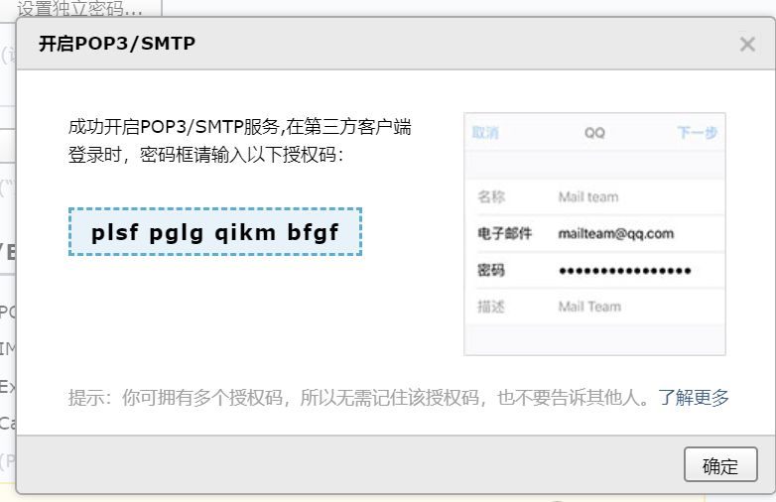

python通过SMTP协议发送邮件失败,报错505或535

<https://blog.csdn.net/fjx1173865548/article/details/57084620>

python自动发邮件总结及实例说明

<https://www.cnblogs.com/yufeihlf/p/5726619.html>

python课程

<https://www.julyedu.com/course/getDetail/66?from=zhpc1/>

#### 批量搜索excel（未验证）

<https://jizhi.im/blog/post/crawler_excel>

<https://blog.csdn.net/u014762921/article/details/77968018>

https://blog.csdn.net/AmyQUE/article/details/50933143