Task2 德州扑克

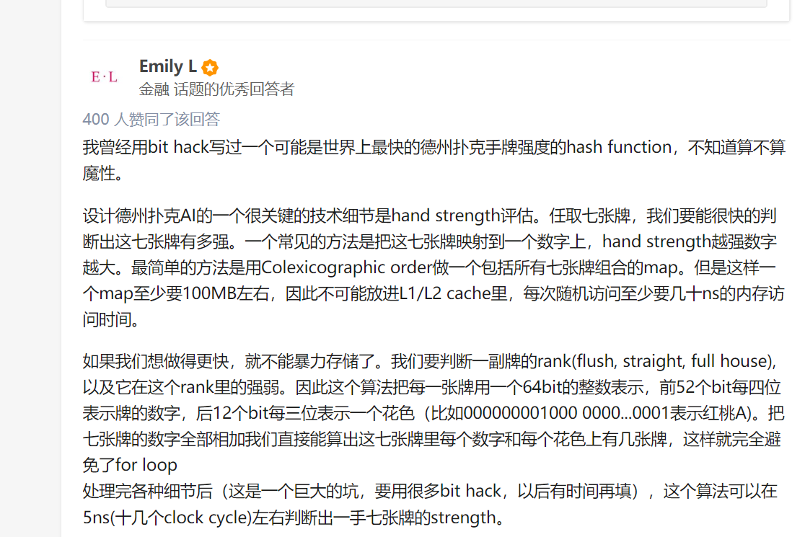

德扑教学

https://www.bilibili.com/video/av9021608/

德扑AI

<http://www.honghaoli.com/2017/06/27/poker-AI-framework-ch/>

对于德州扑克牌手程序的设计问题转化为建立德州扑克牌手模型，并求取纳什均衡条件下的模型参数问题

<https://blog.csdn.net/shiyuan0/article/details/46374649>

德扑程序未验证1

<https://github.com/bubuntux/poker-engine/blob/master/src/main/java/org/dsaw/poker/engine/Card.java>

德扑程序未验证2

<http://www.codeforge.cn/read/39679/%E6%89%91%E5%85%8B%E7%89%8C%E6%B8%B8%E6%88%8F.cpp__html>

## netbeans C++ 环境配置

<https://netbeans.org/kb/docs/cnd/quickstart_zh_CN.html>

<https://netbeans.org/community/releases/80/cpp-setup-instructions.html>

<https://netbeans.org/kb/74/cnd/qt-applications.html>

https://netbeans.org/community/releases/80/cpp-setup-instructions.html#mingw