**Academiejaar 2018 -2018** Bachelor in de INFORMATICA

**A manual to an oasis of silence**

**The Pressure**

# Introduction

This guide will assist you on how to measure Air and Noise quality using sensors through ESP8266 device.

You will need:

* ESP8266
* Air Temperature and Humidity Sensor (DHT11)
* Noise Quality (Microphone KY-038)
* Arduino version 1.8.9
* Account on IBM Watson IoT Platform
* Node-RED

# Setting Up IBM Watson IoT Platform

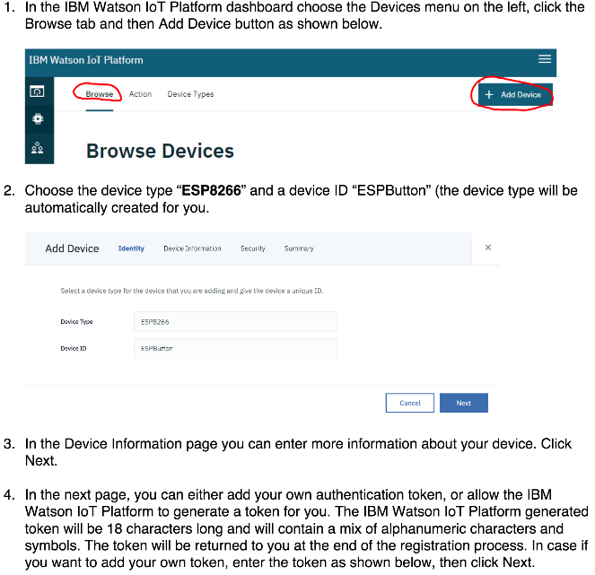

5. At this step, the device should be registered to your Organization and you will be provided with the registration details as marked below. To get your device connected, you need to add the credentials to your device. So make a note of them, especially of the token since this is the last time that you’ll see it.

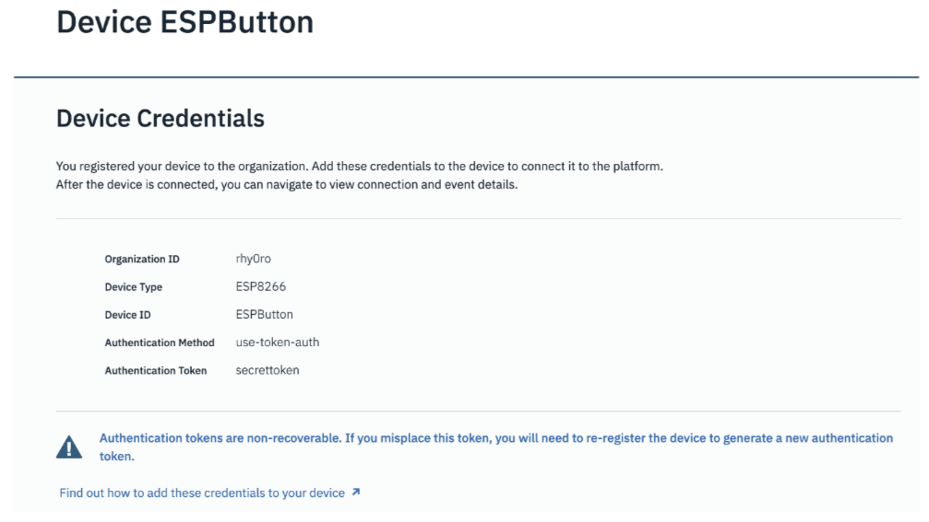

Note:

* Organization ID: Your Organization
* Auth Token: Your Token

6. Now you can see your devices on Browse Devices tab.

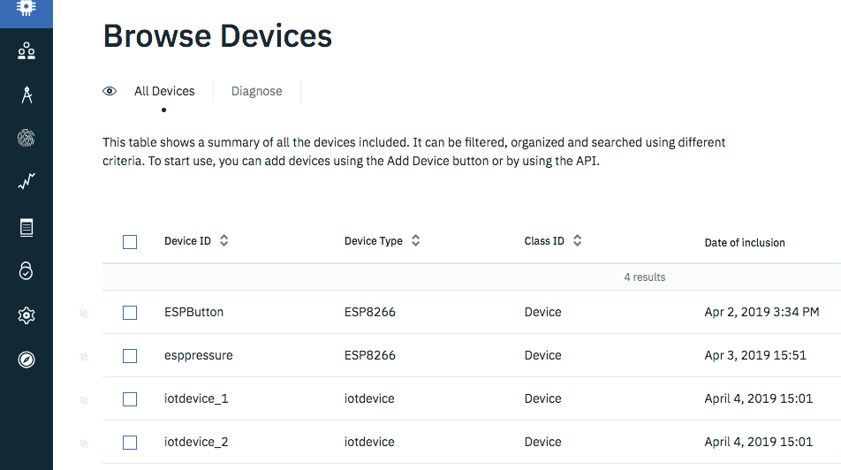

# Connecting the sensors on ESP8266 device

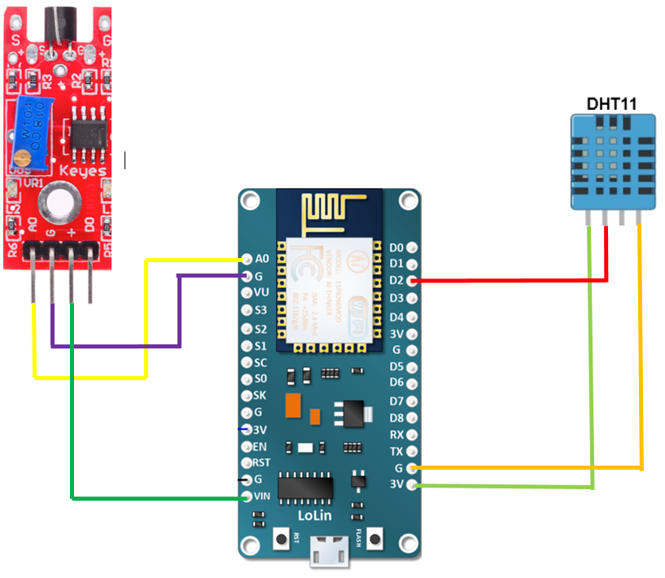Picture above showing ESP8266 Sensor Scheme.

Green cable : +

Red : Digital input

Yellow : - (Ground)

1. Once all the cables and sensors are connected properly it should look like this.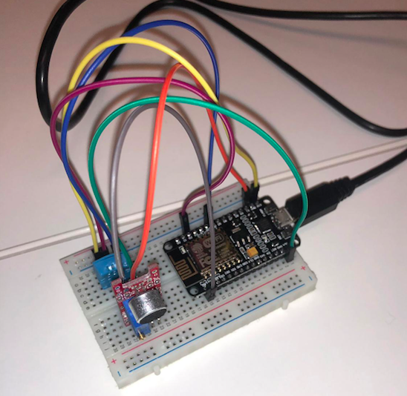
2. Then plug it to the PC and open Arduino.

# Arduino Code

|  |
| --- |
|  |

# Sending data to IBM Platform through MQTT and Arduino

**Prints from arduino Console - Connecting to MQTT and sending data**

## Getting Data on IBM Watson IoT Platform

You can verify the arrival of the JSON payload within the IBM Cloud IoT Platform.

1. Select your device ESPButton from the Browse Devices.
2. Select the “Recent Events” tab as shown below.

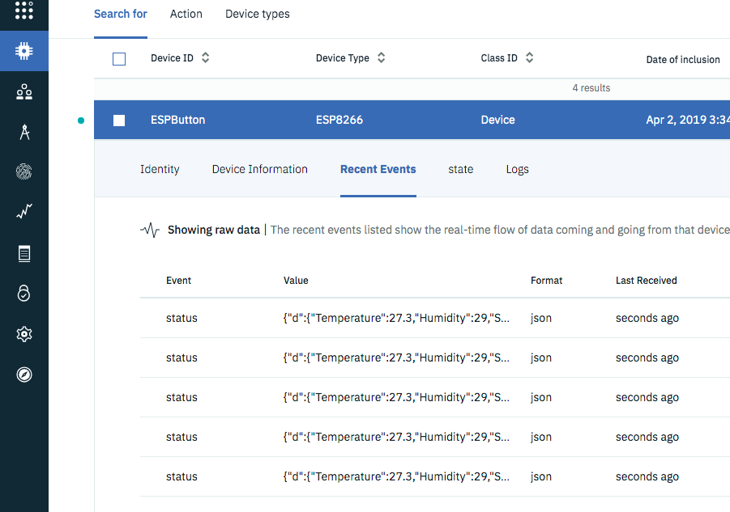

# Node-RED

## Creating a visual representation (node-red dashboard)

1. Set up the connection
   1. Start by creating an ibmiot node and edit the properties.
   2. The authentication should be a bluemix service
   3. The Device Type should be same as the one defined in the IBM Watson IoT Platform

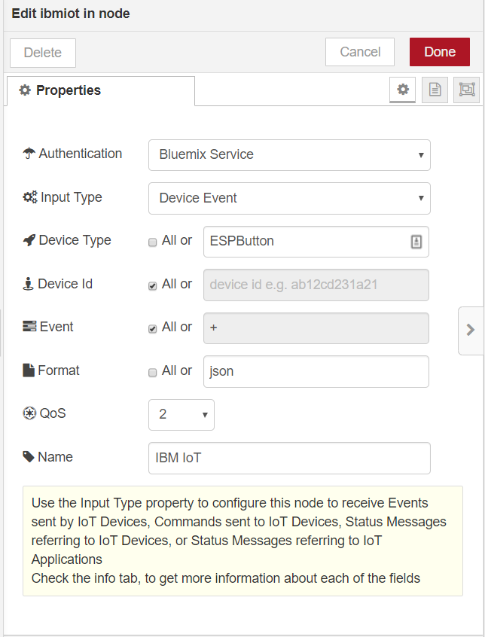

1. Create a function node to extract the wanted information, for this example we will extract the volume information from the JSON.

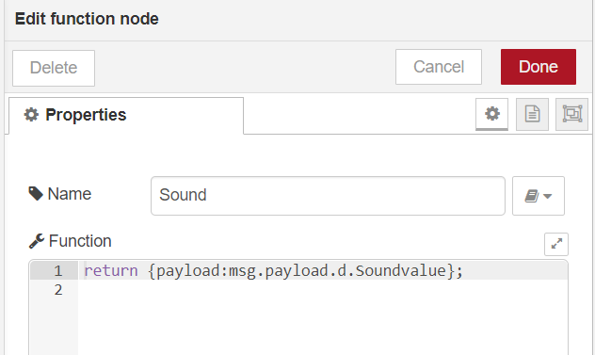

1. Now that we have the necessary information we can add a gauge node, which will visually display the current volume

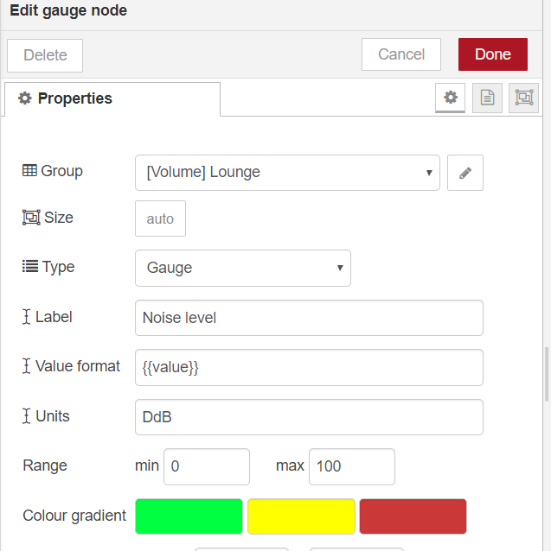

Currently our Node-RED schema looks like this

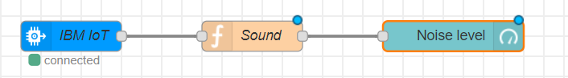

1. Next we add a switch node followed by 3 template nodes. The switch node will analyse the value of the volume and guide it to the correct template

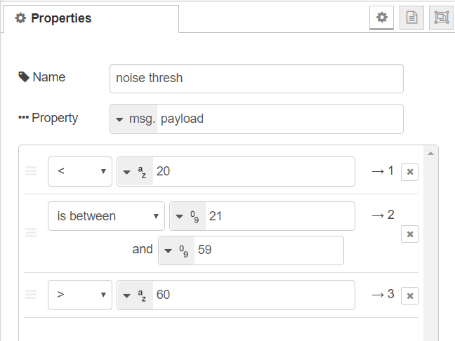

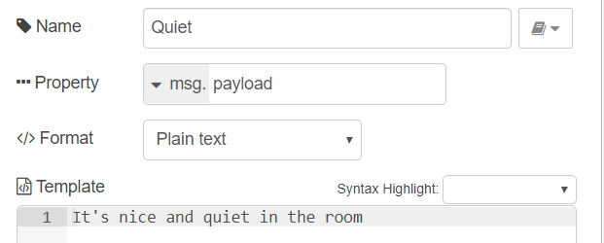

1. And last but not least we will add a text node from dashboard which will display the template. Once we have done all this the result will look similar to this.

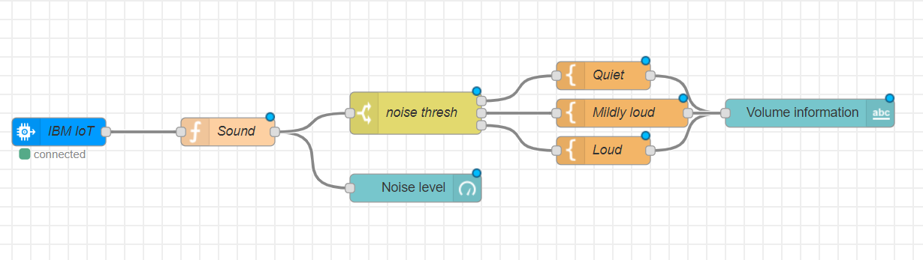

1. Now if we go to dashboard and click on the we will be redirect to a site. Here we can see a gauge with our noise level and below it the message from the template

