**Zabbix Back-end**

Install Zabbix Repository:

* wget https://repo.zabbix.com/zabbix/5.0/ubuntu/pool/main/z/zabbix-release/zabbix-release_5.0-1+focal_all.deb
* dpkg -i zabbix-release_5.0-1+focal_all.deb
* apt update

Install Zabbix sever, frontend and agent:

* apt install Zabbix-server-mysql Zabbix-frondend-php Zabbix-apache-conf Zabbix-agent

Create initial database:

* mysql -u root -p
* password: itf [wachtwoord database bij het instellen van OsTicket, zelde VM!]
* create database Zabbix character set utf8 collate utf8_bin;
* create user zabbix@localhost identified by ‘itf’;
* grant all privileges on Zabbix.* to zabbix@localhost;

On Zabbix server host import initial schema and data. You will be prompted to enter your newly created password.

* zcat /usr/share/doc/zabbix-server-mysql*/create.sql.gz | mysql -uzabbix -p Zabbix

Configure the database for Zabbix server:

Edit file /etc/zabbix/zabbix_server.conf

* DBPassword=itf

Start Zabbix server and agent processes:

Edit file /etc/zabbix/apache.conf, uncomment and set the right timezone for you.

* Php_value date.timezone Europe/Brussels

##### Start Zabbix server and agent processes

##### Start Zabbix server and agent processes and make it start at system boot.

* systemctl restart zabbix-server zabbix-agent apache2
* systemctl enable zabbix-server zabbix-agent apache2

**Zabbix Front-end**

172.27.66.161:8080/zabbix

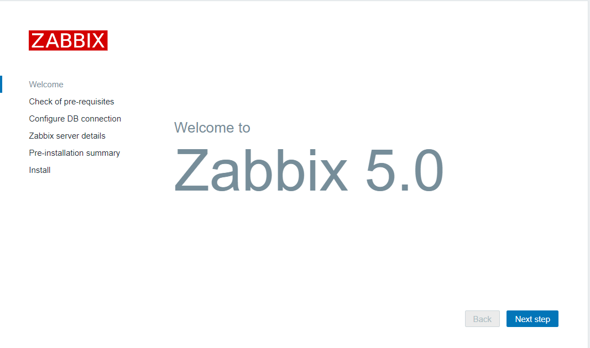

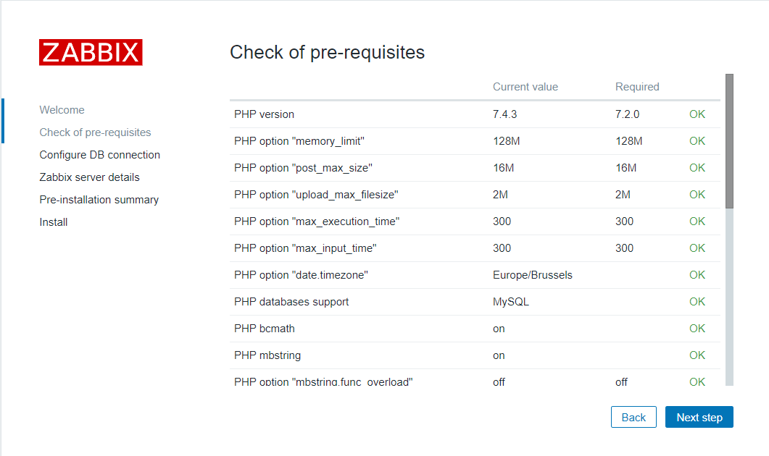

Geef het paswoord in dat je hebt ingegeven bij de installatie. (itf)

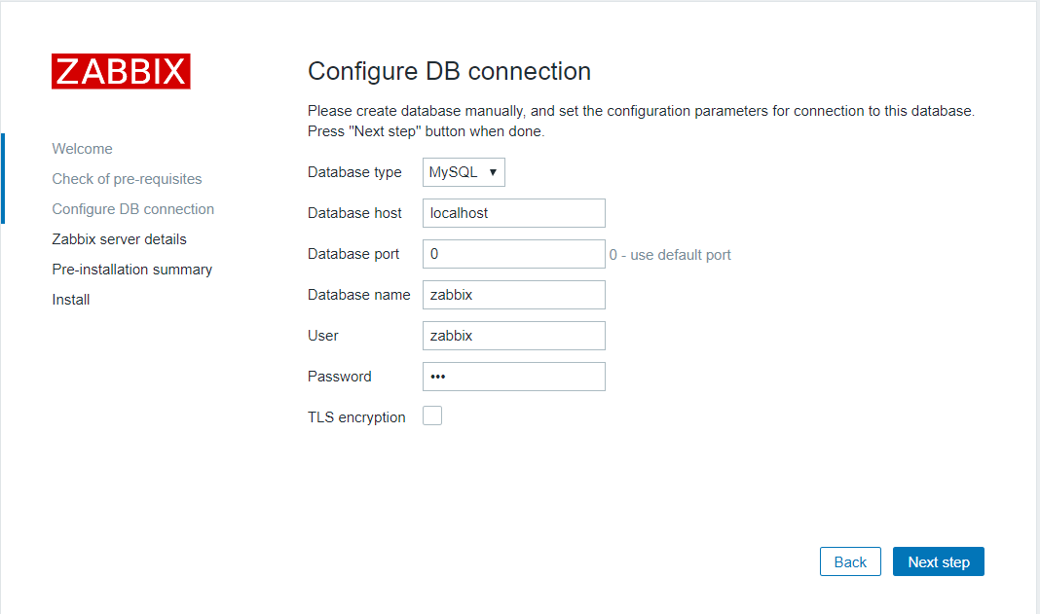

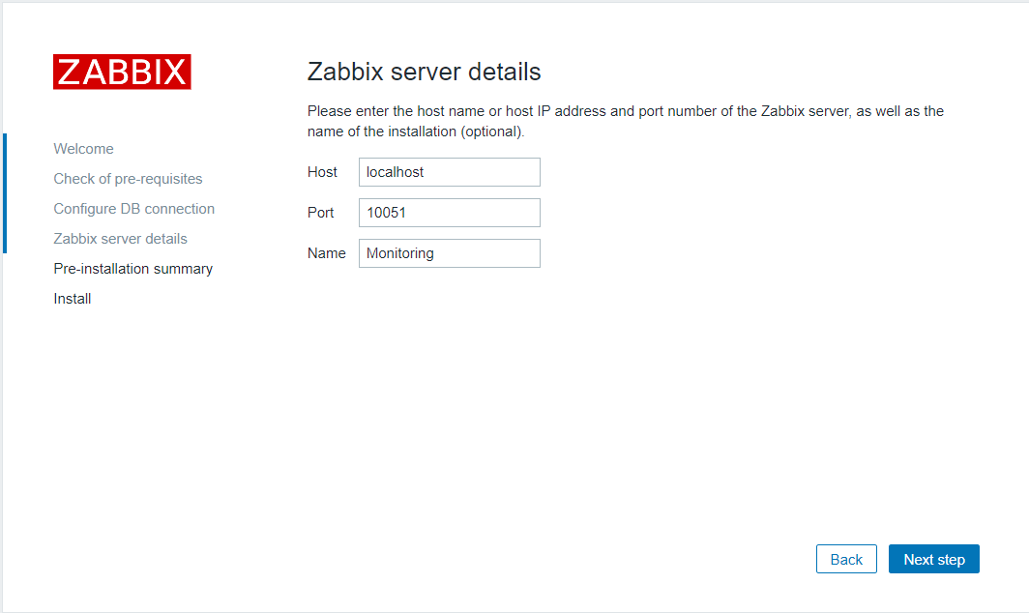

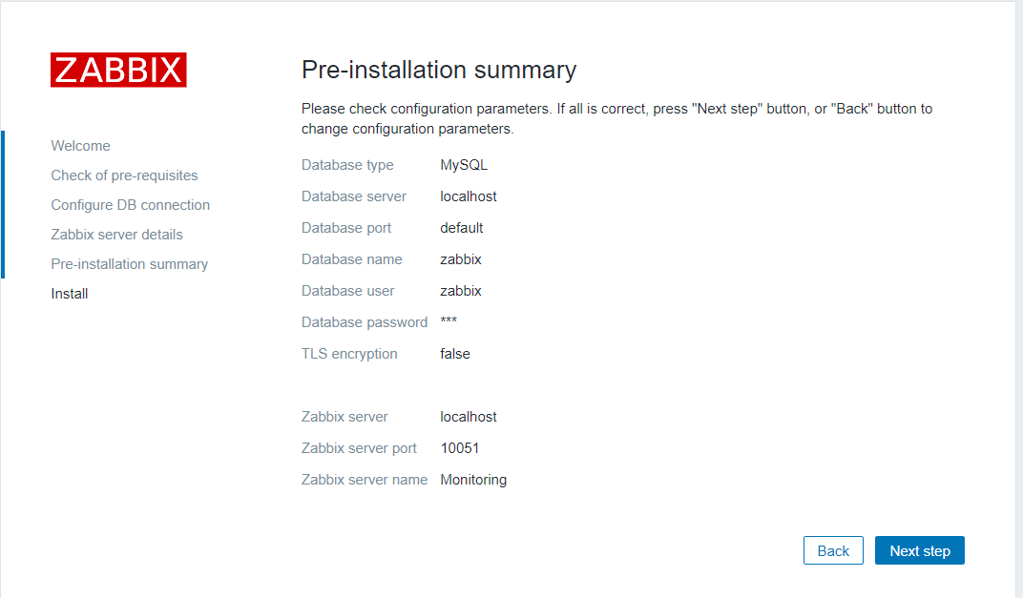

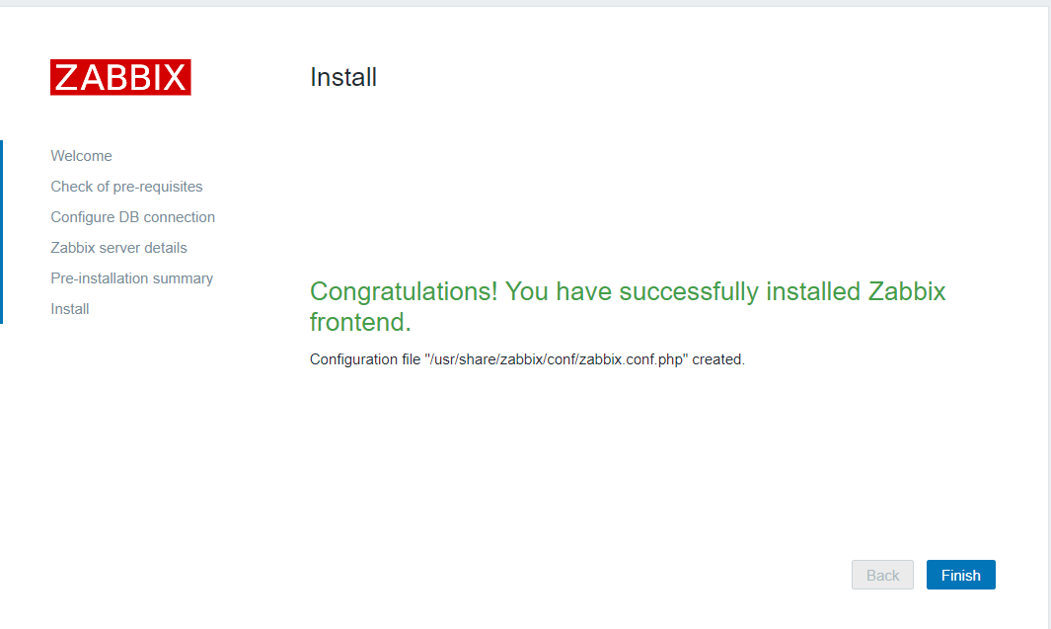

Zabbix frontend is klaar! The default usernaam is **Admin** en het wachtwoord **zabbix**.

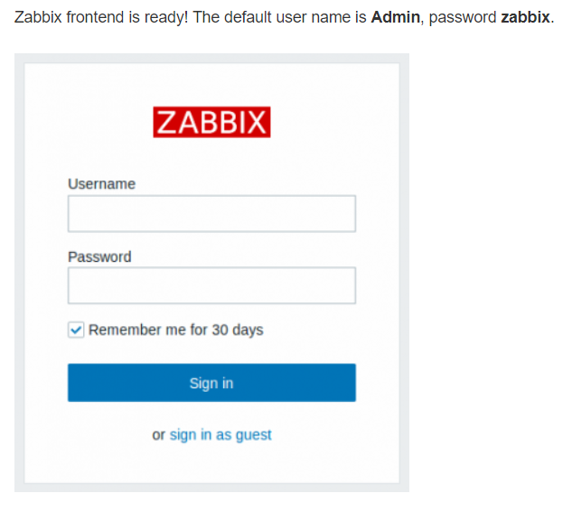

**Installatie Agents**

Nu installeren we in de Agents op de VM’s die we willen monitoren.

We voegen een host toe **Configuration > Hosts > Create Host**

We voegen een template toe aan onze server

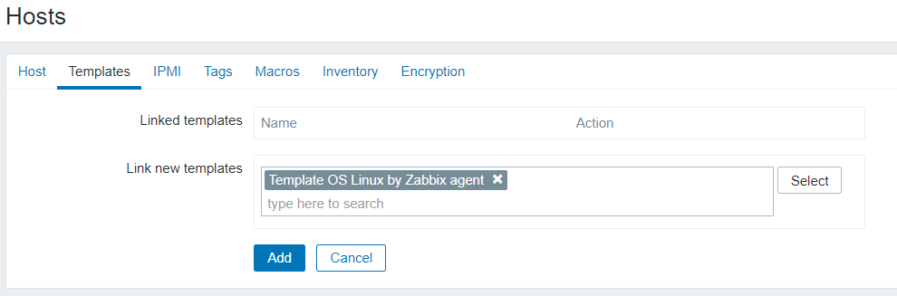

Op de agent zelf downloaden we do nodig software:

* **Sudo apt install zabbix-agant**

We passen de file aan **/etc/zabbix/zabbix_agentd.conf**

 [Zabbix Server]

 [Zabbix server]

We starten de service:

* Sudo service zabbix-agent start
* Sudo service zabbix-agent status

Resultaat:

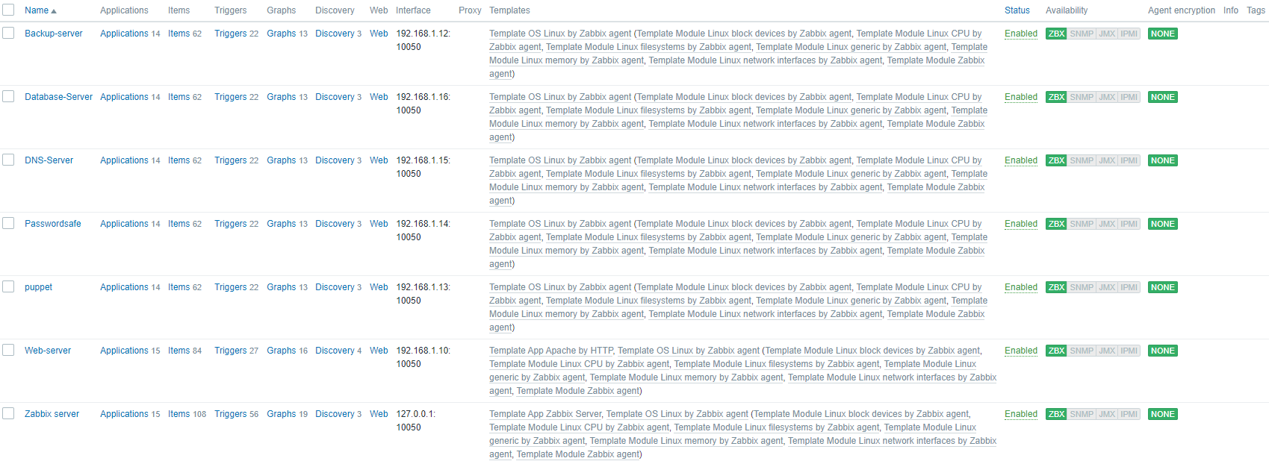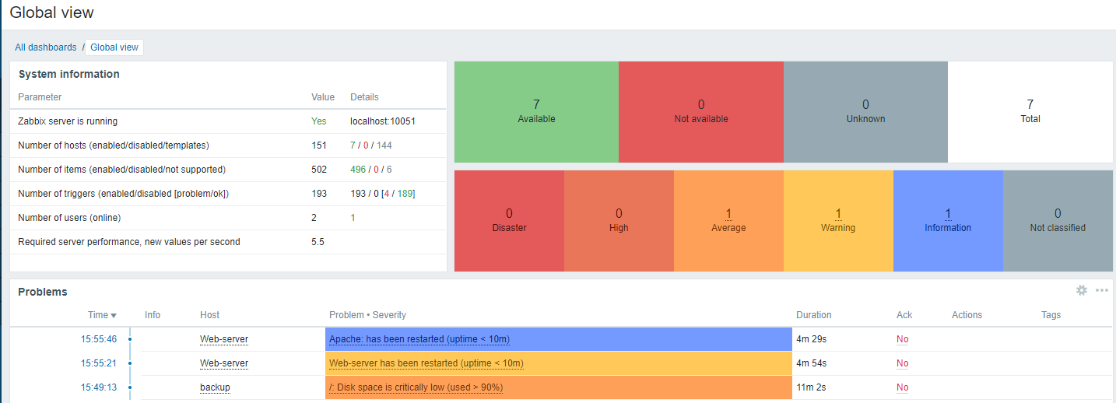

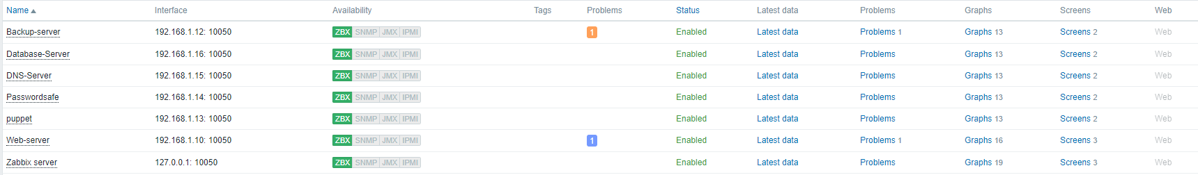

Voorbeeld Graphs Apache Webserver

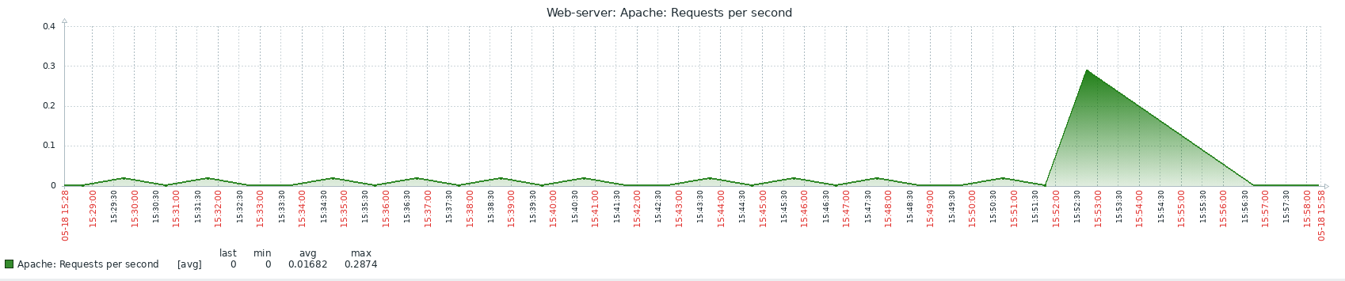

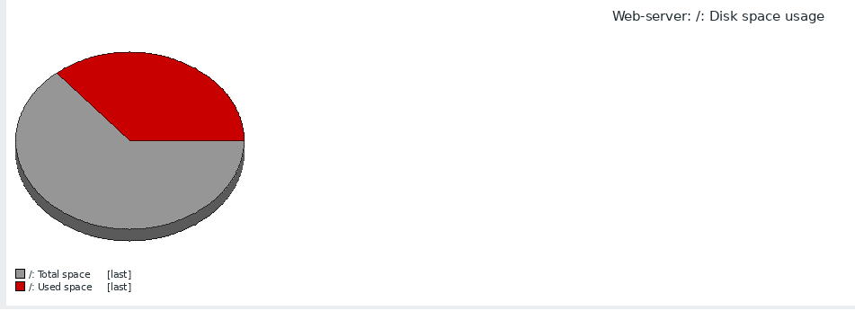

<https://www.zabbix.com/download?zabbix=5.0&os_distribution=ubuntu&os_version=20.04_focal&db=mysql&ws=apache>