**COMP250 REVIEW**

**Lecture 1**

**Algorithm**: a sequence of instructions or operations for manipulating data to produce some result

Grade School Arithmetic:

1. Addition of 2 numbers:

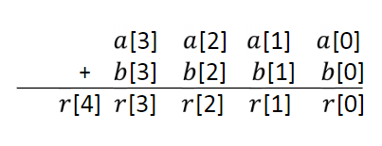

- Use arrays to store each number

- For each column, add r[i] = a[i] + b[i] and carry value to next column

- The result array needs to have 1 more slot than max(a, b)

2. Multiplication of 2 numbers

- Slow: a*b = add a times the number b

- Fast:

- Create 2D array and compute all rows in advance

- For each column, sum of the single digits in the row and add the carry

- Could instead use a running sum and add as we compute the rows

3. Division

- Slow: use num = q * b + r. Subtract num by b, and add 1 to q, until r is smaller than b.

- Fast: long division

**Lecture 2**

Logarithms:

$$\log_{b}{a}=\log_{b}{c}*\log_{c}{a}$$

$$a^{\log_{b}{c}}=c^{\log_{b}{a }}$$

Modulo:

- Quotient remainder theorem: a = b*q + r

- Remainder: a mod b = r

- Convention: find positive remainder

- However, in JAVA:

- In j=Java defined as:

- Addition:

- Multiplication:

$$\left(a*b\right) mod c=\left(\left(a mod c\right)*\left(b mod c\right)\right) mod c$$

Shift elements using mod:

- left shift n spots:

- right shift n spots:

$$index=\left(i+2\right) \% arr.length$$

**Lecture 3**

Base representation:

$${\left(132\right)}_{5}=1*5^{2}+3*5^{1}+2*5^{0}=42$$

Base conversion: m, from decimal to base b

- divide m by b and prepend the remainder of division

- m = previous quotient

Binary Arithmetic:

- Carry when your sum is greater or equal to your base

- carry = # of times you can pull out base from sum

$$carry=\left(a_{i}+b_{i}+carry\right) \% base$$

For all rows, and assign carry to r[n]

**Lecture 3**

Primitive type:

- predefined by the language

- named by a reserve keyword

In Java:

- Integer: byte, short, int, long

- Real num: float, double

- Boolean

- Char

- One can represent $2^{n}$ values with $n$ bits

- One needs $\log_{2}{x}$ (round up) to represent $x$ different values

- One needs $floor((\log_{2}{m)+1)}$ to represent a positive integer $M$

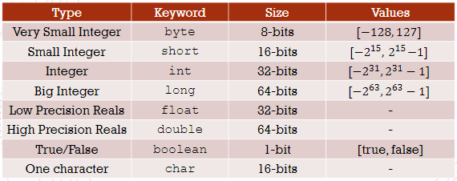

Char

- single quotes

- single character

- A character set: an ordered list of character, **each character corresponds to a number** (i.e. Unicode)

Type Casting:

- Convert back and forth between variables of different types

- Explicit cast is not necessary when going from int -> double, but necessary in reverse!

- In general, widening (going to more bits) does not need explicit type conversion

- Char is more narrow than short, short can store negative values while char cannot, though they are of the same size

**Lecture 5**

**Packages**

- A group of classes: each class is a package member

- A class: a group of methods

- A method: an ordered group of commands

File and folder naming rules in Java:

1. Name of class must match name of file

2. Folder path must match exactly the package name. Each period in package name is a subfolder

Using a package member outside its package:

- write full path

- import the specific class of the package

- import entire package

Java automatically imports java.lang and current package

**Objects and Classes**

- class is a blueprint/template for a type of object

- object: an instance of some class

A class:

- Has attributes/fields

- Constructor (method to create an object)

- Other methods

If you write your own constructor, you **no longer have access** the default constructor!

Inheritance: Every class’ constructor implicitly calls the **super()** constructor. If the constructor is overwritten in the super class, the subclass must have a corresponding **super(with parameters)**

Nested Class

- Define class within another class (outer class)

- Benefits: organize, encapsulation (control over data), readable and maintainable code

**Modifiers**

- keywords that you add to class/method/variable’s definition to change their meaning

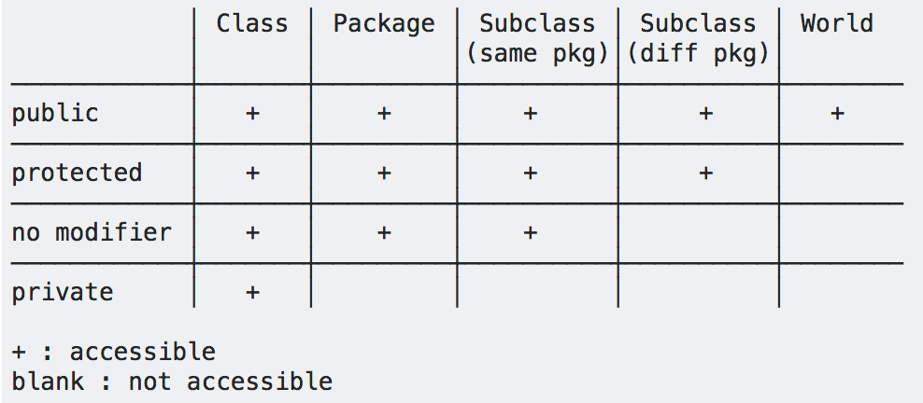

- Only when a member is visible, it can be inherited

- Outer classes can only be declared **public** or **package private**

Encapsulation:

- Wrapping data and code acting on that data in one unit. Better control data

- Make all fields private

- Provide getters and setters

Non-access modifiers:

- static

- final

- abstract

Static:

- fields, methods, and nested classes

- Associated with the entire class and not to a specific instance

- Independent from one specific instance of the class

**- Static fields: class variables**

- Non-static method belongs to an instance of the class

**- Non-static fields: instance variable**

Final:

- Variables, methods, and classes

- Value can never be changed after initial assignment

- Final fields must be initialized

Abstract:

- methods and classes

**UML Diagram**

3 sections:

1. Class name

2. Attributes/Fields

3. Methods

+ if attributes/fields or methods are public and – if they are private

Underline if method or variable is static

#: protected

Local Variables and Fields

- local variables are declared inside a method or block

- fields (class and instance variables) are declared inside a class but outside a method

Differences:

- Scope: where they can be accessed

- local variables: only accessible within method or block of declaration

- class variables: accessible from any method or block within the class

- instance variables: requires existence of an object

Access:

- local variables: cannot have access modifiers. Cannot access local variables from other classes or methods

- Fields: access modifiers, can be accessed from methods within the class and from other classes if public

**Lecture 6**

Inheritance

- a subclass inherits all **public (or protected) fields and methods** from its superclass. Constructors are the only thing not inherited

Object Class

- the only class without a superclass, every class is implicitly a subclass of Object

In the subclass:  
- Declaring a same field: hiding the inherited field

- Writing a **non-static** method with same signature: **overriding**. The non-static method in the **subclass** is called.

- Writing a **static** method with the same signature: **hiding**. The static method in the **superclass** is called.

Overloading

- Two or more methods in the same class with same name but different parameters

Overriding

- Two (non-static) methods with same signature and return type

Constructor

- Default constructor

- Java automatically inserts a call to the no-argument constructor of superclass

Super

- Access members of superclass

- Access overridden methods in the superclass

Modifiers and Inheritance

- A final class cannot be extended!

- A final method cannot be overridden!

**Lecture 7**

toString()

- toString() for **Object** class returns a string consisting of name of class, @, and the hashcode (unsigned hexadecimal representation of hashcode)

- toString() in **String** class returns the object itself

Equals()

- In Object class, equals() is true if and only if they are the same object with the same address

- In String class, equals() is true if both String objects have the same sequence of characters

- In ArrayList class, equals() is true if both lists have same size and corresponding, identical pairs of elements

Clone()

- In ArrayList: clone() returns a shallow copy. Only 1 arraylist

**Type Conversion**

- Implicit upcasting is allowed

- Explicit downcasting: results in run-time error if type casted is of the wrong type

- **Casting does NOT change the object itself, it just labels it differently**

Instanceof

- test whether an object is an instance of the specified type

- returns: true or false

- if the class is a subclass of the specified class: returns true

- a method to prevent error when downcasting

**Lecture 8**

Polymorphism

- JVM calls the **appropriate** method for object that is referred to in each variable. It does not call the method that is defined by the variable’s type

Dog snoopy = new Beagle();

- At compile-time: the compiler uses bark() in Dog class to validate statement

- During run-time: JVM invokes bark() from Beagle class since snoopy is referring to a Beagle object

Abstract

- If you want a class to contain a particular method, but would like the implementation to be specified by the subclass

- **declared without implementation**

Abstract Methods

- the class containing it must be abstract

- every subclass of the current class must either override (implement) the abstract method or declare

Itself as abstract

Abstract Classes

-