Animal Identification and Movement
Control Scheme

Technical
Programming
Concept

PDA System

February, 2004

Table of content:

1 General 3
1.1 Data entry to PDA 3
1.2 Data correction 3
1.3 Time stamps/ID of the tagger 3
1.4 Amount of Data per PDA 3
1.5 Program applications 4
1.6 Batch processing 4
1.7 Maintaining of PDA devices code table 4
1.8 Download HK related data from central database to PDA 5
1.9 Process of synchronizing data between PDA and central I&R database 6
1.10 Upgrade PDA software process 10
1.10.1 BR management on PDA 12
2 Program applications 13
2.1 Identification of tagger 13
2.2 Entering of animal manually/via barcode reader 13
2.3 Changing keeper/holding information 13
2.4 First tagging 14
2.5 Routine registration and tagging on the spot 14
2.6 Communication of movements/death-on-farm on spot 14
2.7 Movement communication at livestock markets and fairs 14
2.8 Holding overview 15
3 Underlying software for PDA I&R solution 16
4 Datailed E-R 17
4.1 System management data 17
4.2 Holder keepers data 18
4.3 Animals and movement data 19
5 User Interface 20
5.1 PDA code table form 20
5.2 Uploaded data view/edit list 20
5.3 Business rules log 21
5.4 HK – PDA synchronization details 21
5.5 PDA synchronization save data report 22
5.6 Identification of tagger 22
5.7 1st tagging campaign 22
5.8 Registration 23
5.9 Communication of movements/death-on-farm on spot 23
5.9.1 Sale 23
5.9.2 Purchase 24
5.10 Movement communication at livestock markets and fairs 24
5.10.1 Sale 24
5.10.2 Purchase 25
5.11 Changing keeper/holding information 25
5.12 Holding overview 25
5.12.1 Keeper attributes 25
5.12.2 Holding summaries 26
5.12.3 Live animals 26
5.12.4 All animals 26
5.12.5 Moved animals 27
6 Data Dictionary 28

General
The PDA programs specified below serve for data capture and data correction of regional I&R Service Units. The applications are based on a PDA database, which is fed by the Central Database of the Central Processing Centre and by data entry to the PDA. Data exchange with the central database is performed by daily (working day) up- and downloads of regional I&R data (animals, holdings, other) via a dial up connection of a regional PC. In order to speed up the transfer time, the transferred data elements only refers to changes, which occurred in the PDA database respectively in the relevant regional data of the central database.
The PDAs are directly allocated to the relevant I&R Service Units, which are identified by unique ID numbers. With regard to regional competence, the relevant ID number of I&R Service Unit the must be stored in the PDA database prior to sending them to the Unit.

Data entry to PDA
Data entry to the PDA can be done in the following way:
- Hand entry
- Touching appropriate buttons on the touch screen
- Reading of barcodes from appropriate forms or from ear tags

Data correction
Simply editing of stored data shall provide data correction. However, in case that the appropriate item is subjected to logical checks, the same checking procedure should apply as with new data entry.

Time stamps/ID of the tagger
In order to enable for full data history an appropriate date and time stamp as well as the tagger ID should accompany each completed date set entered to the PDA.

Amount of Data per PDA
According to the service contract with the service suppliers, there will be a daily up-and download of the PDA with the central database. Therefore the amount of new data stored in the PDA by data entry probably will not exceed 20 KB. However, the total amount of data depends on the no of cows held within the regional I&R Service Unit. The biggest region is Tetovo with approx. 37.000 heads of cattle, which are kept by approx. 11.000 holdings. If a data amount of approx.270 bytes per farm and 80 Bytes per animal, a yearly turn over rate of 35 % of all animals and an average life span of 4 years is assumed, the maximum amount of data roughly sums up to 10 MB per PDA.

Program applications
The applied programs are shown in the following subsections.
Program structure

Batch processing

Users of PDA exchange data via plain text files. In this case exact format of files is defined. Exchanging files is done by file upload and download trough IAS mechanism of uploading and downloading files from/to the database. This is guarantee the file is transferred correctly from origin to destination. If occur the network problem then the error of unsuccessful transfer is shown. This approach is needed for exchanging data with PDA.

Two ways are possible:
- Full download
- Incremental download/upload

In the beginning of installing PDA there will be full download. Then only incremental upload/download will be done. Every data in database has an attribute about date of insertion or modification. On this approach we prepare incremental functionality.

Maintaining of PDA devices code table

Code table holds data regarding which PDA devices can (and are) used for animal identification and registration purposes. Each device is uniquely identified within system and current user of this device is known.

The process of maintaining PDA device code table is as follows:
- user selects “PDA code table” option from appropriate menu
- a new oracle form opens (see user interface section for detail)where the following data can be entered/viewed
  - PDA device id – this field can not be inserted by user, however user can query against values in this field
  - Name of PDA device – value in this field is used for easier identification of PDA device
  - Part number – PDA’s manufacture id which uniquely identifies device. This is unique key in code table (two different devices can not have the same part number)
  - Current user – user of the system, who is currently taking care of PDA device
  - Date of last sync – date of last synchronization between PDA and central database
  - Activity – this checkbox is checked by default. That means that record is valid. If record is not valid any more, then user should uncheck this checkbox. In this case valid to field is automatically set to date, when record is set to not valid any more.

Download HK related data from central database to PDA

This process is similar to all “download” parts of synchronization processes between central database and PDA devices. Download of HK related data can be – from logical point of view – seen as two phase process:
- Initial load of HK related data on PDA – there is no HK related data on PDA device and list of all farms (with appropriate additional data) should be downloaded from central database to PDA. Since there is quite a large amount of data do be transferred, this download will be performed at veterinary department (CPC). Full download can also occur if there is a power supply interrupt (dead batter for example) and data is not stored on part of PDA device storage space that can hold data without constant power supply.
- Incremental load of HK related data – once initial load of HK related data was performed, only changes of data are transferred to PDA from central database
From user’s point of view, both situations are the same, however from system’s point of view there is a great difference between them. According to parameters entered, it is also possible that user select download of already downloaded data. In this case no new set of data is prepared. Instead, previously prepared data is retrieved and re-sent to output file.

The whole process of downloading data from central database to PDA is shown on the following diagrams:

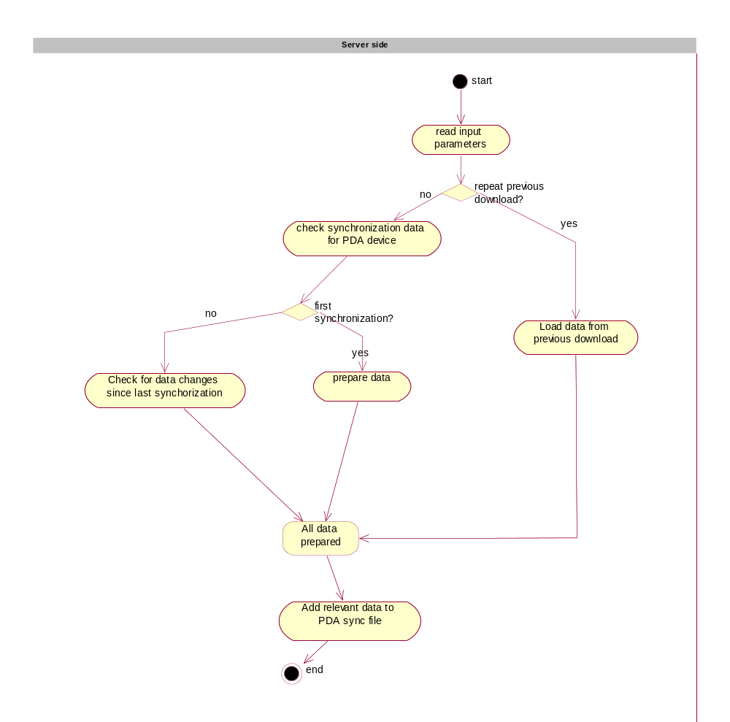

Process of synchronizing data between PDA and central I&R database

Upload:
- On the PDA side “Prepare data for synchronization” has to be selected
- When data is prepared (PDA user receives appropriate message), synchronization process can continue. In case that data is not appropriately prepared, synchronization will fail.
- On personal computer (PC) user has to open (through web browser) appropriate web page for uploading data from PDA.
- On this web page, user has to select file for upload. If PDA device has not been plugged to PC, then this to be done before upload file can be selected. When PDA is plugged to PC, part of its storage space is accessible to user. On this location file to be uploaded can be found.
- When all client-based checking is done (via JavaScript on HTML page), file is uploaded to central database for further processing (see server side processing of uploaded data section for detail).
- As a result of server side processing, a list of results is shown to user for further review.
Download:
- On personal computer (PC) user has to open (through web browser) appropriate web page for downloading data to PDA. Before download can commence, data about which PDA is about to download data has to be provided (otherwise work on PDA will not be possible). In order to meet this requirement the following options are possible:
  - User does nothing – in this case a PDA device where current user is set as default is chosen. This option is the easiest for end user; however it is the least reliable. In case that user wants to download data for PDA for which he/she is not indicated as current user, wrong data set will be downloaded and work on PDA will not be possible. User will have to repeat download.
  - User enters PDA’s part number. In this case PDA device is uniquely identified and the right data set will be downloaded. However there is a (slight) possibility that a typing error occurred. In this case it is possible (if part number entered matches with part number of some other PDA device) to download wrong data set. In this case work on PDA will not be possible, because before data on PDA is transformed into form, that is suitable for further processing, checking if data in downloaded file was prepared for current PDA device is performed.
  - On PDA user selects “Prepare PDA id” option. Result of this operation is file that holds all required identification data about PDA device. This file is put on the part of PDA storage that is accessible to PC. In order to enable PC to “see” part of PDA storage, a special “external” synchronization tool has to be used. This tool is Microsoft’s ActiveSync and it has to be installed on every PC where data is to be transferred from/to the PDA. When this file is prepared, it can be uploaded to database. In this case, central I&R system will have the right data about PDA device for which data set has to be prepared.
- Server side processing of data to be downloaded is performed (see server side processing for download section for detail)
- Data to be downloaded to PDA is prepared. User is prompted to save “download” file to part of PDA device storage, which is accessible from PC. Usually this is HK and movements related data. In case that there exists a newer version of PDA software, the procedure of installing newer version of PDA software is followed (see “download new PDA software” section for details). From technical point of view, it is possible to store download file to PC first and then copy it to PDA.
- On PDA side, user has to login to the application and select option “import downloaded data” before he/she can commence with work. When this option is selected, data from downloaded file is first decrypted and then transformed into form which is suitable for further processing.
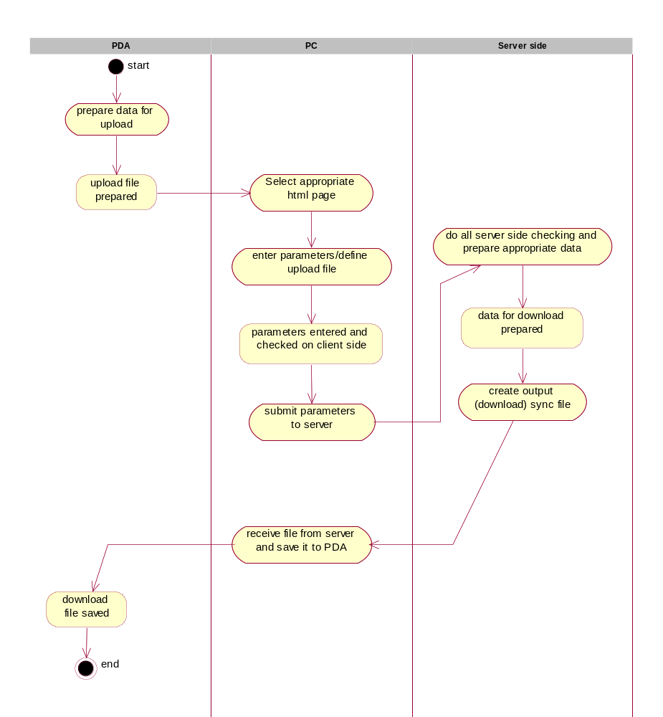

Upload process – server side
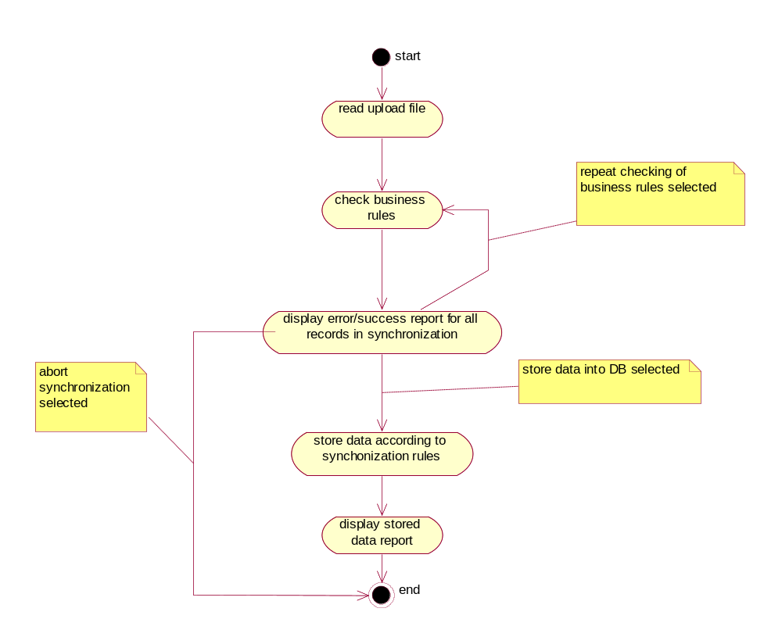

On the server side the following process is in place:
- uploaded file is checked and data is read in appropriate way (each line/record is transformed into form which is suitable for further processing)
- For each record (and in some cases for the whole file) appropriate business rules are triggered.
- Based on data processed and results of business rules checking, a dynamic list (with respective hyperlinks) is created, which is later shown to the user. See user interface section for detail.
- On html page, where the list (mentioned in previous point), user can:
  - View/edit data related to data in a record of the list. This option is available only if user has appropriate privileges to do so and if it makes sense (context related).
  - re-trigger business rules for each record
  - re-trigger business rules for all records that are part of current synchronization process
  - abort current synchronization process
  - define that specific record is to be kept on PDA device (this is taken into account at next download of data from central database)
  - select that file transferred is not fully processed. In this case, records that were not stored into database can be later on re-checked and stored (or rejected) into database.

Upgrade PDA software process

The process of upgrading software that runs on PDA device is as follows:
- As part of downloading process, unique identifier of PDA device has to be provided. Based on this data, current version of PDA software that runs on selected PDA device can be established.
- If software version, which runs on PDA is lower than latest available version, then newer version has to be installed on PDA. In this case a flag that indicates that latest version of PDA software has to be transferred at next download.
- When newer version of PDA software is required then, during download of data, newer version of PDA software is downloaded too. When user on PDA device wants to use newly downloaded data, he/she is first asked to install newer version of software in order to proceed with work.

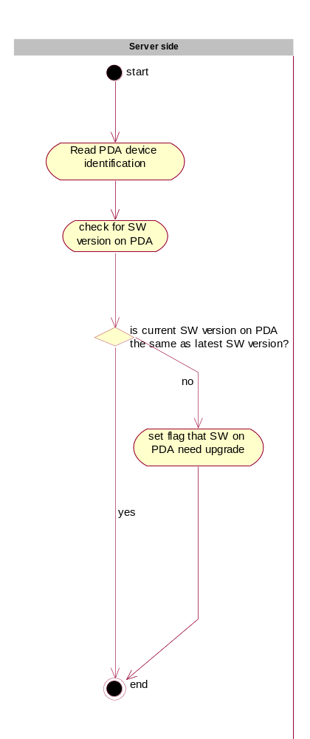

Upgrade of the PDA software applied to the following:
- Upgrade of core functionalities - that may include newer version of data synchronization with the central database subsystem, newer version of barcode reader subsystem, nerwer version of business rules (core) engine, etc
- Upgrade of user interface - this applies to new forms, modified forms, menus,…
- Upgrade of business rules – this applies to new, modified or deleted rules
- Upgrade of data model – this applies to tables and table columns
- Upgrade of “external” synchronization tool – latest version of ActiveSync for the desired version of Windows operating system can be downloaded from the server, to enable data (file) transfer between PDA and personal computer.

BR management on PDA

On PDA, an engine for executing business rules is in place. It operates in a very similar way as correspondent software in central database (even though it is totally different software). That means that every business rule can be switched on or off, or can be triggered if specified condition is met (conditional execution). All business rules are maintained in one place – within central I&R system. Within this system user can decide whether business rule can be implied only within central I&R system, or on PDA as well. However only those business rules, which are implemented within latest version of PDA software can be selected. That means that only a subset of all business rules found in central I&R system will be in place on PDA. This is mainly due to the fact, that only a subset of all data found in central database is replicated to the PDA.

When business rule is changed the following situations may occur:
- System parameter is changed – in this case all changes are automatically replicated to the PDA at next synchronization, because all system parameters are replicated to the PDA. Example: period between two calving is changed
- Condition for execution of business rules is changed – this case is very similar to the changed system parameter case. User (administrator) changes execution condition only in central I&R system and this change is automatically replicated to the PDA at next synchronization. This also applies to the switch off of business rule (business rule is not checked any more).
- Logic of business rule is changed or new business rule is added – this case usually requires programming. In case that new business rule is added to the central I&R and PDA system, it requires coding (programming) on the central database as well as within PDA software. Of course, once business rule is programmatically supported, it can be easily switched on or off (see previous case).

Business rules for download HK related data from central database to PDA

- Only valid user of the system with appropriate privilege can start data download
- User can not start download of data if he/she is not current keeper of PDA device or he/she does not belong to organization which employs current keeper of PDA device.

Program applications
The software solution will cover all processes described PDA Program Specification (File PDA specification.doc). Document is attached this document.

Identification of tagger

Tagger ID is entered manually or by reading of barcode of tagger ID from Tagger ID card. We sugest also entering a password of tagger for performing high security. If the CPC disable The program checks the tagger by his Tagger ID. As written down on his ID card immediately after switch-on. For security sake, any further application should be blocked in case of entry of a non-valid tagger ID. Up to 3 trials to enter a correct tagger ID should be enabled. Thereafter the device should be blocked totally and only be de-blocked by the System Administrator from CPC (prevention from unauthorized use and theft). The tagger is stored with each of the entries entered thereafter.

Detailed process and business rules are described in PDA Program Specification in chapter 2.

Entering of animal manually/via barcode reader

When barcode reader is used for entering animal’s id, all data is obtained automatically. When manual entering of data is selected, user has to first check, that he/she is entering data manually. In this case state of animal’s eartag has to be entered. Also a device “source” must be selected via appropriate radio button.

Changing keeper/holding information

Veterinaries on the field can obtain better real world picture of holder keepers and farms than CPC. It is in great interest of veterinary department to have as much data as possible about situation on the field even though it is not always 100% correct. To provide support for these actions, system allows veterinaries to enter data about new farms and holder keepers on the field and to correct data about farms and holder keepers that are already entered into the system. However no data can be stored into “real” HK tables until veterinary department confirms that new data is valid. This can be done when veterinary department receives hard copy (signed) from the field, which confirms validity of data. When updating HK related data on the PDA the following processes and business rules have to be followed:
- Farm id can not be changed
- When any field is changed, a special flag is set indicating that record has been changed and has to be treated differently than other records when synchronization of data with central database occur.
- Updated data is stored into special “temporary” tables awaiting authorization from veterinary department before “real” tables are updated with changed data.

PDA user has also option to fill in proposals for new farm and holder keeper registrations. When new data is entered the following procedure/business rules should be followed:
- user enters new farm and HK data, however entering of farm_id is not possible.
- farm_id is automatically calculated according to the following formula:
next_farm_id=PDA_DEVICE_ID*100000+next_value_of_counter_on_pda
This formula enables unique numbering of farms without need for permanent online connection with central I&R database.
- PDA user can use this newly “registered farm” (farm_id) for entering movements. When veterinary department properly register these “fictive” farms, their farm id is changed to “real” farm id. The real farm id is then downloaded to PDA at next download of data from central I&R database to PDA device.

Detailed process and business rules are described in PDA Program Specification in chapter 3.

First tagging

The program provides data capture of animals at 1st tagging campaign. Data capture of individuals should start with the eldest animal. Thereby it is ensured that the animal exists when referenced to as a mother of subsequent progenies. Data capture refers to animals which still are to be tagged as well as to tagged animals of the pilot project.
In the latter case the animal keeps the old ear tag, the animal ID is entered by hand and the program converts the animal ID into the appropriate ISO code.
Compared to routine tagging the identification of mother ID is not obligatory. However, in case that a mother ID is entered, the full range of checks – apart from recent calving dates – is applied. The mother ID also may origin from the Pilot Project.
In case of data inconsistency, appropriate corrections of the animal’s data or of the data of the mother should be enabled immediately in the course of data capture.
In the central data base the animals must be identified as “Animal – 1st tagging” as they represent founder animals with limited data background

Detailed process and business rules are described in PDA Program Specification in chapter 4.

Routine registration and tagging on the spot

The program provides registration of each new born calf on the spot; independently whether preliminary notification of the calf’s birth was made or not. Tagging is done immediately after registration.
For security reasons, the mother ID preferably should be scanned from the cattle passport of the mother. By this way it is ensured that the mother is existent on the relevant holding. However, in case of missing mother passport, it should be checked whether the mother was sold or purchased. If either one of those possibilities applies, an off- or on-farm movement communication has to be executed correspondingly prior to registration of the young calf.
The new animal ID is scanned from the ear tag.

It should be noted that a handwritten tagging receipt is issued to the tagger containing the animal ID, holding ID and tagging date. Therefore, the newly tagged animal always can be identified, even in case of data losses.

Detailed process and business rules are described in PDA Program Specification in chapter 5.

Communication of movements/death-on-farm on spot
The program provides communication of movements/death on farm carried out on the spot and replacing communication of movements by postcards. In case of sale or purchase only the movement of the selling resp. purchasing farm may be communicated whereas the recipient resp. sender must communicate the movement by their competent VS separately.

Detailed process and business rules are described in PDA Program Specification in chapter 6.

Movement communication at livestock markets and fairs
The program provides communication of movements on livestock markets carried out commissioned VS. In case of sale, the application creates at least 2 movements:
  - Off-holding movement of selling keeper
  - On-holding movement of livestock market
The purchaser can commission VS additionally with 1 or 2 movements:
  - Off-holding movement of livestock market (in case of purchase or slaughter)
  - On-holding movement of purchasing keeper (in case purchase)
Note: In case that the holding ID is not equivalent to the keeper ID as written down in the keeper passport, the holding ID must be entered by hand.
In case that sale did not come about, the purchaser is seen as equivalent to the seller.
The movement date is taken from the system date

Detailed process and business rules are described in PDA Program Specification in chapter 7.

Holding overview

The program provides a holding overview about keeper attributes as well as about the number of registered animals of the relevant holding. It serves especially the needs of inspections on the spot. The program helps to detect animals that might be sold, purchased or died. After keeper identification, the buttons for the following applications appear which are to be activated by the touch screen:
        - Keeper attributes
Keeper address
Other keeper attributes as shown on the census form
        - Holding summaries:
Total no of animals on holding
Total no of alive animals on holding
Total no of purchased animals
Total no of farm-off movements
        - Individual list of alive animals sorted by birth date
Animal ID
Birth date of the Animal
Age of the Animal
Most recent calving date
State of the animal (born on farm/purchased)
        - Individual list of all animals of holding sorted by birth date
Animal ID
Birth date of the Animal
Most recent calving date
State of the animal (born on farm/purchased/sold/dead/alive)
        - Individual list of all moved animals sort by birth date
Animal ID
Birth date of the Animal
State of the animal (purchased/sold/dead/slaughtered)

Detailed process and business rules are described in PDA Program Specification in chapter 8.

Underlying software for PDA I&R solution

According to the investigation made for the project and technologies that should be used, the following technologies and applications will be used:

On PDA running WinCE:
- Visual Studio .NET C#
- Database: SQL CE
- Connection: ActiveSync

Desktop PC running Windows NT based OS:
- Visual Studio C++ 6.0
- Connection: ActiveSync
- Internet Browser

Central database :
- Oracle

Datailed E-R

System management data

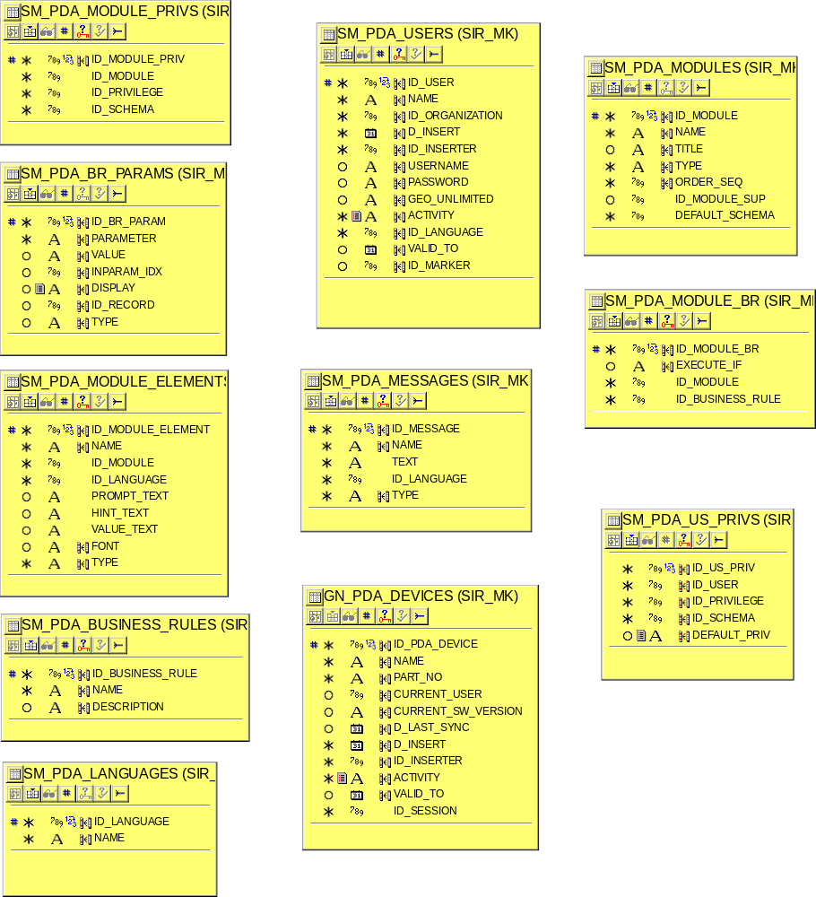

Holder keepers data

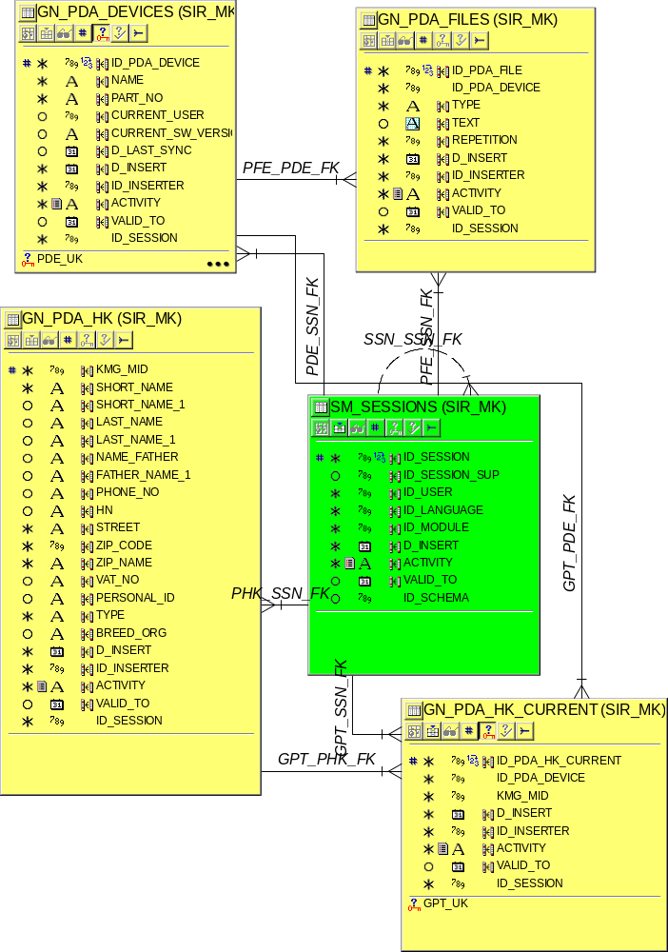

Animals and movement data

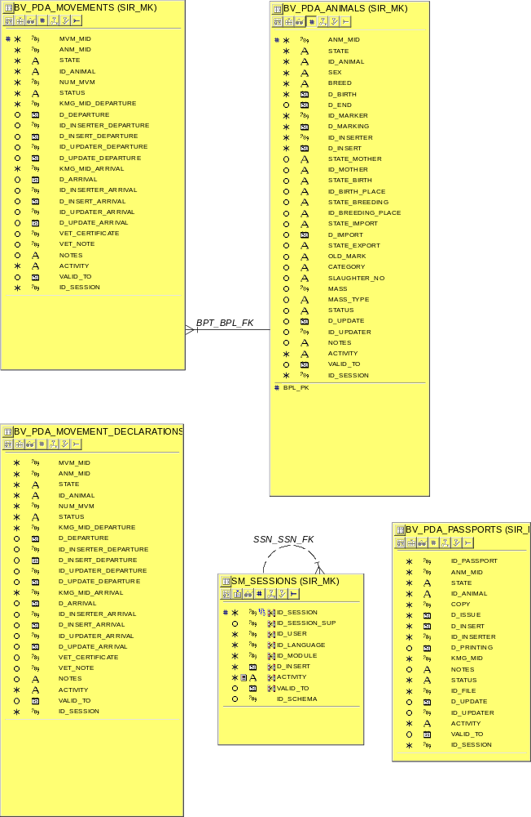

User Interface

All user interface screen forms are presented in English. In production all screen forms will be in Macedonian language and in Cyrillic code page.

PDA code table form

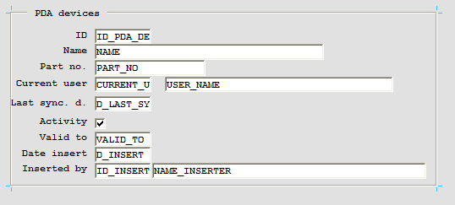

Uploaded data view/edit list

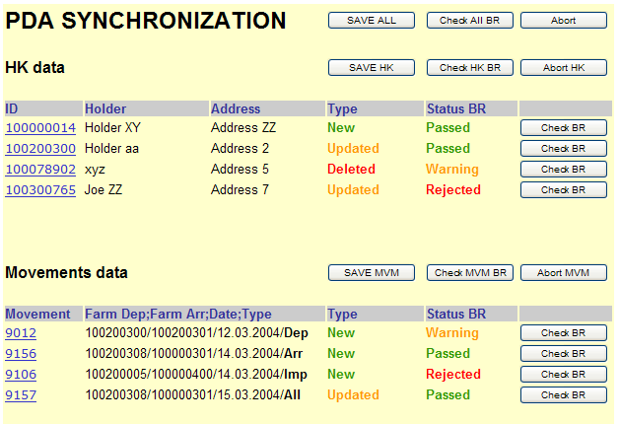

Business rules log

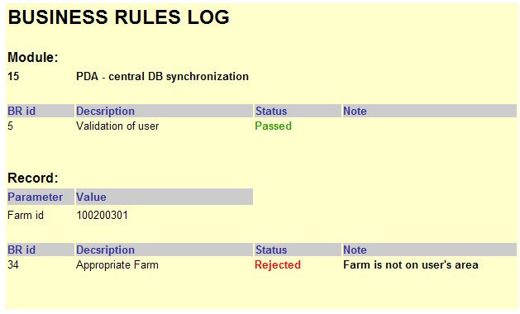

HK – PDA synchronization details

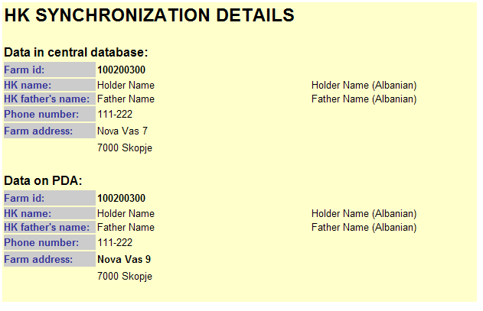

PDA synchronization save data report

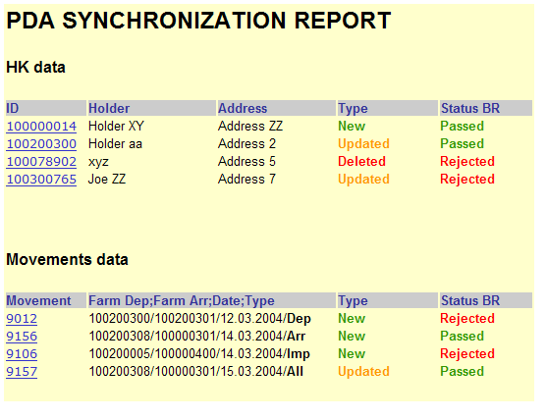

Identification of tagger

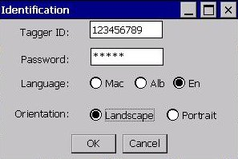

1st tagging campaign

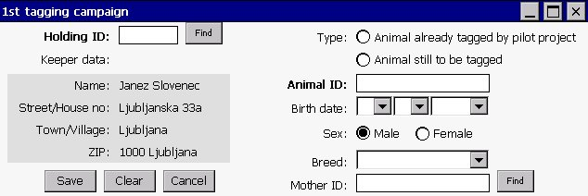

Registration

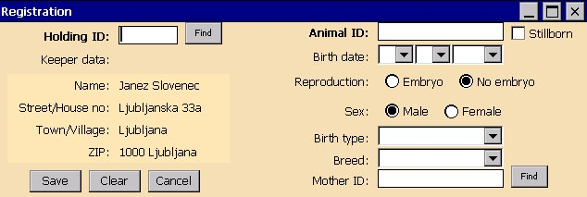

Communication of movements/death-on-farm on spot
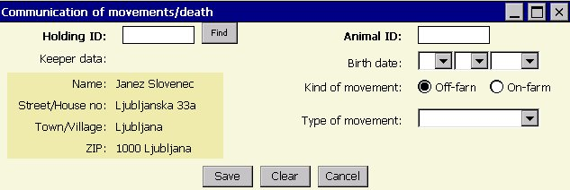

Sale
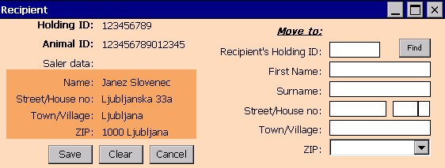

Purchase
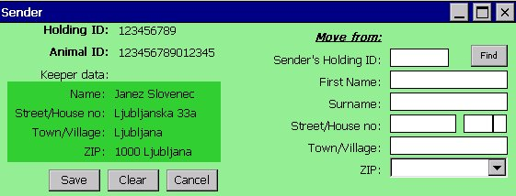

Movement communication at livestock markets and fairs

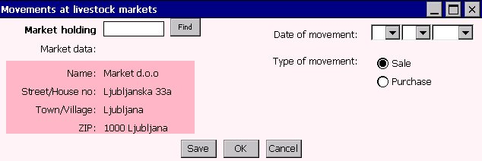

Sale
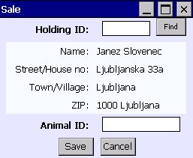

Purchase
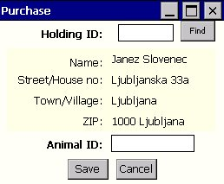

Changing keeper/holding information

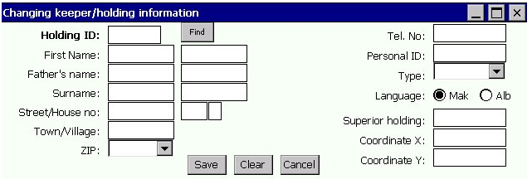

Holding overview

Keeper attributes

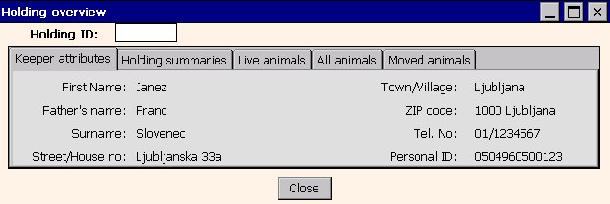

Holding summaries

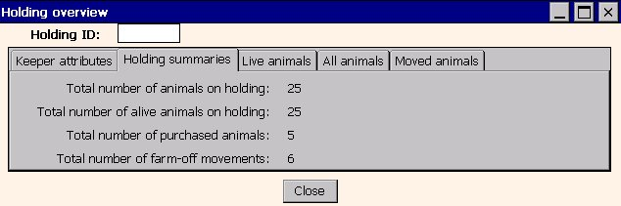

Live animals

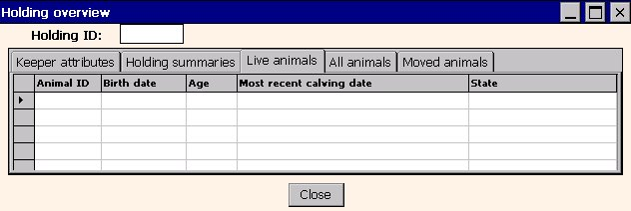

All animals

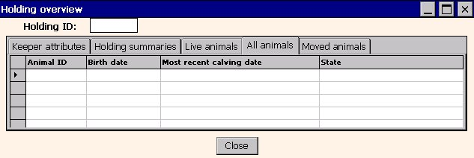

Moved animals

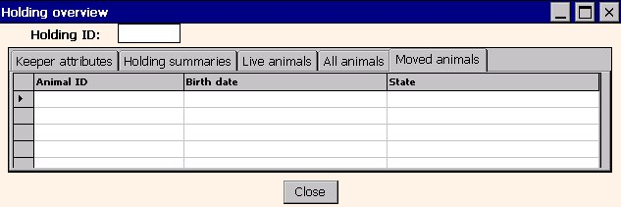

Data Dictionary

Data dictionary is prepared in pdf files which are appended this document.
It is divided in three topics.That files are:
- System_Management Administration_PDA.pdf
- Holder_Keepers-Address_Maintenance_PDA.pdf
- Animals-Movements-Passports_PDA.pdf

