Laboratory Work 8: Smart Help Desk
Implementing Behavioral Design Patterns
Student: Zere Yermekkyzy
Date: 31 October 2026

Objective
The Smart Help Desk application was built in Python and Flask, and all 12 lab tests passed. It stores support tickets in memory and uses five behavioral design patterns to organize its logic:
- Chain of Responsibility
- Command
- Interpreter
- Iterator
- Mediator
Users can create, view, filter, resolve and delete tickets. Each ticket has an ID, title, description, category and status.

Implementation
The application was built on Windows 11 with Python 3.13.15 and Flask 3.1.3. No database is used, so tickets reset when the server restarts.
smart_help_desk/
├── app.py Flask application and routes
├── models.py Ticket data model
├── patterns/
│ ├── __init__.py
│ ├── validation.py Chain of Responsibility
│ ├── commands.py Command
│ ├── interpreter.py Interpreter
│ ├── iterator.py Iterator
│ └── mediator.py Mediator
├── templates/
│ └── index.html
└── static/
└── style.css
The lab places all Python code in app.py. Here it is split so that each pattern has its own file. The classes and behavior are unchanged, and all 12 tests passed again after the split.
The lab's setup commands are for macOS and Linux. On Windows the virtual environment is activated with venv\Scripts\activate instead of source venv/bin/activate. This project used the existing PyCharm virtual environment, .venv, one folder above smart_help_desk.
To run the application, open smart_help_desk in the terminal, run python app.py, and go to http://127.0.0.1:5000.

Testing
All 12 tests passed in Microsoft Edge against the running Flask server, using an automated browser script.
# | Test | Result | Observed
1 | Three example tickets appear | Pass | 3 tickets shown
2 | Create a new ticket | Pass | 4 tickets; "Ticket added successfully."
3 | Submit an empty title | Pass | "Title is required."; ticket count unchanged
4 | Submit a description under 10 characters | Pass | "Description must contain at least 10 characters."; ticket count unchanged
5 | Filter status:open | Pass | 3 tickets, all Open
6 | Filter status:resolved | Pass | 1 ticket, Resolved
7 | Filter category:IT | Pass | 2 tickets, both IT
8 | Filter status:open category:IT | Pass | 1 ticket, Open and IT
9 | Mark an open ticket as resolved | Pass | "Ticket marked as resolved."; the button disappears
10 | Delete a ticket | Pass | 4 tickets became 3; "Ticket deleted."
11 | Click Show all | Pass | 2 filtered tickets became all 3 remaining
12 | Filter status:waiting | Pass | "Invalid filter: status:waiting. Check the status or category value."

Three details affect how these results read:
- Test order: test 9 ran before tests 5 and 6, so status:resolved had a ticket to show. A second ticket (Wi-Fi) was resolved before test 8, so the combined filter returned fewer tickets than category:IT alone.
- Test 3: the browser's required check blocks a truly empty title before it reaches the server. A title of only spaces was used to reach the server-side validation.
- Test 4: the browser's minlength check also blocks this case, so it was turned off for this one submission to show the server-side message.

Screenshots
The screenshots below show the running application at http://127.0.0.1:5000, numbered to match the tests. Tests 5 to 7 show the state after test 9, and test 8 shows the state after the Wi-Fi ticket was also resolved.

Test 1: Three example tickets
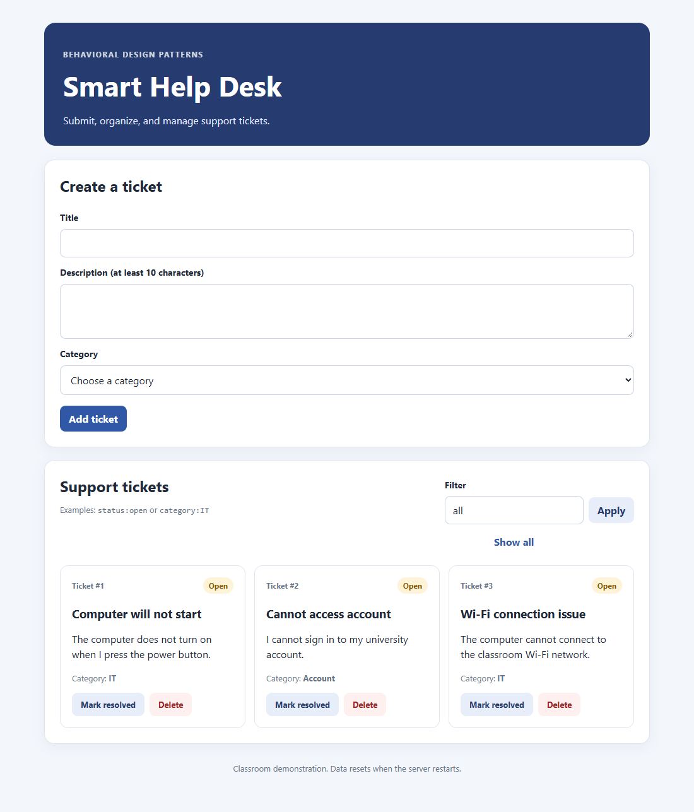

Test 2: New ticket created
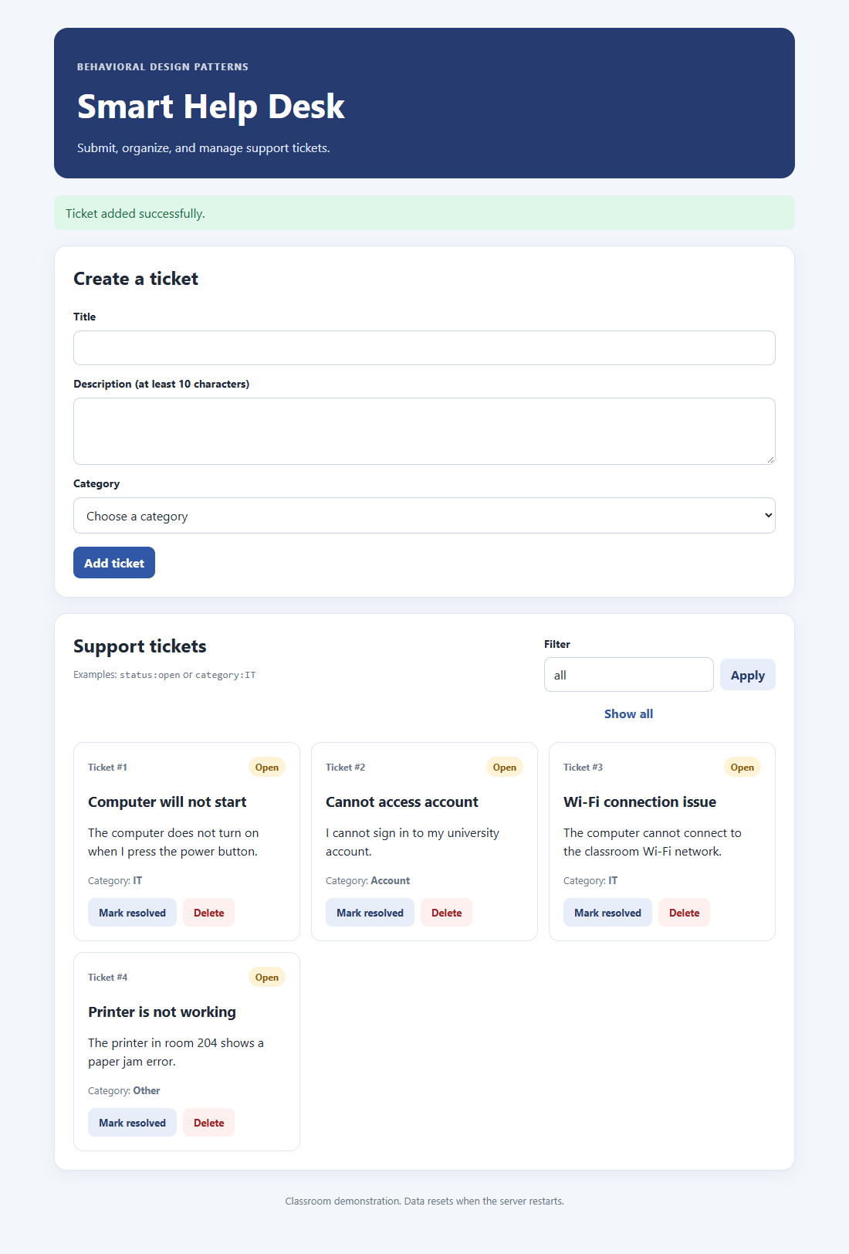

Test 3: Empty title rejected
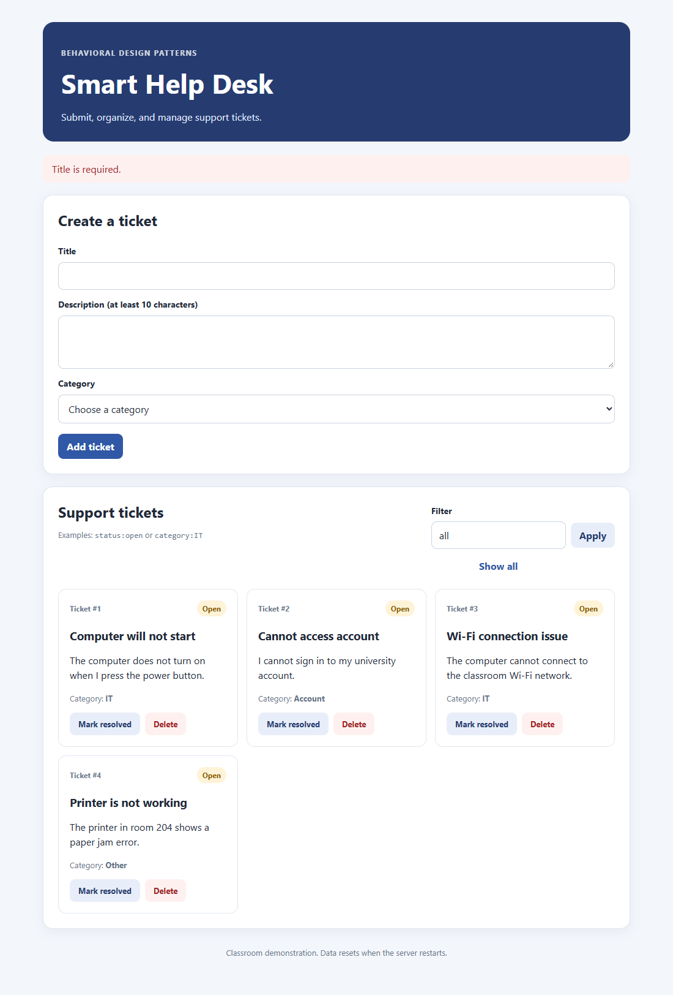

Test 4: Short description rejected
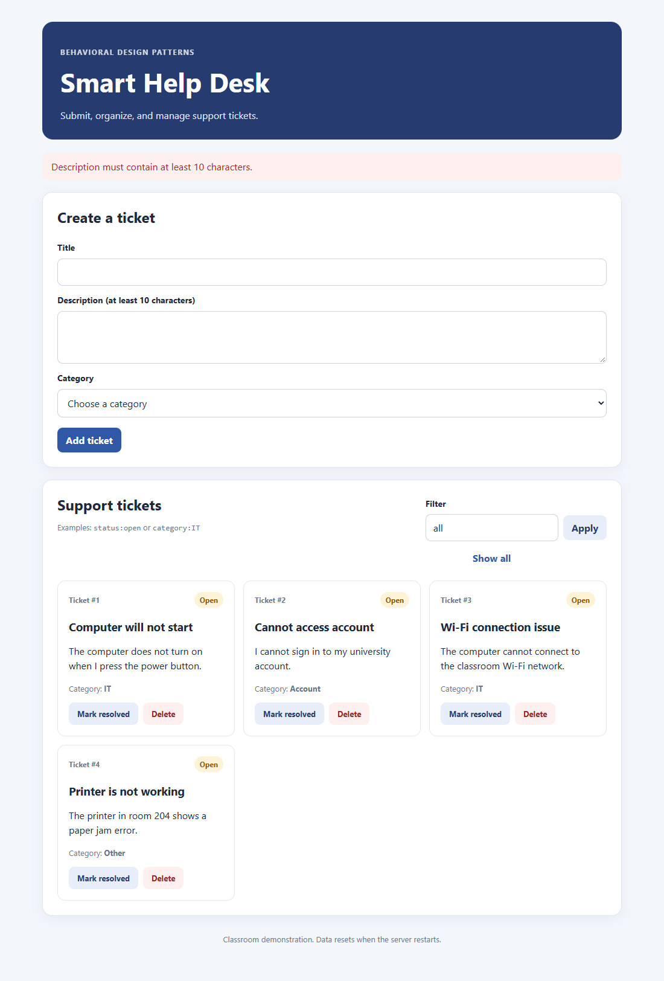

Test 5: Filter status:open
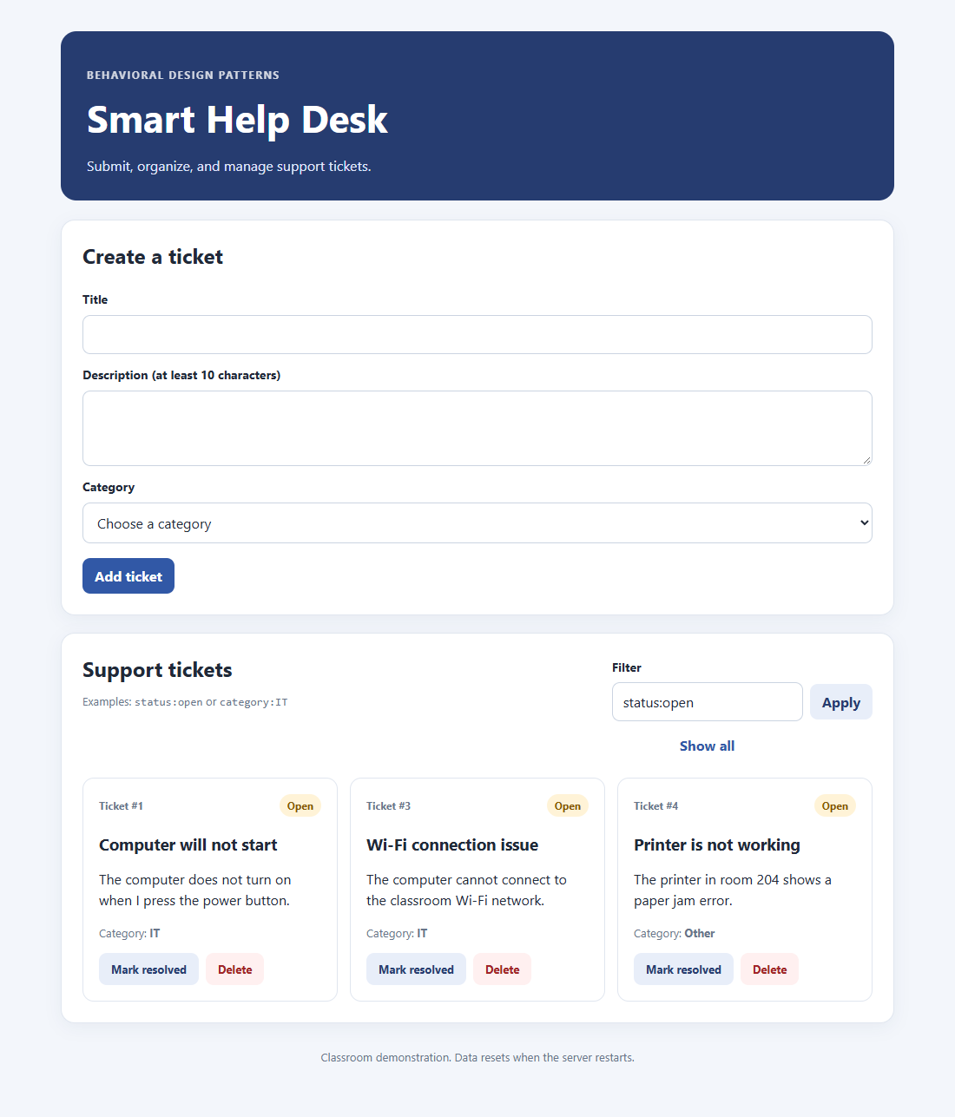

Test 6: Filter status:resolved
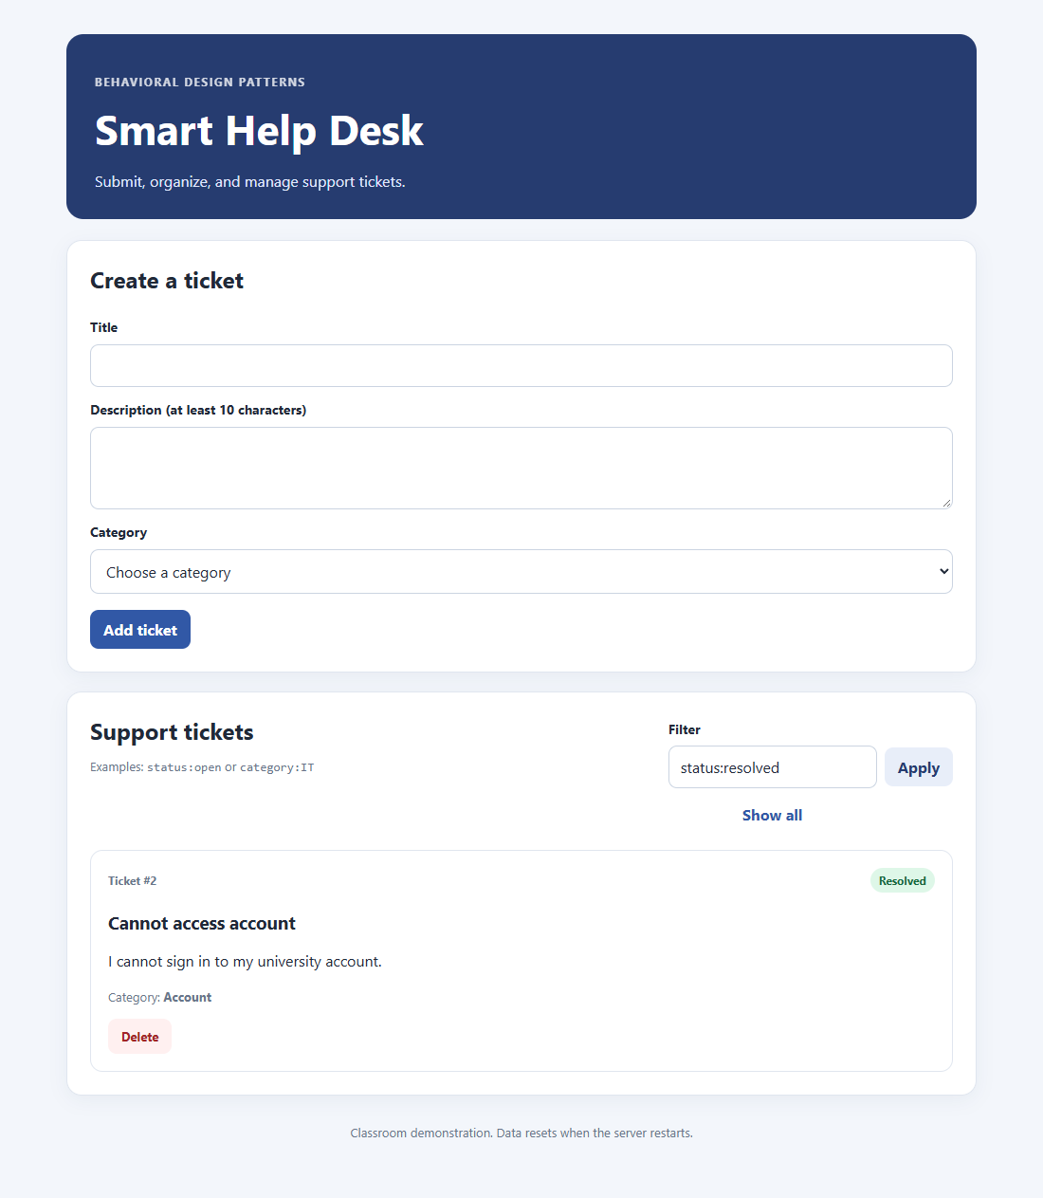

Test 7: Filter category:IT
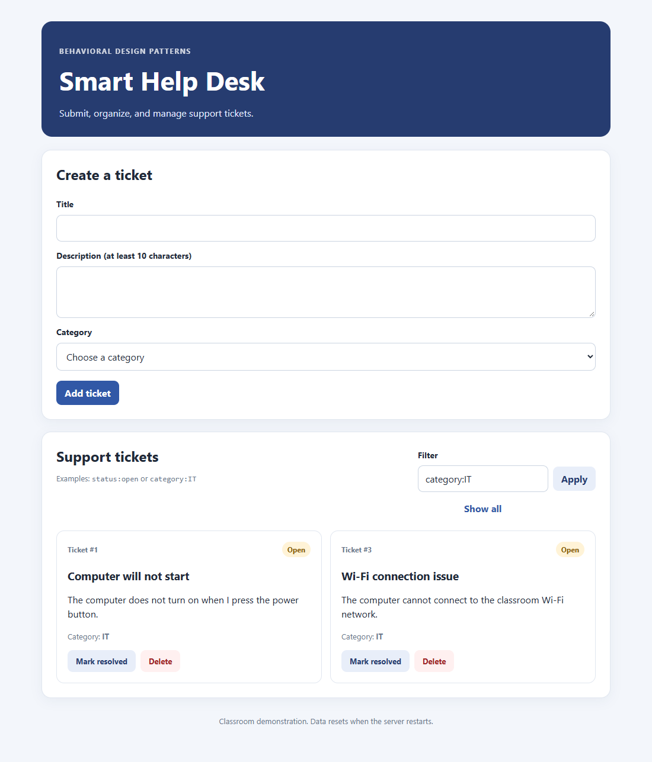

Test 8: Filter status:open category:IT
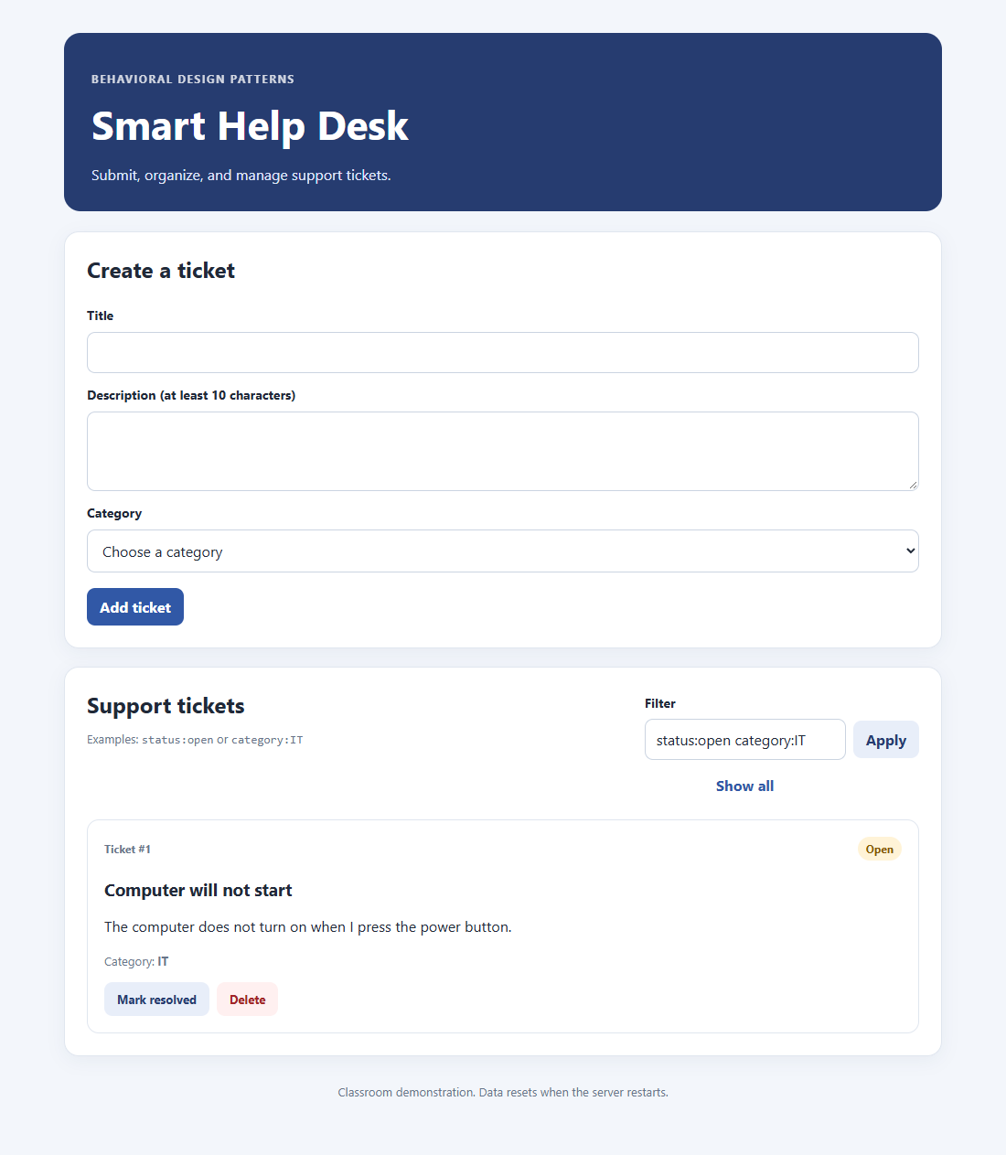

Test 9: Ticket marked as resolved
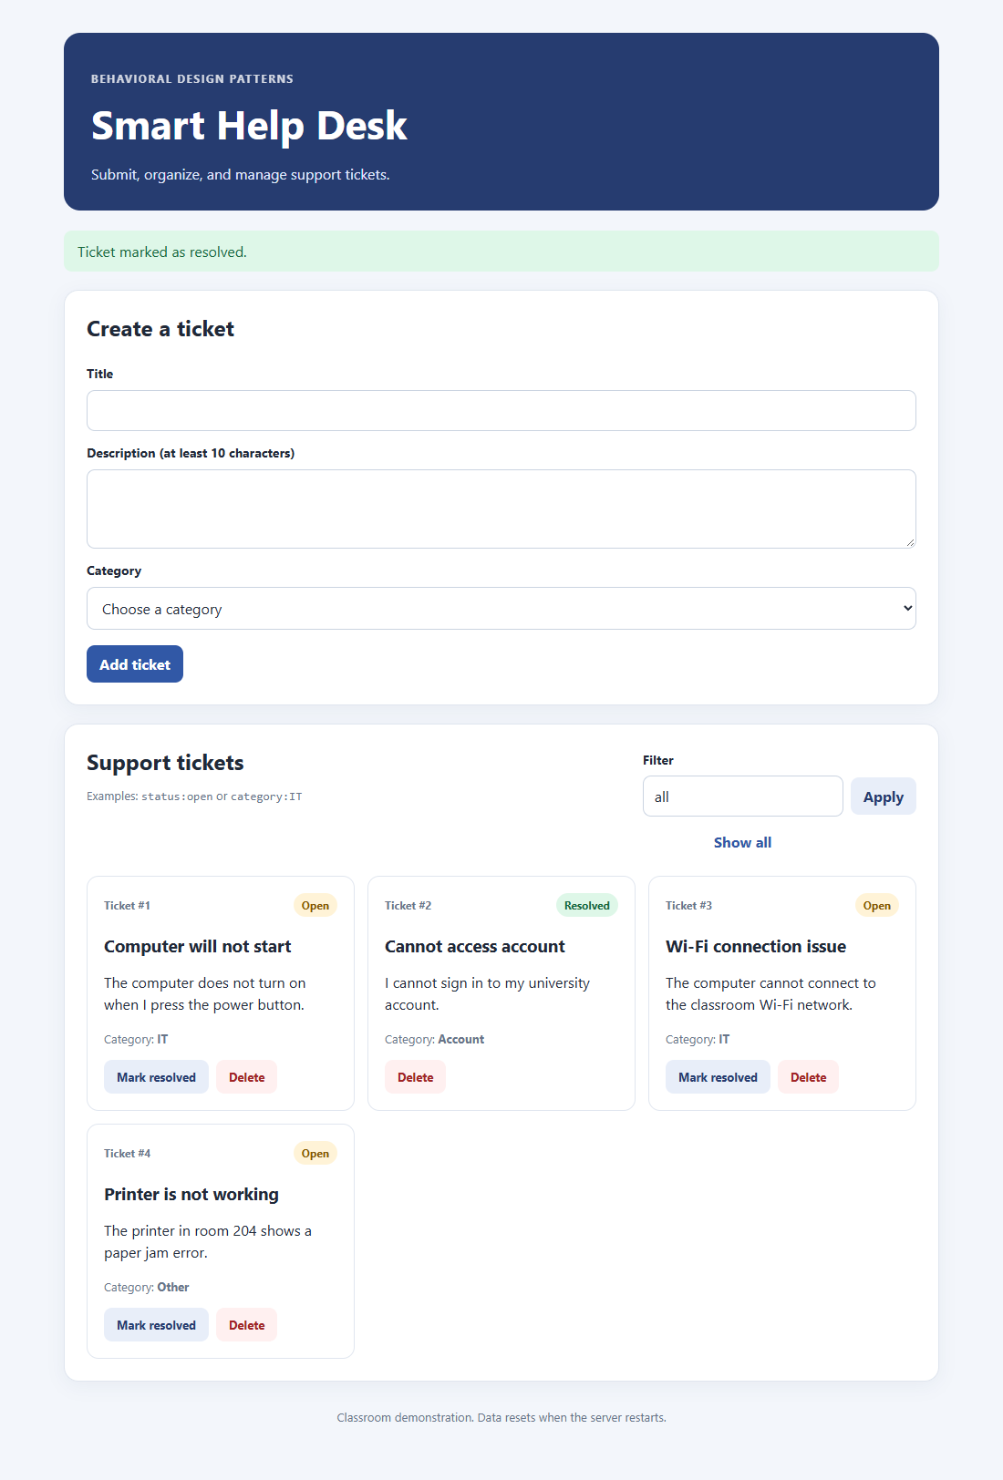

Test 10: Ticket deleted
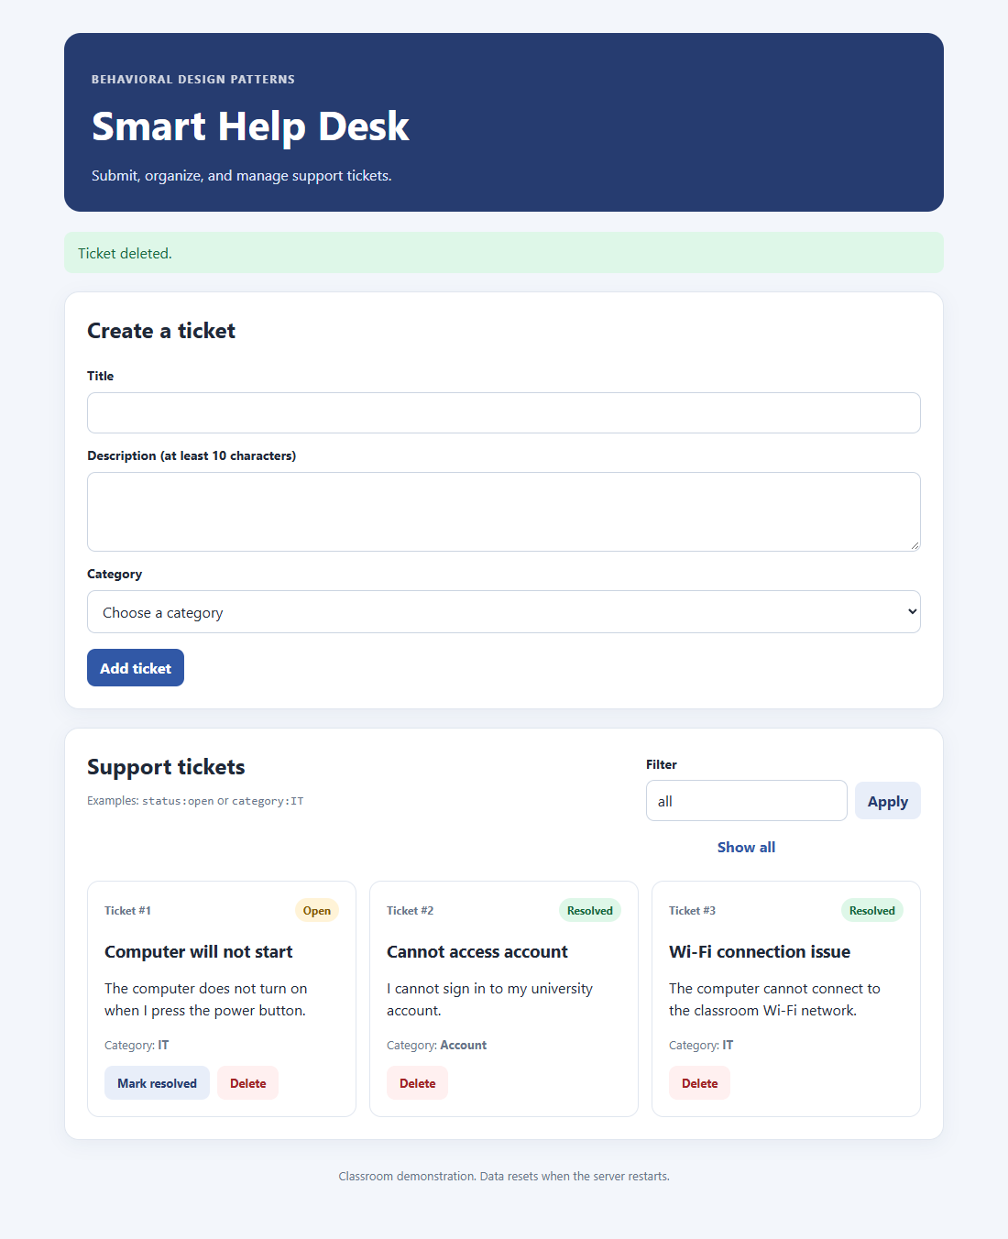

Test 11: Show all
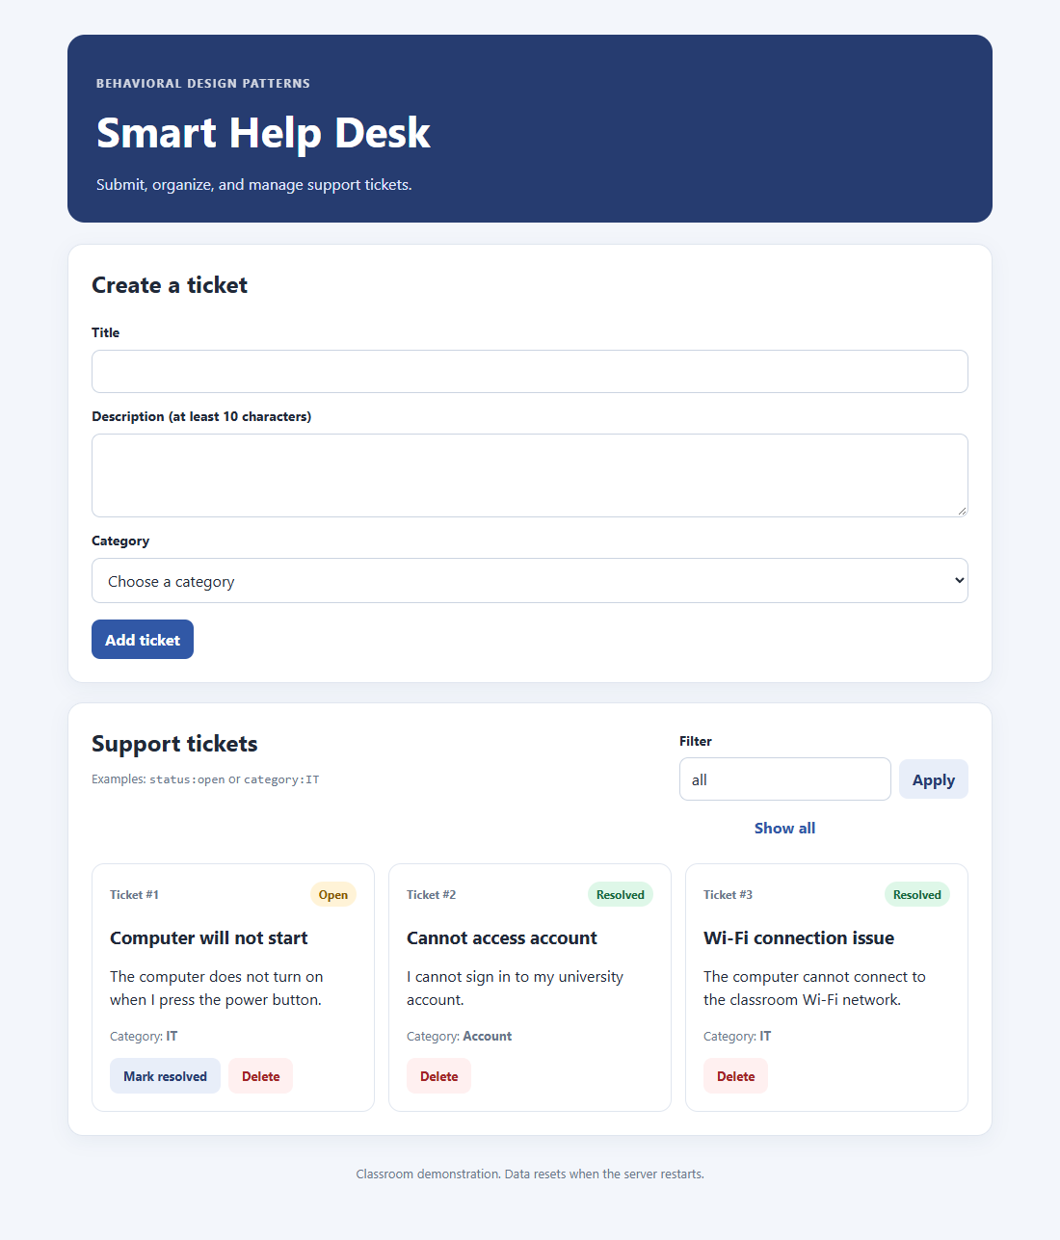

Test 12: Invalid filter
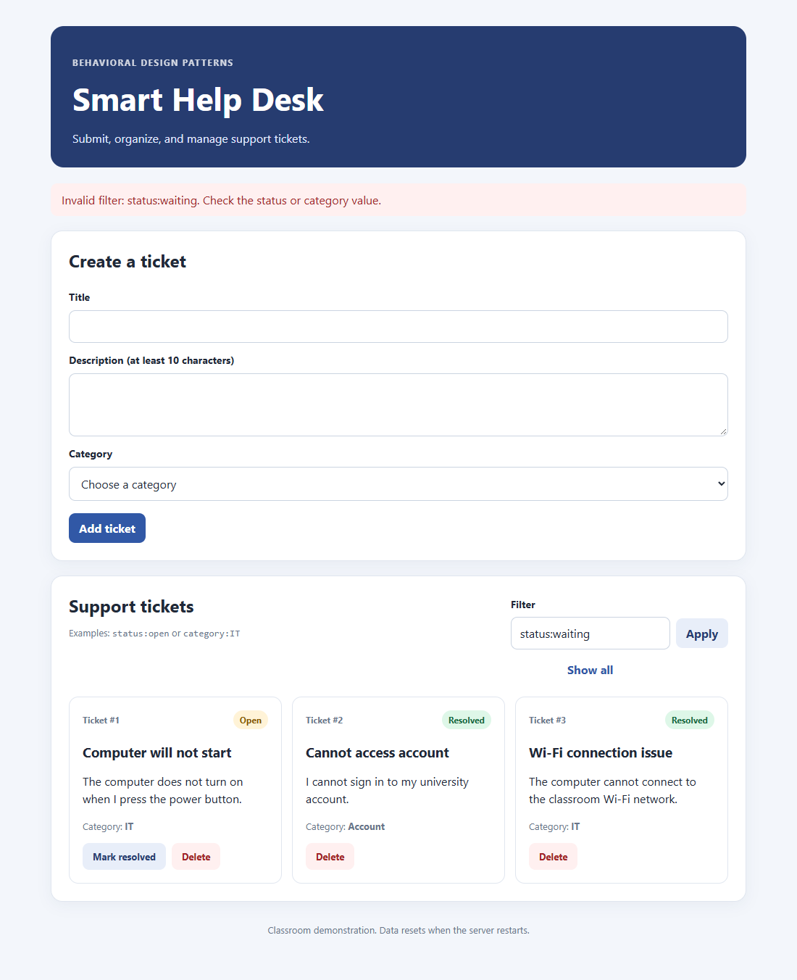

Design Pattern Analysis
Each pattern solves one problem in the application, and the answers below refer to the classes in the patterns folder.

Pattern 1: Chain of Responsibility
Question: Why is it useful to separate validation rules into different handlers?
Answer: Each handler checks one rule, so each rule is easy to read, test and change on its own. A new rule needs only a new handler class and one more link in build_validation_chain(). The chain stops at the first error, so the user gets one clear message.

Pattern 2: Command
Question: How does the Command pattern separate a user action from the code that performs it?
Answer: A command object holds the action and its data, such as ResolveTicketCommand(ticket_id). The Flask route only creates the command and calls execute(), without knowing how the action is carried out. The real work stays in the mediator, so the two sides can change independently.

Pattern 3: Interpreter
Question: What is the difference between status:open and status:open category:IT?
Answer: status:open has one condition and matches every open ticket in any category. status:open category:IT has two conditions joined by AndExpression, so a ticket must be both open and in the IT category. The second query can therefore never return more tickets than the first.

Pattern 4: Iterator
Question: What do the __iter__() and __next__() methods do?
Answer: __iter__() returns the iterator object, here self, which lets Python use it in a for loop or list(). __next__() returns the current ticket and moves the index forward by one. When no tickets remain, it raises StopIteration to end the iteration.

Pattern 5: Mediator
Question: How does the Mediator pattern reduce direct dependencies between application components?
Answer: Components talk to HelpDeskMediator instead of to each other. Routes and commands do not touch the ticket list, the validation chain, the interpreter or the iterator directly. A change to one of these parts is usually limited to the mediator, not to every component that uses it.

Conclusion
The expected result was achieved: the application works and demonstrates all five behavioral patterns, with 12 of 12 tests passing. Together the patterns give each concern one home: validation, user actions, filtering, traversal and coordination. Adding a rule, action or filter therefore changes only a small part of the code.

Appendix: Source Code
The files below are the complete submission code.

app.py
from flask import (
Flask,
flash,
redirect,
render_template,
request,
url_for,
)

from patterns.commands import (
AddTicketCommand,
DeleteTicketCommand,
ResolveTicketCommand,
)
from patterns.mediator import HelpDeskMediator

# ==================================================
# FLASK APPLICATION
# ==================================================

app = Flask(__name__)
app.config["SECRET_KEY"] = "classroom-demo-key"

mediator = HelpDeskMediator()

@app.get("/")
def index():
query = request.args.get("filter", "all")
error = None

try:
tickets = mediator.get_tickets(query)
except ValueError as exc:
tickets = mediator.get_tickets("all")
error = str(exc)

return render_template(
"index.html",
tickets=tickets,
current_filter=query,
error=error,
)

@app.post("/add")
def add_ticket():
command = AddTicketCommand(
request.form.get("title", ""),
request.form.get("description", ""),
request.form.get("category", ""),
)

try:
command.execute(mediator)
flash("Ticket added successfully.", "success")
except ValueError as exc:
flash(str(exc), "error")

return redirect(url_for("index"))

@app.post("/resolve/<int:ticket_id>")
def resolve_ticket(ticket_id: int):
success = ResolveTicketCommand(ticket_id).execute(mediator)

if success:
flash("Ticket marked as resolved.", "success")
else:
flash("Ticket was not found.", "error")

return redirect(url_for("index"))

@app.post("/delete/<int:ticket_id>")
def delete_ticket(ticket_id: int):
success = DeleteTicketCommand(ticket_id).execute(mediator)

if success:
flash("Ticket deleted.", "success")
else:
flash("Ticket was not found.", "error")

return redirect(url_for("index"))

if __name__ == "__main__":
app.run(debug=True)

models.py
from dataclasses import dataclass

# ==================================================
# DATA MODEL
# ==================================================

@dataclass
class Ticket:
id: int
title: str
description: str
category: str
status: str = "Open"

patterns/validation.py
from typing import Optional

# ==================================================
# CHAIN OF RESPONSIBILITY PATTERN
# ==================================================

class ValidationHandler:
def __init__(self):
self._next: Optional["ValidationHandler"] = None

def set_next(self, handler: "ValidationHandler"):
self._next = handler
return handler

def handle(self, data: dict) -> Optional[str]:
error = self.validate(data)

if error:
return error

if self._next:
return self._next.handle(data)

return None

def validate(self, data: dict) -> Optional[str]:
return None

class TitleRequiredHandler(ValidationHandler):
def validate(self, data: dict) -> Optional[str]:
if not data.get("title", "").strip():
return "Title is required."

return None

class DescriptionLengthHandler(ValidationHandler):
def validate(self, data: dict) -> Optional[str]:
description = data.get("description", "").strip()

if len(description) < 10:
return (
"Description must contain "
"at least 10 characters."
)

return None

class CategoryHandler(ValidationHandler):
ALLOWED_CATEGORIES = {"IT", "Account", "Other"}

def validate(self, data: dict) -> Optional[str]:
if data.get("category") not in self.ALLOWED_CATEGORIES:
return "Please choose a valid category."

return None

def build_validation_chain():
title_handler = TitleRequiredHandler()
description_handler = DescriptionLengthHandler()
category_handler = CategoryHandler()

title_handler.set_next(
description_handler
).set_next(category_handler)

return title_handler

patterns/commands.py
# ==================================================
# COMMAND PATTERN
# ==================================================

class AddTicketCommand:
def __init__(self, title, description, category):
self.title = title.strip()
self.description = description.strip()
self.category = category

def execute(self, mediator):
return mediator.add_ticket(
self.title,
self.description,
self.category,
)

class ResolveTicketCommand:
def __init__(self, ticket_id: int):
self.ticket_id = ticket_id

def execute(self, mediator):
return mediator.resolve_ticket(self.ticket_id)

class DeleteTicketCommand:
def __init__(self, ticket_id: int):
self.ticket_id = ticket_id

def execute(self, mediator):
return mediator.delete_ticket(self.ticket_id)

patterns/interpreter.py
from models import Ticket

# ==================================================
# INTERPRETER PATTERN
# ==================================================

class QueryExpression:
def matches(self, ticket: Ticket) -> bool:
raise NotImplementedError

class AllExpression(QueryExpression):
def matches(self, ticket: Ticket) -> bool:
return True

class StatusExpression(QueryExpression):
def __init__(self, status: str):
self.status = status

def matches(self, ticket: Ticket) -> bool:
return ticket.status.lower() == self.status.lower()

class CategoryExpression(QueryExpression):
def __init__(self, category: str):
self.category = category

def matches(self, ticket: Ticket) -> bool:
return ticket.category.lower() == self.category.lower()

class AndExpression(QueryExpression):
def __init__(self, expressions):
self.expressions = expressions

def matches(self, ticket: Ticket) -> bool:
return all(
expression.matches(ticket)
for expression in self.expressions
)

class QueryInterpreter:
ALLOWED_STATUSES = {"open", "resolved"}
ALLOWED_CATEGORIES = {"it", "account", "other"}

@classmethod
def parse(cls, query: str) -> QueryExpression:
query = (query or "").strip()

if not query or query.lower() == "all":
return AllExpression()

expressions = []

for token in query.split():
if ":" not in token:
raise ValueError(
f"Invalid filter: {token}. "
"Use status:open or category:IT."
)

key, value = token.split(":", 1)
key = key.lower()
value = value.strip()

if (
key == "status"
and value.lower() in cls.ALLOWED_STATUSES
):
expressions.append(StatusExpression(value))

elif (
key == "category"
and value.lower() in cls.ALLOWED_CATEGORIES
):
categories = {
"it": "IT",
"account": "Account",
"other": "Other",
}

expressions.append(
CategoryExpression(categories[value.lower()])
)

else:
raise ValueError(
f"Invalid filter: {token}. "
"Check the status or category value."
)

return AndExpression(expressions)

patterns/iterator.py
# ==================================================
# ITERATOR PATTERN
# ==================================================

class TicketIterator:
def __init__(self, tickets):
self._tickets = list(tickets)
self._index = 0

def __iter__(self):
return self

def __next__(self):
if self._index >= len(self._tickets):
raise StopIteration

ticket = self._tickets[self._index]
self._index += 1

return ticket

patterns/mediator.py
from itertools import count
from typing import Optional

from models import Ticket
from patterns.interpreter import QueryInterpreter
from patterns.iterator import TicketIterator
from patterns.validation import build_validation_chain

# ==================================================
# MEDIATOR PATTERN
# ==================================================

class HelpDeskMediator:
def __init__(self):
self._tickets = []
self._ids = count(1)
self.validator = build_validation_chain()

self.add_ticket(
"Computer will not start",
"The computer does not turn on when I press the power button.",
"IT",
)

self.add_ticket(
"Cannot access account",
"I cannot sign in to my university account.",
"Account",
)

self.add_ticket(
"Wi-Fi connection issue",
"The computer cannot connect to the classroom Wi-Fi network.",
"IT",
)

def add_ticket(self, title, description, category):
data = {
"title": title,
"description": description,
"category": category,
}

error = self.validator.handle(data)

if error:
raise ValueError(error)

ticket = Ticket(
id=next(self._ids),
title=title.strip(),
description=description.strip(),
category=category,
status="Open",
)

self._tickets.append(ticket)

return ticket

def find_ticket(self, ticket_id: int) -> Optional[Ticket]:
return next(
(
ticket
for ticket in self._tickets
if ticket.id == ticket_id
),
None,
)

def resolve_ticket(self, ticket_id: int) -> bool:
ticket = self.find_ticket(ticket_id)

if ticket is None:
return False

ticket.status = "Resolved"
return True

def delete_ticket(self, ticket_id: int) -> bool:
ticket = self.find_ticket(ticket_id)

if ticket is None:
return False

self._tickets.remove(ticket)
return True

def get_tickets(self, query="all"):
expression = QueryInterpreter.parse(query)

matching_tickets = [
ticket
for ticket in self._tickets
if expression.matches(ticket)
]

return list(TicketIterator(matching_tickets))

templates/index.html
<!doctype html>
<html lang="en">
<head>
<meta charset="utf-8">
<meta name="viewport" content="width=device-width, initial-scale=1">
<title>Smart Help Desk</title>
<link rel="stylesheet"
href="{{ url_for('static', filename='style.css') }}">
</head>
<body>
<main class="container">

<header class="hero">
<p class="eyebrow">BEHAVIORAL DESIGN PATTERNS</p>
<h1>Smart Help Desk</h1>
<p>Submit, organize, and manage support tickets.</p>
</header>

{% with messages = get_flashed_messages(with_categories=true) %}
{% if messages %}
<section class="messages" aria-live="polite">
{% for category, message in messages %}
<p class="message {{ category }}">{{ message }}</p>
{% endfor %}
</section>
{% endif %}
{% endwith %}

{% if error %}
<p class="message error">{{ error }}</p>
{% endif %}

<section class="panel">
<h2>Create a ticket</h2>

<form action="{{ url_for('add_ticket') }}"
method="post"
class="ticket-form">

<label for="title">Title</label>
<input id="title"
name="title"
type="text"
maxlength="100"
required>

<label for="description">
Description (at least 10 characters)
</label>
<textarea id="description"
name="description"
rows="3"
minlength="10"
required></textarea>

<label for="category">Category</label>
<select id="category" name="category" required>
<option value="" selected disabled>
Choose a category
</option>
<option value="IT">IT</option>
<option value="Account">Account</option>
<option value="Other">Other</option>
</select>

<button type="submit">Add ticket</button>
</form>
</section>

<section class="panel">
<div class="list-heading">
<div>
<h2>Support tickets</h2>
<p class="muted">
Examples: <code>status:open</code> or
<code>category:IT</code>
</p>
</div>

<form action="{{ url_for('index') }}"
method="get"
class="filter-form">

<label for="filter">Filter</label>
<input id="filter"
name="filter"
type="text"
value="{{ current_filter }}"
placeholder="all / status:open">

<button type="submit" class="secondary">Apply</button>

<a class="reset-link" href="{{ url_for('index') }}">
Show all
</a>
</form>
</div>

{% if tickets %}
<div class="ticket-list">
{% for ticket in tickets %}
<article class="ticket-card">

<div class="ticket-topline">
<span class="ticket-id">
Ticket #{{ ticket.id }}
</span>

<span class="status {{ ticket.status|lower }}">
{{ ticket.status }}
</span>
</div>

<h3>{{ ticket.title }}</h3>
<p>{{ ticket.description }}</p>

<p class="category-label">
Category:
<strong>{{ ticket.category }}</strong>
</p>

<div class="actions">
{% if ticket.status == 'Open' %}
<form
action="{{ url_for('resolve_ticket', ticket_id=ticket.id) }}"
method="post">

<button type="submit" class="secondary">
Mark resolved
</button>
</form>
{% endif %}

<form
action="{{ url_for('delete_ticket', ticket_id=ticket.id) }}"
method="post"
onsubmit="return confirm('Delete this ticket?');">

<button type="submit" class="danger">
Delete
</button>
</form>
</div>

</article>
{% endfor %}
</div>
{% else %}
<p class="empty-state">
No tickets match this filter.
</p>
{% endif %}
</section>

<footer>
Classroom demonstration. Data resets when the server restarts.
</footer>

</main>
</body>
</html>

static/style.css
:root {
font-family: -apple-system, BlinkMacSystemFont, "Segoe UI", sans-serif;
color: #202938;
background: #f3f6fb;
}

* {
box-sizing: border-box;
}

body {
margin: 0;
}

.container {
width: min(100% - 32px, 960px);
margin: 36px auto;
}

.hero {
padding: 30px;
margin-bottom: 22px;
border-radius: 18px;
color: white;
background: #263c70;
}

.eyebrow {
font-size: 12px;
font-weight: 700;
letter-spacing: 1.5px;
opacity: 0.8;
}

h1 {
margin: 8px 0;
font-size: clamp(30px, 5vw, 44px);
}

.hero p:last-child {
margin-bottom: 0;
color: #e0e8ff;
}

.panel {
margin: 20px 0;
padding: 24px;
border: 1px solid #e0e6ef;
border-radius: 16px;
background: white;
box-shadow: 0 5px 20px rgb(26 43 77 / 5%);
}

h2 {
margin-top: 0;
}

.ticket-form {
display: grid;
gap: 9px;
}

label {
margin-top: 5px;
font-size: 14px;
font-weight: 650;
}

input,
textarea,
select {
width: 100%;
padding: 11px 12px;
border: 1px solid #cbd4e1;
border-radius: 9px;
background: white;
color: inherit;
font: inherit;
}

textarea {
resize: vertical;
}

button,
.reset-link {
display: inline-block;
padding: 10px 14px;
border: 0;
border-radius: 9px;
background: #3158a6;
color: white;
font: inherit;
font-weight: 650;
text-decoration: none;
cursor: pointer;
}

.ticket-form button {
margin-top: 8px;
justify-self: start;
}

button:hover,
.reset-link:hover {
filter: brightness(0.94);
}

.secondary {
background: #e8eef9;
color: #263c70;
}

.danger {
background: #fff0f0;
color: #a12626;
}

.list-heading {
display: flex;
justify-content: space-between;
align-items: flex-start;
gap: 24px;
}

.list-heading h2 {
margin-bottom: 6px;
}

.muted,
.category-label,
footer {
color: #68758a;
font-size: 13px;
}

.filter-form {
display: grid;
grid-template-columns: minmax(150px, 220px) auto;
gap: 8px;
align-items: center;
}

.filter-form label {
grid-column: 1 / -1;
}

.filter-form .reset-link {
padding: 9px 10px;
background: transparent;
color: #3158a6;
text-align: center;
}

.ticket-list {
display: grid;
grid-template-columns: repeat(auto-fit, minmax(250px, 1fr));
gap: 14px;
margin-top: 18px;
}

.ticket-card {
padding: 18px;
border: 1px solid #e0e6ef;
border-radius: 13px;
overflow-wrap: anywhere;
}

.ticket-topline,
.actions {
display: flex;
justify-content: space-between;
align-items: center;
gap: 8px;
}

.ticket-id {
color: #68758a;
font-size: 12px;
font-weight: 700;
}

.status {
padding: 5px 9px;
border-radius: 20px;
font-size: 12px;
font-weight: 700;
}

.status.open {
background: #fff3d7;
color: #855600;
}

.status.resolved {
background: #def7e8;
color: #17683b;
}

.ticket-card h3 {
margin-bottom: 8px;
}

.ticket-card p {
line-height: 1.5;
}

.actions {
justify-content: flex-start;
flex-wrap: wrap;
margin-top: 14px;
}

.actions form {
margin: 0;
}

.actions button {
font-size: 13px;
}

.message {
padding: 12px 15px;
border-radius: 9px;
}

.message.success {
background: #def7e8;
color: #17683b;
}

.message.error {
background: #fff0f0;
color: #a12626;
}

.empty-state {
padding: 20px;
border-radius: 10px;
background: #f7f9fc;
color: #68758a;
text-align: center;
}

footer {
padding: 10px 0 25px;
text-align: center;
}

@media (max-width: 650px) {
.container {
width: min(100% - 20px, 960px);
margin: 16px auto;
}

.hero,
.panel {
padding: 19px;
}

.list-heading {
display: block;
}

.filter-form {
margin-top: 18px;
grid-template-columns: 1fr auto;
}

.filter-form input {
grid-column: 1 / -1;
}
}

