Data Base System Implementation
COP-6726
Submitted by:
Naman Arora
UFID: 3979-0439
Nikunj Sarda
UFID: 9360-6581
Introduction:
This document is intended to present the outcomes and the process of the completed work for the Project 2 milestone 1. The heap file implementation has been successfully materialized and tested. The repository for all the work is present here.

Source File Hierarchy:
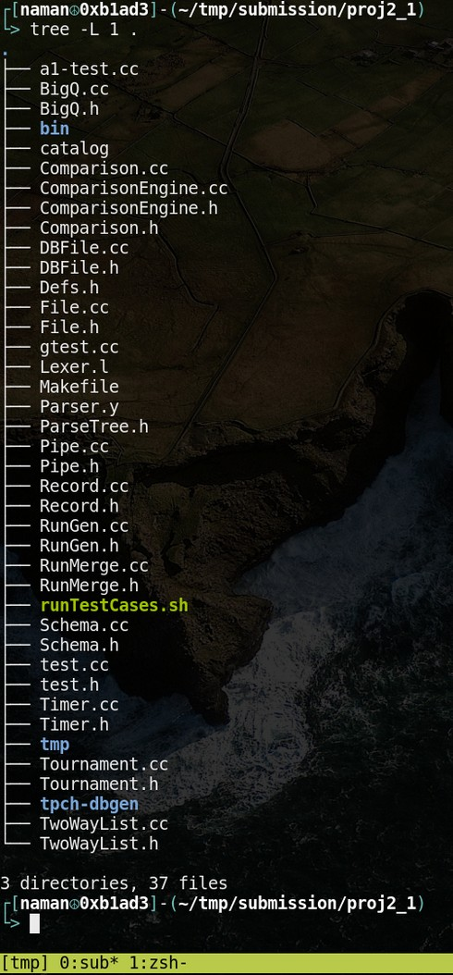

The directories are arranged in a flat manner with the exception of exactly three, viz. bin/, tpch-dbgen/ and tmp/. The bin/ directory is the output destination for the dbfile, i.e. dbfile directory. The tpch-dbgen is the git repository for the TPCH sub program. tmp/ houses all the test case files, tc{1,2,3,4}.txt along with some patch files viz, tc{1,2,3,4}_txt.patch, test_{cc,h}.patch, runTestCases_sh.patch and a1-test_cc.patch. These patch files demark where the respective files differ from the vanilla ones provided. Output1.txt exists in tmp/ directory too.
*Note that since the test.cc and a1-test.cc have been modified to provide all the relations as options, the second line of test cases have been altered to reflect the same relations.

The compilation process:
The compilation process is accomplished by a recursive call to Makefiles in each subdirectory by the Makefile in the src/ directory.
The provided NamanArora_NikunjSarda_p1.zip has one sub-directory, src/.
- $> unzip NamanArora_NikunjSarda_p1.zip
- $> cd proj2_1
Now to build the test.out:
- $> make test.out
Also, to build a1-test.out:
$> make a1-test.out
To make the gtest (assuming the gtest framework is installed and available in default linker library path)
- $> make gtest.out
To generate tpch-dbgen files (tpch-dbgen/ sub-dir is always compiled with all of the above targets)
- $> cd tpch-dbgen/
- $> make
- $> ./dbgen <options> -s <size>
All the available relation binary files are available in bin/
To clean the repository,
- $> make clean

Change Log:
- Added Tournament class in mem/tournament.{cc,h}
- Added Run_Gen class in mem/run_gen.{cc,h}
- Added Run_Merge class in mem/run_merge.{cc,h}
- Finished the BigQ class in mem/bigq.{cc,h}
- Changed the output1.txt location from root to tmp/
- Changed tc*.txt locations from root to tmp/
- Modified options provided for selecting relations as *.tbl files in a1-test.cc and test.cc files, and reflected those same number selection changes in tc*.txt files too.

BigQ Class:
- thread_arg :: thread_arg(Pipe *in_pipe, Pipe *out_pipe, int run_len, OrderMaker *order, File *f, Page *pg)
Initializing the class variable to their respective values.
- BigQ :: BigQ(Pipe *in_pipe, Pipe *out_pipe, OrderMaker *order, int run_len)
The class constructor to start the worker thread.
- struct thread_arg *wrkr_init(struct thread_arg *a)
The function to instantiate the initial thread and return the same.
- void *wrkr_run(void *a)
The function to start the run generation and the run merge and free the memory.

Tournament Class:
- Tournament :: node :: node(Record * in, int init_pos)
The function to initialize the node structure.
- Tournament :: Tournament(int n_ext, struct OrderMaker *order)
The class constructor to create tournament tree and comparison engine.
- Tournament :: ~Tournament()
The class destructor to free up the memory.
- Tournament :: push_winner(struct node *winner)
The function to push the winner in winner queue
- int Tournament :: promote(struct node *winner, int pos)
This function
- int Tournament :: play_matches(int pos)
The function to determined the winner among the two player.
- int Tournament :: feed(Record *in)
The function to feed the tree.
- std :: queue <Record *> *Tournament :: flush()
The function to return the winner queue.
- int Tournament :: get_nxt_spot(int pop)
The function to locate an empty spot.
- int Tournament :: get_player_num()
The function to get number of players.
- Record *Tournament :: get_nxt_winner()
The function to return the next, if any, record in sorted fashion

RunGen Class:
- RunGen :: RunGen(Pipe *in_pipe, int run_len, OrderMaker *order)
The class constructor to initialize class variable to initial values.
- RunGen :: ~RunGen()
The class destructor to free up the memory.
- int RunGen :: setup_dbf()
The function to create run db file to write present run.
- void RunGen :: write(std :: queue <Record *> *que)
The function to write the records in the run db file.
- int RunGen :: fetch_rec(Record **rec)
The function to fetch the record from the input pipe.
- std :: vector<int> *RunGen :: generator()
The function to start the run and sent the record to tournament tree for sorting.

RunMerge Class:
- thread :: thread(pthread_t *tid, Pipe *pipe, const RunMerge *ref, int r_no, int r_size)
The function to initialize the structure thread with respective values.
- RunMerge :: RunMerge(Pipe *out_pipe, std :: vector <int> *run_sizes, struct OrderMaker *order)
The class constructor to initialize class variable with respective values.
- RunMerge :: ~RunMerge()
The class destructor to free up the memory.
- thread *RunMerge :: init_thread(pthread_t *tid, int r_no, int r_size)
The function to initialize the initial thread.
- void RunMerge :: join_wait()
The function to join individual threads together.
- void RunMerge :: merge_init()
The function to create merge thread.
- void RunMerge :: new_feed()
The function to get the sorted record for the merging process.
- void *thread_handler(void *a)
The function to write the record in the output pipe.

