**Twitter data analysis:**

* 330 million active monthly users
* 500 million tweets per day
* 6000 tweets every second
* A total of 1.3 billion accounts have been created.
* Out of these 1.3 billion accounts, 44% made an account and left before ever sending a Tweet
* Only 550 million people have ever sent a Tweet.
* 707 is the average number of followers.
* During the 2014 FIFA World Cup Final, 618,725 tweets were sent in a single minute - Highest
* Noon to 1:00 p.m. local time, on average for each time zone, is the most popular time to tweet
* The highest volume of tweets occurs between 11:00 a.m. and 1:00 p.m., peaking between noon and 1:00 p.m
* The fewest tweets are sent between 3:00 and 4:00 a.m
* The highest number of retweets and favorites occurs between 8:00 p.m. and 11:00 p.m., peaking between 9:00 and 10:00 p.m.
* New Tweets per second (TPS) record: 143,199 TPS. Typical day: more than 500 million Tweets sent; average 5,700 TPS
* Current twitter architecture can handle 10 - 20K requests / sec / host

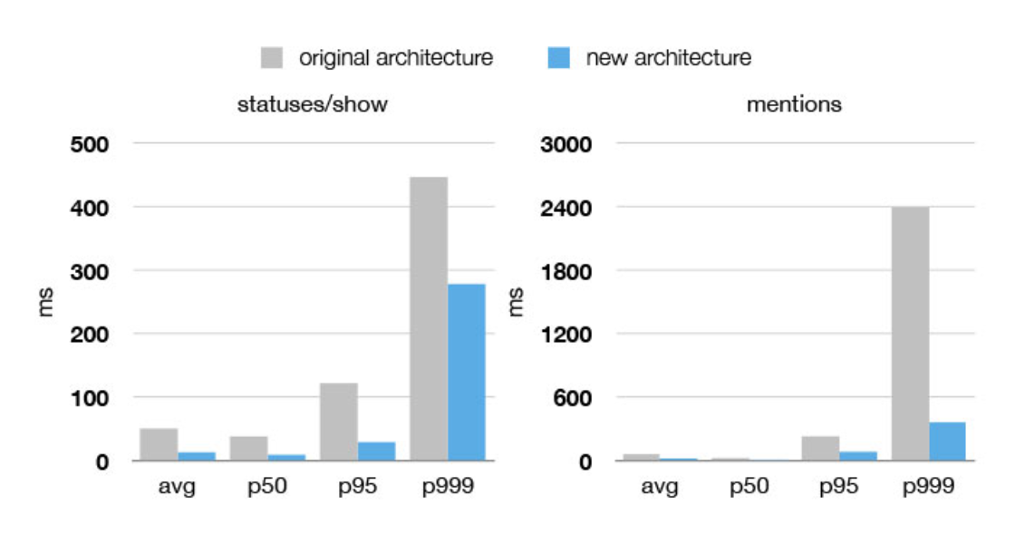

Currently the P-four-nine is twice the mean.

“P-four-nines" means, it's the latency at the 99.99th percentile, meaning only one in 10,000 requests has a worse latency.