Introduction
- It is a good idea use high level elements, more close to the problem domain to specify the laws.
- Instead these laws should be ideally executable. (in contrast to omini)
- Minsly has been doing a long term research in the field of interaction laws, and he has proposed the LGI approach. In LGI approach ….
In this section, we show that the elements that compose the conceptual model of XMLaw can be mapped to the LGI approach. It means that we can use high level abstractions to specify the laws, and in the second step there is a choice of which infrastructure is used to perform the enforcement, i.e., it is possible to use the current MLaw with a centralized mediator, or use a high scalable infrastructure provided by LGI.

LGI and XMLaw
LGI has a rich set of events that can be monitored on each controller. Once these events are monitored, it is possible to use operations in order to implement the law. We have summarized the main regulated events and operations of LGI in Table 1.

Regulated Events
adopted | Represents the birth of an LGI agent—more specifically, this event represents the point in time when an actor adopts a given law L to operate under, thus becoming an L-agent.
arrived | This event occurs when a message M sent by agent X to agent Y, arrives at the controller of Y. (The home of this event is agent Y—the receiver.)
disconnected | This event occurs at the private controller of an agent when its actor has been disconnected.
exception | This event may occur when the primitive operation, which has been invoked by the home agent, fails.
obligationDue | This event is analogous to the sounding of an alarm clock, reminding the controller of the coming due of a previously imposed obligation, of a specified type. Obligation are imposed by means of the primitive operation imposeObligation,
reconnected | This event occurs at the private controller of an agent when its previously disconnected actor has been reconnected.
sent | This event occurs when the actor of x sends a message m addressed to an agent y operating under law L’. The sender x is the home of this event.
stateChanged | This event occurs at an agent x when a pending state-obligation at x comes due.
submitted | This event, which is a counterpart of the arrived event, occurs at an agent x, when an unregulated message m sent by some process at host h, using port p, arrives at x. It is, of course, up to law L under which x operates to determine the disposition of this message.
Operations
deliver | This operation, which has the form deliver([x,L’],m,y), delivers to the home actor the message m, ostensibly sent by x, operating under law L’
forward | Operation forward(x,m,[y,L’]) sends the message m to Ty, the controller of the destination y—assummed here to operate under law L’; x is identified here as the ostensible sender of this message.
add | adds term t to the CS.
remove | Removes from CS a term that matches t, if any. If there is no such term to be removed, this operation has no effect.
replace | Replaces a term t1 from CS, if any, with term t2. If there is  no term t1 to be replaced, then this operation has no effect.
incr | Operation incr(f,d), locates a unary term f(n), and increments its argument by d.
decr | decr(f,d) is the implied counterpart of incr.
replaceCS | Operation replaceCS(termList) replaces the whole control-state of the home agent with the specified list of terms.
addCS | Operation addCS(termList) appends the terms in the list termList to the control state of the home agent.
imposeObligation | imposeObligation(oType, dt, timeUnit) imposes an obligation of the specified type on the home agent, to come due after a delay dt, given in the specified time units.
repealObligation | Operation repealObligation(oType)removes all pending obligations of type oType, along with all associated obligation-terms in DCS.
imposeStateObligation | Operation imposeStateObligation(termList) would cause a stateChanged) event to occur upon any change in any of the terms of the CS that are indicated by the termList parameter.
repealStateObligation | Operation repealStateObligation(all) repeals the current state-obligation, as well as the corresponding audited(termList) term from the DCS
Table 1 – Main regulated events and operations of LGI approach. (This list is not intended to be complete.)

Most of the events found in Table 1 are related to low level information about communication issues (disconnected, reconnected), sending or receiving of messages, or state changes on the control state. From the point of view of the operations, they are also mostly concerned with low level instructions such as forward, deliver, add and so on. However, we argue that is possible to use the LGI constructs as building blocks to form higher level abstractions. XMLaw has a rich set of high level abstractions, and bellow we show how we can map some of them to LGI instructions and still having the same meaning.

The protocol of the Figure 1 can be directly specified in XMLaw through the elements Protocol, State, Transition and Message. In order to achieve the same behavior in LGI, one could write the law as in Table 2. In this LGI law, the term currentState models the current states of the protocol and the event simulates generation of events. Then, for example, in the first line, an agent A sends the message m1 to the agent B; if the current state is s0, then it is removed from the list of current states the state s0, the state s1 is added to the list, we simulate the generation of a transition_activation event and the message is forward.
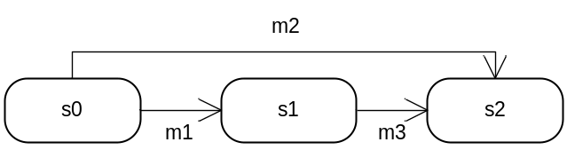
Figure 1 – Protocol Example

sent(A,m1,B) -> currentState(s0)@CS, do(remove(currentState(s0))), do(add(currentState(s1))), do(add(event(t1,transition_activation))), do(forward).
sent(A,m2,B) -> currentState(s0)@CS, do(remove(currentState(s0))), do(add(currentState(s2))), do(add(event(t2,transition_activation))), do(forward).
sent(B,m1,A) -> currentState(s1)@CS, do(remove(currentState(s1))), do(add(currentState(s2))), do(add(event(t3,transition_activation))), do(forward).
Table 2 – Protocol specification in LGI

Table 3 shows how some situations found in XMLaw can be mapped to the LGI approach.
Activate a clock in 5 seconds.  For that we have used the imposeObligation operation. | imposeObligation("myLGIclock",5)
Deactivate a clock. | repealObligation("myLGIclock ")
Sensing a clock ticks.  The obligationDue event happens when the time specified in the obligation expires. | obligationDue("myLGIclock ")
Simulating periodic clocks.  We use a loop in the specification for simulate periodic clocks. In this example, first we “declare” a clock, then when this clock expires, then an obligationDue event is generated that in its turn activates another imposeObligation and so on. | imposeObligation("myLGIclock ",5).  obligationDue("myLGIclock") :- imposeObligation("myLGIclock ",5).
Activates a norm when a transition is fired.  In this case, the imposeStateObligation would cause an stateChanged event whenever the event(t1,transition_activation) term is added to the CS. Then when the second command states that when this stateChanged happens, then the norm n1 is made active. | imposeStateObligation( event(t1,transition_activation) ).  stateChanged(event(t1,transition_activation)) :- do( add( event(n1,norm_activation) ) ), do(add(norm(n1,active,valid)).
Table 3 – XMLaw situation modeled using LGII

Global Properties
Accordingly to [1], “any policy that can be implemented via a central mediator—which can maintain the global interaction state of the entire community—can be implemented also via an LGI law”. As an example of a global property, suppose the situation in the Figure 2. In this example, 3 agents are interacting in the context of the specified protocol. Agent A sends the message m1 to Agent B. As agents A and B have interacted, their controllers update the current state propertly. However, agent C has not participated of this interaction and therefore, its controller has not updated its current state, causing an inconsistence. This happens because the monitoring is performed in decentralized way with no explicit synchronization programmed.

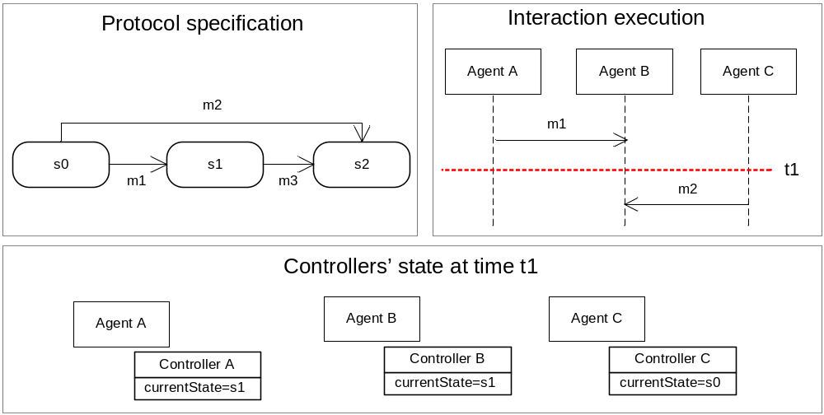
Figure 2 – Example of the need for synchronization of controllers on global properties

The general way to overcome this problem is to have specific synchronization protocols implemented such as done with token rings in Islander [3]. In LGI it is done by introducing a central coordinator that receives all the messages, and therefore keeps a consistent global state. The Table 4 introduces the idea of how it could be implemented in LGI. This approach has one advantage over the centralized mediator used in XMLaw once the XMLaw mediator cannot protect itself against congestion due to some overactive participants which may lead to denial of service. Under LGI, on the other hand, the law may limit the frequency of messages that can be issued by any given participant and this limit can be locally enforced, and is, thus, less susceptible to congestion.

alias(coordinator,'law-coordinator@les.inf.puc-rio.br').

// any message is forward to the central coordinator
sent(X,M,Y) :- do(forward(X,[M,Y],#coordinator)), do(forward).

// laws ...and redirection to the real addressee
arrived(#coordinator,A,m1,B) -> currentState(s1)@CS, do(remove(currentstate(s1))), do(add(currentState(s2))), do(deliver), do(forward(A,m1,B))..
Table 4 – Redirecting to a central coordinator

Discusssions
Both XMLaw and LGI deal only with the exchange of message between agents, and are not sensitive to the internal behavior of agents, and to changes in their internal state. In general, LGI is most effective for laws that are naturally local, while XMLaw is most effective for laws that are naturally global. The law under both approaches is not intended to specify all the details of the interaction between the agents; it is merely a constraint over the interaction.
From a conceptual point of view, LGI provides a state abstraction (control state), a set of events relating to communication issues (sending and receiving of messages, for example), and a set of operations for manipulating the state. The state acts basically as a hashtable where terms are stored. However, as there is no restriction to the type of terms that can be used, from one hand there is a great flexibility that is useful to adapt the approach to various domains, on the other hand a small set of high level predicates could be more useful to help in the coordination and enforcement of laws without the complexity of creating new terms.
The mapping of the elements from XMLaw to LGI can be summarized as creating a prolog-based model of XMLelement. That is because, the events and operations provided in LGI are general and related to low level concepts. The mapping can be a used if there is a need for a decentralized architecture such as LGI.
It is also important to say that although global properties can also be implemented in LGI, if one uses the general solution presented in [2] and referred in Table 4, one it is not making use of the decentralized nature of LGI. On the other hand, it is also possible to write laws that make use of very specific and domain dependent knowledge to synchronize states just when it is need, however it introduces complexity for the specification of the laws and brings to the law specification concerns of distributed synchronization.
To summarize, XMLaw is an alternative approach to specify laws in an open multi-agent systems that presents high level abstractions with the goal of making easier the task of specify interactions laws.

References

- Minsky, N., Law Governed Interaction (LGI): A Distributed Coordination and Control Mechanism - (An Introduction, and a Reference Manual). 2005. http://www.moses.rutgers.edu/documentation/manual.pdf - Accessed at January, 14th, 2007.
- Minsky 2
- Islander

