Instructions for the Preparation of Camera-Ready Contributions

Carlos Lucena¹ | Marcelo Blois² | Ricardo Choren³ | Viviane Silva⁴
Computer Science Dept,  PUC-Rio¹  R. M de S. Vicente, 225  Rio de Janeiro/RJ  22453-900 – Brasil  lucena@inf.puc-rio.br | Informatics Dept,  PUCRS²  Av. Ipiranga, 6681  Porto Alegre/RS  90619-900 – Brazil  blois@inf.pucrs.br | Computer Eng. Dept  IME³  Pça Gen Tibúrcio, 80  Rio de Janeiro/RJ  22290-270 – Brazil  choren@de9.ime.eb.br | Informatics Dept  UCM³  C/ J. G. Santesmases, s/n  Madrid  28040 – Spain  viviane@fdi.ucm.es

Abstract | The abstract should summarize the contents of the paper and should contain at least 70 and at most 150 words. It should be set in 10-point font size and should be in italics. There should be two blank (10-point) lines after the abstract (before the keywords). This document is in the required format.  Keywords: We would like to encourage you to list your keywords (up to six) in this section.

1 Introduction
This instruction file for Word users may be used as a template. Kindly send the final and checked Word and PDF files of your paper to Viviane Silva (viviane@fdi.ucm.es). You should make sure that the Word and the PDF files are identical and correct and that only one version of your paper is sent. It is not possible to update files at a later stage. Please note that we do not need the printed paper.
All manuscripts must be in English. These guidelines include complete descriptions of the fonts, and related information for producing your camera-ready manuscripts. Please follow them and if you have any questions, direct them to the special issue editor in charge of your JBCS issue: Viviane Silva.

2 Style-type and Fonts
Wherever Times is specified, Times Roman or Times New Roman may be used. If neither is available on your word processor, please use the font closest in appearance to Times. Avoid using bit-mapped fonts if possible. True-Type 1 fonts are preferred.

3 Main Text
Type your main text in 10-point Times, single-spaced. Do not use double-spacing. The first paragraph of a section should not be indented. All other paragraphs should be indented 1/4 inch (approximately 0.5 cm). Be sure your text is fully justified—that is, flush left and flush right. Please do not place any additional blank lines between paragraphs.
Figure and table captions should be 9-point Times font, with a line space after it. Initially capitalize only the first word of each figure caption and table title. Figures and tables must be numbered separately. For example: “Figure 1. Database contexts”, “Table 1. Input data”. Figure captions are to be centered below the figures. Table titles are to be centered above the tables.

4 First-order Headings
For example, “1 Introduction”, should be Times 14-point boldface, all words capitalized, flush left. First-order headings, as in this paragraph, should have a small full line before it – you should copy this format. Do not use a period (“.”) after the heading number.

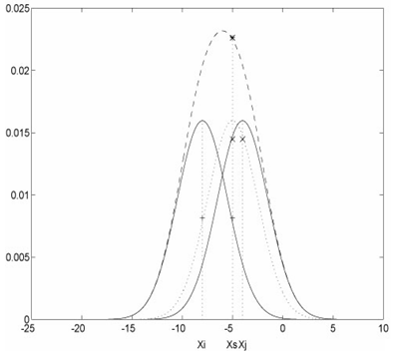
Figure 1. Sample figure caption
4.1 Second-order Headings
As in this heading, they should be Times 12-point boldface, all words capitalized, flush left.

4.1.1. Third-order headings. Third-order headings, as in this paragraph, are discouraged. However, if you must use them, use 10-point Times, boldface, initially capitalized, flush left, preceded by one blank line, followed by a period and your text on the same line.

Acknowledgements. The heading should be treated as a 3rd level heading and should not be assigned a number.

References
The “References” heading should be treated as a 1st level heading and should not be assigned a number. List and number all bibliographical references in 10-point Times, single-spaced, at the end of your paper.
References should be ordered by the first author’s last name. When referenced in the text, enclose the citation number in square brackets, for example [1]. Where appropriate, include the name(s) of editors of referenced books.
URL page title. http://your reference url, Date.
Test, C. Thesis Title. PhD Thesis, University, Location, Date.
Test, C.; Doe, J. Article title. Proceedings Title, Publisher, Location, Date, pp. 1-10.
Test, C. Article title. Journal number(issue), Publisher, Location, Date, pp. 1-10.
Test, C. et al. Book Title, Publisher, Location, Date.

