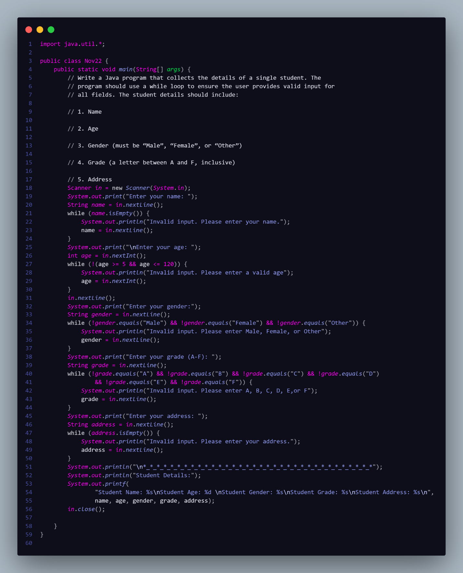

***Output:***

Enter your name: Saugat

Enter your age: 19

Enter your gender:M

Invalid input. Please enter Male, Female, or Other

Male

Enter your grade (A-F): g

Invalid input. Please enter A, B, C, D, E,or F

F

Enter your address:

Invalid input. Please enter your address.

Ghattekulo

*_*_*_*_*_*_*_*_*_*_*_*_*_*_*_*_*_*_*_*_*_*_*_*_*_*_*_*_*_*_*_*_*_*

Student Details:

Student Name: Saugat

Student Age: 19

Student Gender: Male

Student Grade: F

Student Address: Ghattekulo