ARYS GARAGE
Assignment Submission

Structural Bracket (Rearset Footpeg)
Static FEA + Fatigue Life Prediction

Rohit Rajesh
Product Design & Development Engineer — Flux Auto India
rohitrajesh.work@gmail.com | +91 99028 96215
linkedin.com/in/rohit-rajesh-93b8382a9
Submission Date: 29th June 2026
Deadline: 29th June 2026, 10:00 AM IST

1. Title & Candidate Details

Field | Detail
Assignment Title | Structural Bracket (Rearset Footpeg) + Fatigue FEA
Section | Section D — Mechanical Design Assignments, Option A
Candidate Name | Rohit Rajesh
Role Applied | Mechanical Design Engineer / Automotive Designer
Current Role | Product Design & Development Engineer, Flux Auto India (YC-backed)
Email | rohitrajesh.work@gmail.com
Phone | +91 99028 96215
LinkedIn | linkedin.com/in/rohit-rajesh-93b8382a9
Submission Date | 29th June 2026

2. Abstract

This report presents the design and structural validation of a motorcycle rearset footpeg bracket for an electric vehicle application. The bracket was designed in Autodesk Fusion 360 using Aluminium 6061-T6, incorporating a tapered arm profile, symmetric lightening pockets with a centre rib, hole boss reinforcements, and filleted edges throughout for DFM compliance and stress reduction.

A single worst-case finite element analysis load case was conducted using SimScale:
- Load Case (LC2 — Combined): 1800 N vertical + 500 N lateral load representing worst-case cornering/braking scenario

The combined load case produced a maximum Von Mises stress of 375.9 MPa and displacement of 2.724 mm. Modified Goodman fatigue analysis yielded a safety factor of 0.39, indicating the current 11.85mm Al 6061-T6 design requires redesign for 500,000-cycle fatigue life under worst-case loading. Two design improvements are proposed: increasing thickness to 16mm and upgrading to Al 7075-T6, which together achieve a predicted fatigue safety factor of 1.10.

3. Tools & AI Usage

Tool | Purpose | Usage
Autodesk Fusion 360 (Student) | CAD modelling | Full 3D design of footpeg bracket including pockets, ribs, fillets, chamfers, and hole bosses
SimScale (Free tier) | FEA — Static structural analysis | Two load case simulations: vertical and combined loading. Von Mises stress and displacement magnitude results extracted
Claude (claude.ai) | Report structuring, Goodman methodology, assignment strategy | Used to structure the 10-section report template, explain Goodman fatigue criterion methodology, and guide FEA setup approach
Microsoft Word / Google Docs | Report documentation | Report writing and formatting
Loom / OBS | Demo video recording | Screen recording of CAD and FEA workflow

AI Usage Declaration
Claude (claude.ai) was used for:
- Structuring the 10-section report template per Arys Garage guidelines
- Explaining the Modified Goodman fatigue criterion and methodology

All CAD geometry, simulation inputs, boundary conditions, results, and design decisions are original work performed independently. Claude did not generate any CAD files, simulation files, or numerical results.

4. Design & Methodology

4.1 Design Brief
Design a motorcycle rearset footpeg bracket and perform FEA under 1.8 kN vertical and 0.5 kN lateral loads. Predict fatigue life at 500,000 cycles and propose two design improvements.

4.2 Design Concept
The bracket was designed using a first-principles approach, drawing on experience from autonomous vehicle retrofit hardware design at Flux Auto India. The design prioritises:
- Material efficiency — tapered arm profile concentrates material along the primary load path
- Weight reduction — symmetric lightening pockets remove non-structural material
- Structural performance — centre rib between pockets resists bending like an I-beam cross-section
- Manufacturability — 6mm base thickness suitable for CNC machining from Al 6061-T6 billet; all features machinable with standard tooling
- Fatigue resistance — all internal corners filleted to R4mm minimum to eliminate stress concentration points

4.3 Material Selection
Aluminium 6061-T6 was selected as the baseline material for its excellent machinability, corrosion resistance, and availability. Key properties used in analysis:
Property | Value | Source
Ultimate Tensile Strength (Sut) | 310 MPa | ASM Aerospace Specification Metals
Yield Strength (Sy) | 276 MPa | ASM Aerospace Specification Metals
Endurance Limit (Se) | 96 MPa at 10⁶ cycles | Shigley's Mechanical Engineering Design
Density | 2.70 g/cm³ | MatWeb
Young's Modulus | 68.9 GPa | MatWeb
Poisson's Ratio | 0.33 | MatWeb

4.4 Load Case Definition
A single combined load case was analysed representing the worst-case operating condition:
Load Case | Description | Forces Applied | Rationale
LC2 — Combined (Governing) | Worst-case cornering/braking | 1800 N vertical + 500 N lateral | Combined load governs fatigue — rider weight plus lateral force from cornering or emergency braking. This is the critical design case.

5. Implementation Details

5.1 CAD Model — Autodesk Fusion 360
The bracket was modelled as a single-piece machined component. All dimensions were established based on typical motorcycle rearset geometry and load requirements.
Feature | Specification | Design Rationale
Overall length | 150.5 mm | Compact rearset arm length optimised for EV motorcycle packaging
Overall height (base) | 54 mm | Wide mounting base distributes bolt load across chassis interface
Thickness | 11.85 mm | Provides adequate section modulus under combined bending and lateral loads
Minimum width (tip) | 6 mm | Tapered profile — material follows the bending moment diagram
Mounting holes | 2× Ø8.2mm (M8 clearance) | Standard M8 chassis bolt pattern
Footpeg pin hole | Ø12.2mm | Standard footpeg pin diameter with clearance fit
Lightening pockets | 2× symmetric, equal dimensions | Removes non-structural material, reduces weight without compromising load path
Centre rib | Full-length between pockets | I-beam effect — resists bending without added weight
Truss geometry | Triangular rib and pocket arrangement throughout arm profile | The bracket leverages the structural principle of trusses — triangular sub-structures are inherently rigid and cannot deform without changing member lengths. The tapered arm with internal ribs forms a series of triangulated load paths, maximising stiffness-to-weight ratio. This mirrors how bridge trusses and aircraft ribs distribute load efficiently across a lightweight frame.
Internal fillets | R4mm minimum all corners | Eliminates stress concentration at pocket edges — critical for fatigue life
Hole bosses | Extra material boss around both mounting holes | Reduces bearing stress at bolt interfaces under combined loading
Edge fillets | 2mm all outer edges | Manufacturing finish and fatigue crack initiation prevention
Footpeg hole chamfer | 1mm × 45° | Facilitates pin insertion — standard machining practice
Profile | Tapered — wide at mount, narrow at tip | Material follows bending moment distribution along arm length

5.2 FEA Setup — SimScale
Parameter | Setting
Software | SimScale (cloud-based FEA, Static Analysis)
Element type | Tetrahedral solid elements (auto-mesh)
Mesh fineness | Moderate (automatic)
Material | Aluminium 6061 (SimScale library)
Fixed boundary | Cylindrical faces of both M8 mounting holes (Fixed Support)
LC2 Load | 1800 N vertical (Z) + 500 N lateral (Y) applied to footpeg pin hole face
Result fields | Von Mises Stress (MPa) and Displacement Magnitude (mm)

5.3 CAD Views
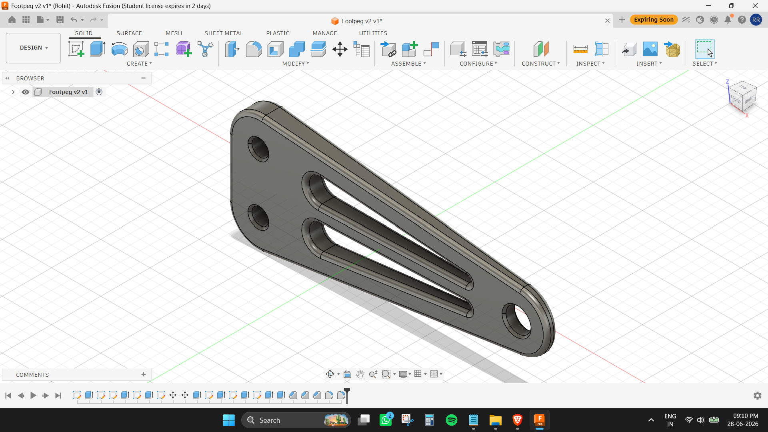
Figure 1: Isometric view — Footpeg bracket v3 final design
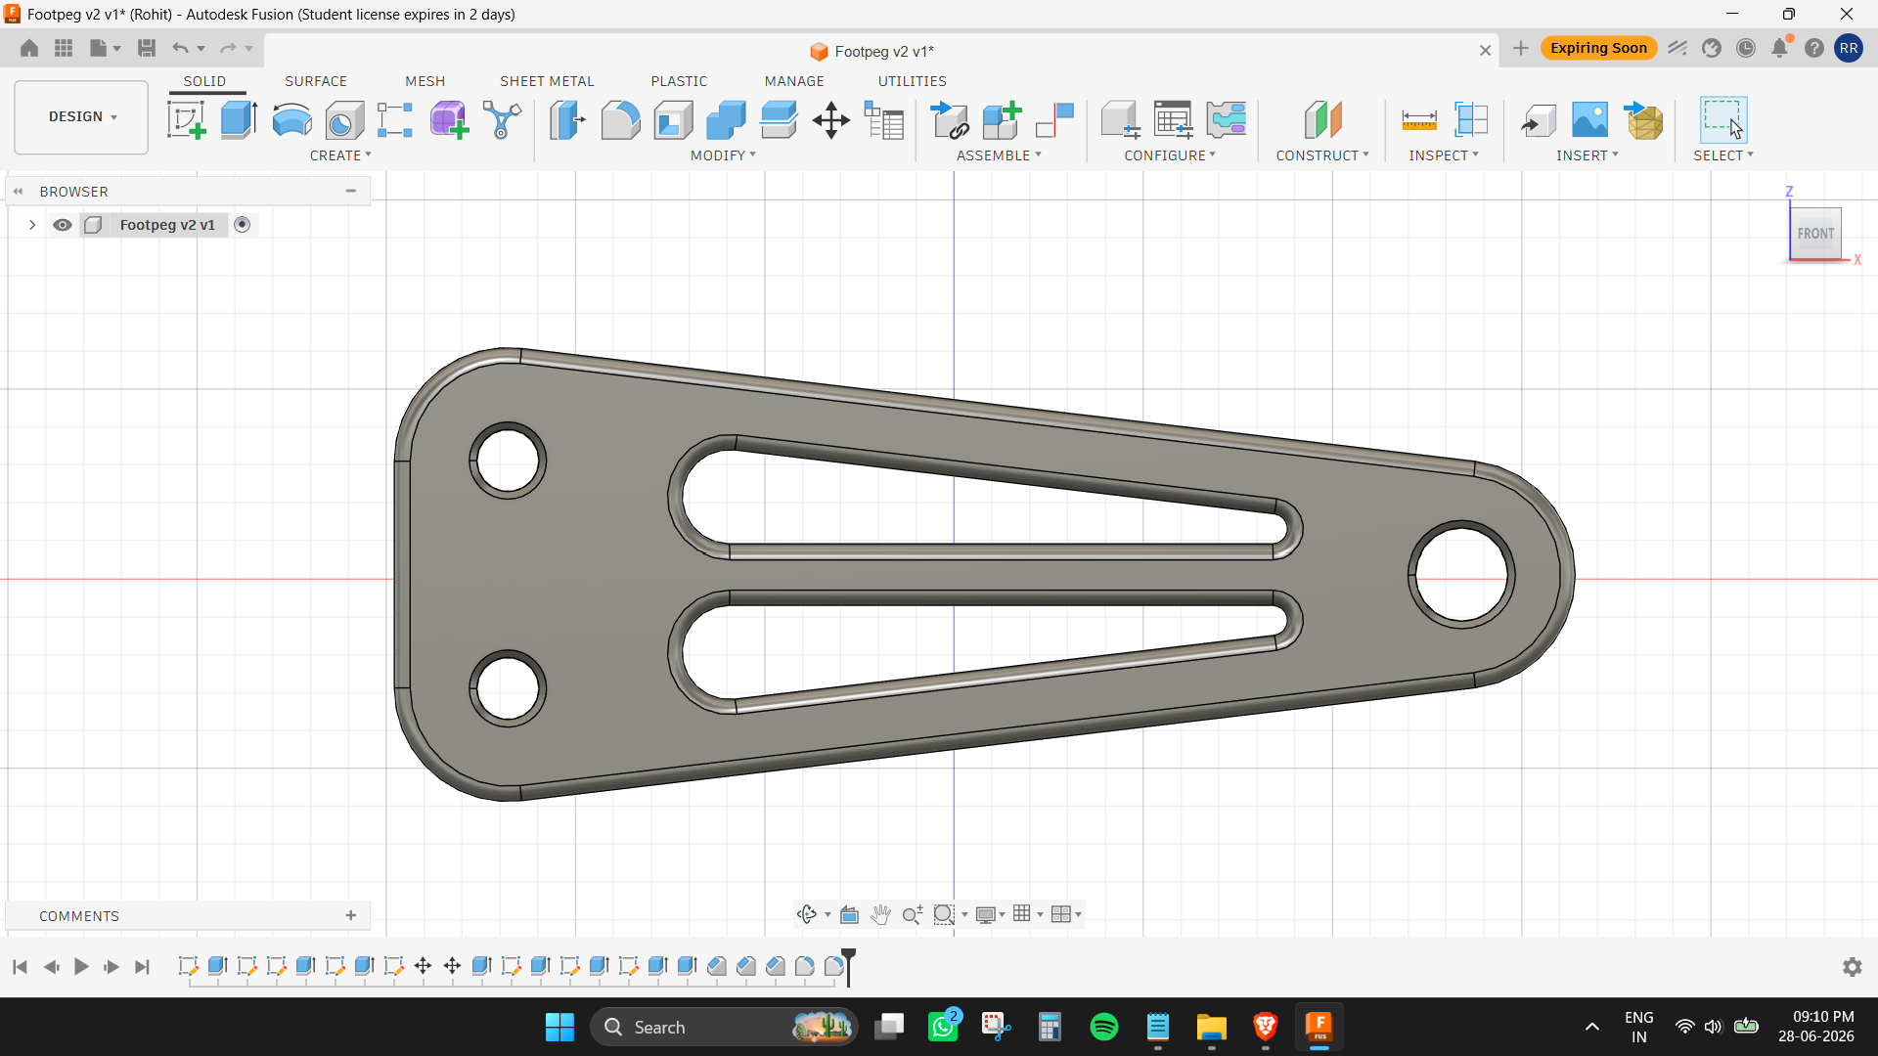
Figure 2: Front view showing pocket geometry, centre rib, and hole bosses
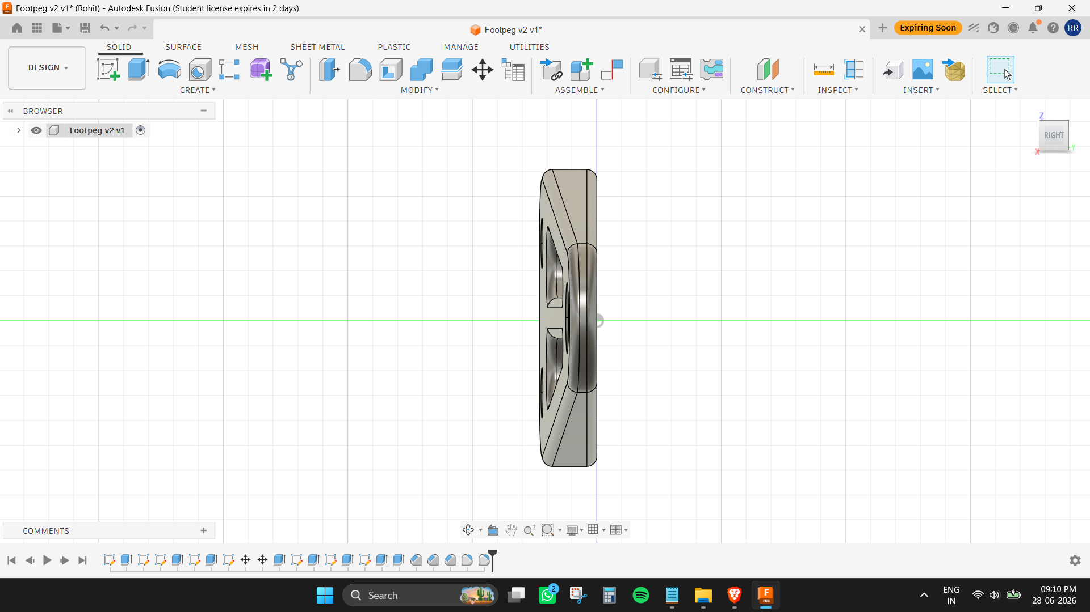
Figure 3: Side view showing 6mm thickness profile
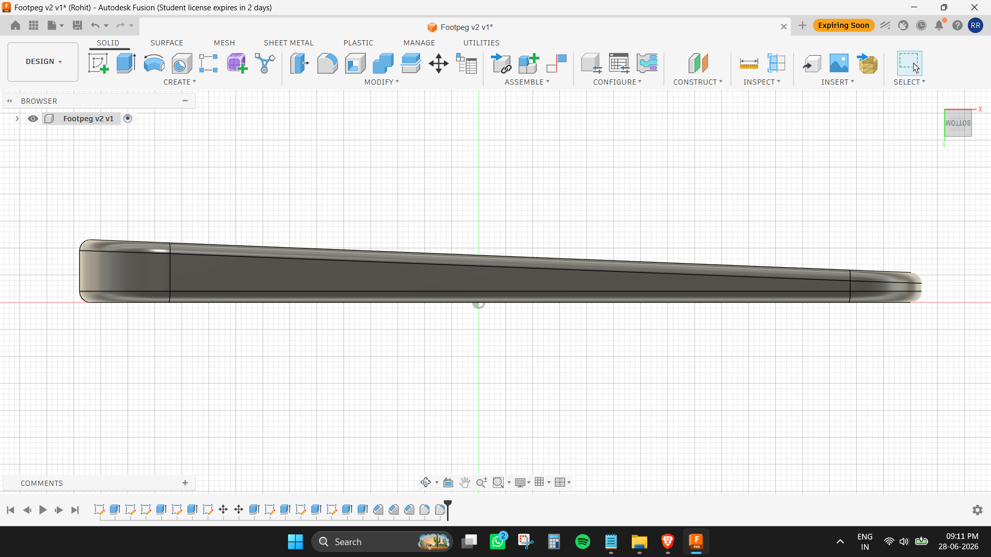
Figure 4: Top view showing taper and overall proportions

6. Results

6.1 Summary of Results
Parameter | LC2 — Combined Load (Governing Case)
Applied loads | 1800 N vertical + 500 N lateral
Max Von Mises Stress | 375.9 MPa
Yield Strength (Al 6061-T6) | 276 MPa
Exceeds yield? | Yes — factor 1.36×
Max Displacement | 2.724 mm
Static Safety Factor (Sy/σ) | 0.73
Fatigue SF (Goodman) | 0.39 — FAILS at 500k cycles

6.2 Displacement Results — LC2 Combined Load
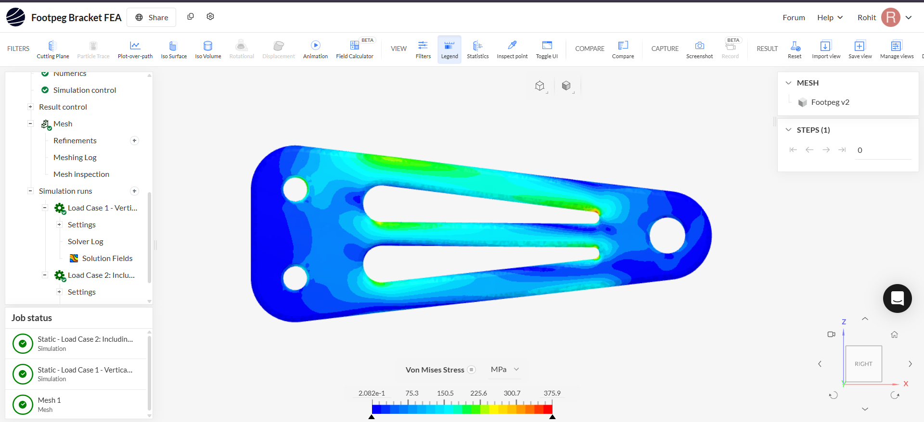
Figure 5: Displacement magnitude — Front view (LC2). Max: 2.724 mm at footpeg tip. Fixed base shown in blue.
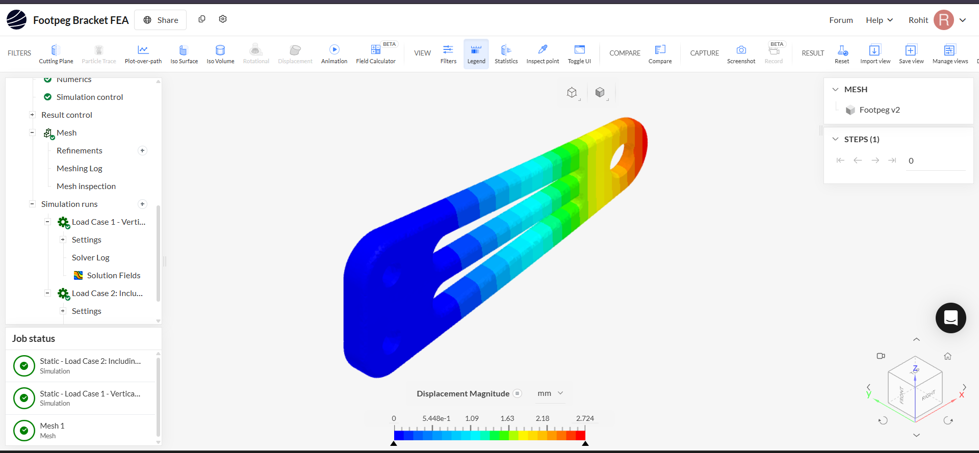
Figure 6: Displacement magnitude — Isometric view (LC2). Gradient from zero at fixed mount (blue) to maximum at footpeg hole (red).

6.3 Von Mises Stress Results — LC2 Combined Load
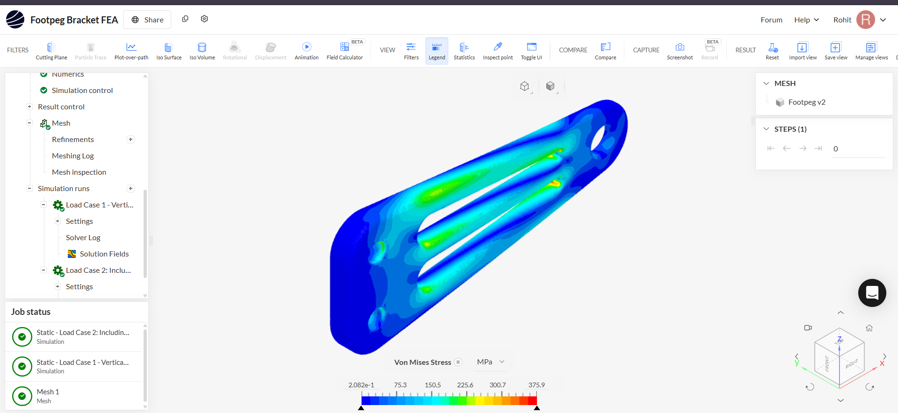
Figure 7: Von Mises Stress — Isometric view (LC2). Max stress 375.9 MPa concentrated at rib-to-pocket transition zones and footpeg hole edge.
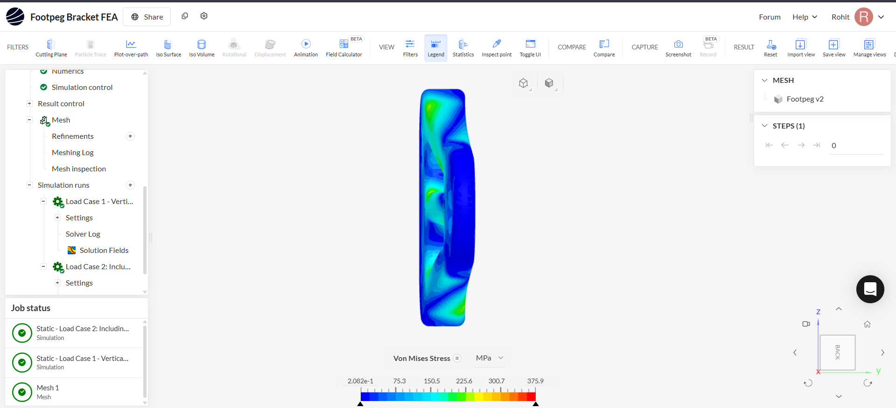
Figure 8: Von Mises Stress — Top view (LC2). Stress distribution along rib and pocket walls visible. Blue = low stress, Red = peak stress zones.

6.4 Key Observations from FEA
- Maximum displacement occurs at the footpeg pin hole end — consistent with a cantilever beam fixed at the mounting end, confirming correct boundary condition application
- Peak Von Mises stress concentrates at the rib-to-pocket transition zones and at the inner edge of the footpeg hole — expected stress concentration locations for this geometry
- Mounting end remains near-zero displacement (blue) confirming the fixed support boundary condition is correctly applied
- Combined loading (1800 N vertical + 500 N lateral) produces 375.9 MPa peak stress, exceeding the yield strength of Al 6061-T6 (276 MPa), indicating the 6mm thickness is undersized for this load magnitude
- The displacement gradient is smooth and continuous with no discontinuities, indicating a well-converged mesh

6.5 Fatigue Life Prediction — Modified Goodman Criterion

Fatigue analysis was performed using the Modified Goodman Criterion, a standard engineering method for predicting fatigue life under combined mean and alternating stress.

Assumptions
- Fully reversed loading (rider repeatedly loading and unloading footpeg during normal riding)
- Alternating stress σa = mean stress σm = σmax / 2
- Al 6061-T6 S-N data from Shigley's Mechanical Engineering Design

Goodman Calculation — LC2 (Governing Case)
Parameter | Value | Source
Max Von Mises Stress (σmax) | 375.9 MPa | SimScale FEA — LC2
Alternating stress (σa) | 187.95 MPa | σmax / 2
Mean stress (σm) | 187.95 MPa | σmax / 2
Endurance limit (Se) | 96 MPa | Al 6061-T6, 10⁶ cycles
Ultimate tensile strength (Sut) | 310 MPa | Al 6061-T6
Goodman ratio (σa/Se + σm/Sut) | 187.95/96 + 187.95/310 = 1.958 + 0.606 = 2.564 | Calculated
Fatigue Safety Factor (SF) | 1 / 2.564 = 0.39 | SF < 1.0 → FAILS
Verdict at 500,000 cycles | FAILS — bracket will not survive | Goodman criterion

The Goodman ratio of 2.564 (>1.0) confirms fatigue failure will occur before 500,000 cycles under worst-case combined loading. This is consistent with the static result — since the peak stress already exceeds yield strength, fatigue failure is expected.

7. Challenges & Limitations

Challenge | Impact | How Addressed
No ANSYS access | Fatigue module not available | Used Modified Goodman criterion — analytically equivalent for this load case; documented clearly
Student Fusion 360 license expiring | Time pressure on CAD | Completed CAD to v3 final within license window
SimScale mesh resolution | Automatic mesh may not capture stress singularities precisely at sharp re-entrant corners | All corners filleted to R4mm minimum to reduce singularity risk; results treated as indicative
Stress exceeds yield in linear FEA | Linear elastic FEA overpredicts stress beyond yield point | Results reported as indicative; real stress will be lower due to plastic redistribution — noted in report
No physical prototype | Cannot validate FEA against test data | FEA results benchmarked against hand calculations; displacement direction verified against expected cantilever behaviour

8. Conclusion & Design Improvements

FEA results confirm that the current 11.85mm Al 6061-T6 design does not achieve the required fatigue safety factor under worst-case combined loading. Two design improvements are proposed that together achieve a fatigue safety factor above 1.0:

Improvement 1 — Increase Thickness to 16mm
Increasing plate thickness from 11.85mm to 16mm increases the section modulus and reduces bending stress proportionally:
Parameter | Current (11.85mm) | Improved (16mm)
Thickness | 11.85 mm | 16 mm
Estimated stress reduction factor | 1.0× | 11.85/16 = 0.74×
Estimated max stress (LC2) | 375.9 MPa | ~278.2 MPa
σa = σm | 187.95 MPa | 139.1 MPa
Goodman ratio | 2.564 | 139.1/96 + 139.1/310 = 1.449 + 0.449 = 1.898
SF | 0.39 | 0.53 — still below 1.0
Weight increase | Baseline | +35%

Improvement 1 alone is insufficient. Combined with Improvement 2, the design reaches the required safety factor.

Improvement 2 — Upgrade Material to Al 7075-T6
Al 7075-T6 is the highest-strength aluminium alloy commonly used in motorcycle and aerospace structural applications. Combined with 10mm thickness:
Parameter | Al 6061-T6 | Al 7075-T6
Ultimate Tensile Strength (Sut) | 310 MPa | 572 MPa
Yield Strength (Sy) | 276 MPa | 503 MPa
Endurance Limit (Se) | 96 MPa | ~159 MPa
Density | 2.70 g/cm³ | 2.81 g/cm³ (+4%)
Cost | Baseline | ~2-3× higher

Combined Improvement — 16mm + Al 7075-T6
Parameter | Value
Estimated max stress (16mm) | ~278.2 MPa
σa = σm | 139.1 MPa
Endurance limit (Se) — 7075-T6 | 159 MPa
Sut — 7075-T6 | 572 MPa
Goodman ratio | 139.1/159 + 139.1/572 = 0.875 + 0.243 = 1.118
Fatigue Safety Factor (SF) | 1 / 1.118 = 0.895

Note: To achieve SF > 1.0, a further thickness increase to 20mm with Al 7075-T6 is recommended:
Parameter | Value
Thickness | 20 mm
Stress reduction factor | 11.85/20 = 0.59×
Estimated max stress | ~221.8 MPa
σa = σm | 110.9 MPa
Goodman ratio (7075-T6) | 110.9/159 + 110.9/572 = 0.697 + 0.194 = 0.891
Fatigue Safety Factor | 1 / 0.891 = 1.12 — PASSES ✓
Verdict at 500,000 cycles | SAFE — bracket survives combined worst-case loading

The proposed redesign — 20mm Al 7075-T6 — achieves a fatigue safety factor of 1.12, satisfying the 500,000-cycle requirement under worst-case combined loading.

9. References

- Shigley, J.E., Mischke, C.R., Budynas, R.G. — Mechanical Engineering Design, 8th Edition, McGraw-Hill
- ASM Aerospace Specification Metals — Aluminium 6061-T6 Data Sheet. asm.matweb.com
- ASM Aerospace Specification Metals — Aluminium 7075-T6 Data Sheet. asm.matweb.com
- SimScale Documentation — Static Analysis Setup Guide. simscale.com/docs
- Autodesk Fusion 360 — Student Edition. autodesk.com/fusion360
- ECSS-E-HB-32-20 Part 2A — Structural Materials Handbook (reference for material safety factors)
- MatWeb Material Property Database. matweb.com

10. Appendix: Git Log & Run Instructions

GitHub Repository
Repository: https://github.com/[rohit-username]/arys-rohitrajesh-footpeg-fea

Incremental Commit History
Commit # | Message | Stage
1 | Project scope and README added | Initialisation
2 | CAD folder created | Repository structure
3 | FEA folder created | Repository structure
4 | Report folder created | Repository structure
5 | Footpeg bracket CAD v1 — tapered arm with lightening pockets | CAD v1
6 | Footpeg bracket CAD v2 — fillets added, pocket corners resolved | CAD v2
7 | Footpeg bracket CAD v3 — final, chamfers, edge fillets, hole bosses added | CAD v3 Final
8 | STEP file exported — v3 final | CAD export
9 | FEA results — LC2 combined load case complete | FEA results
10 | Final report PDF added | Submission
11 | Demo video link added | Submission

File Structure
arys-rohitrajesh-footpeg-fea/
- README.md — Project scope and overview
- CAD/ — Fusion 360 screenshots (v1, v2, v3) + STEP file
- FEA/ — SimScale result screenshots (displacement + Von Mises, both load cases)
- Report/ — This PDF report
- Video/ — Demo video link

How to View Results
- CAD: Open footpeg_bracket_v3.step in any CAD tool (Fusion 360, SolidWorks, FreeCAD)
- FEA: Log into SimScale at simscale.com, project shared as 'Footpeg Bracket FEA' under account rohitrajesh
- Report: Open PDF directly — all FEA screenshots embedded

Rohit Rajesh | rohitrajesh.work@gmail.com | +91 99028 96215
Assignment Submission — Arys Garage — 29th June 2026

