**Assignment 7:**

**CalculatorController.java**

import org.springframework.web.bind.annotation.*;

@RestController

@RequestMapping("/calculator")

public class CalculatorController {

@GetMapping("/add")

public double add(@RequestParam double operand1, @RequestParam double operand2) {

return operand1 + operand2;

}

@GetMapping("/subtract")

public double subtract(@RequestParam double operand1, @RequestParam double operand2) {

return operand1 - operand2;

}

@GetMapping("/multiply")

public double multiply(@RequestParam double operand1, @RequestParam double operand2) {

return operand1 * operand2;

}

@GetMapping("/divide")

public double divide(@RequestParam double operand1, @RequestParam double operand2) {

if (operand2 == 0) {

throw new IllegalArgumentException("Cannot divide by zero");

}

return operand1 / operand2;

}

}

**CalculatorServiceApplication.java**

package com.cs.CalculatorService;

import org.springframework.boot.SpringApplication;

import org.springframework.boot.autoconfigure.SpringBootApplication;

@SpringBootApplication

public class CalculatorServiceApplication {

public static void main(String[] args) {

SpringApplication.*run*(CalculatorServiceApplication.class, args);

}

}

Outputs:

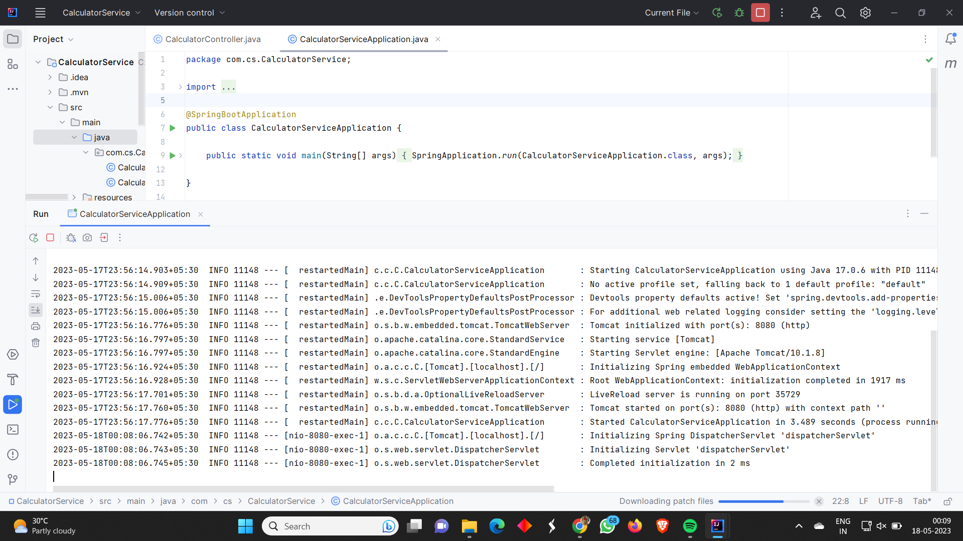

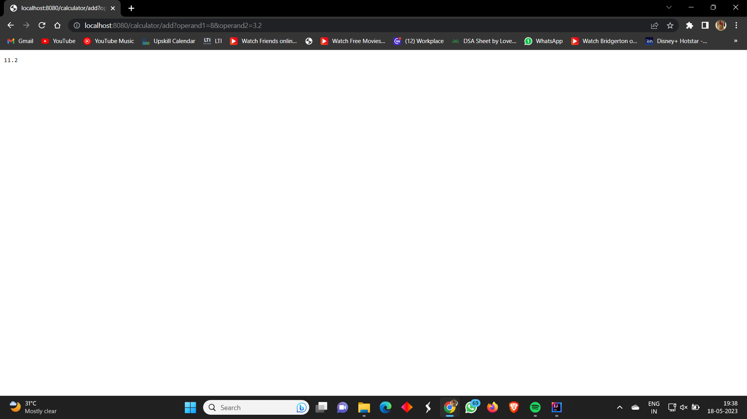

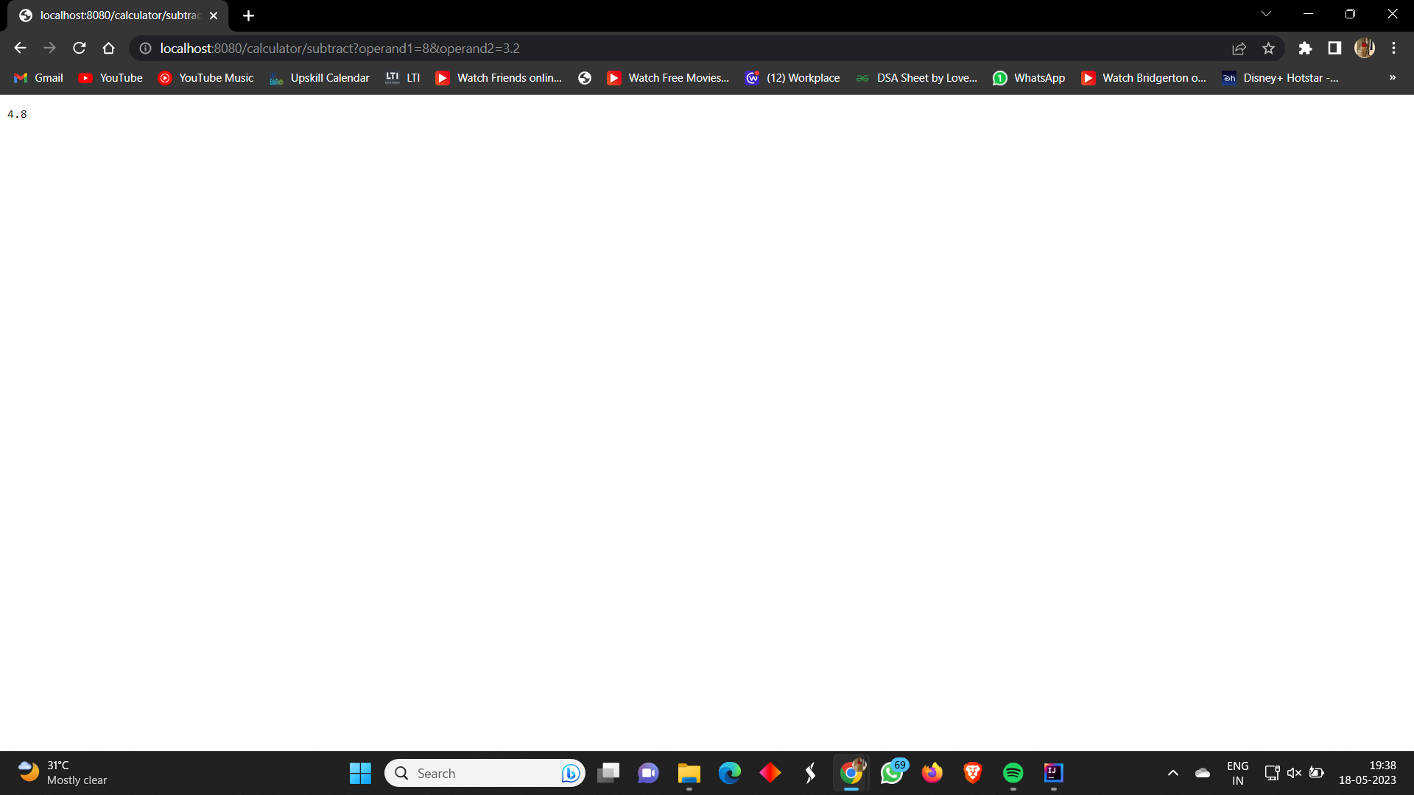

**CalculatorService.java**

package com.csa.CalculatorServiceApplication;

public interface CalculatorService {

double add(double operand1, double operand2);

double subtract(double operand1, double operand2);

double multiply(double operand1, double operand2);

double divide(double operand1, double operand2);

}

**CalculatorController.java**

package com.csa.CalculatorServiceApplication;

import org.springframework.web.bind.annotation.*;

@RestController

@RequestMapping("/distributed/calculator")

public class CalculatorController {

private final CalculatorService calculatorService;

public CalculatorController(CalculatorService calculatorService) {

this.calculatorService = calculatorService;

}

@GetMapping("/add")

public double add(@RequestParam double operand1, @RequestParam double operand2) {

return calculatorService.add(operand1, operand2);

}

@GetMapping("/subtract")

public double subtract(@RequestParam double operand1, @RequestParam double operand2) {

return calculatorService.subtract(operand1, operand2);

}

@GetMapping("/multiply")

public double multiply(@RequestParam double operand1, @RequestParam double operand2) {

return calculatorService.multiply(operand1, operand2);

}

@GetMapping("/divide")

public double divide(@RequestParam double operand1, @RequestParam double operand2) {

return calculatorService.divide(operand1, operand2);

}

}

CalculatorServiceImpl.java

package com.csa.CalculatorServiceApplication;

import org.springframework.context.annotation.Bean;

import org.springframework.stereotype.Service;

import org.springframework.web.client.RestTemplate;

@Service

public class CalculatorServiceImpl implements CalculatorService {

private final RestTemplate restTemplate;

public CalculatorServiceImpl( RestTemplate restTemplate) {

this.restTemplate = restTemplate;

}

@Bean

@Override

public double add(double operand1, double operand2) {

String url = "http://localhost:8080/calculator/add?operand1={operand1}&operand2={operand2}";

return restTemplate.getForObject(url, Double.class, operand1, operand2);

}

@Bean

@Override

public double subtract(double operand1, double operand2) {

String url = "http://localhost:8080/calculator/subtract?operand1={operand1}&operand2={operand2}";

return restTemplate.getForObject(url, Double.class, operand1, operand2);

}

@Bean

@Override

public double multiply(double operand1, double operand2) {

String url = "http://localhost:8080/calculator/multiply?operand1={operand1}&operand2={operand2}";

return restTemplate.getForObject(url, Double.class, operand1, operand2);

}

@Bean

@Override

public double divide(double operand1, double operand2) {

String url = "http://localhost:8080/calculator/divide?operand1={operand1}&operand2={operand2}";

return restTemplate.getForObject(url, Double.class, operand1, operand2);

}

}

CalculatorServiceApplication.java

package com.csa.CalculatorServiceApplication;

import org.springframework.boot.SpringApplication;

import org.springframework.boot.autoconfigure.SpringBootApplication;

import org.springframework.context.annotation.ComponentScan;

@SpringBootApplication

@ComponentScan(basePackages = "com.csa.config")

public class CalculatorServiceApplication {

public static void main(String[] args) {

SpringApplication.*run*(CalculatorServiceApplication.class, args);

}

}

Outputs:

