Internship Report

Task 2: Web application security analysis with open-source tools

#Wappalyzer
It is web technology detection tool which helps us to detect which technologies are being used by the web application and server.
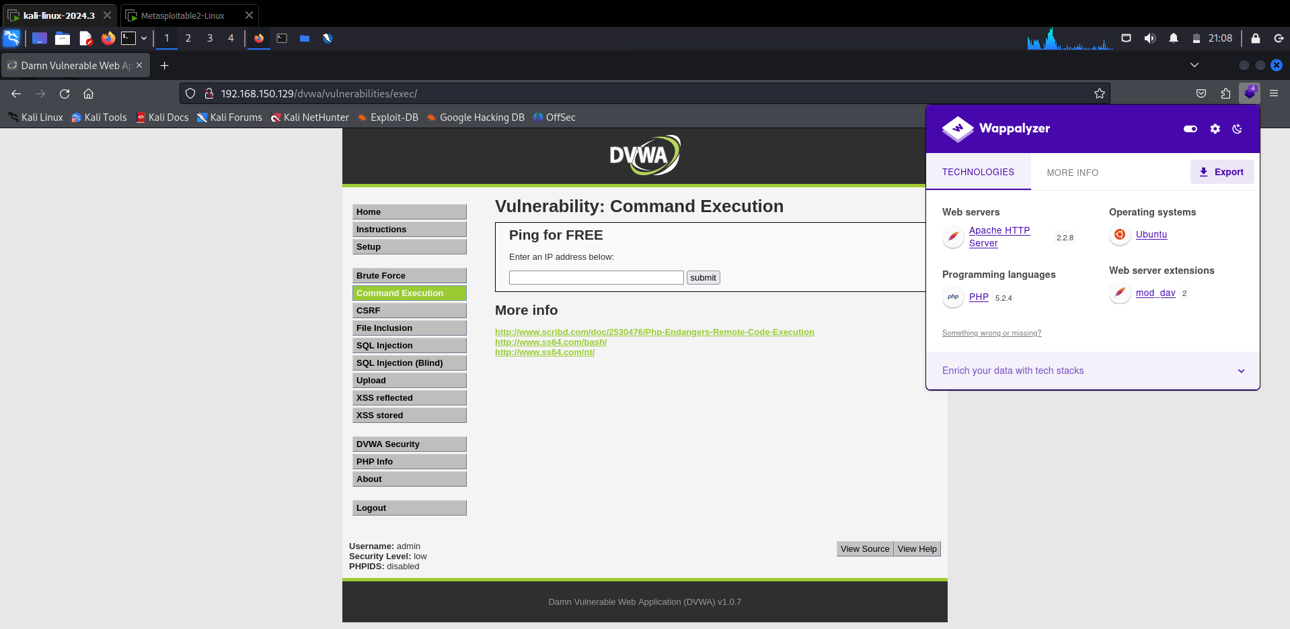

Versions:
Apache HTTP server: 2.2.8
PHP version: 5.2.4
Mod dav version: 2
Operating system: ubuntu

#Zaproxy scan

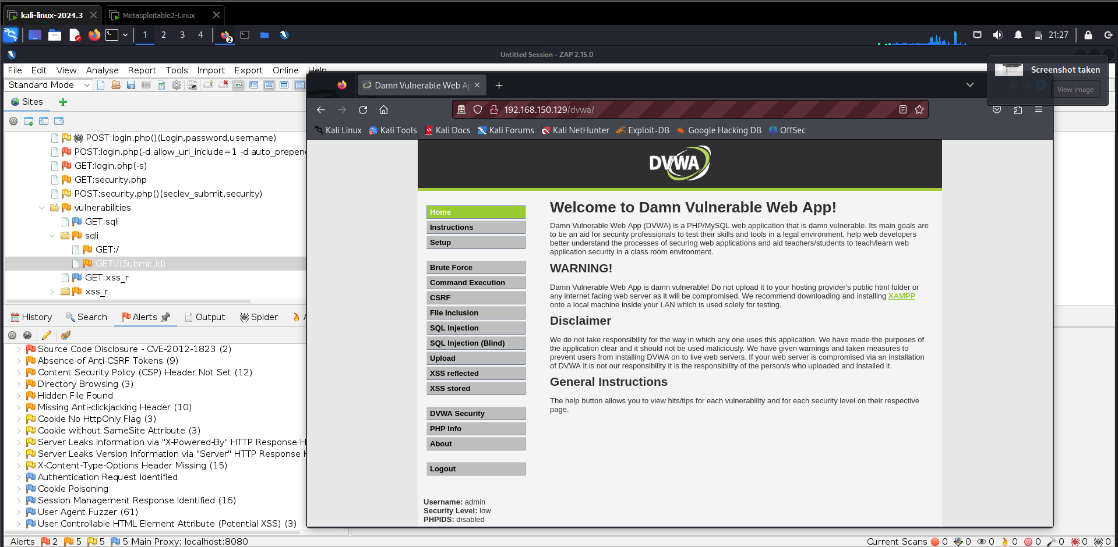

#1 Vulnerability

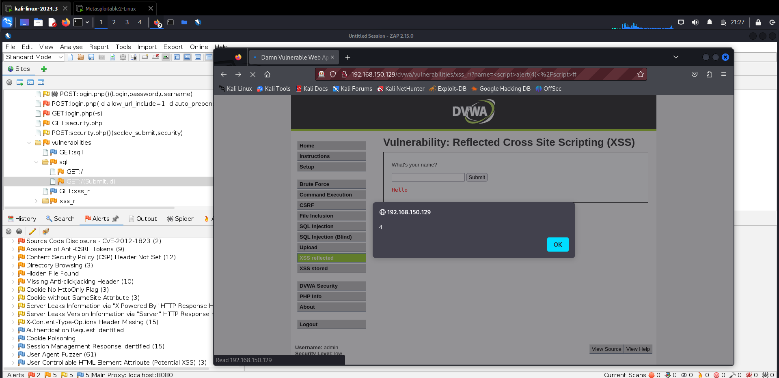
Vulnerability Name: XSS
Severity: Medium
Payload: <script>alert(“4”)</script>
Impact: This vulnerability leads to steal user’s cookie and perform malicious actions.
Vulnerability Description: User supplied input are not properly validate, there is no validation. I injected a malicious JavaScript code which you can see in the screenshot.
Vulnerability Fix: Implement CORS security header in the HTTP request and properly validate user supplied inputs.
Steps to reproduce the attacks:
- Go to XSS vulnerable URL page of the DVWA.
- Put above payload in the field and click ok.

#2 Vulnerability

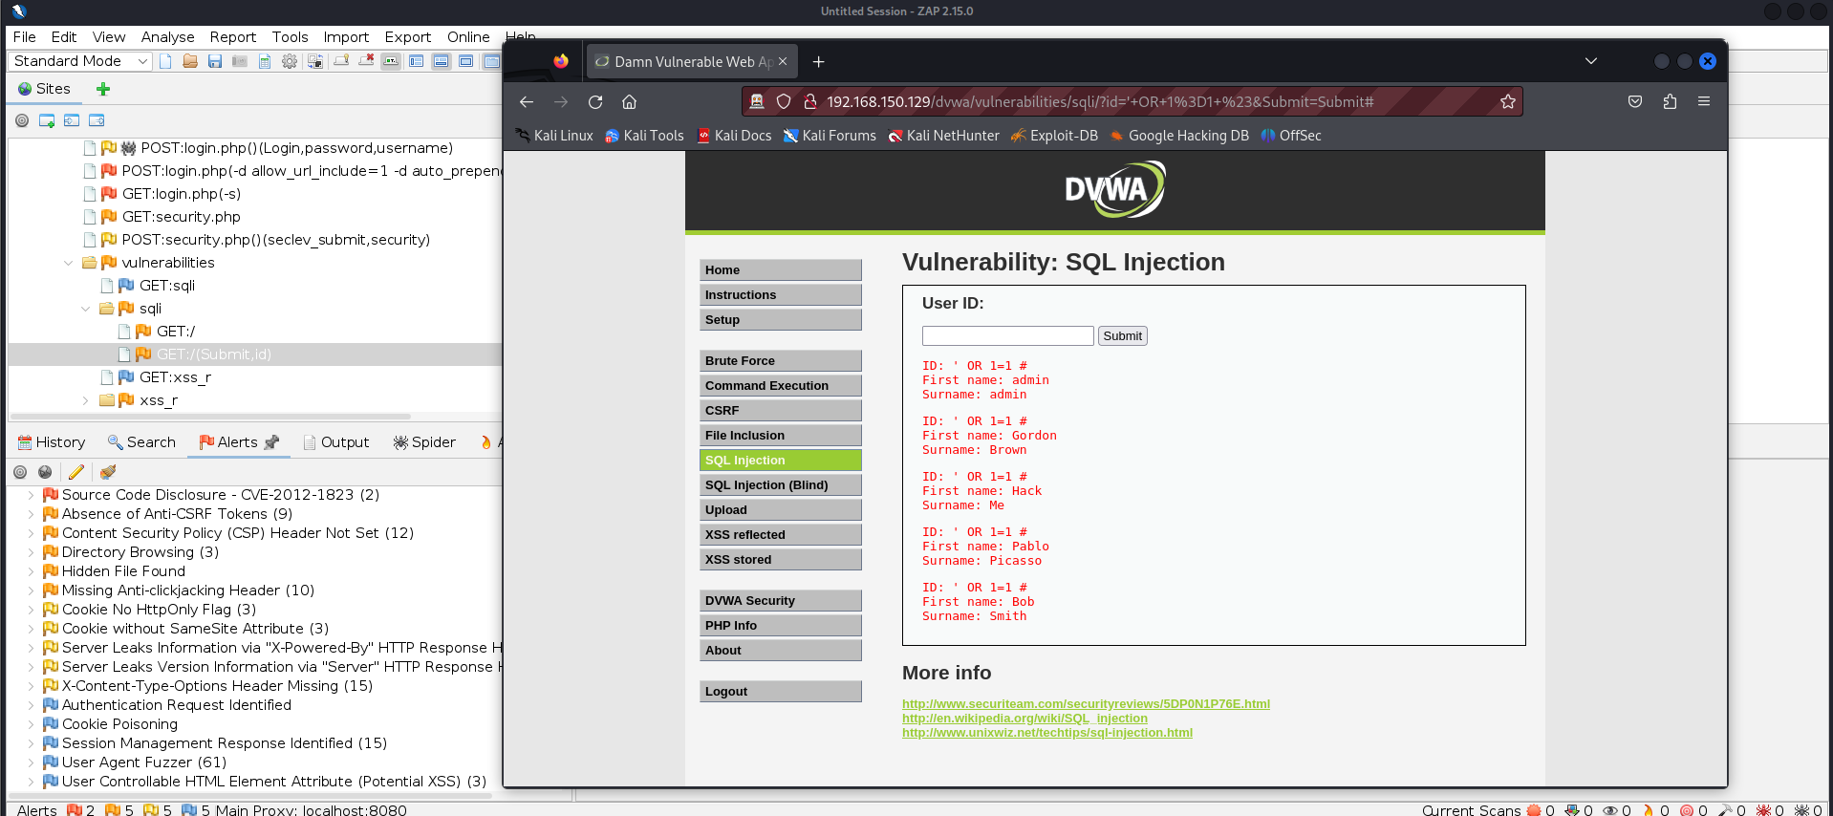
Vulnerability Name: SQL
Severity: HIGH
Payload: ‘ OR 1=1#
Impact: This vulnerability leads to database takeover.
Vulnerability Description: Any person can easily inject SQL query in user ID field and get other user’s information.
Vulnerability Fix: Validate user supplied input before using it in the SQL query.
Steps to reproduce the attacks:
- Go to User ID vulnerable page URL.
- Put the above payload in the user ID field and click on submit.

#3 VULNERABILITY

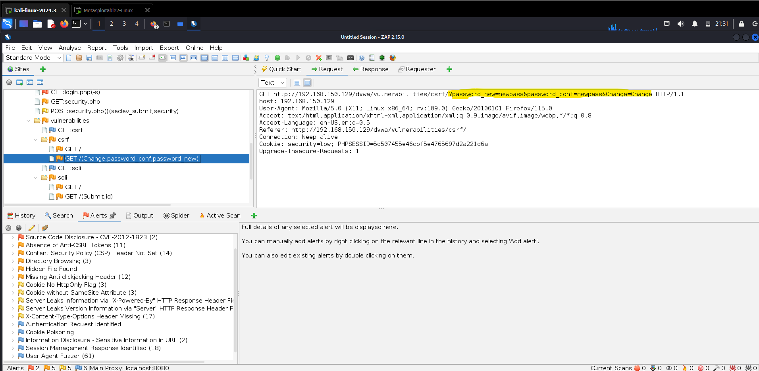
Vulnerability Name: CSRF (client-side request forgery)
Severity: Medium
Impact: This vulnerability leads to account takeover and can be used to performed malicious action.
Vulnerability Description: whenever a user changes their password, username or anything, the HTTP request does not contain a CSRF token along with credentials.
Vulnerability Fix: HTTP password change request should include the CSRF token or some sort of authentication.
Steps to reproduce the attacks: check out this medium post.

