Internship Report

Task 1. Network security

Network Threats
- Virus: A computer virus is a type of malware that replicated itself by modifying other computer programs/software and insert its own code into other programs.
- Worms: A worm is a standalone malware that replicates itself to spread over other computer networks. It does not require human interaction and does not need to attach itself to other programs in order to spread.
- Trojan: A trojan horse disguise itself as legitimate code. It is a type of malware that hides within a legitimate file or program to gain access to your device.
- Phishing attack: A phishing attack is a social engineering tactic to steal confidential data to deliver ransomware or other form of malware. An attacker uses trusted communication source that looks legitimate.
Unusual traffic analysis:
- Unusual IP Addresses: Traffic from unfamiliar IP addresses3.
- Repeated Login Attempts: Multiple failed logins attempt in a short period of time.
- Unusual Data Transfers: Large amounts of data being transferred during an RDP session.
How to protect network: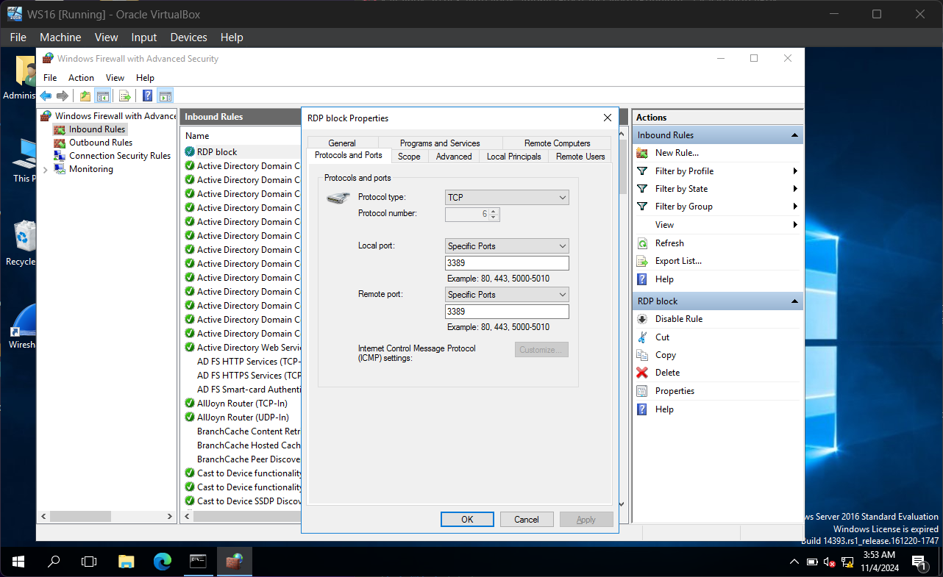
- Block any unwanted port connection.
- Keep your system and anti-virus up to date.
- Monitor network activities using windows eventviewer.exe.
- Setup firewall rules according to your requirement.
Wireshark Captured Traffic:
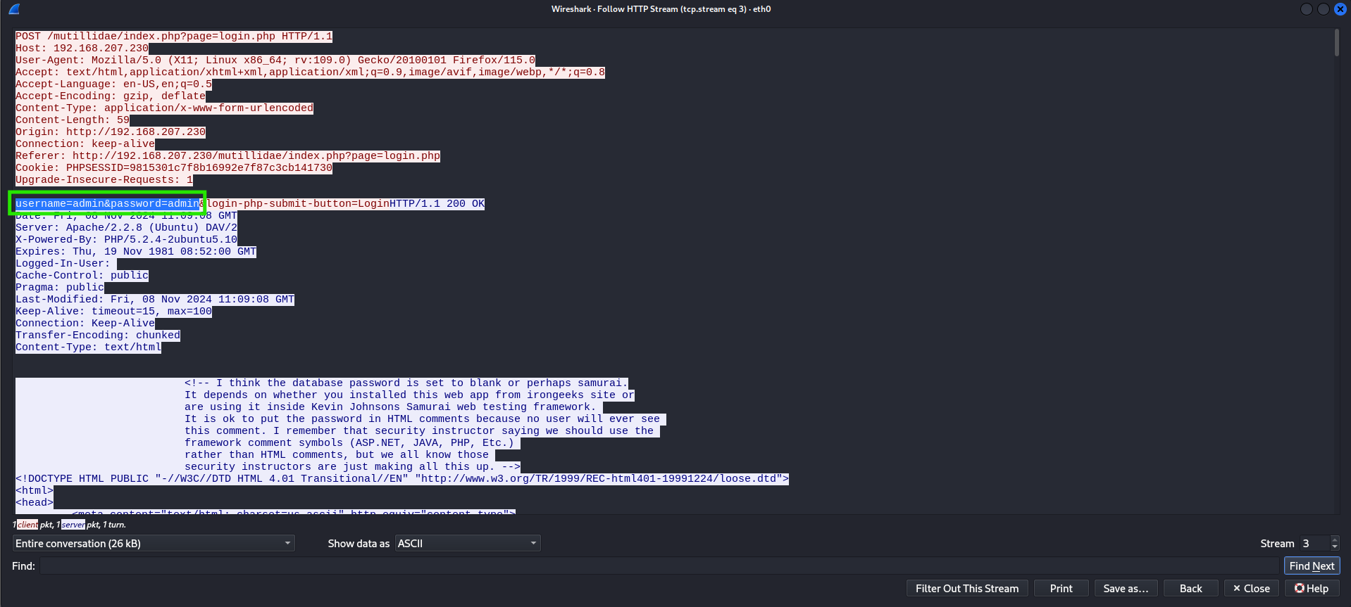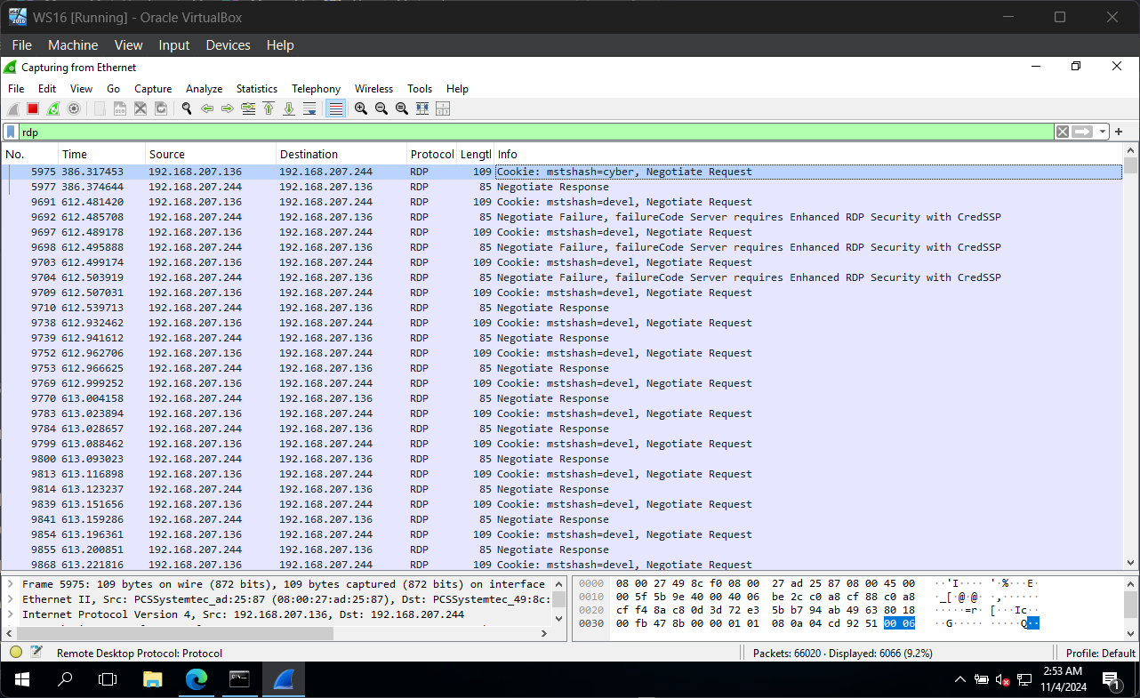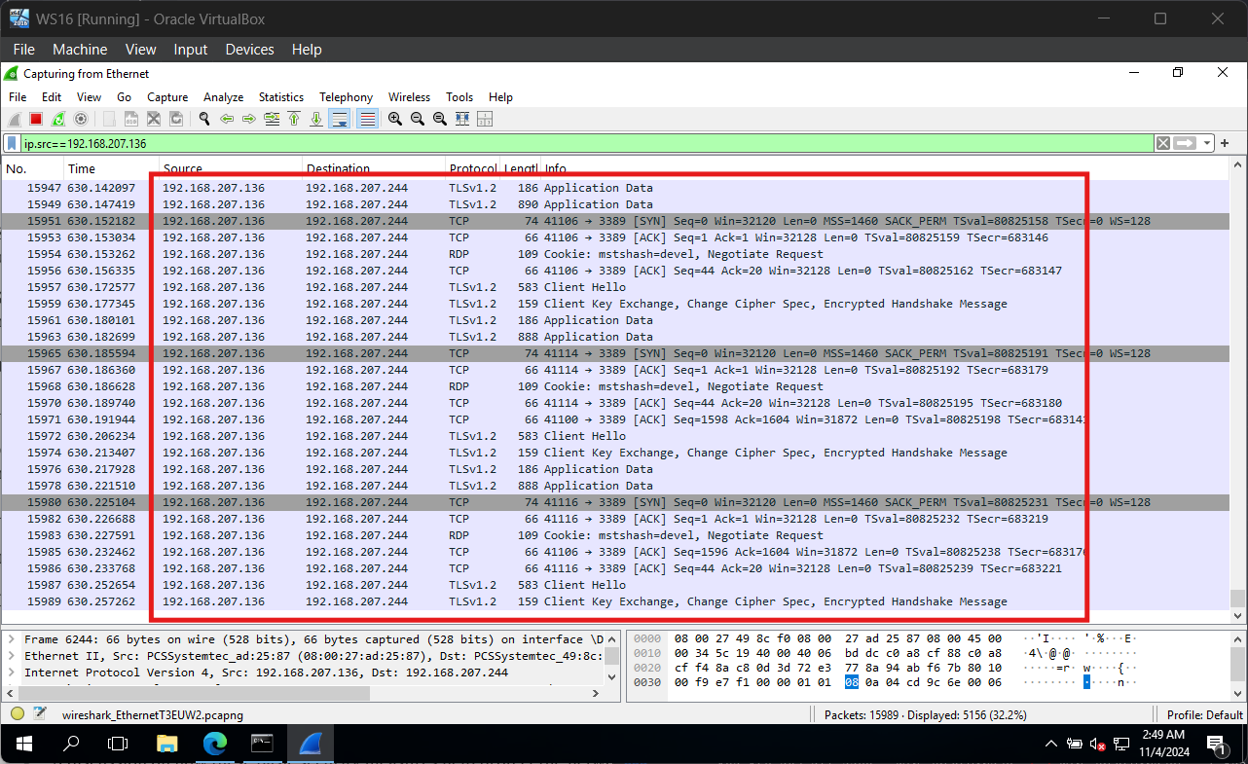

Additional security measure can be implemented in a large or complex network:
  - Install a physical firewall (hardware device).
  - Regular log monitoring.
  - Change default passwords.
  - Use https to protect from MITM attacks.

Importance of security in everyday life:
Technology has become an integral part of human life and we are surrounded by the technology. Keeping our personal information, financial data and documents safe from attacks. Now days, cyber-attacks are very common, it is really important to secure our data by enabling 2FA (2 Factor Authentication), using strong password and knowing common attack techniques.

