CS 255 Project Two - System Design Document

Author: Dominick Griggs

# UML Use Case Diagram

This diagram shows the different people who use the system and the tasks they perform. It includes students, secretaries, administrators, IT officers, and the DMV system. Students can register, schedule lessons, take classes, and complete practice tests. Staff manage schedules, accounts, and reports. The DMV provides updated rules and practice material.

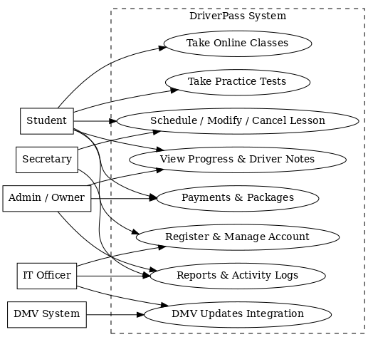

# UML Activity Diagrams

Two activity diagrams illustrate the workflows for scheduling a lesson and taking a practice test.

Activity Diagram: Schedule Lesson

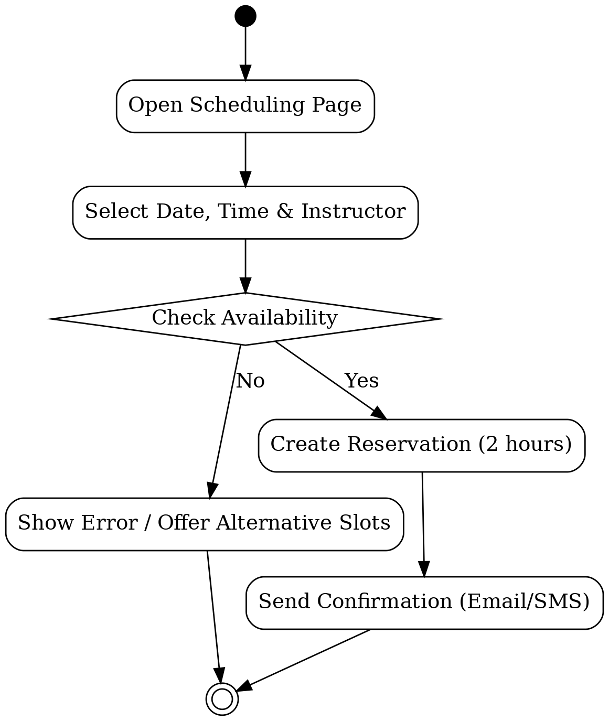

Activity Diagram: Take Practice Test

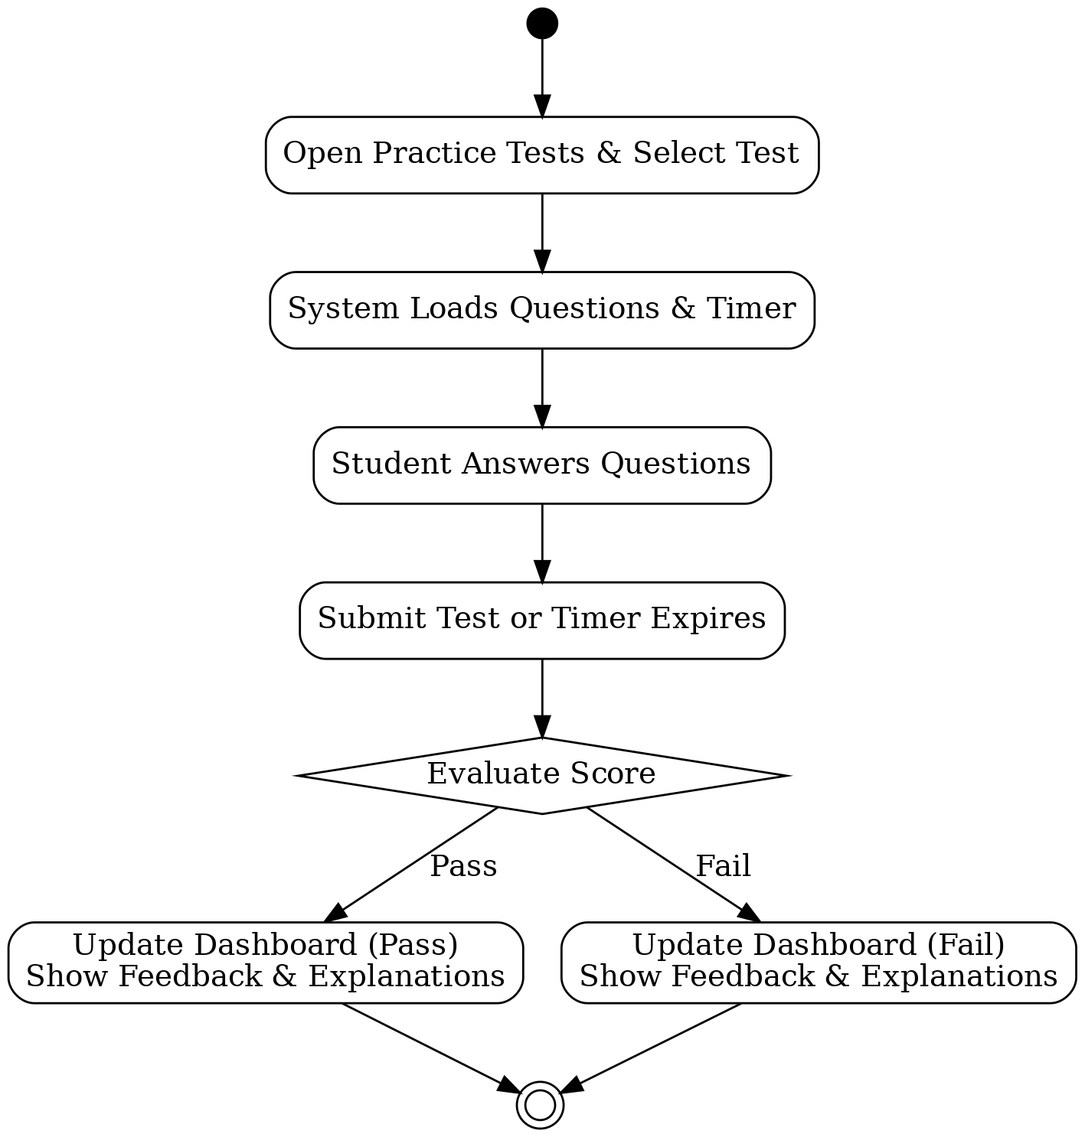

# UML Sequence Diagram

This sequence diagram illustrates the communication flow when scheduling a lesson. It shows the interactions between the student, the web application, the scheduler, the database, and the notification service to ensure a reservation is properly created and confirmed.

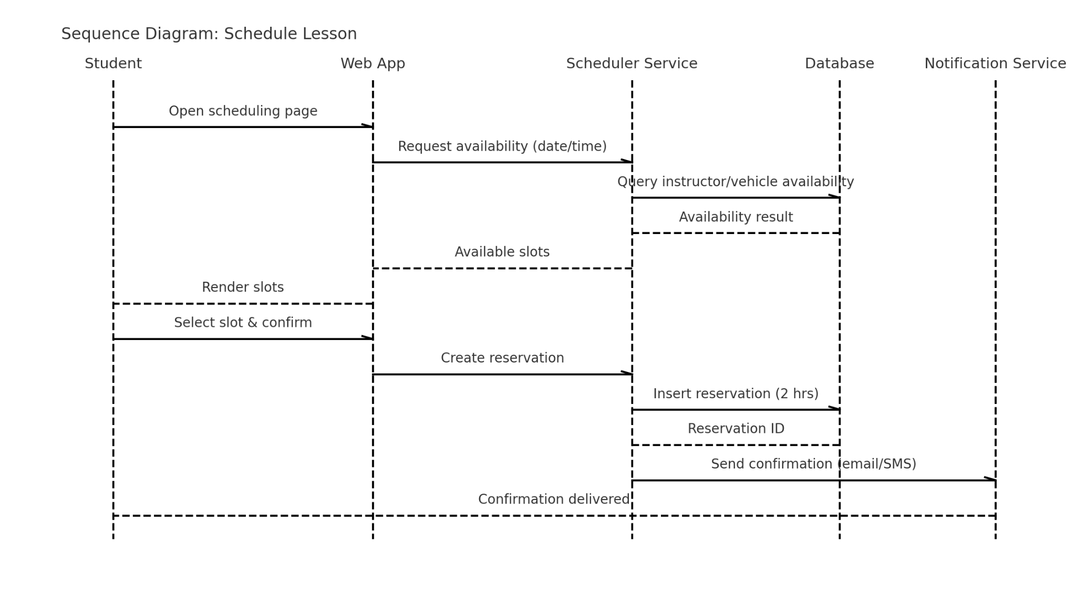

# UML Class Diagram

This class diagram defines the core system entities and their relationships, including users, lessons, instructors, vehicles, packages, classes, practice tests, test results, and activity logs. It also shows inheritance between user roles and the base user class.

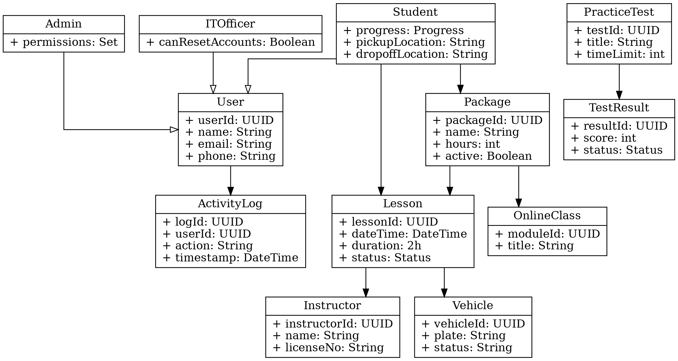

# Technical Requirements

Hosting & Infrastructure:  
- The system will be hosted in a secure cloud environment with automated backups, monitoring, and disaster recovery measures.  
- Load balancing will ensure multiple users can access the system simultaneously without performance issues.  
- A managed SQL database will store user information, lessons, progress, and logs.  
  
Software Stack:  
- Frontend: Responsive web application accessible via major browsers on both desktop and mobile.  
- Backend: RESTful web services for scheduling, accounts, practice tests, and reporting.  
- Database: SQL-based schema with structured relationships between users, lessons, instructors, and vehicles.  
- Integrations: DMV system for updated rules and test content, email/SMS for notifications, and CSV/Excel exports for reports.  
  
Security & Access Control:  
- Role-based access with permissions for students, secretaries, administrators, and IT officers.  
- Encrypted communication using TLS and secure password storage.  
- Account management features including password resets and disablement.  
- Comprehensive audit logging to track all critical actions.  
  
Performance & Reliability:  
- Scheduling and test submissions should respond within 2 seconds under normal load.  
- Concurrency control prevents double-booking of instructors or vehicles.  
- Real-time monitoring and alerts detect downtime or failures.  
- Caching frequently accessed content like practice questions for faster performance.  
  
DevOps & Governance:  
- Continuous integration and deployment pipelines for efficient updates.  
- Version control for tracking system changes.  
- Regularly tested backups with documented Recovery Point Objective (RPO) and Recovery Time Objective (RTO).  
- CASE tools (such as Lucidchart) will be used to maintain UML diagrams and keep documentation current.