CSY2061- Mobile Application Development Assignment 2 Resit
Joshua Luke Perry (21428656) University Of Northampton
Table of Contents
1 Introduction 3
2 Project Design 4
3 Implemented Features 5
3.1 Table of Features 5
3.2 Existing User Accounts 6
3.3 Key Features 7
4 Testing 8
4.1 Blackbox Testing 8
4.2 Whitebox Testing 9
4.3 Bugs 10
5 Conclusion 11
Bibliography 12

Table of Figures
Figure 1: Entity Relationship Diagram 4
Figure 2: UML Diagram Displaying the Relationships Between the Project's Classes 4

Index of Tables
Table 1: Implemented Features 5
Table 2: Existing User Accounts 6
Table 3: Bugs Found Within the Project 10

1 Introduction

2 Project Design
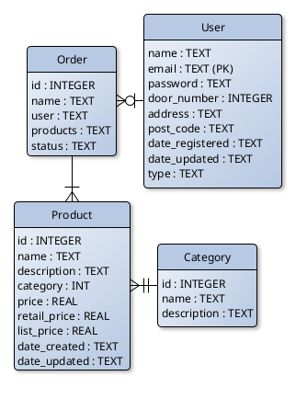Figure 1: Entity Relationship Diagram
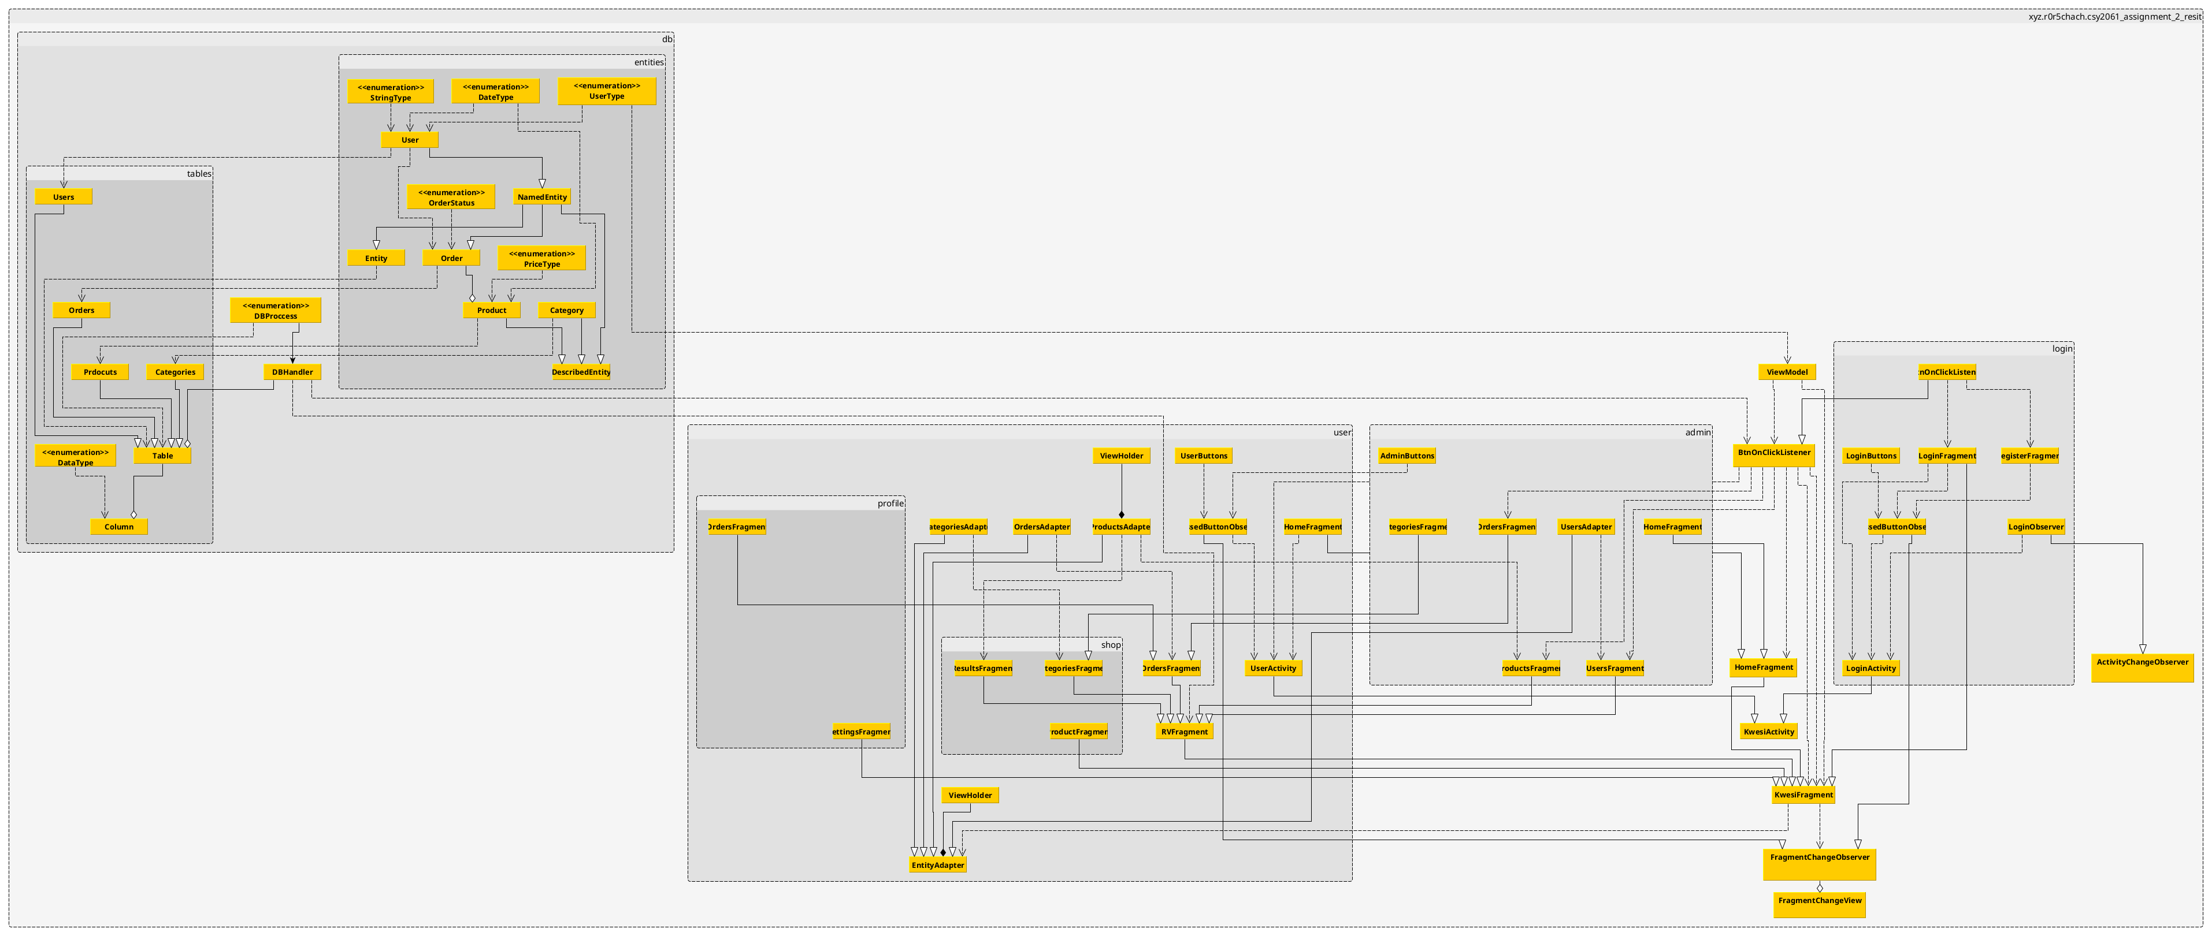Figure 2: UML Diagram Displaying the Relationships Between the Project's Classes

3 Implemented Features

3.1 Table of Features
Table 1: Implemented Features
Feature | Implemented (Partial/Full/None) | Any Comments
Register for the application | Full | Option to register for the application on the login screen
Login to application | Full | User is verified against exisiting users in the database
Logout of application | Partial | When application is closed the user is logged out, however no button to manually logout within the app
View all categories | Partial | All backend code to allow for categories to be viewed has been created, however, interacting beyond the generated list has yet to be implemented
Add a product to the basket | None | This feature was going to be implemented after admin control as without someone to manage the store, no products would be available for users
Remove product from the basket | None | Same as above
Create an order | None | Same as above
Check the status of an order | Partial | This is done within the order viewing screen, reachable through the view all orders screen
View all orders (previous and current) | Partial | All logic to retrieve orders has been written however there is an inability to interact with the orders beyond the display screen
Admins can CRUD Categories | Partial | All backend code to CRUD categories had been create, however for the admin to achiebe this, interaction beyond the category viewing screen would need to be possible
Admin can CRUD Products | Partial | Same as above
Products are assigned to categories | Full | When a product is created by an admin, a category has to be defined
Products should contain (name, description, price, list price, retail price, date created, date updated | Full | The table definition for the products within the database confrom to the brief specification
Admins can CRUD Users | Partial | Same as other CRUD features
Admins can export all users’ orders to a file | None | This feature was a stretch goal for this project, so was left to be implemented last.
The user can update their own details | Partial | Same issue as the CRUD features
Date updated column updated when a user updates their profile | None | As a use cannot submit the updates ,due to the front end not being fully connected to the backend, this feature was unable to be implemented
The user should be able to update their profile picture | None | Profile pictures are yet to be implemented and therefore changing them is impossible

3.2 Existing User Accounts
Table 2: Existing User Accounts
Email | Password | Account Type
test | test | user
admin | test | admin

3.3 Key Features

3.3.1 Directory structure
- Java.xyz.r0r5chach.csy2061_assignment_2_resit
  - db
    - entities
    - tables
  - login
  - user
    - admin
    - profile
    - shop
- res
  - layout
  - values
- AndroidManifest.xml
Refer to Appendix 1 for the complete file structure

3.3.2 Key Classes
The most important classes for the project are the ones found in the root package of the project. These are generalized/abstracted classes that define most of the logic for how the application works.

3.3.2.1 KwesiActivity
This class extends from the basic AppCompactActivity that most applications use. Since all the activities in this project require the ability to communicate with fragments they contained, this class handles initisialisation of the activity layout, fragment view kayout, and the view model that allows the fragments to talk to the activity. All the activities in this project inherit from this class.
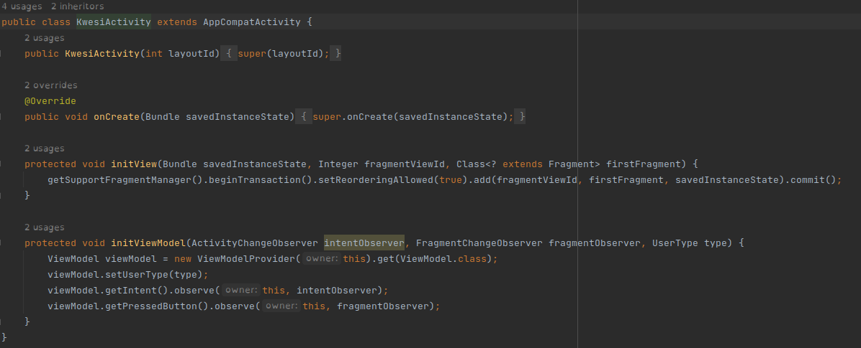Figure 3: Screenshot Displaying the KwesiActivity Class

3.3.2.2 KwesiFragment
This class extends from the basic Fragment that most applications use. As mentioned above, all the fragments require the ability to talk to their activity. All other fragments inherit from this class allowing all the fragments to easily define listeners for their buttons, this is because the button listeners handle the view model for the fragments as any activity interaction from the fragments are triggered by button presses.

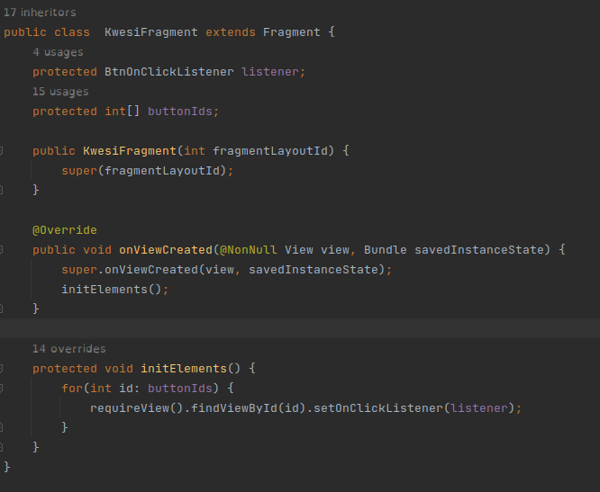Figure 4: Screenshot Displaying the KwesiFragment Class

3.3.2.3 Viewmodel

4 Testing

4.1 Blackbox Testing

4.2 Whitebox Testing

4.3 Bugs
In section 3.1 some issues with the product were outlined in the comments of the features. Bugs that have been found in the program are as follows:
Table 3: Bugs Found Within the Project
Bug Description | Suggestion of How to Solve
Hints in editable text views do not disappear when user enter input | Remove hint when view focus is detected

5 Conclusion

Bibliography

Appendix 1 Complete File Structure
(Items with an * require additional work to provide a functioning product)
- Src
  - main
    - java.xyz.r0r5chach.csy2061_assignment_2_resit
      - db
        - entities
          - Category.java
          - DateType.java
          - DescribedEntity.java
          - Entity.java
          - NamedEntity.java
          - Order.java
          - OrderStatus.java
          - PriceType.java
          - Product.java
          - StringType.java
          - User.java
          - UserType.java
        - tables
          - Categories.java
          - Column.java
          - DataType.java
          - Orders.java
          - Products.java
          - Table.java * Add ability to index products by category
          - Users.java
        - DBHandler.java
        - DBProccess.java
      - login
        - BtnOnClickListener.java
        - LoginActivity.java
        - LoginButtons.java
        - LoginFragment.java
        - LoginObserver.java
        - PressedButtonObserver.java
        - RegisterFragment.java
      - user
        - admin
          - AdminButtons.java * Define button ids for buttons that control fragments
          - CategoriesFragment.java * Create a BtnOnClickListener
          - HomeFragment.java
          - OrdersFragment.java * Create a BtnOnClickListener & replace empty list with db call
          - ProductsFragment.java * Create a BtnOnClickListener
          - UsersAdapter.java
          - UsersFragment.java * Create a BtnOnClickListener
        - profile
          - OrdersFragment.java * replace empty list with db call
          - SettingsFragment.java * add call to db to update settings
        - shop
          - BasketFragment.java * needs to be created
          - Categories.java
          - ProductFragment.java * needs to be created
          - ResultsFragment.java * needs to be created
        - CategoriesAdapter.java
        - EntityAdapter.java
        - HomeFragment.java
        - OrderAdapter.java
        - OrdersFragment.java
        - PressedButtonObserver.java * Define buttons that change fragments
        - ProductsAdapter.java
        - RVFragment.java
        - UserActivity.java
        - UserButtons.java * Define button ids for buttons that change fragments
      - ActivityChangeObserver.java
      - BtnOnClickListener.java
      - FragmentChangeObserver.java
      - FragmentChangeView.java
      - HomeFragment.java
      - KwesiActivity.java
      - KwesiFragment.java
      - ViewModel.java
    - res
    - AndroidManifest.xml
- build.gradle

