Grazioso Salvare Rescue Dashboard
CS 340 • Project Two README
Rosalie Reblora | Southern New Hampshire University

Project overview
This client/server dashboard helps Grazioso Salvare identify animal-shelter dogs whose breed, sex, and age match search-and-rescue training profiles. It retrieves Austin Animal Center Outcomes records from MongoDB and presents them in an interactive Dash application. Users can switch between rescue categories, inspect individual records, review breed distributions, and view a selected animal’s geolocation.

Required functionality and architecture
- Unfiltered Austin Animal Center Outcomes table with pagination, sorting, column filtering, and single-row selection.
- Radio-button filters: Water Rescue, Mountain or Wilderness Rescue, Disaster or Individual Tracking, and Reset / All Animals.
- MongoDB-backed filtering via the AnimalShelter CRUD Python module; filtering updates the data table, breed-distribution pie chart, and Leaflet map.
- Grazioso Salvare logo linked to https://www.snhu.edu and the developer identifier “Rosalie Reblora.”

MVC structure
The application follows the Model–View–Controller (MVC) design concept. MongoDB is the Model: the aac.animals collection stores shelter records as BSON documents, and the AnimalShelter class in CRUD_Python_Module.py accesses those records through PyMongo. This isolates database queries from presentation code.
Dash supplies the View through app.layout: html.Div and html.Center organize the page, dcc.RadioItems displays the rescue choices, dash_table.DataTable displays selectable records, dcc.Graph renders the Plotly pie chart, and dash_leaflet.Map displays an animal location. These browser components present the current data to the user.
Dash also supplies Controller behavior through @app.callback functions. update_dashboard() receives the selected rescue type, calls get_rescue_query() and db.read(), and replaces the table records. update_graphs() reads the displayed table data to recalculate breed percentages. update_map() reads the current table rows and selected row index to position a Leaflet marker. update_styles() highlights selected columns. Thus a change in the interface triggers Python functions and refreshes the appropriate views without manually reloading the page.

Tools and rationale
- MongoDB (Model): a NoSQL document database suited to records with many fields, including breed, animal type, outcome, age, and coordinates. BSON documents map naturally to Python dictionaries through PyMongo. MongoDB supports precise server-side filtering using $in for breed alternatives and $gte/$lte for age ranges, so the dashboard retrieves matching animals rather than manually scanning all records in Python.
- PyMongo: MongoDB’s official Python driver. AnimalShelter uses a MongoClient connection, authentication, and collection.find(query); results become Python dictionaries that Pandas can convert into DataFrames. The reusable CRUD class keeps database access separate from the dashboard and supports future maintenance.
- Dash / JupyterDash (View and Controller): Dash creates the interface in Python and uses declarative layouts plus reactive callbacks to connect user input to outputs. JupyterDash runs the application inside Codio/JupyterLab, reducing the need for a separate frontend built with JavaScript. This made it practical to build a maintainable interactive dashboard using the Python tools already used in the course.
- Pandas: converts MongoDB query results into DataFrames and table records; removes the MongoDB _id ObjectId before Dash serialization.
- Plotly Express: creates an interactive pie chart of breed counts.
- Dash Leaflet: displays a map marker for the selected animal’s latitude and longitude.
- Codio and JupyterLab: the course-hosted development environment used to edit, execute, and test the notebook against the configured MongoDB service.

Rescue filters and MongoDB queries
The filters follow the CS 340 Dashboard Specifications Document, page 4. All rescue queries require animal_type = Dog and match the preferred sex, breed list, and inclusive age interval in weeks.
Filter | Breed list | Sex | Age (weeks)
Water Rescue | Labrador Retriever Mix; Chesapeake Bay Retriever; Newfoundland | Intact Female | 26–156
Mountain/Wilderness | German Shepherd; Alaskan Malamute; Old English Sheepdog; Siberian Husky; Rottweiler | Intact Male | 26–156
Disaster/Tracking | Doberman Pinscher; German Shepherd; Golden Retriever; Bloodhound; Rottweiler | Intact Male | 20–300
Reset | All breeds / all animal types | Any | Any
Implementation: the get_rescue_query() function returns a MongoDB query dictionary. The controller calls db.read(query), converts results to table records, and resets row selection. A separate callback recalculates breed counts for the pie chart; the map callback uses the selected record’s named location_lat and location_long fields. Reset sends an empty query {} to retrieve all records.

Implementation steps
I first prepared the database and reusable Python data-access module, then built the user interface, connected its callbacks, and tested each rescue scenario. The sequence below documents the completed work.
- Imported the shelter outcomes CSV into MongoDB aac.animals and created the aacuser database account in earlier coursework.
- Reused CRUD_Python_Module.py from Project One and the tested interactive table/map from Module Six.
- Completed ProjectTwoDashboard.ipynb: branding, radio filters, MongoDB query logic, and dynamic callbacks.
- Added Plotly breed distribution and connected Leaflet map to table selection.
- Tested each filter and Reset in Codio; reviewed screenshots of table and chart outputs.

Testing and screenshots
The following screenshots were supplied from the running Codio dashboard. Some are cropped to show the chart or table; the branding screenshot is separate. For strict compliance with the rubric’s requirement that every proof screenshot show both logo and developer name, new combined full-dashboard captures may be needed before final submission.

Dashboard branding and initial controls
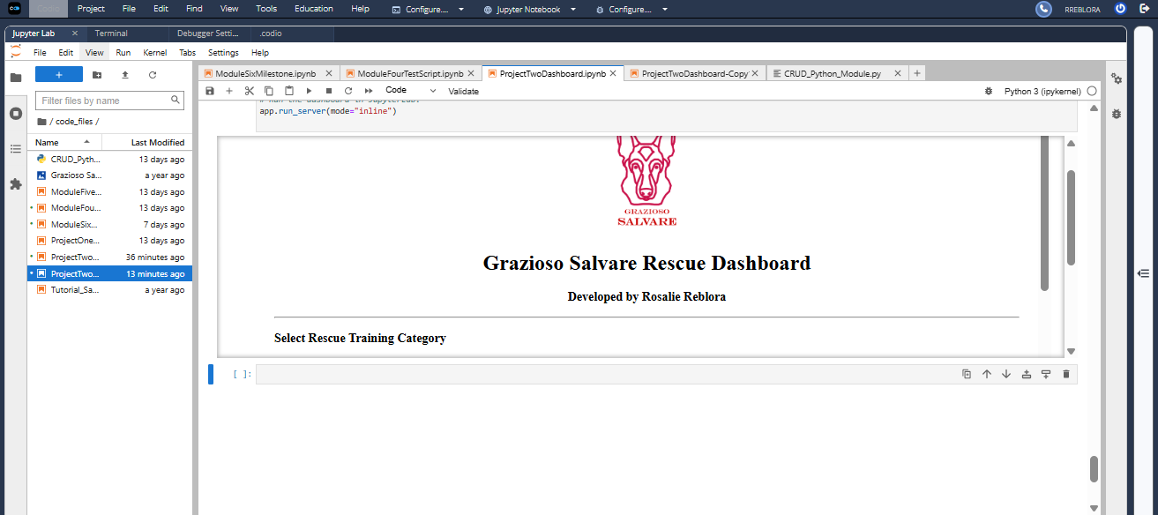
Figure 1. Grazioso Salvare logo, developer identifier, and rescue filter controls.
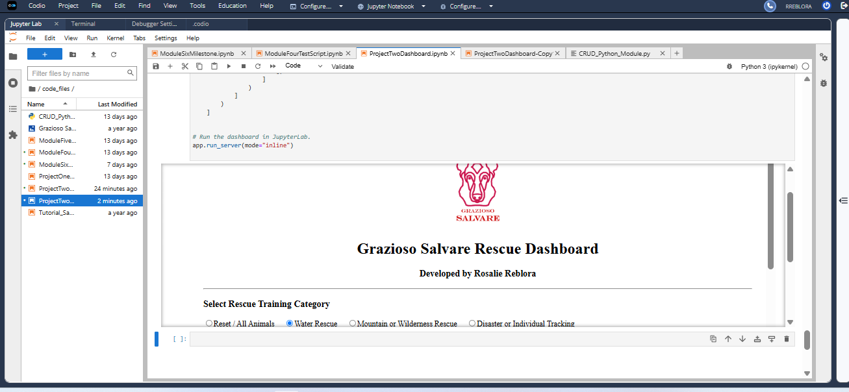
Figure 2. Interactive dashboard showing the filter selection and table area.

Water Rescue
The Water Rescue selection displayed matching Labrador Retriever Mix records in the supplied test screenshots. The breed chart showed only Labrador Retriever Mix for that filtered set, and the Leaflet map showed a selected location.
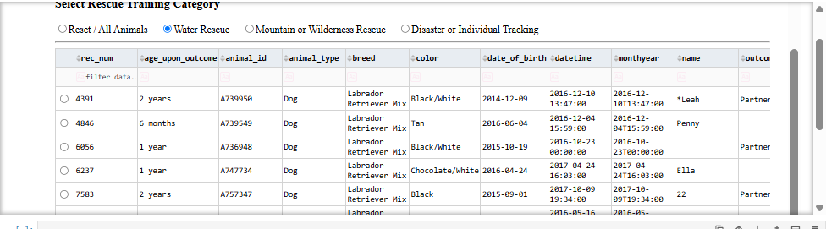
Figure 3. Water Rescue filtered table.
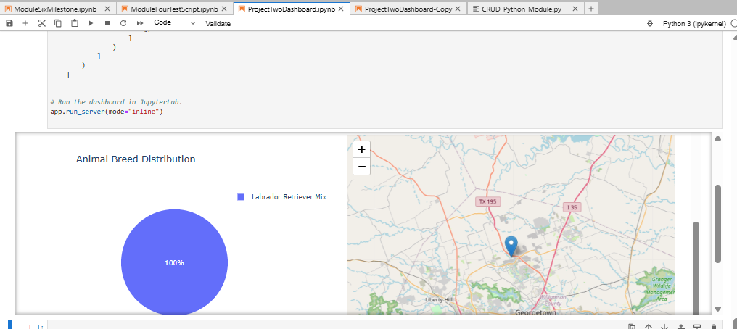
Figure 4. Water Rescue breed chart and location map.

Disaster or Individual Tracking
The supplied screenshots showed four matching records. The breed chart included Rottweiler, Bloodhound, and German Shepherd, and a map marker was visible.
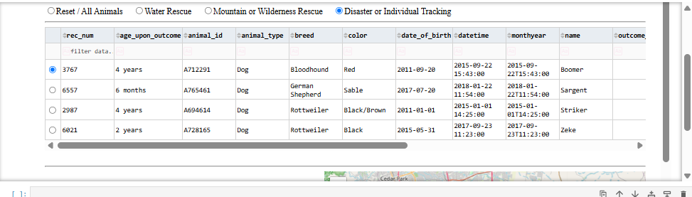
Figure 5. Disaster/Individual Tracking filtered table.
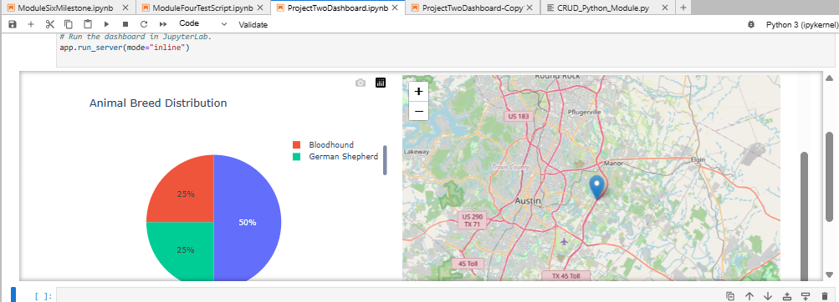
Figure 6. Disaster/Individual Tracking chart and map.

Mountain or Wilderness Rescue
The supplied screenshots showed five matching dogs, with Siberian Husky, Alaskan Malamute, German Shepherd, and Rottweiler represented in the chart.
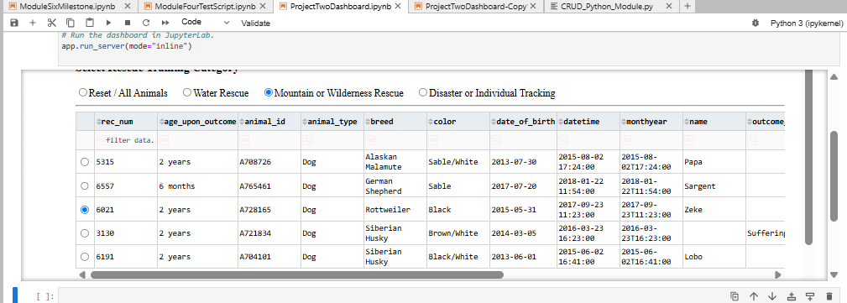
Figure 7. Mountain/Wilderness filtered table.
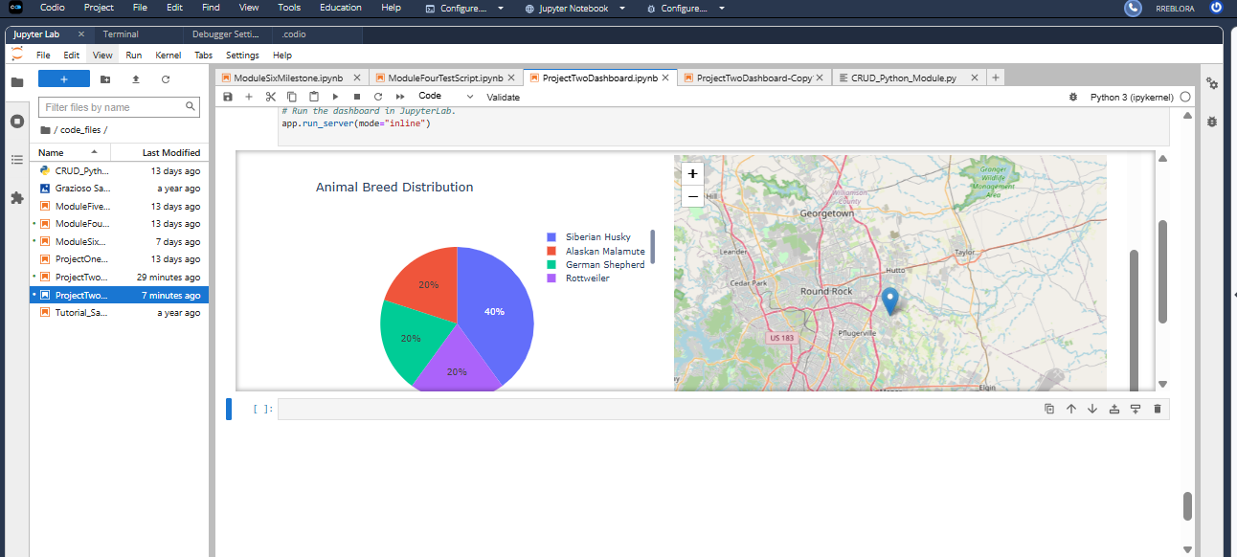
Figure 8. Mountain/Wilderness breed chart and map.

Reset / All Animals
Reset restored the unfiltered dataset, including animals outside the dog-only rescue categories. The screenshots show the unfiltered table and corresponding charts.
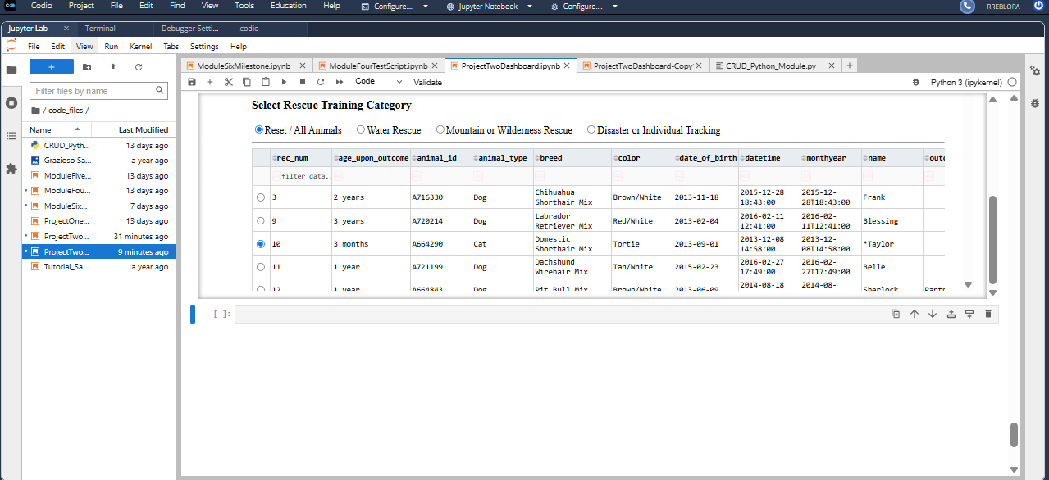
Figure 9. Reset / All Animals table.
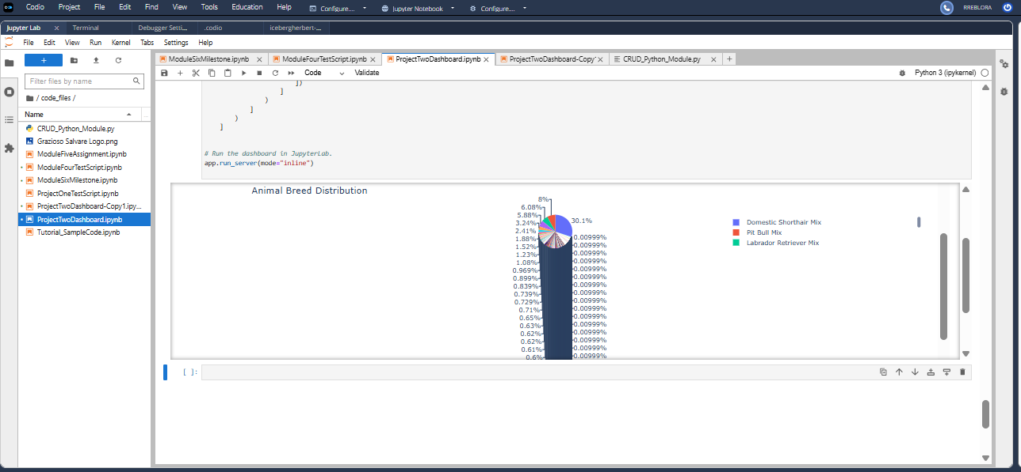
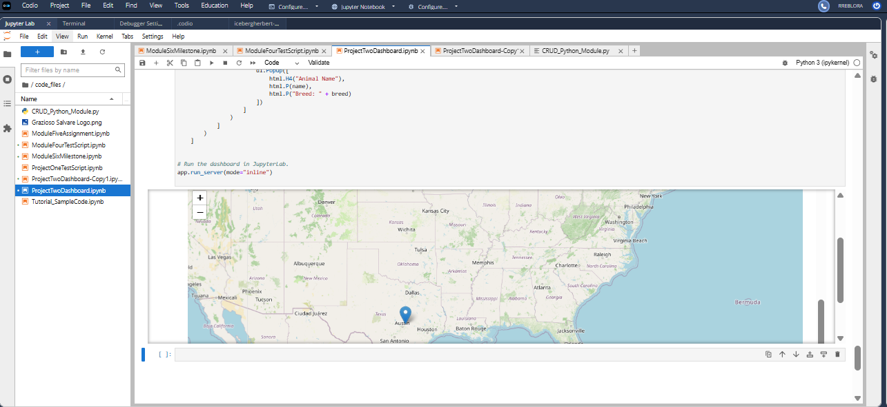
Figure 10. Unfiltered chart and map.

Challenges and solutions
Several practical issues appeared during development. I resolved them by checking module names, data types, callback inputs, and the notebook output, then rerunning the affected cells to confirm the dashboard worked as intended.
- Module import mismatch: updated the starter import to use CRUD_Python_Module and the AnimalShelter class.
- MongoDB ObjectId: removed the _id column from DataFrames to avoid JSON serialization errors in Dash.
- Notebook duplication and stale heading: removed duplicate layout code and reran the notebook to refresh the dashboard.
- Map not updating: enabled single-row selection and wired the map callback to table selection.
- Callback None values: added guards for empty selections, missing data, and invalid coordinates.
- Screenshots: the dashboard spans more than one screen; images document separate portions. Combined captures are recommended for strict rubric compliance.

How to reproduce the project
Prerequisites: Python with JupyterLab, a running MongoDB instance, the shelter outcomes CSV, the Grazioso Salvare logo image, and the two project source files. These steps describe a local installation; in Codio, MongoDB and most dependencies may already be configured.
- Install Python 3, JupyterLab, and MongoDB Community Server (or connect to an authorized MongoDB instance). Install dependencies with: python -m pip install jupyterlab ipykernel jupyter-dash dash dash-leaflet plotly pandas pymongo matplotlib numpy.
- Place ProjectTwoDashboard.ipynb, CRUD_Python_Module.py, and the supplied Grazioso Salvare logo in the same project directory.
- Import the supplied dataset using: mongoimport --db aac --collection animals --type csv --headerline --file aac_shelter_outcomes.csv. If your MongoDB deployment requires authentication, include authorized connection options and create a database user with appropriate privileges; follow your course environment configuration.
- Configure AnimalShelter for the actual MongoDB host, port, database aac, collection animals, authentication database, and account credentials. Localhost in Codio is not localhost on a different computer. Do not publish passwords in the notebook or GitHub; remove hardcoded secrets from shared copies.
- Open ProjectTwoDashboard.ipynb in JupyterLab, select the correct Python kernel, and run all cells. Ensure the logo filename matches the path used by the notebook. The notebook uses app.run_server(mode="inline") in Codio; JupyterDash version and proxy settings can affect how it appears elsewhere.
- Select each rescue filter, confirm the table/pie/map change, click different animal rows to verify map updates, and use Reset to return to all animals.

Resources and references
- SNHU, CS 340 Dashboard Specifications Document (provided course resource).
- MongoDB PyMongo documentation: https://www.mongodb.com/docs/languages/python/pymongo-driver/
- MongoDB mongoimport: https://www.mongodb.com/docs/database-tools/mongoimport/
- Dash framework and layouts: https://dash.plotly.com/
- Dash callbacks (controller): https://dash.plotly.com/basic-callbacks
- Dash DataTable: https://dash.plotly.com/datatable
- Dash Leaflet project: https://github.com/emilhe/dash-leaflet
- Plotly Express: https://plotly.com/python/plotly-express/
- Pandas documentation: https://pandas.pydata.org/docs/
- JupyterLab documentation: https://jupyterlab.readthedocs.io/
.

