DAD 220 Module One Lab Template

Overview
To complete this lab, go to your Codio virtual lab environment and start a new terminal session. Once there, perform the steps below to complete this activity. Manually enter any commands you are asked to write.

At the end of each step in the activity, replace the bracketed text with a screenshot, brief explanation, or both, as indicated. Size each screenshot and its explanation to fit about one-quarter of the page with the description written below the screenshot. Review the Template Screenshot Example linked in the guidelines and rubric for this assignment to see an example of how screenshots for your assignment should look.

Create a Database
- Create a new database and update the name to your last name; then connect to it. Type the following commands after the prompt mysql>:

  - CREATE DATABASE last_name_here;
    - For example, if your database is going to be named Jetson, then substitute "Jetson" for "last_name_here".
    - Press Enter.
  - SHOW DATABASES;
    - Press Enter.
    - You should see a listing of all of the databases (or schemas) in MySQL, including the one you just created.
  - USE last_name_here;
    - Press Enter.
    - Substitute the name of your database (for example, "Jetson") for "last_name_here". This SQL statement connects your MySQL session to the database you just created.
  - Capture a screenshot of the results of this action.

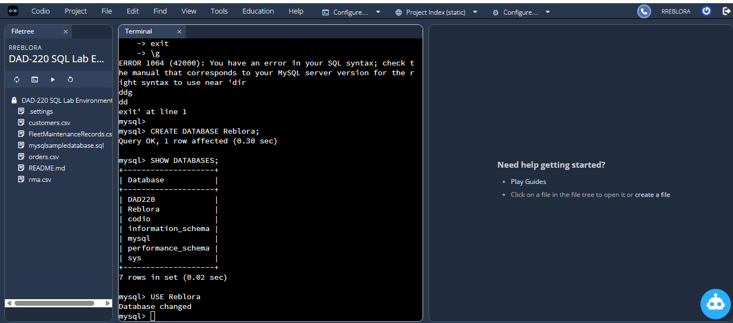

On this step, I used the CREATE DATABASE command and created a new database with the name Reblora. After that, I used SHOW DATABASES; to check that my new database was created and displayed. At
the end, I used the USE Reblora; command to connect to it.

- Create a table called tb2 and list out the tables in your database with one field by typing the following commands after the prompt mysql>:

  - CREATE TABLE tb2 (user_id VARCHAR( 50 ));
    - Press Enter.
  - SHOW TABLES;
    - Press Enter.
  - DESCRIBE tb2;
    - Press Enter.
  - Capture a screenshot of the results of this action.

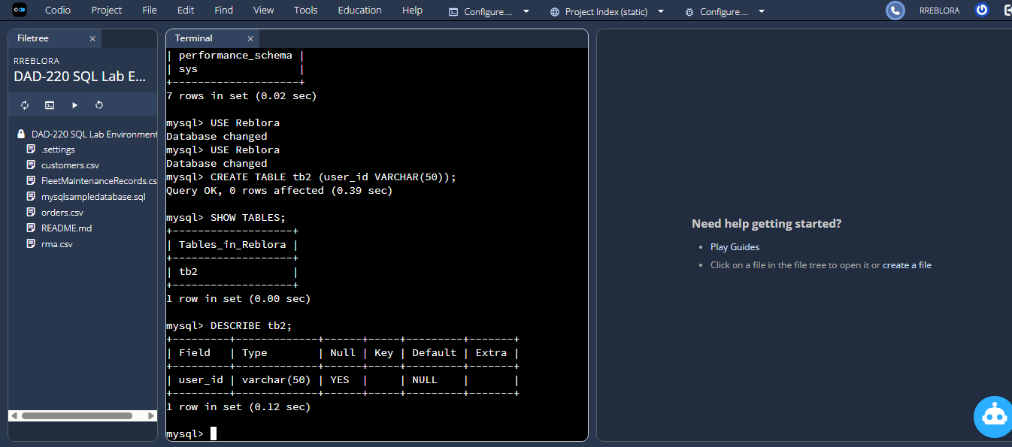

In this step, I made a new table tb2 with one column. The column has a name user_id and can contain strings of up to 50 characters called VARCHAR(50). I then used SHOW TABLES; to see if this new table really exists in the Reblora database, and used DESCRIBE tb2; to see the table structure, including column names and data types.

- Add a second field into the table and describe it. Do this by entering the following commands after mysql>:

  - ALTER TABLE tb2 ADD newfield VARCHAR(25);
    - Press Enter.
  - DESCRIBE tb2;
    - Press Enter.
  - Capture a screenshot of the results of this action.

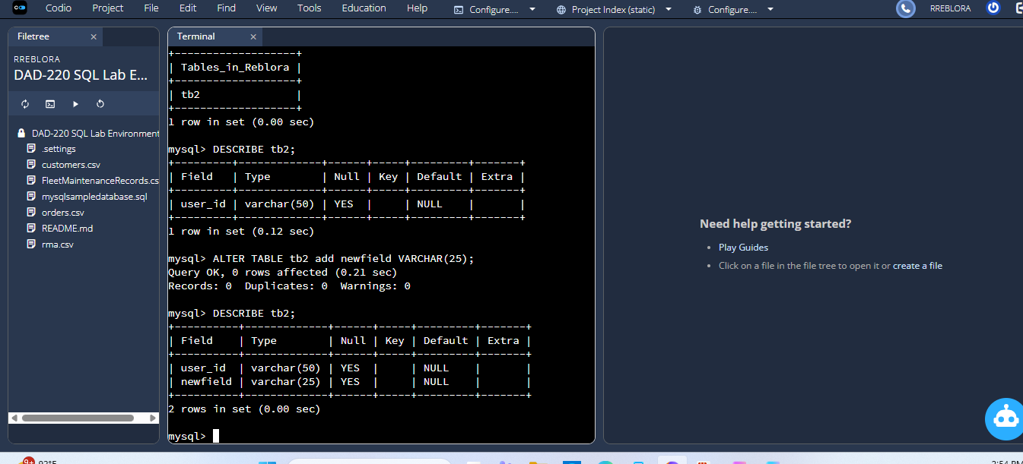

For this example, I add another field to my table called newfield column using the ALTER TABLE command. I make it VARCHAR(25) so that it can be a string of up to 25 characters in length. Then I
type DESCRIBE tb2; to see if it worked. The output lists both user_id and newfield, so I know the new column was added successfully.

- Organize your work to match the screenshot example and guidelines in the example document linked in the Supporting Materials section of the guidelines and rubric. Your submission should show that your work is original and the commands you have written for this lab worked correctly.

