DAD 220 Module Three Lab Template

Overview
To complete this lab, go to your Codio virtual lab environment and start a new terminal session. Once there, connect to the employee information you entered in the Module Two lab. Then perform the steps below to complete the activity. Manually enter any commands you are asked to write.

At the end of each step in the activity, replace bracketed text with a screenshot, brief explanation, or both, as indicated. Size each screenshot and its explanation to fit about one-quarter of the page with the description written below the screenshot. Review the Template Screenshot Example linked in the guidelines and rubric for this assignment to see an example of how screenshots for your assignment should look.

Create Joins Between Tables

- Update the name of the Branches table that you created in the previous lab to say "Department".

  - Use an ALTER statement to RENAME the Branches table "Department".
  - Capture these outputs in a screenshot to validate that you successfully completed this step.

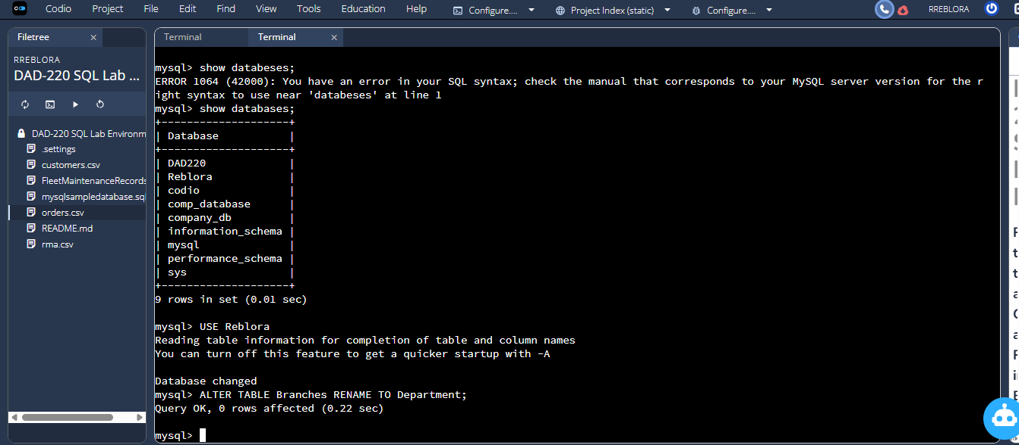

- Insert fields to the Department table so that joins can be performed on tables.

  - INSERT INTO Department VALUES
(1, 'Accounting'),
(2, 'Human Resources'),
(3, 'Information Systems'),
(4, 'Marketing');

  - Write a SELECT statement for this table to prove this step and validate that it ran correctly with a screenshot.

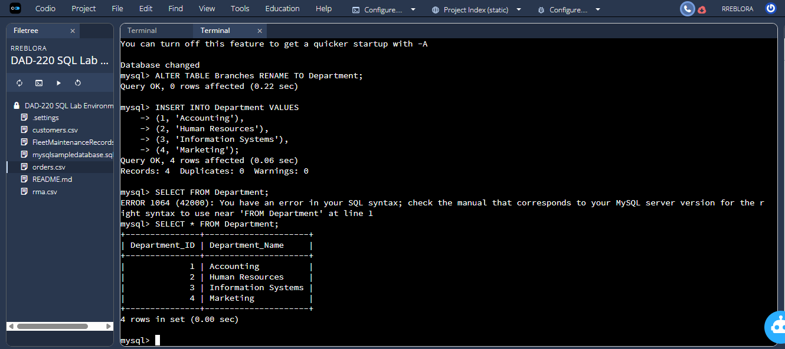

- Perform joins between the Department and Employee tables and show results for how many employees work in each of the four departments. This action will only provide information on the records that are already there.

  - Department 1 = Accounting

    - Command: SELECT First_Name, Last_Name, Department.Department_Name FROM Employee INNER JOIN Department ON Employee.Department_ID = Department.Department_ID WHERE Employee.Department_ID = 1;
  - Using SELECT statements similar to that above, perform joins to produce results for the following tables:

    - Department 2 = Human Resources
    - Department 3 = Information Systems
    - Department 4 = Marketing

  - Capture the results of these joins and validate your work by providing a screenshot. You should have the same number of records as you do employees.

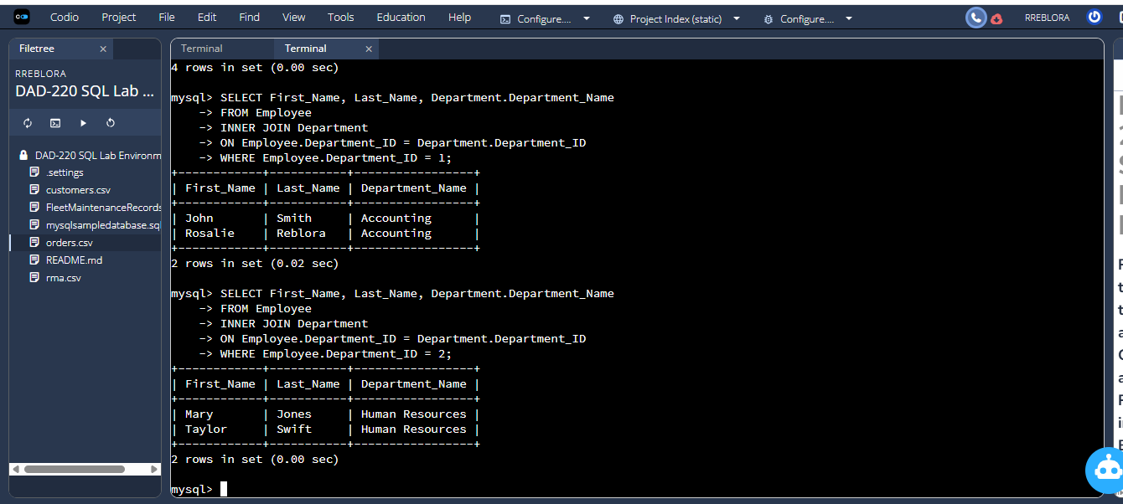

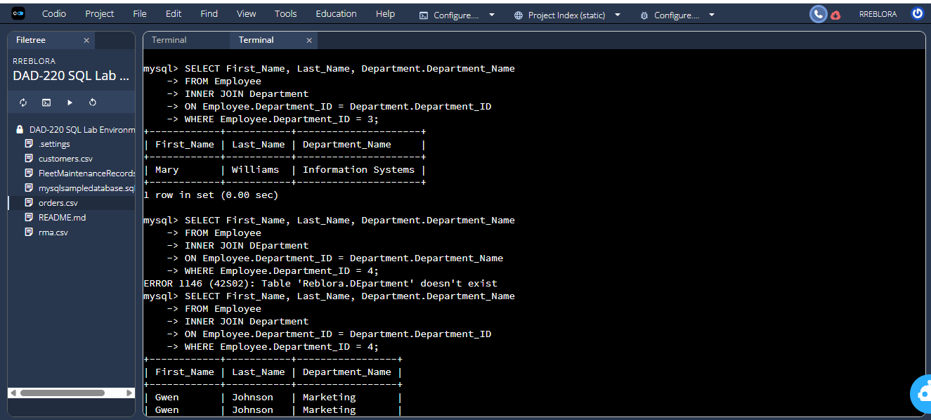

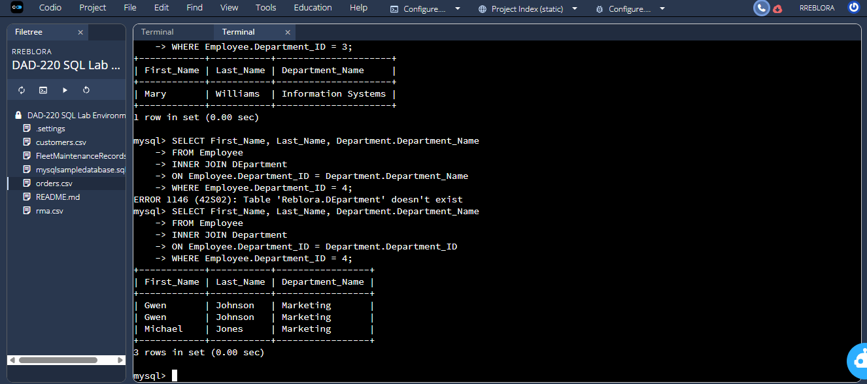

- Populate the Employee table with information for 10 new employees.

  - Give the employees unique names and include attributes for all necessary fields. Note: Reference attributes from the lab in Module Two. Department ID values must be between 1 and 4.

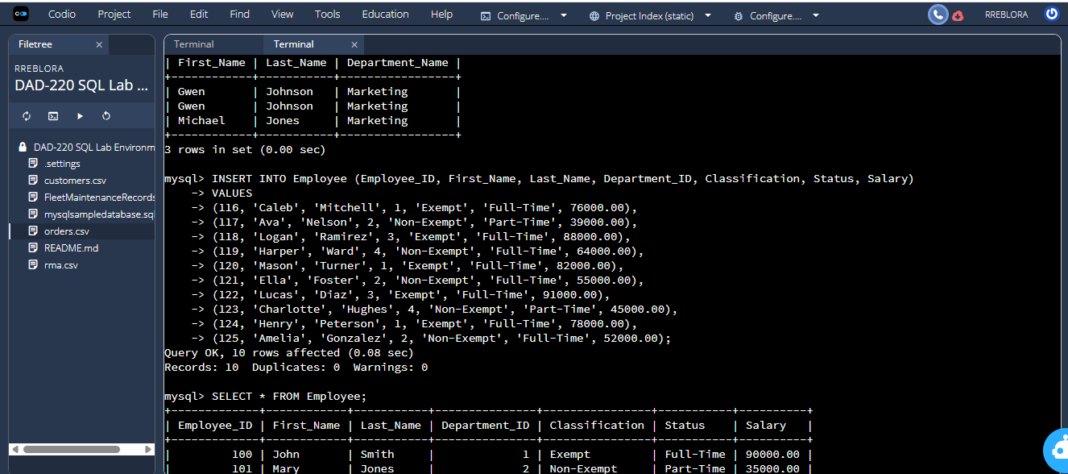

- Perform a join across the Employee and Department tables for each of the four departments. New and existing records should be displayed in the results.

  - Take a screenshot to capture the updated results that the Employee and Department joins show and validate that they have run correctly. You should have the same number of records as you do employees.

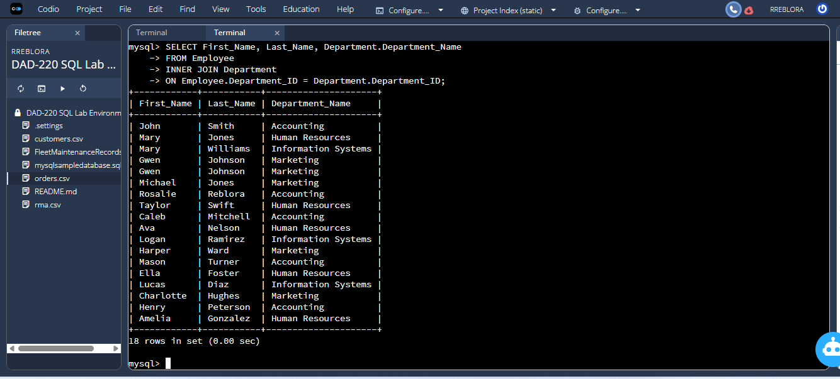
- Identify the resultant outputs of the commands you wrote and answer the following question:

  - How many records are returned for employees in each department?

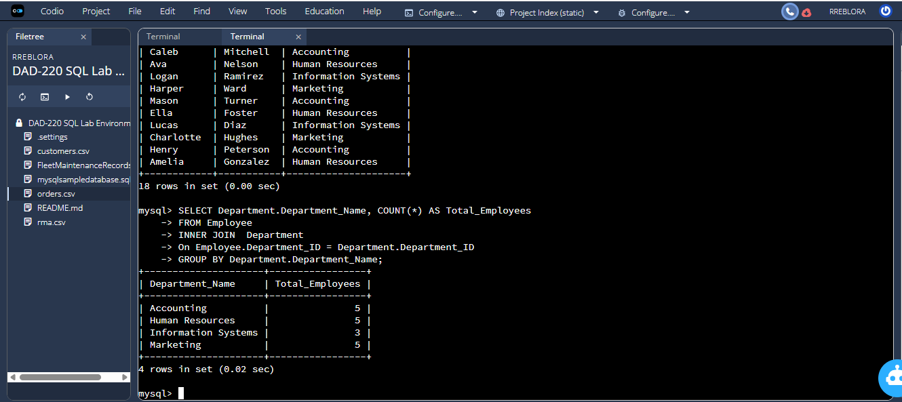

Totals per Department:
Department | Department_ID | Total Employees
Accounting | 1 | 5 employees
Human Resources | 2 | 5 employees
Information Systems | 3 | 3 employees
Marketing | 4 | 5 employees

- Create a CSV file that contains only the records of employees in Human Resources and Information Systems. If you run this query multiple times, be sure to use a different file name each time. MySQL will not overwrite an existing file.

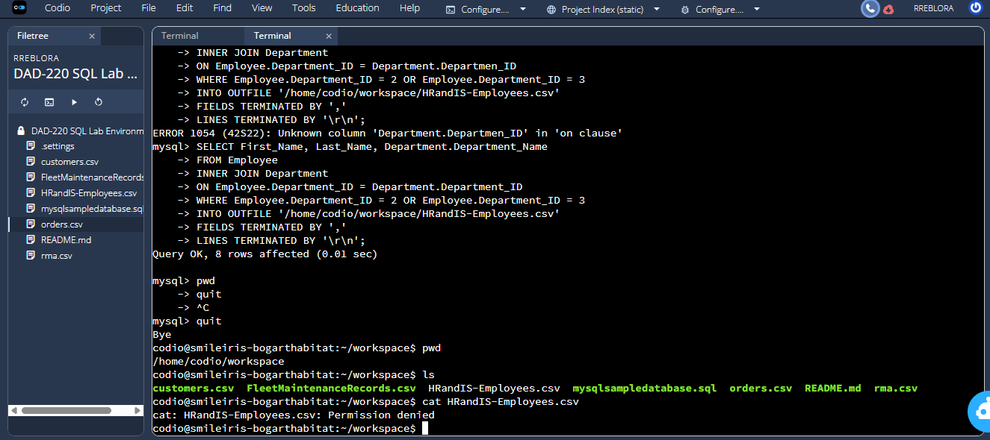

  - Enter the command listed below.

    - Command: select First_Name, Last_Name, Department.Department_Name from Employee inner join Department on Employee.Department_ID = Department.Department_ID where Employee.Department_ID = 3 OR Employee.Department_ID = 2 into outfile'/home/codio/workspace/HRandIS-Employees.csv' FIELDS TERMINATED BY',' LINES TERMINATED BY '\r\n';



  - Print the file output to the screen.

    - In order to print your screen, start by refreshing your browser.
    - Type the word "quit" after your MySQL prompt. Then press Enter to exit to the Linux shell. Do not exit the virtual lab environment.
    - Print the output of your file to the screen using these steps:
      - Type "pwd" and press Enter. Then type "ls" and press Enter again to list your files.
      - Next, type "cat HRandIS-Employees.csv" and press Enter.
      - Capture these outputs in a screenshot to validate that you successfully completed this step.



- Reflection: Provide detailed insight on the prompts below. Explain your process and how and why your process worked. Write your responses to the questions below in paragraph form.

  - Process

    - Explain how the joins you used in this assignment worked.

I used INNER JOINs to pull from both Employee and Department tables for this assignment. INNER JOIN compares the rows from both tables on specified
columns that have the same values. For instance, if the Employee row has Department_ID = 2, it checks the Department table for the Department with
Department_ID = 2. Only rows with the same values are selected to be in the returned table. This meant that I could show not only the employee’s
information, but the department name as well. The JOIN “connected” the information together from separate tables.

    - Describe why the commands you used were able to retrieve the Department table when you selected the Department name.

The SELECT statements could read the Department table because the JOIN told MySQL specifically to look at both the Employee and the Department tables
and match them by the common key, Department_ID. MySQL knew to look for the Department_Name column in the Department table, because the SELECT
clause asked for Department.Department_Name. If JOIN had not been used, only the Employee table would have been visible, but the command worked
because the two tables were related.

  - File creation and extraction

    - Identify how many records are in the file when you write the records of your query to a CSV file.

18 records

    - Explain, in detail, the process of extracting data to a flat file.

The CSV file that has been generated from the query that selects all employees that work in Human Resources and Information Systems departments has all rows of employees that have Department_ID 2 or 3. There are as many rows in this file as there are employees that work in those departments. The extraction of data is being done by the SELECT statement with INTO OUTFILE including the file path, column delimiter and row terminator. I navigated out of MySQL and checked for the existence of the file in the Linux shell with pwd and ls commands, and then I printed out its contents with the cat command. The SELECT statement generates the specified flat file with the desired data.

