DAD 220 Module Four Lab Template

Overview

Begin by doing the following steps in the IDE (Codio):

- Load the classicmodels data set.
- Start a new terminal session and run this command: mysqlsampledatabase.sql
- Write commands to use the classicmodels database and show its tables to verify that you are in the right place.

Then perform the steps below to complete the lab. Manually enter any commands you are asked to write. At the end of each step, replace the bracketed text in this template with your screenshot, response, or both, as indicated. Submit your completed template for grading and feedback. Screenshots should be sized to about one-quarter of a page. Written responses should be in complete sentences. Rename this document by adding your last name to the file name before you submit it.

Identify Cardinality and Table Relationships

- Retrieve employee tuples and identify the number of employees in San Francisco and New York.
  - Command for San Francisco: select firstName, lastName, jobTitle, offices.city from employees inner join offices on employees.officeCode = offices.officeCode where state = 'CA'.
  - Write and run a command to return records from New York on your own.
  - Validate the completion of this step with a screenshot of these two tables.

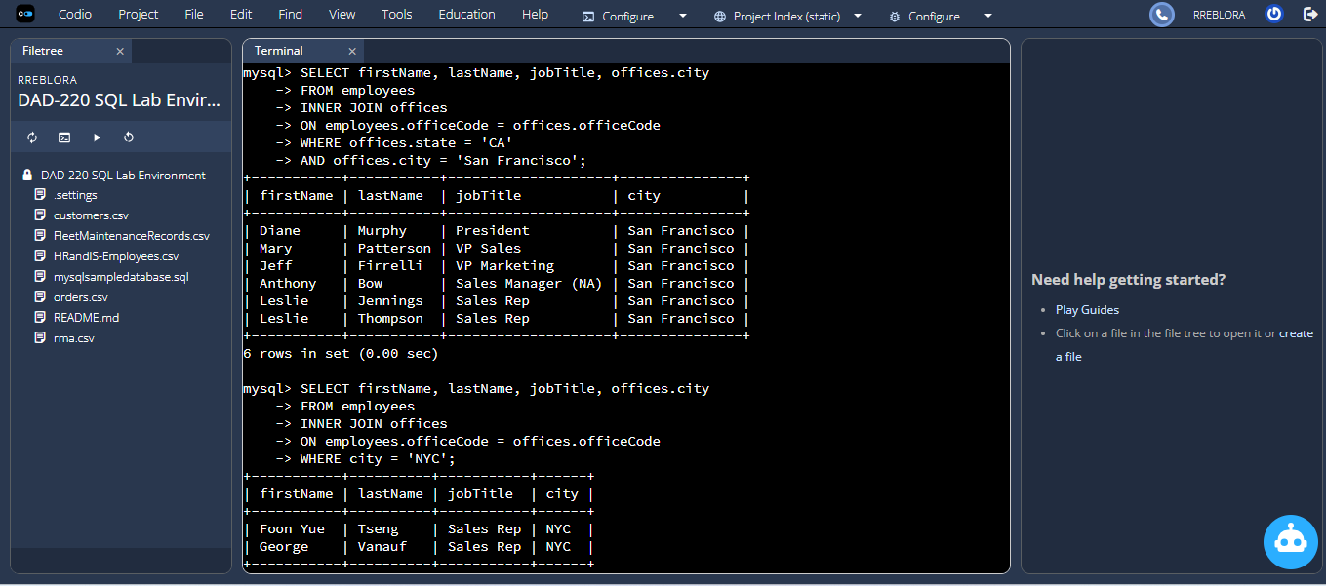

- Retrieve order details for orderNumber 10330, 10338, and 10194 and identify what type of cardinality this represents in the entity relationship model.
  - Retrieve the order details by running SELECT queries with WHERE clauses against the orders and orderdetails tables.

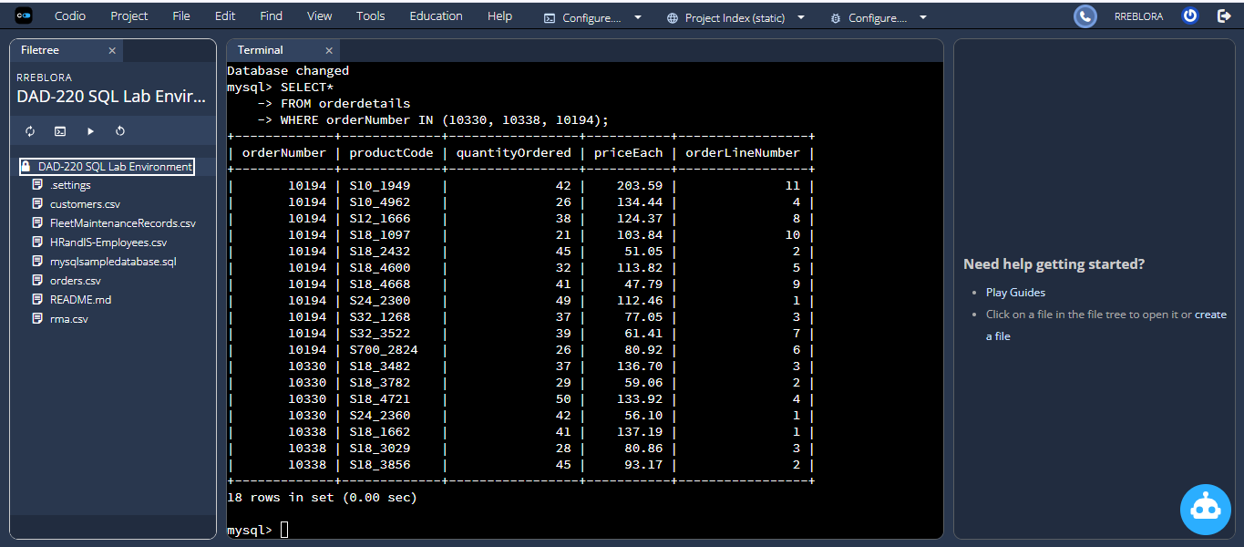

  - Now, identify what type of cardinality this represents in the entity relationship model.

Order → OrderDetails is One-to-Many
One order can have many products.

- Delete records from the payments table where the customer number equals 103.
  - Run a DESCRIBE statement to identify fields in the Payments table first. You are creating a file with any name you choose.
  - Select the records from the Payments table for customer number 103 before deleting them.

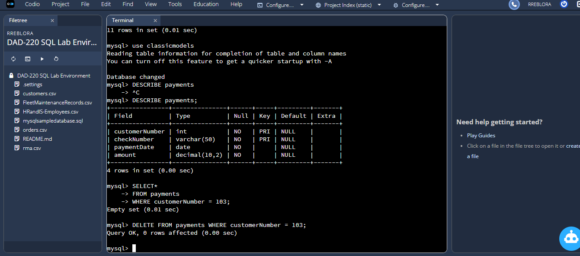

  - Delete the records from the Payments table for customer number 103.
  - Run a SELECT statement against the table to show that customer number 103 is no longer there.

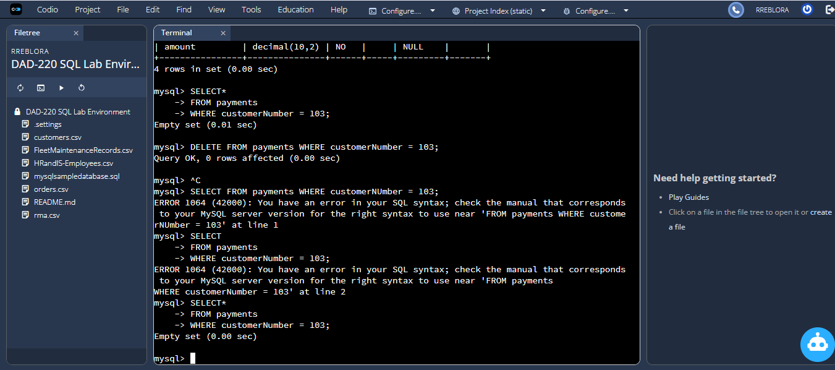

- Retrieve customer records for sales representative Barry Jones and identify if the relationships are one-to-one or one-to-many.
  - Remember: SELECT, FROM, INNER JOIN, and WHERE.
  - Use Barry’s employeeNumber, 1504, and perform a join between the customer salesRepEmployeeNumber to retrieve these records.
    - Identify whether these entities demonstrate one-to-one or many-to-many relationships.

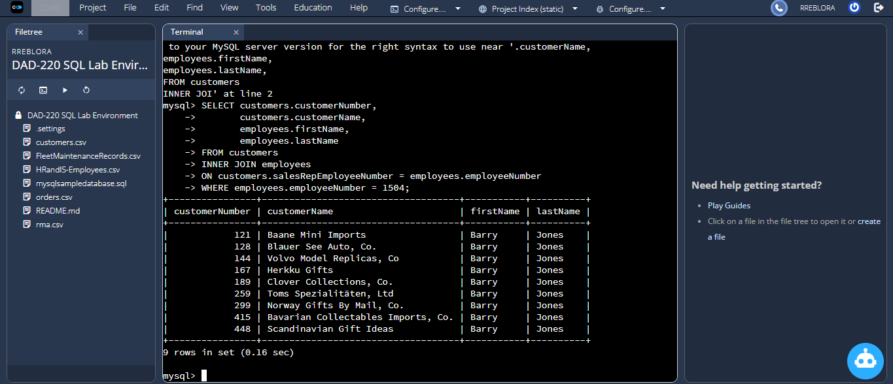

One-to-Many
One sales rep (Barry) serves many customers.

- Retrieve records for customers who reside in Massachusetts and identify their sales rep and the relationship of entities. Identify if these entities demonstrate one-to-one or many-to-many relationships.
  - Remember: SELECT, FROM, INNER JOIN, and WHERE.
  - Use employee.firstName and employee.lastName in your command.
  - Identify whether these entities demonstrate one-to-one or many-to-many relationships or one-to-many.

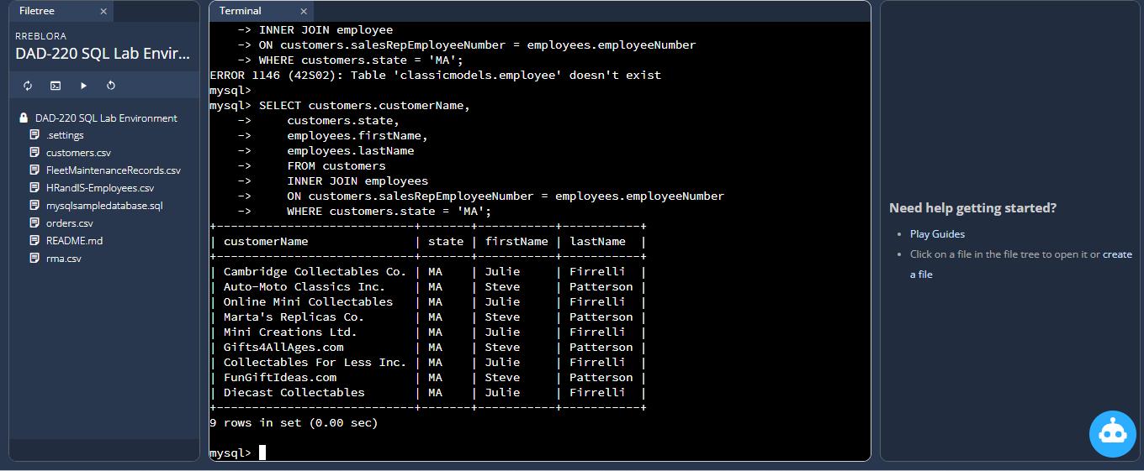

One-to-Many
One sales rep serves many MA customers.

- Add one customer record with your last name using an INSERT statement. You may use the name of a celebrity or fictional character if you don’t use your own name.

  - You may use the name of a celebrity or fictional character if you don’t use your own name. Think of this as your signature.
  - Complete these actions to get to the right place to enter this information: (1) Show databases, (2) use classicmodels, (3) show tables, (4) describe customers;
    - You should now see all of the fields that you’ll need to fill in to complete this step.
    - Reference your Module Two lab or resources on how to populate these fields if you need to.
    - Populate the following fields:

customerNumber
customerName
contactLastName
contactFirstName
phone
addressLine1
addressLine2
city
state
postalCode
country
salesRepEmployeeNumber
creditLimit

    - Run a SELECT statement on the Customers table and capture it in a screenshot.

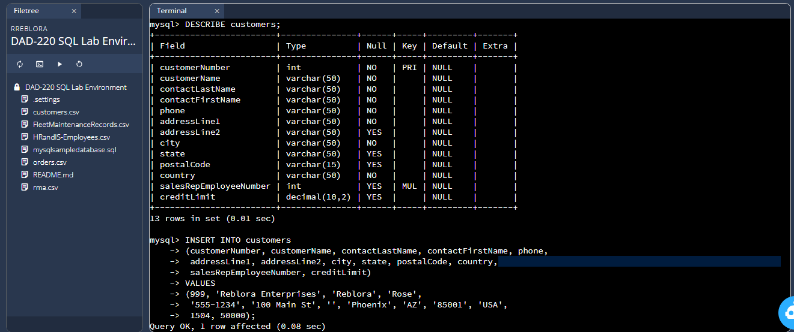

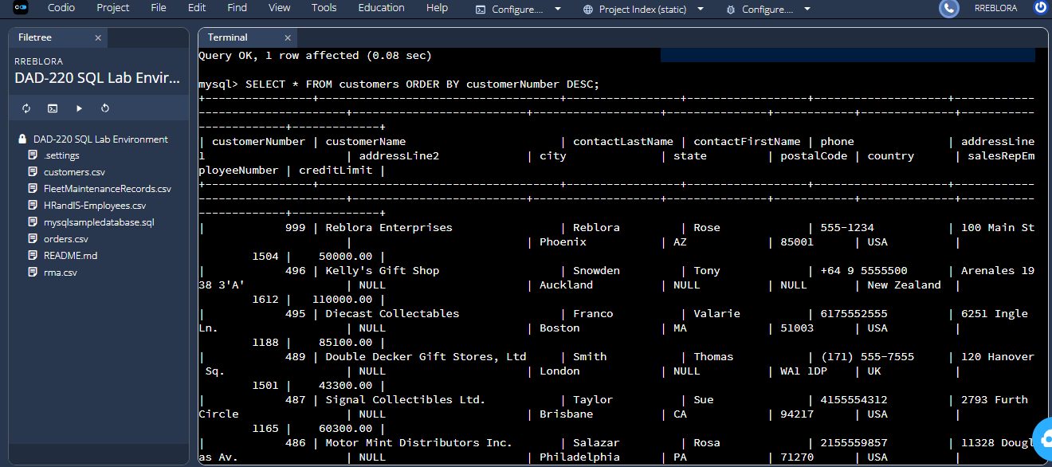

- Reflection: Use the lab environment or the screenshots you’ve worked with for this step. Address the prompts below in your reflection. Write a paragraph in response to each prompt:
  - Define how cardinality is applied to the databases you’ve been working with. Explain why different numbers of records were returned from the different offices.

- Cardinality is the numeric relation between two objects. Within the classicmodels database, the cardinality between two tables is the number of records from one table that can be tied to records in another table. Each office has many employees so San Francisco returns more employees than New York, because the office record has more related employee records. Cardinality is the reason that two SELECT statements return a different number of rows.

  - Compare and contrast the different queries you ran and how cardinality applies to them.

- The queries in this lab illustrate different types of cardinality. Querying employees by city results in a one-to-many relationship since one office can have many employees. The order/orderdetails query also exhibits one-to-many since each order can have many line items. The customer and sales-rep query once again is one-to-many since one sales rep supports many customers. Each of these queries can exhibit different behavior depending on how many related records are present and cardinality can be used to describe those differences.

  - Describe two of the crucial benefits of cardinality in this type of database.

- First, cardinality allows for an accurate database design by explaining how data is associated, therefore reducing invalid or duplicated records. Second, query efficiency is improved because knowing cardinality will allow the developer to write efficient joins as well as predict the number of returned results. Understanding if the relationship is one-to-one or one-to-many will also allow a developer to organize tables in an easy to understand manner.

