DAD 220 Module Five Major Activity Template

Overview

Review the scenario for this activity in the guidelines and rubric. Then complete the steps below as you work through the directions for this activity. Replace the bracketed text with your screenshots and responses to the prompts. Size each screenshot and its explanation to fit approximately one-quarter of the page with the description written below the screenshot. Review the Template Screenshot Example linked in the guidelines and rubric for this assignment to see an example of how screenshots for your assignment should look.

Create a Database

- Write SQL commands that capture specific, usable data that can be used in your analysis.

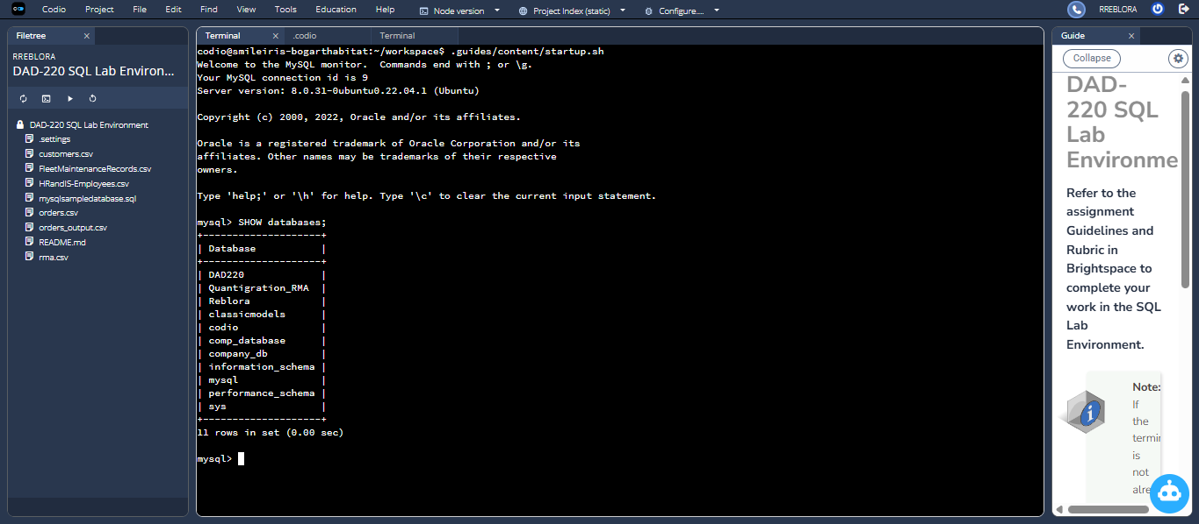

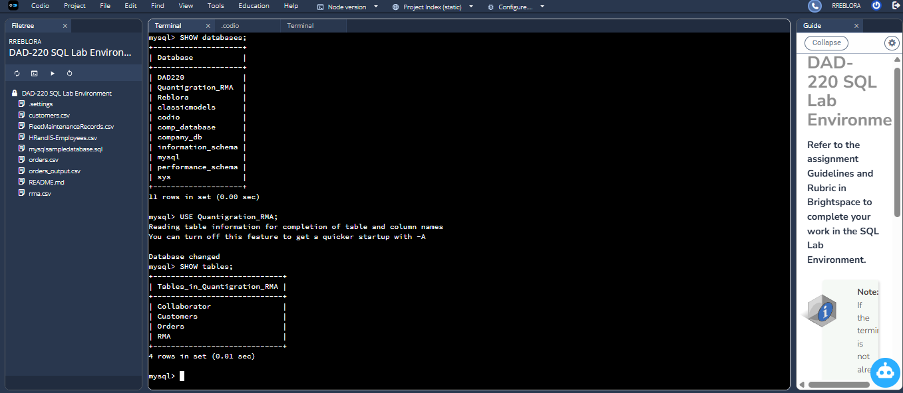

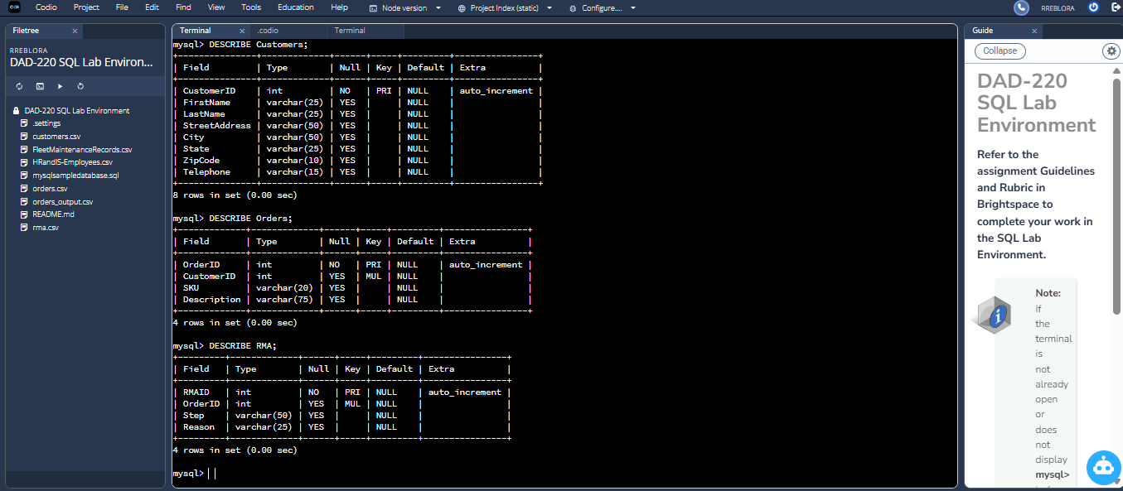

- Analyze the results of queries to identify specific information that can be presented in your summary.
  - Sales by region:
    - Analyze sales data by state to determine where the company has the largest customer base.

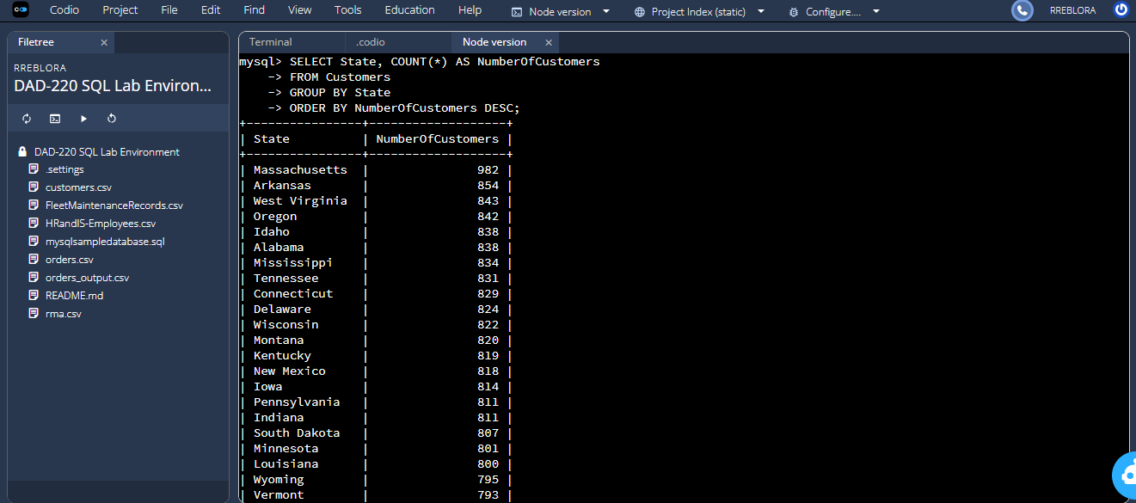

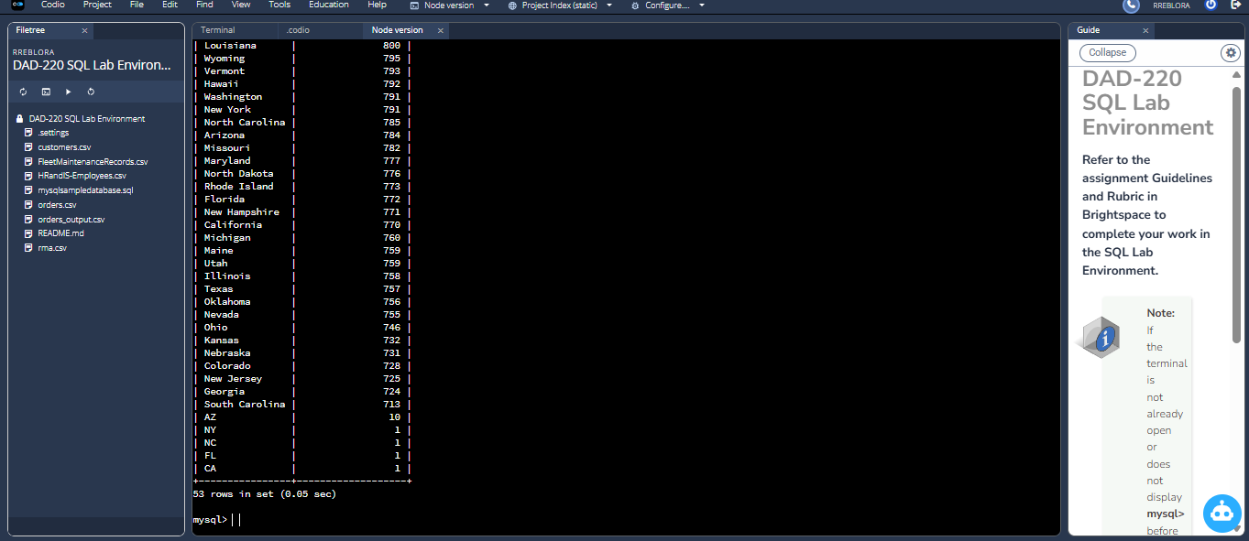

Massachusetts has the highest/largest customer base of 982.

    - Analyze the data to determine the top three products sold in the United States.

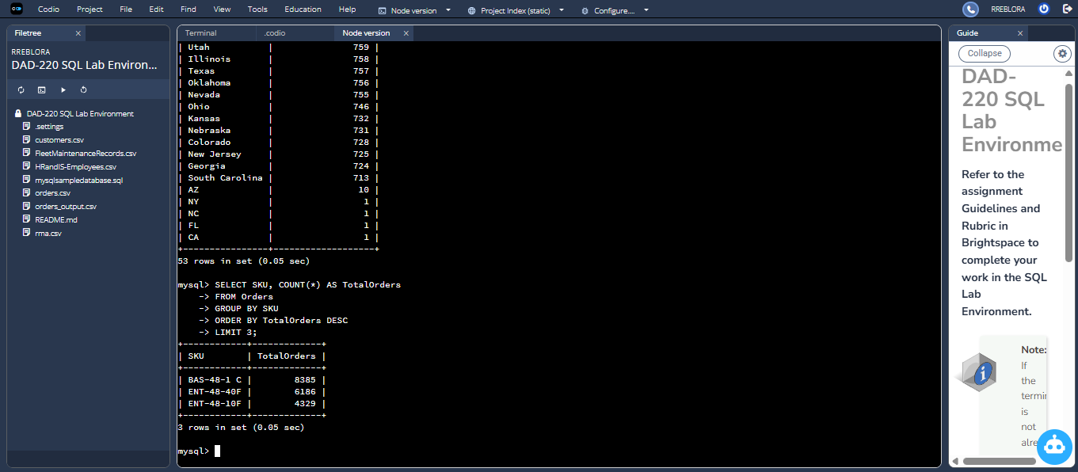

- The frequency of each SKU appearing in the Orders table is demonstrated by this query. Top selling items are those products which customers purchase the most. This can then be used for inventory planning, demand forecasting and budgeting. This query shows how often each SKU is shown in the Orders table. Top selling products are items customers order most often. This could be used for inventory planning, demand forecasting and budgeting.

    - Analyze the data to determine the top three products sold in the southeastern region of the United States.
- Southeastern states to include in your analysis: Virginia, North Carolina, South Carolina, and Georgia

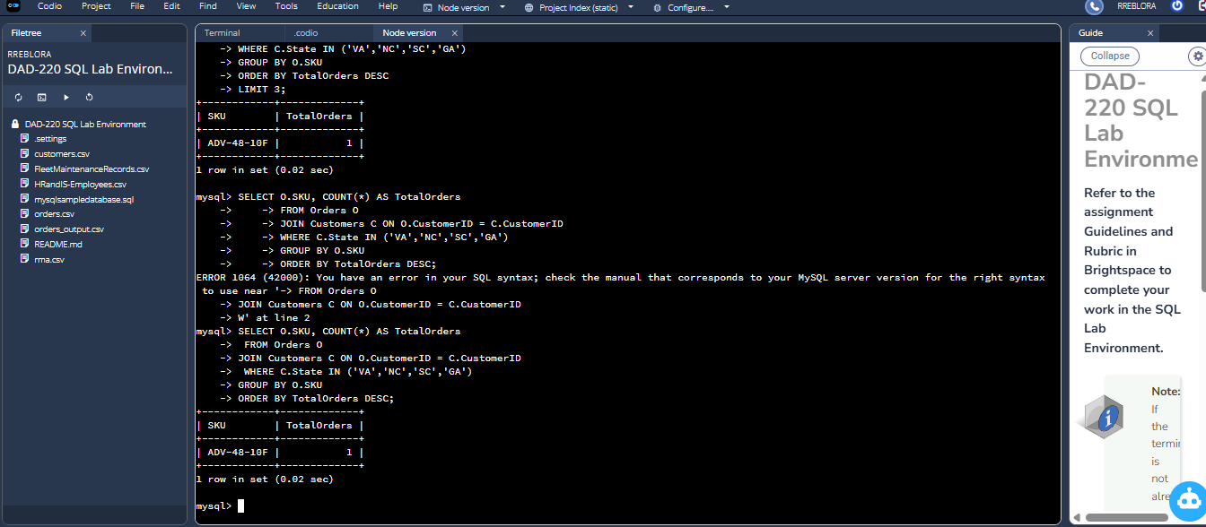

- To see the top products selling in the southeastern United States, I joined the Orders and Customers tables and connected each order with the state the customer was from. Only the four southeastern states (Virginia, North Carolina, South Carolina, and Georgia) with my limited data were used, and then I recorded how many times each product SKU showed up in orders from those states. Following the grouping and ordering of results by total sales, I found the top three products sold in the Southeast. This helps the company identify which products are most in demand in this area, so that the sales team can allocate inventory, target regional promotions more effectively, and plan marketing strategies more effectively.

  - Returns by region:
    - Analyze the data to determine the top three products returned in the United States.

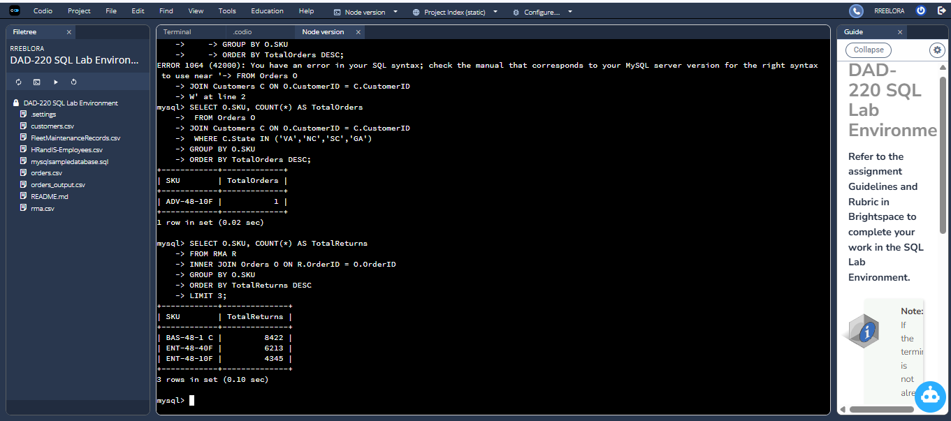

- When we consider return merchandise authorizations (RMAs) across the United States, we find that the majority of customer returns are from three products. The BAS-48-1C model is the most frequent item returned nationally, with 8,422 returns. Then comes the ENT-48-40F, with 6,213 returns, and then the ENT-48-10F, with 4,345 returns. Such high return volumes indicate quality control problems, performance problems, or customer-usage problems affecting these products.

    - Analyze the data to determine the top three products returned in the northwestern region of the United States.
- Northwestern states to include in your analysis: Washington, Oregon, Idaho, and Montana

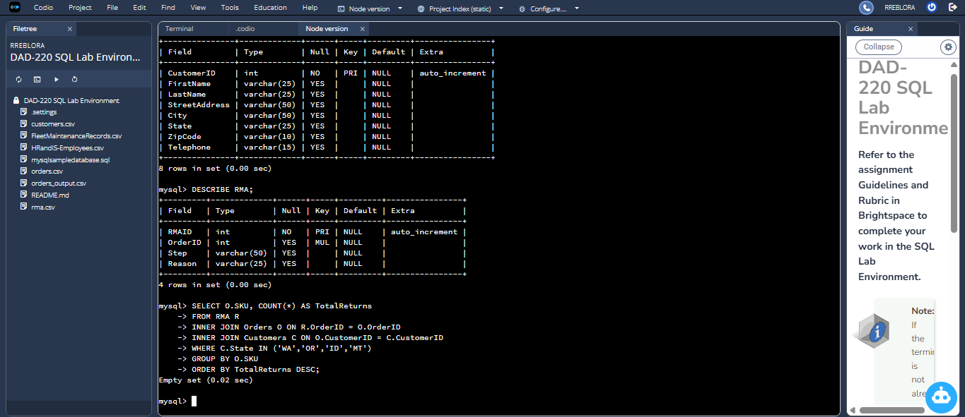

- There were no results obtained in the RMA data file for product returns from northwestern states of Washington, Oregon, Idaho, and Montana. This is to say that there were no customers within the four states with return records in the time span considered in the dataset. This could be for multiple reasons:
The business may have no or few customers in these states. Customers in this region may not have reported returns during the recorded timeframe. The dataset may simply not include northwestern return information.

- Write a report to the Quantigration product manager that explains your findings in a way nontechnical stakeholders can understand and use.
  - Provide an effective summary of your findings from the analysis of the sales and returns data you captured. Write at least one paragraph for each of your responses to the prompts below.

    - Sales data by region: Provide a well-written summary of findings from your analysis in Step Two, Part A.

- According to our sales data, customer distribution varies widely from region to region, with a few states making up the majority of the company’s customer base, while others have much lower revenues. As of today, Massachusetts has the highest number of customers of any region, making it the business’s strongest market. Arkansas ranks closely behind, adding up to a sizeable share of total sales. This regional awareness allows us to see where the market demand of customers is most concentrated, so marketing, inventory planning, and customer support resources are used efficiently. What’s more, in the southeastern region—Virginia, North Carolina, South Carolina, and Georgia—the top three products sold were identified by analyzing order frequency. If they also know which products are most appreciated where in the US, they can predict inventory requirements more accurately and customize sales models based on regional purchase habits.

    - Returns data by region: Provide a well-written summary of findings from your analysis in Step Two, Part B.

- Our review of return merchandise authorizations (RMAs) showed clear patterns for product returns in the United States. Nationwide, the three most returned items were BAS48-1C, ENT-48-40F, and ENT-48-10F with return volumes 8,422, 6,213, and 4,345 respectively. The high return rates possibly point to issues with product performance, durability, or customer expectations. Dealing with these items first may help in making the biggest decrease in return costs and happier customers. In contrast, in reviewing the reporting of return activity in the northwestern region (Washington, Oregon, Idaho, and Montana), we observed that no return records existed for customers in these states. This could be a sign of low sales there, solid product reliability, or just no data. Overall, return insights demonstrate where improvements may be necessary to our product and where customer experience is likely to be good.

