DAD 220 Project Two Template

Overview
Review the scenario for this activity in the guidelines and rubric. Then complete the steps below as you work through the directions for this activity. Replace the bracketed text with your screenshots and responses to the prompts. Size each screenshot and its explanation to fit approximately one-quarter of the page with the description written below the screenshot. Review the Template Screenshot Example linked in the guidelines and rubric for this assignment to see an example of how screenshots for your assignment should look.

RMA Report
Write a report to respond to the manager’s requests. In the report, you should complete the following actions:

- Summarize the data you’ve been working with.
- Identify key information that will help the company streamline operations.

Your report should explain your findings in a way nontechnical stakeholders can understand and use.

Use the steps below to capture the required data and produce the analysis report.

- Begin by writing SQL commands to capture specific usable data for your analysis. You already preloaded the data you need into Codio.
- Specifically, the product manager wants you to complete the following analysis:

  - Analyze the number of returns by state and describe findings to include in your report.

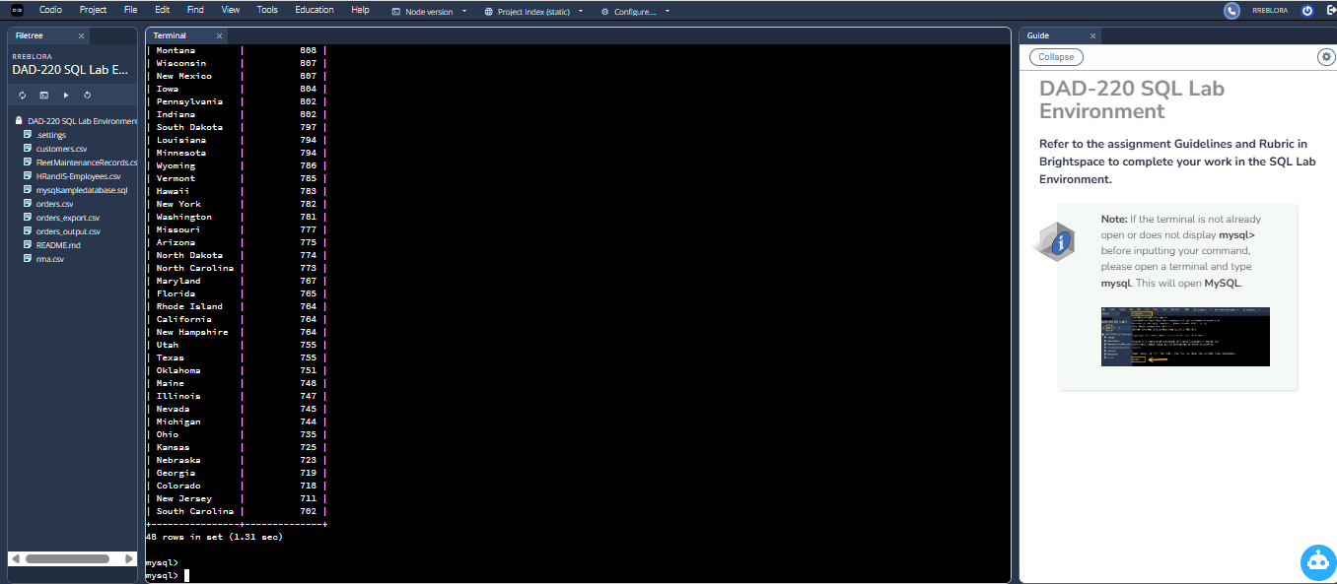
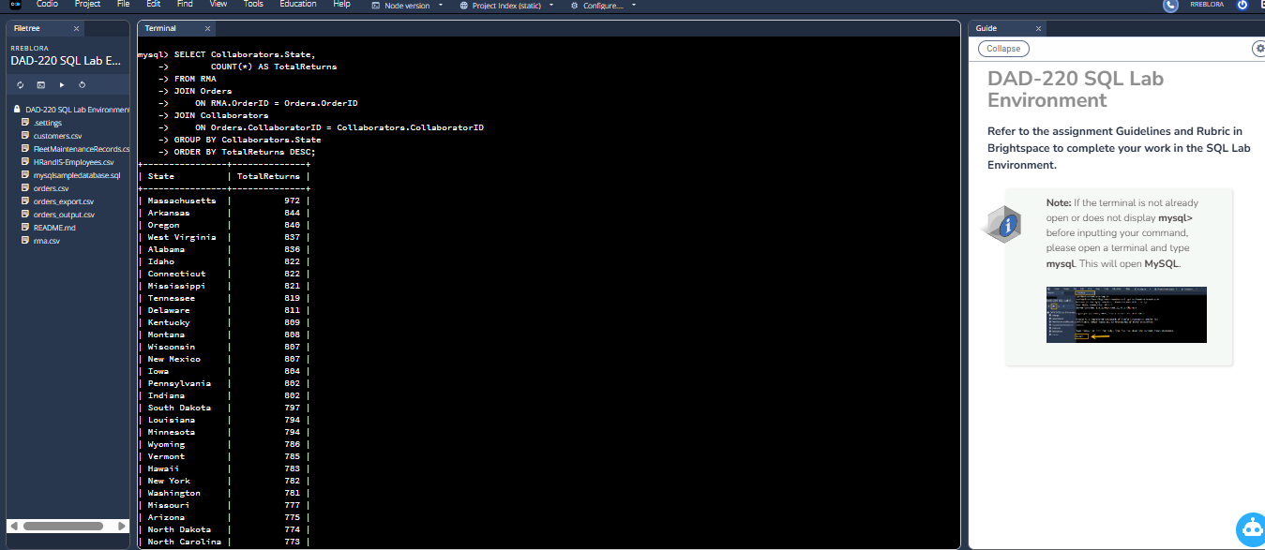

- Analysis of Returns by State. The data from the RMA shows that states across the U.S. have varying returns, with the largest number being Massachusetts, which records 972 returns. Other states, including Arkansas (844), Oregon (840), and West Virginia (837), also report higher return volumes. Most states generally follow a consistent range of 750 to 820 returns which indicates that returns are not concentrated in any part of the country. These findings give the product manager visibility on where returns most occur. High return states may need a direct focus as to customer service, product quality reports and logistics evaluations. Also, the fairly homogenous pattern of returns indicates that the problem is probably systemic: something about product durability or shipping conditions, perhaps, rather than specific to one part of the country.

  - Analyze the percentage of returns by product type and describe findings to include in your report.
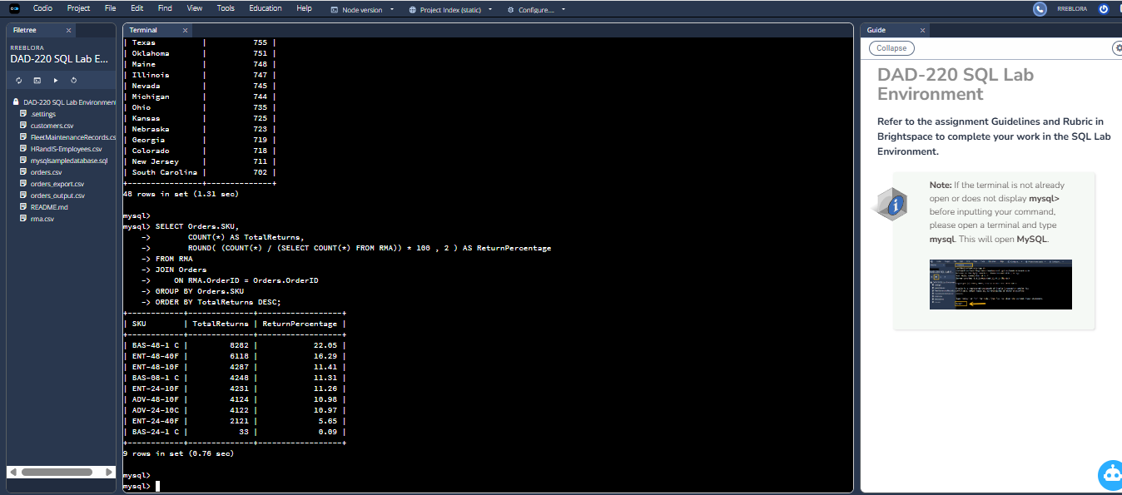

- Return percent by category indicates that a few SKUs represent the bulk of all RMAs processed by Quantigration. BAS-48-1 C has the highest return volume at 22.05%, so potentially a quality issue or usage issue might need to be looked into. Several enterprise switches (e.g. ENT-48-40F, ENT-48-10F, ENT-24-10F, and ENT-24-40F) are also considerable contributors to the number of returns, comprising more than half of all defective units received. Mid-level advanced switch models like ADV-48-10F and ADV-24-10C add about 11% each, meaning that returns are distributed over multiple product lines and not one. The lowest return rate comes from BAS-24-1 C, giving 0.09%. This could reflect higher reliability or lower number of deliveries being made or any combination of the two. These trends give an indication of what products require the best quality control, more educational methods for consumers in general, or perhaps redesign to lower return rates and improve operating efficiencies.

- Write a report to clearly summarize your RMA data analysis for stakeholders. When you summarize the results, consider the following questions:

  - How does the data provide the product manager with usable information?

  - What are the potential flaws in the data that has been presented?

  - Are there any limitations on your conclusions or any other ways of looking at your findings that you haven’t considered? Clearly communicate your findings to stakeholders.

RMA Data Analysis Summary Report

The RMA data gives information on quite a few trends and implications concerning which regions are receiving the most returns and products returned the most frequently. For example, based on RMA data, Massachusetts is found to be the place with the highest volume of total returns along with BAS-48-1C and ENT-48-40F switches, representing a significant proportion of total product-related issues. With this information in mind, a product manager could identify those potential quality-control weaknesses, potential shipping risks in particular parts of the country, or training deficiencies with customers who may be improperly installing or configuring equipment. Identifying key regions for the most returns gives the company the ability to concentrate customer support and distinguish which carriers or distributors are contributing to an increased defect rate. By understanding the products that account for the highest percentage of returns, the product team can schedule engineering reviews with their product lines at the best possible time. On balance, this information gives a roadmap to reduce overall return volume and improve product reliability and consumer satisfaction.
Although insightful, there are some issues that might affect interpretation. For one, the RMA entries might not prove if it’s actual product defect, user error, or shipping damage, thus difficult to identify what is causing the return. Secondly, the data is based on this assuming correct and complete entry by warehouse staff and customer care technicians. All of the contradictions, i.e., inappropriate product-type classification, incorrect state information, and missing reason codes can potentially influence the outcomes. Also, some of the products have very low returns, which suggests that those low returns might indicate that the return data have only really been partially recorded rather than low return rates. Last, the information is incomplete on factors like total units sold per product or per region and there is limited analysis of return in terms of sales volume.
The findings from this analysis should not be considered conclusions - but rather, they should be interpreted as directional insights. Because we don’t have total sales per product or per state, we can’t tell if high returns reflects high number of units sold. For instance, a product with high levels of returns could be the item sold most frequently, and so return rate could actually be normal. Likewise states with high return count might have larger customer bases, which would naturally increase the number of RMAs. It would also be interesting to study trends over time to see if specific kinds of products degrade more quickly or if certain regions register seasonal spikes in returns. Finally, examining the drivers of returns — like defects, incorrect shipments or cosmetic damage — would provide a fuller picture and inform more targeted improvements.

