

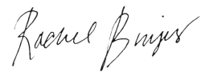



Rachel Brujis
General Manager
Thinkful - a Chegg service
Course Dates
2
/8/2023 -
8/26/2023
31
Penn Plaza - 12th Floor, 132 West 31st New York, NY
10001
The Education Team at Thinkful certifies
Rosalie Reblora
has successfully completed the Cybersecurity Certificate Program

