

College of Professional Studies, Northeastern University
Loan Prediction and Risk Analysis System
Final Report

Professor Samuel Li
By
Rajan Rajeshrao Deshpande

Introduction
The "Loan Prediction and Risk Analysis System" is designed to address the growing need for accurate loan risk assessments in financial institutions. This system leverages predictive analytics to evaluate the likelihood of loan default based on customer demographic and financial data. The primary users of this application include loan officers, data analysts, and system administrators.
The solution operates on a freemium model, allowing basic functionality for free but charging for advanced predictive analytics and reporting features. This ensures accessibility to small financial institutions while providing scalability for larger organizations. My interest in data engineering and predictive modeling inspired this project, which also aligns with real-world challenges in loan risk management.
The app assists loan officers in making informed decisions, improves customer segmentation for analysts, and supports administrators in managing system integrity. It contributes to reducing financial risks and enhancing the quality of loan portfolios.

Business Analysis
User Personas:
1. Loan Officers: Use the system to review customer profiles, submit loan applications, and assess risk predictions to approve or reject applications.
2. Data Analysts: Extract data for reporting, analyze risk trends, and provide insights into customer demographics to enhance strategic decision-making.
3. System Administrators: Maintain database integrity, enforce security protocols, and periodically retrain predictive models to ensure accuracy.

Business Rules:
- Each Customer can submit multiple Loan Applications.
- A Loan Application is linked to a single Risk Prediction that includes a risk flag and probability score.
- The system ensures that only verified Loan Officers can approve or reject applications.
- Predictive models are retrained quarterly to adapt to changing financial patterns.
- Customer data is securely stored and adheres to regulatory compliance standards.

Table Design and Analysis
The database structure includes seven primary entities:

1. Customers:
PK: customer_id
Fields: income, age, marital_status, home_ownership, car_ownership, profession, years_in_current_job, credit_score

2. Loan Applications:
PK: application_id
FK: customer_id
Fields: loan_amount, purpose_of_loan, status

3. Predictions:
PK: prediction_id
FK: application_id
Fields: risk_flag, probability_score, model_version

4. Loan Officers:
PK: officer_id
Fields: name, branch, contact_details

5. Analysts:
PK: analyst_id
Fields: name, department, contact_details

6. System Administrators:
PK: admin_id
Fields: name, security_clearance_level, contact_details

7. Audit Logs:
PK: log_id
FK: user_id (can reference officers, analysts, or administrators)
Fields: action, timestamp, details

ER Diagram:
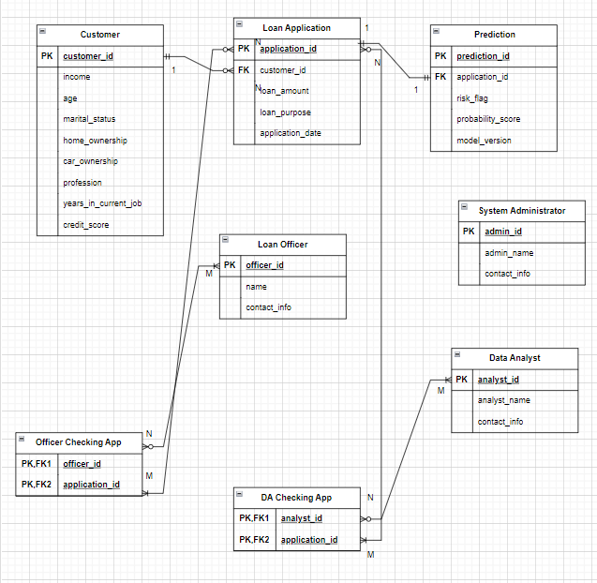
Summary of Relationships
Primary Table | Related Table | Relationship Type | Key Connections
Customer | Loan Application | 1 | Customer.customer_id → Loan Application.customer_id
Loan Application | Prediction | 01:01 | Loan Application.application_id → Prediction.application_id
Loan Officer | Loan Application | M | Loan Officer.officer_id → Loan_Officer_Application.officer_id
Loan Officer | Loan Application | (via Loan_Officer_Application) | Loan Application.application_id → Loan_Officer_Application.application_id
Data Analyst | Loan Application / Prediction | M | Data Analyst.analyst_id → Data_Analyst_Application.analyst_id
Data Analyst | Loan Application / Prediction | (via Data_Analyst_Application) | Loan Application.application_id → Data_Analyst_Application.application_id
System Administrator | N/A (Manages System) | Independent | Administers data integrity and predictive model updates

Database Implementation
Here are sample SQL queries for real-world application scenarios:
1. Retrieve high-risk loan applications:
SELECT c.name, la.loan_amount, p.risk_flag, p.probability_score
FROM Customers c
JOIN Loan_Applications la ON c.customer_id = la.customer_id
JOIN Predictions p ON la.application_id = p.application_id
WHERE p.risk_flag = 'High';
2. Count of applications by purpose:
SELECT purpose_of_loan, COUNT(*) AS application_count
FROM Loan_Applications
GROUP BY purpose_of_loan;

3. Applications handled by each loan officer:
SELECT lo.name, COUNT(la.application_id) AS total_applications
FROM Loan_Officers lo
JOIN Loan_Applications la ON lo.officer_id = la.officer_id
GROUP BY lo.name;
4. Recent activities in the audit log:
SELECT al.action, al.timestamp, al.details
FROM Audit_Logs al
ORDER BY al.timestamp DESC
LIMIT 10;
5. Average loan amount by risk category:
SELECT p.risk_flag, AVG(la.loan_amount) AS avg_loan_amount
FROM Loan_Applications la
JOIN Predictions p ON la.application_id = p.application_id
GROUP BY p.risk_flag;

Analytics, Reports, and Metrics
Key Reports:
1. Loan Approval Trends: Monthly trends of approved vs. rejected applications.
2. Risk Analysis: Distribution of risk categories across different loan purposes.
3. Customer Segmentation: Analysis of customer demographics by loan amount and risk level.
4. Performance Metrics: Evaluation of loan officers based on application outcomes.
5. Audit Reports: Logs detailing critical system changes for compliance.

SQL for Analytics:
The SQL queries listed above provide the foundation for generating these reports. For instance, the "Average Loan Amount by Risk Category" query can be visualized as a bar chart to highlight risk-related trends.

Security Concerns
The database handles sensitive customer and financial data, necessitating strict security measures:
- Data Encryption: All customer and loan data must be encrypted at rest and in transit.
- Access Control: Role-based access ensures that only authorized users can view or modify data.
- Audit Trails: Logs of all user activities are maintained to detect and address unauthorized access.
- Compliance: Adheres to regulations like GDPR and PCI DSS for data protection and financial security.

Architecture
The system utilizes a client-server architecture with the following features:
- Cloud Hosting: Hosted on a secure cloud platform (e.g., AWS, Azure) for scalability and reliability.
- Database: A relational database (SQLite for development, PostgreSQL for production).
- Front-End: Web-based interface for users, accessible via browsers.
- Back-End: APIs connect the application to the database for real-time data retrieval and updates.

Project Wrap-Up and Future Considerations
This project has deepened my understanding of database design and its integration with predictive analytics. Key takeaways include the importance of:
- Structuring data to align with business rules.
- Ensuring data integrity and security.
- Leveraging analytics to drive decision-making.

Future enhancements could include
- Expanding predictive capabilities using advanced machine learning models.
- Implementing multi-language support for global users.
- Enhancing reporting features with real-time dashboards.

