110550126 曾家祐

Numerical methods Assignment 4



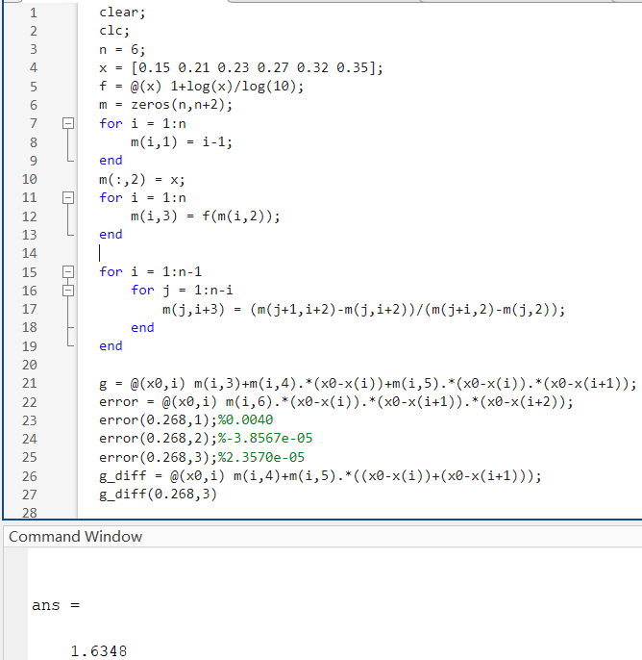

We first use the for loop to generate the divided differences table

|  |  |  |  |  |  |  |  |
| --- | --- | --- | --- | --- | --- | --- | --- |
| i |  |  |  |  |  |  | F[xi…xi+5] |
| 0 | 0.15 | 0.1761 | 2.4355 | -5.7505 | 15.3474 | -38.8116 | 94.5795 |
| 1 | 0.21 | 0.3222 | 1.9754 | -3.9088 | 8.7494 | -19.8957 |  |
| 2 | 0.23 | 0.3617 | 1.7409 | -2.9464 | 5.9640 |  |  |
| 3 | 0.27 | 0.4314 | 1.4757 | -2.2307 |  |  |  |
| 4 | 0.32 | 0.5051 | 1.2973 |  |  |  |  |
| 5 | 0.35 | 0.5441 |  |  |  |  |  |

And calculate the error of quadratic interpolating polynomial, since the error of start from x(3) have min error, we calculate the f’(0.268)from x3 and use three point(0.23, 0.3617) (0.27,0.4314) (0.32,0.5051)

f’(0.268) = 1.6348

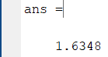

We first use the for loop to generate the divided differences table

|  |  |  |  |  |  |  |  |
| --- | --- | --- | --- | --- | --- | --- | --- |
| Xi | fi | △fi | △2fi | △3fi | △4fi | △5fi | △6fi |
| 0.3 | 0.3985 | 0.2613 | -0.0064 | -0.0022 | 0.0003 | 0.0001 | 0 |
| 0.5 | 0.6598 | 0.2549 | -0.0086 | -0.0018 | 0.0004 | 0.0001 |  |
| 0.7 | 0.9147 | 0.2464 | -0.0104 | -0.0014 | 0.0005 |  |  |
| 0.9 | 1.1611 | 0.2360 | -0.0118 | -0.0010 |  |  |  |
| 1.1 | 1.3971 | 0.2241 | -0.0128 |  |  |  |  |
| 1.3 | 1.6212 | 0.2113 |  |  |  |  |  |
| 1.5 | 1.8325 |  |  |  |  |  |  |

(a)

We choose the starting point 0.7

the f’(0.72) =1.2510

(b)

We choose the starting point 1.3

the f’(1.33) =1.0790

(c)

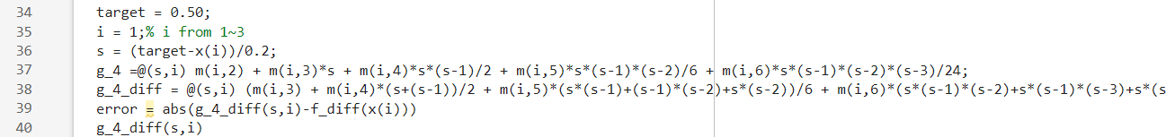 We choose the starting point 0.3

the f’(0.5) =1.2925

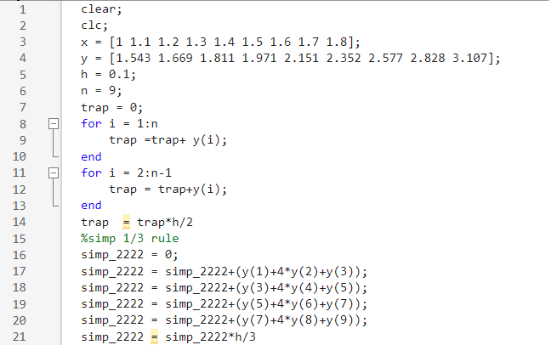

we first initial the points and use it to calculate the integral by Simpson’s 1/3 rule and Trapezoidal Rule.

Trapezoidal Rule: 1.7684

Simpson’s 1/3 Rule:1.7669

For 9 points (8 panels), we can use two 3/8 rule and one 1/3 rule (3+3+2 = 8) to calculate the integral

There are three possible:

1.3/8 rule on points(1~4),(4~7) 1/3 rule on point (7~9)

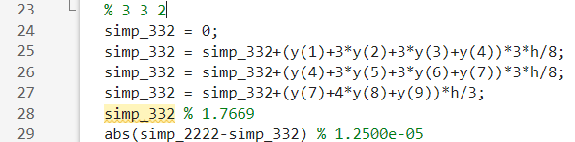

Ans = 1.7669

Error = 1.25e-05

2.3/8 rule on points(1~4),(6~9) 1/3 rule on point(4~6)

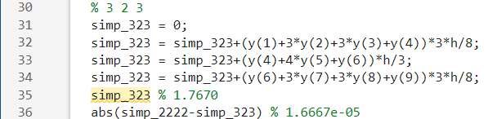

Ans = 1.7670

Error = 1.6667e-05

3.3/8 rule on points(3~6),(6~9) 1/3 rule on point (1~3)

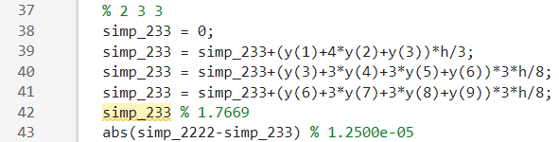

Ans = 1.7669

Error = 1.25e-05

The minimum error is 1.25e-05 (error is compare with Simpson 1/3 rule)

Ans = 1.7669

With 3/8 rule on points(1~4),(4~7) 1/3 rule on point (7~9)

First we initial the interval a, b and the function f. we use the while loop and use if(abs(now-prev)<0.02)to determine how many iteration to run. In while loop we first calculate the points and h and use these value with f(x) to calculate the value of Integrate 𝑓(𝑥) = 1/𝑥 2 over the interval [0.2, 1].

Ans = 4.003227

at 6th iteration with 65 points, h = 0.012500

We use two for loop to calculate the single integral outer for loop is two calculate different a,b

And the inner for loop is to calculate the integral by three term Gaussian quadrature.

we get the integral of e^x = 3.23646921, integral of sin(2y) =0.11409502

ans = 0.36926502