C:
1.
#include<stdio.h>
#include<stdlib.h>
typedef struct sll
{
int data;
struct sll *next;

}NODE;
int n1=0,n2=0,n3=0,n4=0,n5=0;
void add(NODE **head)
{
NODE *temp,*nu;
nu=malloc(sizeof(NODE)*1);
printf("enter value:");
scanf("%d",&(nu->data));
nu->next=NULL;
if(*head==NULL)
*head=nu;
else
{
temp=*head;
while(temp->next)
temp=temp->next;
temp->next=nu;

}

}

void print(NODE *head)
{
while(head)
{
printf("%d->",head->data);
head=head->next;

}
printf("\n");
}

void change(NODE **head,int data)
{
NODE *temp,*prev;
temp=*head;
while(temp)
{
if((temp->data==data)&&(temp!=*head))
{
prev->next=temp->next;
temp->next=(*head);
*head=temp;
break;
}
prev=temp;
temp=temp->next;
}

}
void change_to(NODE **head,int data,int first)
{
NODE *temp,*prev,*temp2=NULL,*temp3=NULL;
temp=prev=*head;
temp2=temp3=*head;
while(temp)
{
if(temp->data==first)
{
temp3=temp;
temp2->next=temp->next;
}
if(temp->data==data)
{
prev->next=temp->next;
temp->next=temp2->next;
temp3->next=temp;
break;
}

prev=temp;
temp=temp->next;
}

}
void search(NODE **head,int data)
{
NODE *temp,*prev;
temp=prev=*head;
/////

if(data==1)
{
if(n1>=n2)
if(n1>=n3)
if(n1>=n4)
{
if(n1>=n5)
change(head,data);

else
change_to(head,data,5);

}
else
change_to(head,data,4);
}
if(data==3)
{
if(n3>=n1)
if(n3>=n2)
{
if(n3>=n4)
if(n3>=n5)
change(head,data);
}
else
change_to(head,data,2);

}

/////

if(data==4)
{
if(n4>=n1)
if(n4>=n2)
if(n4>=n3)
if(n4>=n5)
change(head,data);
}
if(data==5)
{
if(n5>=n1)
if(n5>=n2)
if(n5>=n3)
{
if(n5>=n4)
change(head,data);
else
change_to(head,data,4);
}
else
change_to(head,data,3);

}
if(data==2)
{
if(n2>=n1)
if(n2>=n3)
if(n2>=n4)
if(n2>=n5)
change(head,data);
else
change_to(head,data,5);

}

}

int main()
{
NODE *head=NULL;
int ch,data,cnt=0,*arr;
while(1)
{
printf("1.add \n2.print\n3.search\n");
scanf("%d",&ch);
switch(ch)
{
case 1:add(&head);break;
case 2:
// search(&head,data);
print(head);break;
case 3:

printf("enter the data to be searched:");
scanf("%d",&data);

if(data==1)
{
n1++;
}
else if(data==2)
{
n2++;
}
else if(data==3)
{
n3++;
}
else if(data==4)
{
n4++;
}
else if(data==5)
{
n5++;
}
search(&head,data);
break;
case 4:return 0;
default:printf("invalid\n");break;

}
}

}
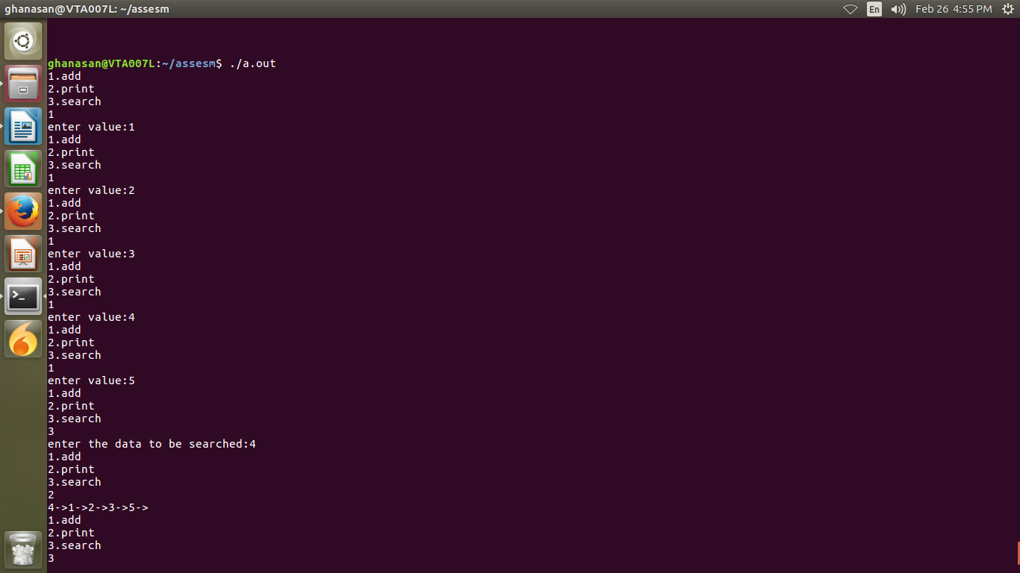

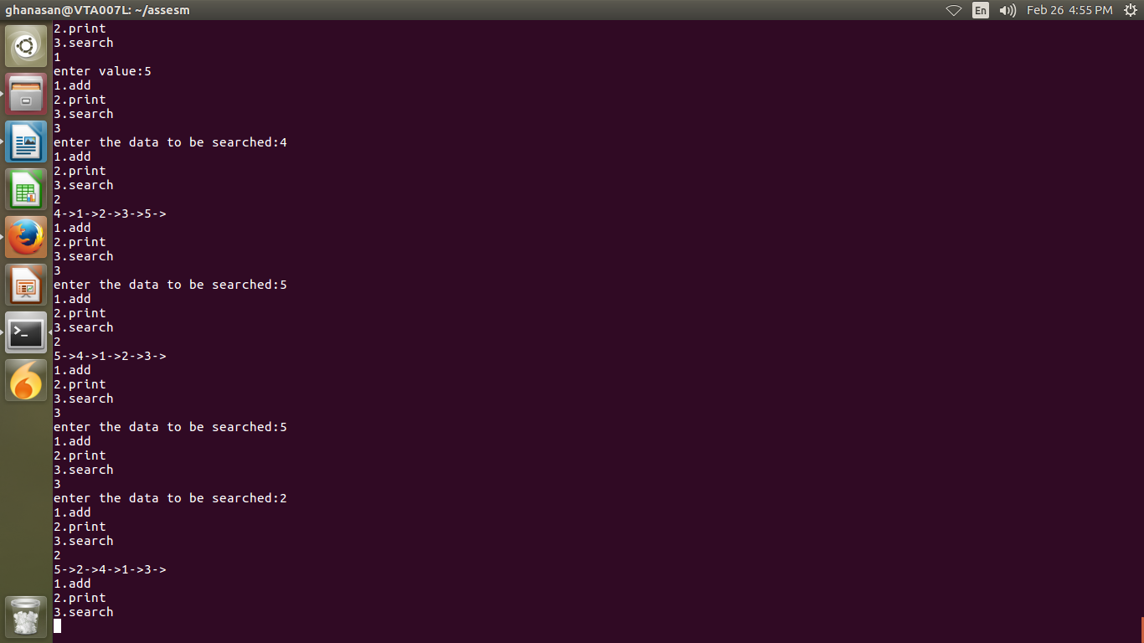

2.
#include<stdio.h>
#include<stdlib.h>
int main()
{
int T,N,*arr,i,j,sum=0;
printf("enter test cases:");
scanf("%d",&T);
while(T>0)
{
printf("enter array size:");
scanf("%d",&N);
arr=malloc(sizeof(int)*N);
if(arr==NULL)
{
puts("memory not allocated");
return 1;
}
printf("enter elements into array:");
for(i=0;i<N;i++)
scanf("%d",&arr[i]);
for(i=0;i<N;i++)
for(j=i+1;j<N;j++)
{
sum+=arr[i]^arr[j];
}
printf("sum is %d\n",sum);
free(arr);
sum=0;
T--;
}

}

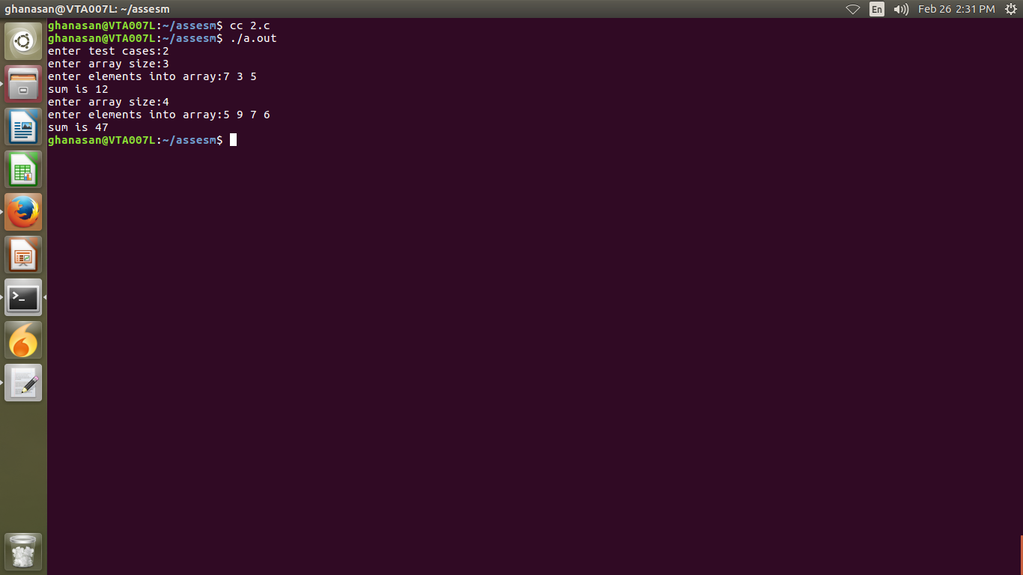

Linux
1.
BIOS:basic input output system
it will initialises the hardware and load the mbr
MBR:
initialises the boatloader and loads grub
GRUB:
it ask for which kernel you want to a run if you have multiple kernels,if you don’t select anything loads default
kernel:
initiales the file system
Init:
this is the first process to be executed.

2.
stack overflow:
it will occure when you are using the stack beyond the size of stack.whenever it occures the process will terminates.
->to overcome this you need to makesure how much stack is required by your application,and allocate(increase the size of stack) that size of stack using setrlimit and getrlimit.

3.
Memoryleak:
you are dynamically allocating memory and you are not freeing it,at this condition memory leak will comes into picture.
->using valgrind tool we can check how many buffers are freed.

4.
Mutex:
->the process who locked it only can unlock it
->deadlock will occure
->follows locking machanism
Semaphore:
->anyone can unlock
->deadlock will not occure
->follow signaling machanism

6.
if a process is looking for a page which is not there in the page table is called as page fault.

7.
deadlock:
there are two common resources in a process,if one thread is locked one resource and other thread is locked other resource and thread1 requires resoures 2 which is locked by thread2 and thread2 requieres resoure1 which is locked by thread1,at this time deadlock will occures i.e both the threads are waiting(blocked) for resoures to be released.
We use semaphore to overcome this issue.

8.
Static library:
it means the library is linked at compile time itself.
Eg:
vi sample.c
Int main()
{
int a;
printf(“Hello\n”);
scanf(“%d”,&a);
}
here scanf ,printf are linked dynamically
cc sample.c
->>>nm a.out
here you can check printf , scanf are undefined(i.e U) that means dynamiclly added.
-->ldd a.out
displays dynamically included

If you compile like
cc -static sample.c
this is static linking
-->>>nm a.out
scanf,printf are defined here(i.e T)
--->>ldd a.out
displays no dynamic linking

->static linking will increase the size of executable

ar rcs libs.a sum.o mul.o (here sum.o,mul.o are object files created using fpic)
here lis.a is staic library
Dynamic linking:
means the libraries are added at linker stage i.e dynamically
->default linkage is dynamic linking
->executable size decreases.

Gcc –shared lib.so sum.o mul.o ((here sum.o,mul.o are object files created using fpic))
here lib.so is dynamic library.

9.
when an interrupt is raised the controll will be given to isr and cpu will executes that isr and comes back to the process where it has been paused

10.
kernel panic:
error occured in the kernel which can’t be recovered.
->using kdump we can debud

