**Power BI Assignment 2**

1. Explain the advantages of Natural Queries in PowerBi with an example?

Sometimes the fastest way to get an answer from your data is to perform a search over your data using natural language. The Q&A feature in Power BI lets you explore your data in your own words using natural language. Q&A is interactive, even fun. Eg- What is highest sales in last year, Top 10 products by sales, Show the sales of specific country.

1. Explain Web Front End(WFE) cluster from Power BI Service Architecture?

The Web Front End cluster manages the initial connection between the back end cluster and the clients. It uses AAD (Azure Active Directory) to authenticate clients. Moreover, it provides various tokens for connecting clients to the Power BI service. Besides, Power BI also uses the Azure Content Delivery Network (CDN) to distribute the content efficiently. Besides, it uses ATM (Azure Traffic Manager) to distribute content to users based on various geographical locations.

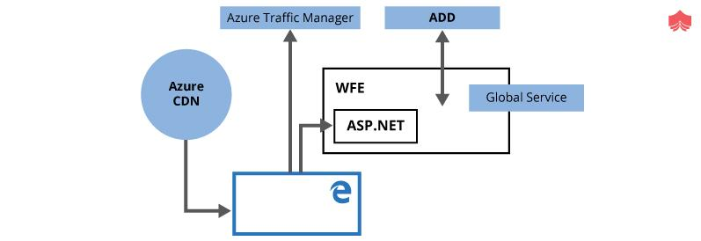

1. Explain Back End cluster from Power BI Service Architecture?

The Back End Cluster is useful to maintain various reports, storage, data sets, and other services under Power BI. In the BEC, the client has only two points to interact directly with the information or data. These are the Gateway Role and Azure API Management. Moreover, these components are useful for various services like load balancing, authentication, and routing, etc.

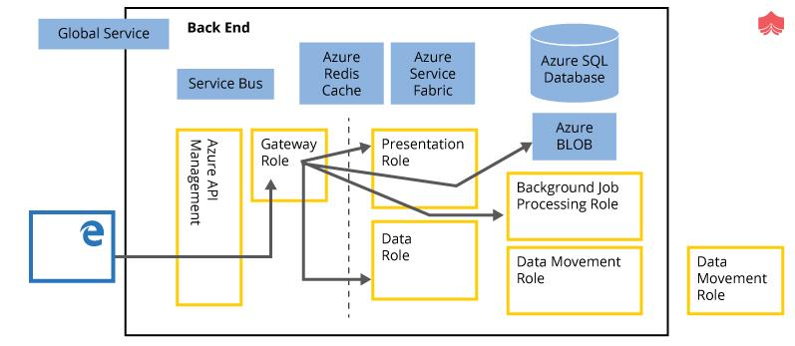

1. What ASP.NET component does in Power BI Service Architecture?

The ASP.NET component within the WFE cluster **parses the token to determine which organization the user belongs to, and then consults the Power BI Global Service**. The WFE specifies to the browser which back-end cluster houses the organization's tenant.

1. Compare Microsoft Excel and PowerBi Desktop on the following features:

Data import

Data transformation

Modeling

Reporting

Server Deployment

Convert Models

Cost

1. List 20 data sources supported by Power Bi desktop.
2. Excel Workbook.
3. Text/CSV.
4. XML.
5. JSON.
6. Folder.
7. PDF.
8. Parquet.
9. SharePoint folder.
10. Power BI dataflows
11. Power BI datasets
12. Python script
13. R script
14. Salesforce Objects
15. Salesforce Reports
16. SAP HANA
17. SharePoint Folder
18. SQL Server
19. SQL Server Analysis Services
20. GitHub
21. Google Sheets