**Power BI Assignment 3**

1. List and explain different PowerBi products?

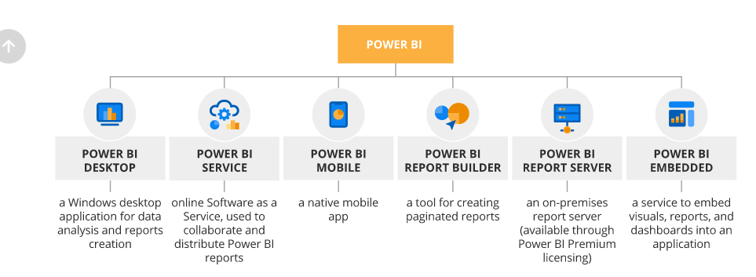

1. What limitations of Excel, Microsoft solved by PowerBi?

### Single Source of Truth – Workspace. By building a [Workspace](https://docs.microsoft.com/en-us/power-bi/service-new-workspaces) in Power BI, you can give your company the advantage of structuring and associating data schema into one place.

### Cloud Service -  Data can be uploaded from multiple on-premise sources (Excel, DB, CSV, etc.) or reported directly from multiple cloud web services such as [Azure](https://smartbridge.com/modernization/), MailChimp, Zendesk, and [Salesforce](https://smartbridge.com/salesforce/). Once uploaded, reports are accessible from any modern browser. Power BI also has dedicated apps for most popular devices, such as Windows, Android, and iOS.

### Q&A - Do you know what you’re looking for, but don’t know where (or how) to find it? With Q&A, users can browse their data by typing questions into a Natural Language capability tool that Power BI has incorporated.

### Quick Insights-Do you think there’s something happening in your company, but you’re unable to find out what? [Quick Insights](https://docs.microsoft.com/en-us/power-bi/service-insights) is a powerful algorithmic tool that automatically detects outliers, trends, correlations, majority, etc.

### Data Manipulation - Is your spreadsheet so big that simply changing a cell takes forever? Power BI data model compression algorithm enhances the speed for data manipulation. Once the model is imported into the web service, Power BI brings the solutions of [Azure Data Lake Gen 2.](https://docs.microsoft.com/en-us/azure/storage/blobs/data-lake-storage-introduction) into play.

* Weekly Features

1. Explain PowerQuery?

Power Query is the data connectivity and data preparation technology that enables end users to seamlessly import and reshape data from within a wide range of Microsoft products, including Excel, Power BI, Analysis Services, Dataverse, and more.

1. Explain PowerMap?

Power Query and Power Map are two of the new Excel features for Power BI announced this morning at the Worldwide Partner Conference. Together, these two tools enhance the self-service business intelligence experience in Excel by allowing you to discover, combine, refine and visualize your data.

1. How powerBi eliminated the need to host SharePoint Server on premises?
2. Explain the updates done in Power Bi Service(power BI 2.0) as compared to older version ?

### Ease of Use

Workspace version 2 made some functions easier to apply in the Power BI service. As an example, you can set the workspace image directly in the Power BI service. With the old version, you couldn’t do that. With the old version, one of the ways to set an image for the workspace was to go to the Office portal and change the image of the office 365 group.

### Decoupled from Office 365

It also helps in decoupling the Office 365 groups and Power BI workspaces. In the old version of workspaces, with the creation of workspace, an office 365 group was created also. those two were coupled to each other. In the app workspace Version 2, however, the creation of app workspace can be separate.

### Assign AD Groups to Workspace Roles

In the older version of workspace, you could only assign users individually as the admin of the group. In the workspace version 2, now you can have an AD group assigned as a role membership in the workspace.