Team page

http://teamadmin.club/teams/mapola-fc-2003-boys/

1. Center team image, control the size displayed to max -height 400px
2. Missing player info – see attached example – This team has players in the backend but they are not showing up

http://teamadmin.club/teams/89/

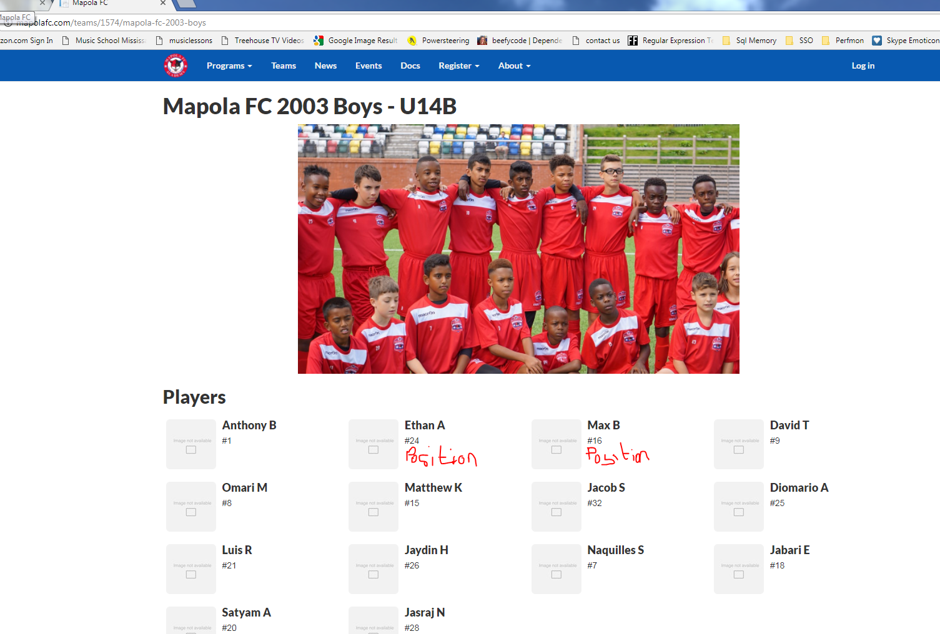

Format:

Image Name

#

Position

1. <http://teamadmin.club/programs/curriculum/>
   1. Download link incorrect, please grab pdf from mapola site

http://mapolafc.com/forms/Curriculum.pdf

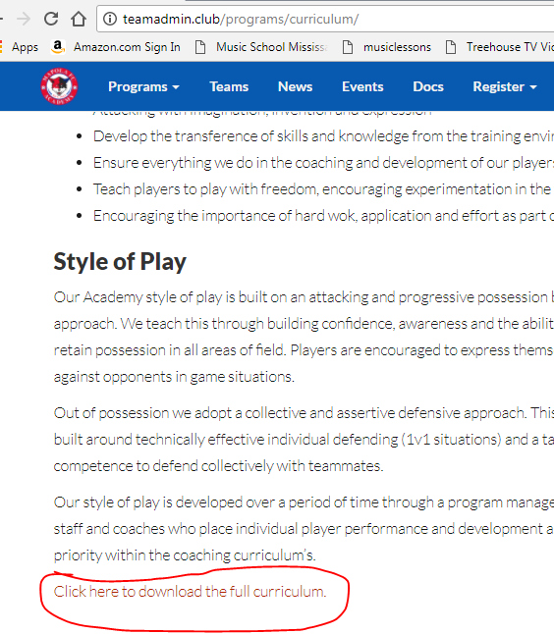

1. News Page

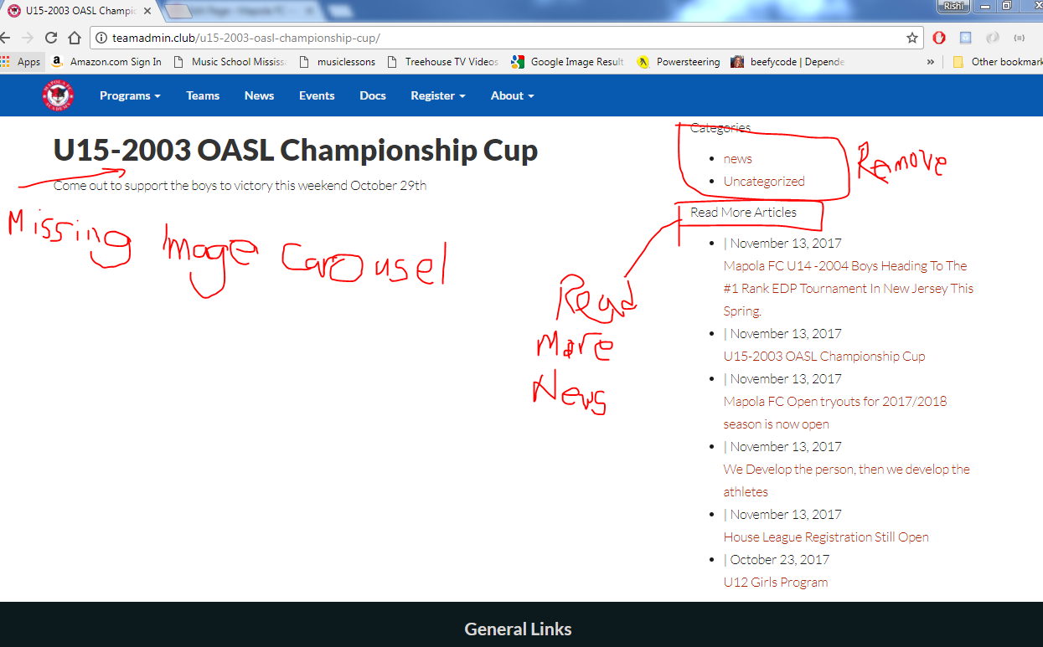

1. <http://teamadmin.club/event/u9-indoor-league-islington-rangers-vs-mapola-fc/>

Event details not showing map – check http://www.mapolafc.com/events/55 as an example

1. Header missing on following pages

<http://teamadmin.club/about/>

<http://teamadmin.club/academy-graduates/>