1. Install Power BI Desktop and share the final screenshot of the report view page which appears when power desktop starts.

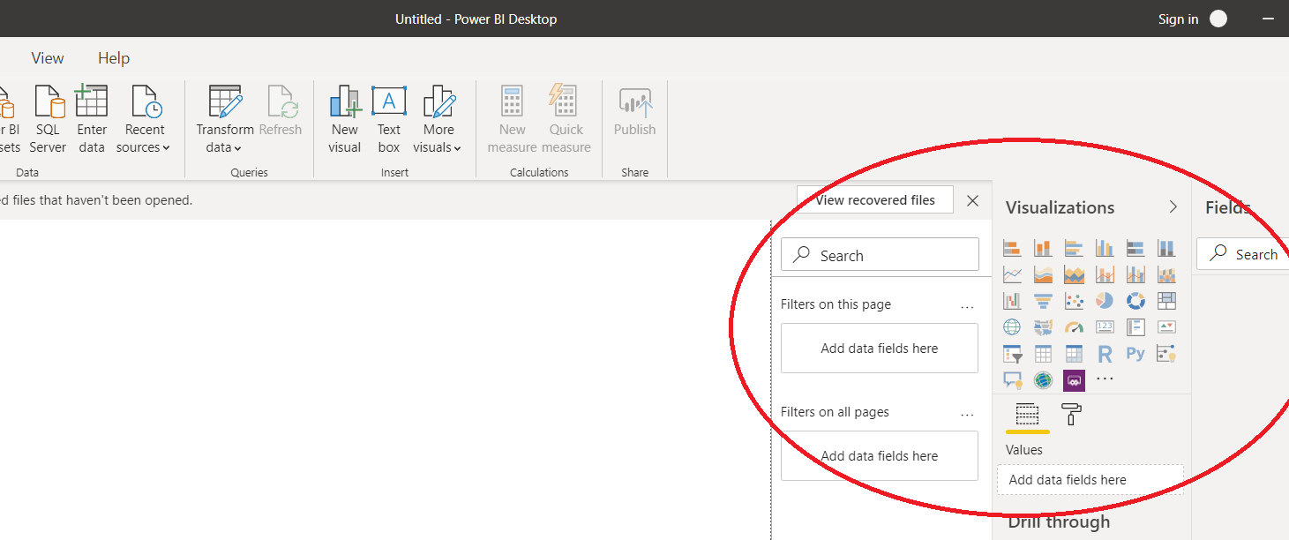

1. Prepare a document and with the following screenshot − Report View − Data View − Model View − Power Query Editor − Advance Editor

**Report View**

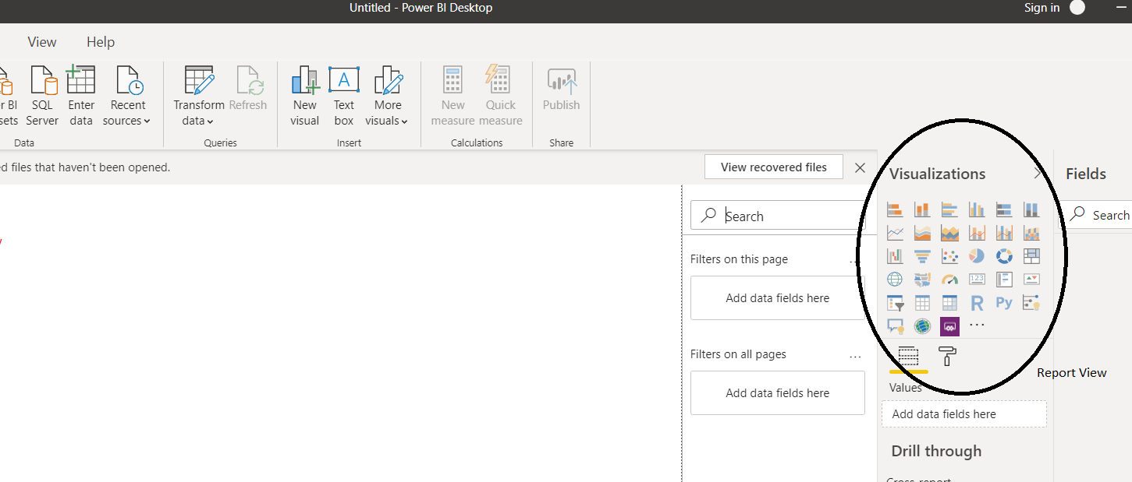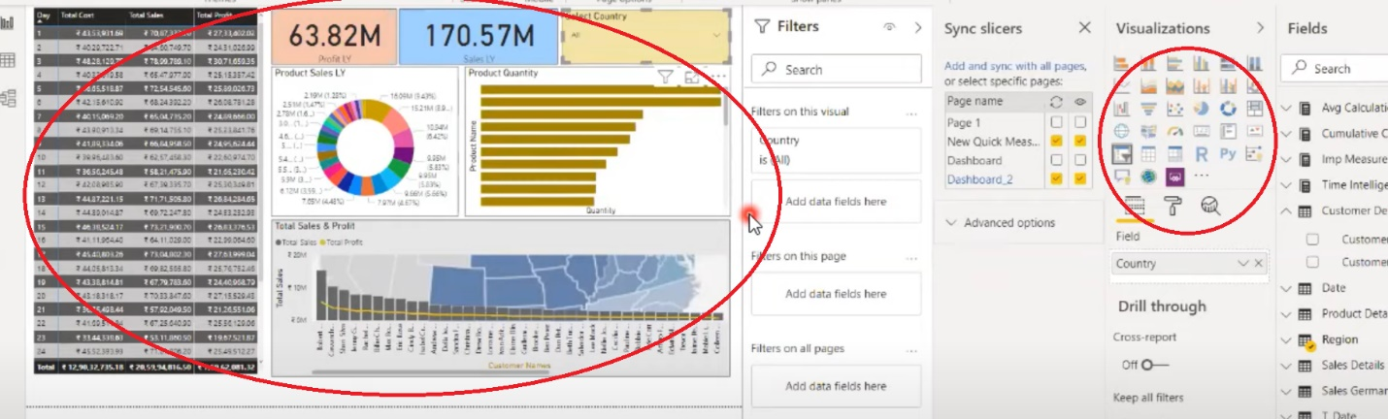

**Data View**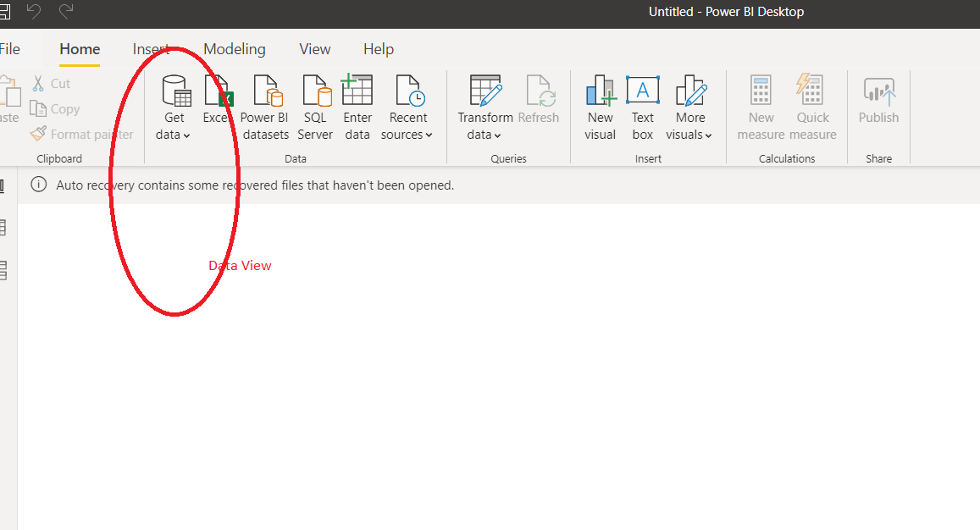

**Model View**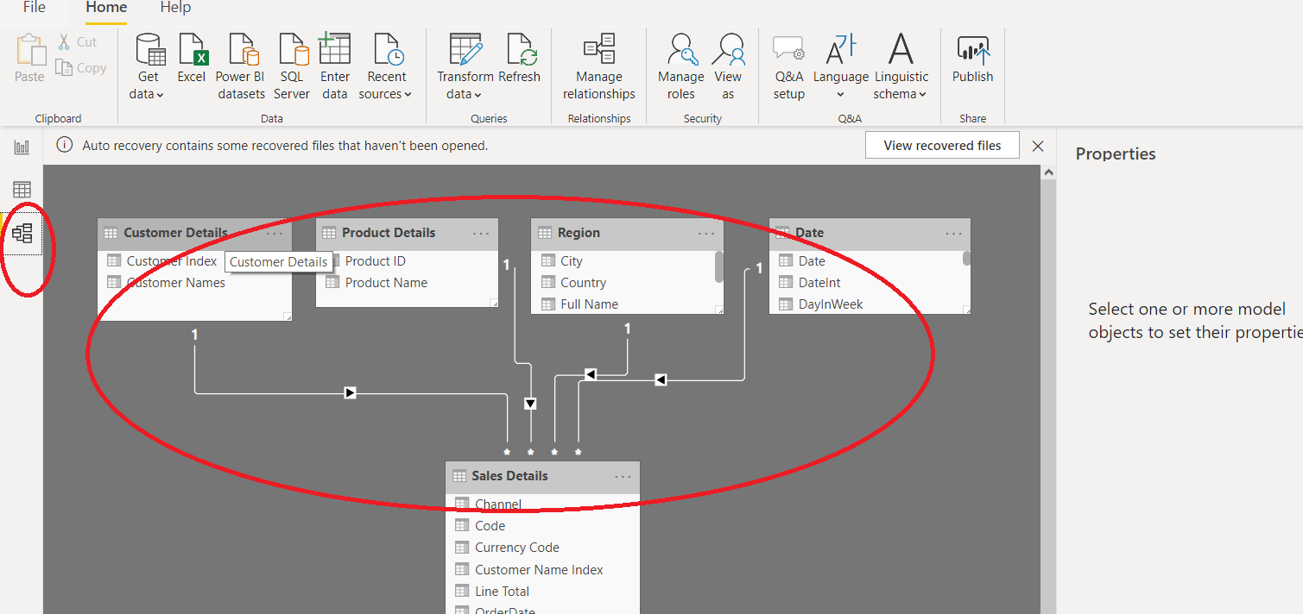

**Power Query Editor**

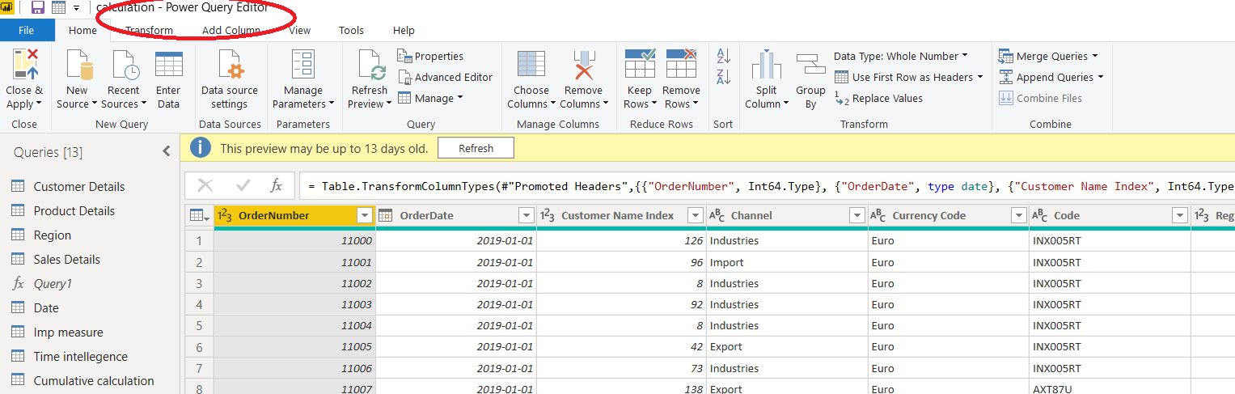

**Advance Editor**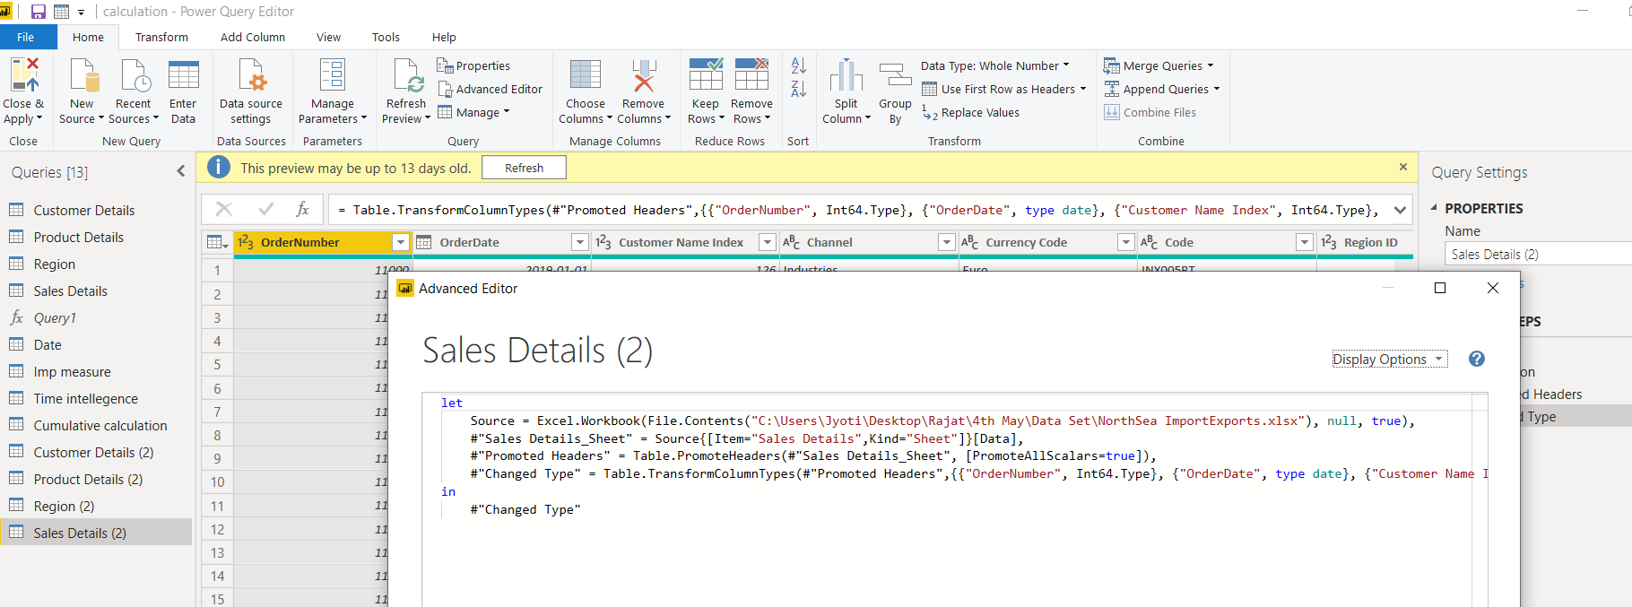

**Prepare a document with details of the following along with their price**

**− Power BI Desktop**

**− Power BI Pro**

**− Power BI Premium**

**Power BI Desktop** is a free application you install on your local computer that lets you connect to, transform, and visualize your data.

**Power BI Pro** is an individual user license that lets users read and interact with reports and dashboards that others have published to the **Power BI** service. Users with this license type can share content and collaborate with other **Power BI Pro** users.

The **Pro** plan costs $9.99/user/month. It includes data collaboration, data governance, building dashboards with a 360-degree real-time view and the ability to publish reports anywhere. Users can try it a free trial for 60 days before purchasing the subscription

**Power BI Premium** is a capacity-based offering that includes: Flexibility to publish reports broadly across an enterprise, without requiring recipients to be licensed individually per user. Greater scale and performance than shared capacity in the **Power BI** service.

The minimum **cost** of entry is $4,995 (P1) plus $9.99 (Pro) for a total of $5,004.99 per month